Behaviour and Exclusions Policy

Ratified by: | CURRICULUM AND STANDARDS | Date: FEB 2023
Next review by: | FEB 2025

Sinai Jewish Primary School is committed to creating an environment where exemplary behaviour is at the heart of productive learning. Everyone is expected to maintain the highest standards of personal conduct, to accept responsibility for their behaviour and encourage others to do the same. Our behaviour policy guides staff to teach self-regulation and discipline, not compliance. We aim to promote good behaviour through a culture of mutual respect, placing an emphasis on respectful behaviour, strong partnerships and dynamic interventions.
Everyone is responsible for good behaviour in the school. This includes children, staff, parents and governors. It forms part of the whole school ethos with everyone sharing the same high expectations.

1. Aims
- Create a positive culture that promotes excellent behaviour, ensuring that all pupils have the opportunity to learn and reach their full potential in a calm, safe and supportive environment
- Establish a whole-school approach to maintaining high standards of behaviour that reflect the values of the school
- Outline the expectations and consequences of behaviour
- Provide a consistent approach to behaviour management that is applied equally to all pupils
- Define what we consider to be unacceptable behaviour, including bullying and discrimination

2. Statutory requirements
This policy is based on legislation and advice from the Department for Education (DfE) on:
- Behaviour and discipline in schools: advice for headteachers and school staff, 2016
- Behaviour in schools: advice for headteachers and school staff 2022
- Searching, screening and confiscation at school 2018
- Searching, screening and confiscation: advice for schools 2022
- The Equality Act 2010
- Keeping Children Safe in Education
- Exclusion from maintained schools, academies and pupil referral units in England 2017
- Suspension and permanent exclusion from maintained schools, academies and pupil referral units in England, including pupil movement - 2022
- Use of reasonable force in schools
- Supporting pupils with medical conditions at school
It is also based on the Special Educational Needs and Disability (SEND) Code of Practice.
In addition, this policy is based on:
- Section 175 of the Education Act 2002, which outlines a school’s duty to safeguard and promote the welfare of its pupils
- Sections 88 to 94 of the Education and Inspections Act 2006, which requires schools to regulate pupils’ behaviour and publish a behaviour policy and written statement of behaviour principles, and give schools the authority to confiscate pupils’ property
- DfE guidance explaining that maintained schools must publish their behaviour policy online

3. Roles and responsibilities

3.1 The Governors
The governors are responsible for reviewing and approving the written statement of behaviour principles (appendix 1). The governors will also review this behaviour policy in conjunction with the Headteacher and Deputy Headteacher and monitor the policy’s effectiveness, holding the Headteacher to account for its implementation.

3.2 The Headteacher
The Headteacher is responsible for reviewing this behaviour policy in conjunction with the governors. The Headteacher and Deputy Headteacher will ensure
- that the school environment encourages positive behaviour
- that staff deal effectively with poor behaviour
- that staff implement this policy consistently with all groups of pupils and that rewards and sanctions are applied consistently
- that all staff understand the behavioural expectations and the importance of maintaining them
- that new staff are provided with a clear induction into the school’s behavioural culture to ensure they understand its rules and routines, and how best to support all pupils to participate fully
- appropriate training is offered in behaviour management as part of ongoing CPD, and the impact of special educational needs and disabilities (SEND) and mental health needs on behaviour, to any staff who require it, so they can fulfil their duties set out in this policy
- this policy works alongside the safeguarding policy to offer pupils both sanctions and support when necessary
- that the data from the behaviour log is reviewed regularly, to make sure that no groups of pupils are being disproportionately impacted by this policy

3.3 Teachers and Staff
Staff are responsible for:
- Creating a calm and safe environment for pupils
- Establishing and maintaining clear boundaries of acceptable pupil behaviour
- Implementing the behaviour policy consistently
- Modelling expected behaviour and positive relationships
- Communicating the school’s expectations, routines, values and standards through teaching behaviour and in every interaction with pupils
- Providing a personalised approach to the specific behavioural needs of particular pupils
- Recording significant behaviour incidents on CPOMs promptly
- Challenging pupils to meet the school’s expectations
The senior leadership team will support staff in responding to behaviour incidents.

3.4 Parents and carers
Parents and carers are expected to, where possible to:
- Get to know the school’s behaviour policy and reinforce it at home where appropriate
- Support their child in adhering to the schools behaviour policy and home/school agreement
- Inform the school of any changes in circumstances that may affect their child’s behaviour
- Discuss any behavioural concerns with the class teacher promptly
- Take part in any pastoral work following misbehaviour (for example: attending reviews of specific behaviour interventions)
- Raise any concerns about the management of behaviour with the school directly, whilst continuing to work in partnership with the school
- Take part in the life of the school and its culture

3.5 Pupils
Pupils will be made aware of the following during their induction into the behaviour culture:
- The expected standard of behaviour they should be displaying at school
- That they have a duty to follow the behaviour policy
- The school’s key rules and routines
- The rewards they can earn for meeting the behaviour standard, and the consequences they will face if they don’t meet the standard
- The pastoral support that is available to them to help them meet the behavioural standards
- Pupils will be supported to meet the behaviour standards and will be provided with repeated induction sessions wherever appropriate. Pupils will be asked to give feedback on their experience of the behaviour culture to support the evaluation, improvement and implementation of the behaviour policy.
- Extra support and induction will be provided for pupils who join mid-year.

4. Sinai’s School Rules
In order to create a culture that promotes excellent behaviour the following rules are in place:
- Be respectful
- Be responsible
- Be ready
- Be the best you can be

At the beginning of the year all children must be given the opportunity to discuss how they are going to follow Sinai’s school rules. These rules must be clearly displayed in each room and referred to regularly so that children and parents know what is expected at all times. At the beginning of every term children are reminded of the school rules and behaviour expectations. Expectations for behaviour are well defined focussing on successful behaviour and key routines that the children are expected to develop.

5. The Curriculum and Learning
We believe that an appropriately structured curriculum contributes to effective learning and good behaviour. Thorough planning for the needs of individual pupils, the active involvement of pupils in their own learning, and structured feed-back will result in positive behaviour being maximised.
It follows that lessons should have clear objectives and steps to success that are explained and understood by the children, and differentiated to meet the needs of all children. All lessons should contain regular opportunities for assessment for learning. Marking is both a supportive activity, providing feed-back to the children on their progress and achievements, and a signal that the children's efforts are valued and that progress matters.

5.1 PSHE Programme/JS Curriculum
Creating a positive school culture and ethos where children are aware of expectations and rules is paramount. A clearly planned, well-structured PSHE and JS Curriculum form the basis of preventative work and ensure consistency and involvement for all. They create opportunities for children to develop positive values and understand and respect both difference and diversity. This is reinforced through the Midah of the month. It must be remembered that staff are pivotal in leading and modelling positive behaviour and interactions.
Through the curriculum children are given a wide range of opportunities to develop their knowledge and understanding of diversity and should be clearly taught how to interact with each other. They are given a variety of strategies to deal with unknown situations and to protect themselves from bullying. Children are taught to understand the appropriate ways to behave and strategies to manage their own relationships. They have appropriate behaviour modelled to them and the opportunities to role play strategies for dealing with conflict. Children are actively encouraged to take responsibility for their own actions and make ‘smart’ decisions. They are given opportunities to discuss the use of language and differences between banter and behaviour that makes people feel threatened or hurt.
The PSHE program aims to teach the children the most appropriate ways to behave and improve their behaviour. If there is a break down in behaviour, additional PSHE lessons are used to supplement the curriculum, to teach how to deal with scenarios in a way tailored to the specific needs of the class or group, alongside ongoing restorative conversations.

5.2 Growth Mindset
With Growth Mindset being an important part of our learning ethos, all children will be fully aware that success, however defined, is achieved through hard work, perseverance and focused practice based on seeking and responding to feedback. Sinai School students learn to be resilient, welcome challenge and understand that failure is a necessary part of the journey to success. We believe that there are no upper limits to what our students can achieve if they have the right attitude to learning and display the behaviours necessary for success.
We believe praise should be specific and focus on the process that students have gone through to achieve high levels of attainment and on positive behaviour and effort.

5.3 Zones of regulation
Zones of Regulation is a framework that develops awareness of feelings, energy and alertness levels while exploring a variety of tools and strategies for regulation, prosocial skills, self-care, and overall wellness. Zones of regulation is used in school to support the children regulate their behaviour. It provides the children with an easy way to think and talk about how they feel on the inside and sort these feelings into four coloured Zones, all of which are expected in life. Once they understand their feelings and zones, we can help them learn to use tools/strategies to manage their different Zones in order to meet goals and achieve tasks, managing big feelings, and healthy relationships with others.

6 Bullying
Bullying is a continuum of behaviour rather than a separate issue. Bullying is;
behaviour by an individual or a group, repeated over time that intentionally hurts another individual either physically or emotionally” (DfE “Preventing and Tackling Bullying”, July 2017)
Bullying is defined as the repetitive, intentional harming of one person or group by another person or group, where the relationship involves an imbalance of power.
Bullying is, therefore:
- Deliberately hurtful
- Repeated, often over a period of time
- Difficult to defend against
Bullying can include; emotional, physical, prejudice and discriminatory (including: racial, faith based, gendered, homophobic/biphobic, transphobic, disability based), sexual, direct or indirect verbal or cyber-bullying.
Bullying differs from teasing/falling out between friends or other types of aggressive behaviour. It can be when there is a deliberate intention to hurt or humiliate, there is a power imbalance that makes it hard for the victim to defend themselves, and is usually persistent.
The safety of the children is paramount. If a child hurts or bullies another pupil, the adult dealing with the situation must record this. The School does not tolerate bullying of any kind. If an act of bullying or intimidation has taken place, staff will act immediately to stop any further occurrences of such behaviour.
Sinai provides a secure environment where children know how to, and feel safe to, report any incidents of inappropriate behaviour, bullying or allegations relating to safe guarding.
If a child makes an allegation against another child relating to safeguarding it must be reported to the designated safe guarding officer who will investigate and deal with as appropriate.
Incidents of bullying are carefully recorded on CPOMs and analysed for trends.
(Details of our school’s approach to preventing and addressing bullying are set out in our Anti-Bullying Policy)

7 Expectations, Rewards and Sanctions
Sinai Jewish Primary School has a very specific system of rewards and sanctions applied across the school to ensure that there is mutual respect between all members of staff and pupils.
(see appendices)

7.1 Expectations for Good Work:
Good work is recognised as:
- Giving thoughtful, considered answers
- Working to their full potential
- Working collaboratively: sharing ideas and taking turns
- Using steps to success to meet learning objectives
- Achieving individual targets
- Achieving group/class targets
- Striving for neat presentation

7.2 Expectations for Good Behaviour:
Good behaviour is recognised as following Sinai’s School Rules.
Classroom management
Teaching and support staff are responsible for setting the tone and context for positive behaviour within the school.
They will:
- Create and maintain a stimulating environment that encourages pupils to be engaged
- Display the school rules and their own classroom rules
- Develop a positive relationship with pupils, which may include:
  - Greeting pupils in the morning/at the start of lessons
  - Establishing clear routines
  - Communicating expectations of behaviour in ways other than verbally
  - Highlighting and promoting good behaviour
  - Concluding the day positively and starting the next day afresh
  - Having a plan for dealing with low-level disruption
  - Using positive reinforcement

7.3 Behaviour expectations outside the classroom

7.3.1 In the Playground
Pupils are expected to:
- Follow Sinai’s School Rules
- Include other children in their games and ensure no child is excluded.
- Treat playground equipment with care.
- Report any accidents/ incidents to one of the adults on duty.
Staff are expected to:
- Ensure all playground areas are supervised by appropriate adults during playtimes.
- Staff must take responsibility for being on time and organise cover if they are going to be absent.
- All staff on duty must be vigilant at all times and patrol all areas of the playground.
- Staff must wear Hi-Vis jackets so children can clearly identify them.
- Listen to and deal with behaviour appropriately; i.e. give out warnings. Pass on all incidents resulting in a negative dojo, or a more serious consequence to the class teacher at the end of play. (see also playground rules/policy)

7.3.2 Lunchtime (including dining room and playground)
- All staff, including lunchtime staff are encouraged to praise good behaviour.
- All lunchtime staff to deal with inappropriate behaviour by talking to the children concerned.
- Lunchtime staff to inform lead supervisor of any inappropriate behaviour during lunchtime. Lead supervisor to inform class teachers if necessary.

7.3.3 Transition from playground to classroom
- At the end of playtime the whistle will be blown.
- All children must walk quietly and sensibly to their lines.
- All teachers should be out in the playground at this time (after break and lunch) to collect their children.
- Children must line up, in register order, one behind the other without talking.

7.3.4 School Building
- Pupils play outside before school and during school playtimes unless given specific permission by a teacher or member of SLT.
- Similarly parents should drop off and collect children from the playground and not be inside the building unless they have a meeting with a member of staff, in this instance parents should go to the office and not straight up to the classroom.
- Sinai is a calm, orderly place at all times. Therefore, the children should be taught and encouraged to show respect in everything they do. For safeguarding reasons children and parents should not be in the school building without prior permission and then signing in at the front desk.
- Pupils must respect and look after the fabric of the building and all school property. Parents may be asked to pay for any deliberate damage incurred.

7.3.5 Toilets and cloakrooms
- Children are expected to behave appropriately, respect the privacy of others and maintain a high standard of hygiene.
- Pupils must ask permission before going to the toilets or cloakroom during lesson times.

7.4 Behaviour Outside School (Coach/School Trips/Off-Site Activities/Clubs):
We expect all pupils to uphold the high standards expected at school when taking part in an off-site activity. These are carefully planned by the staff and will extend the curriculum for the children. We would not wish to exclude any child from such an activity.
The welfare and safety of all the children in a group is our prime concern, so if a child is not able to demonstrate responsible behaviour in school, it is possible that this could pose a problem for the child or the group as a whole whilst off-site, and the teacher may have to exclude a pupil from a trip if there are problems with general behaviour. In certain circumstances, it may be possible to include a child if the parent accompanies the child.
Sanctions may be applied where a pupil has misbehaved off-site when representing the school, such as on a school trip or on the bus on the way to or from school.
A behaviour agreement / contract will be put into place for all children ahead of residential ‘overnight’ trips. This is to ensure that all children take a personal responsibility to ensure their behaviour is of a good enough standard to enjoy the benefits of a residential trip. It also ensures they understand that continued good behaviour is expected both before, during and after any trip.
Children who attend clubs run by external providers are expected to follow the schools behaviour policy. The school reserves the right to exclude a child if his/her behaviour disrupts the group as a whole and we receive complaints from a supplier.
Children who take all school transport to / from school must continue to uphold the school’s high expectations for behaviour whilst they are on the coach and whilst waiting for the coach. If they fail to do so then they may be excluded from using the coach.

7.5 Online misbehaviour
The school can issue behaviour sanctions to pupils for online misbehaviour when:
- It poses a threat or causes harm to another pupil
- It could have repercussions for the orderly running of the school
- It adversely affects the reputation of the school
- The pupil is identifiable as a member of the school
Sanctions will only be given out on school premises or elsewhere when the pupil is under the lawful control of a staff member.

7.6 Suspected criminal behaviour
If a pupil is suspected of criminal behaviour, the school will make an initial assessment of whether to report the incident to the police. When establishing the facts, the school will endeavour to preserve any relevant evidence to hand over to the police.If a decision is made to report the matter to the police, the Headteacher / member of the senior leadership team will make the report.
The school will not interfere with any police action taken. However, the school may continue to follow its own investigation procedure and enforce sanctions, as long as it does not conflict with police action. If a report to the police is made, the designated safeguarding lead (DSL) will make a tandem report to children’s social care, if appropriate.

7.7 Zero-tolerance approach to sexual harassment and sexual violence
The school will ensure that all incidents of sexual harassment and/or violence are met with a suitable response, and never ignored. Pupils are encouraged to report anything that makes them uncomfortable, no matter how ‘small’ they feel it might be.
The school’s response will be:
- Proportionate
- Considered
- Supportive
- Decided on a case-by-case basis
The school has procedures in place to respond to any allegations or concerns regarding a child’s safety or wellbeing. These include clear processes for:
- Responding to a report
- Carrying out risk assessments, where appropriate, to help determine whether to:
  - Manage the incident internally
  - Refer to early help
  - Refer to children’s social care
  - Report to the police
Please refer to our child protection and safeguarding policy for more information.

7.8 Rewards
Our emphasis is on rewards to reinforce good behaviour, rather than on failures. We believe that rewards have a motivational role, helping children to see that good behaviour is valued. The most common reward is praise, informal and formal, public and private, to individuals and groups. It is earned by the maintenance of good standards as well as by particularly noteworthy achievements, in school work and homework. Rates of praise for behaviour should be as high as for hard work.

7.8.1 Rewards for good behaviour and good work:
When a pupil’s behaviour meets or goes above and beyond the expected behaviour standard, staff will recognise it with positive recognition and reward. This provides an opportunity for all staff to reinforce the school’s culture and ethos.
Positive reinforcements and rewards will be applied clearly and fairly to reinforce the routines, expectations and norms of the school’s behaviour culture.
Positive behaviour will be rewarded with:
- Verbal praise
- Children to receive a Dojo for good behaviour.
- For significant achievements children will visit SLT for praise and a reward.
- Midah of the month certificate to celebrate children who have shown the months Midah/value
- Postcard from Headteacher - each week the Head teacher will recognise good behaviour, kindness, achievement and effort. Individual postcards are written and posted to nominated children in each class every week.

7.8.2 Achievement Assembly
At the end of every term, there will be an achievement assembly to celebrate a wide range of achievements. These may include:
- Work Ethic and Effort
- Achievement
- Subject specific awards are given at the end of the year (including French, Science, PE)
- JS awards
- Sporting achievements, club or competition team winners
- Attendance

7.9 Sanctions
When a pupil’s behaviour falls below the standard that can reasonably be expected of them (ie following Sinai’s School Rules), staff will respond in order to restore a calm and safe learning environment, and to prevent recurrence of misbehaviour.
Staff will endeavour to create a predictable environment by always challenging behaviour that falls short of the standards, and by responding in a consistent, fair and proportionate manner, so pupils know with certainty that misbehaviour will always be addressed.
De-escalation techniques can be used to help prevent further behaviour issues arising, such as the use of pre-arranged scripts and phrases.
All pupils will be treated equitably under the policy, with any factors that contributed to the behavioural incident identified and taken into account.
When giving behaviour sanctions, staff will also consider what support could be offered to a pupil to help them to meet behaviour standards in the future.
The school will follow the following sanctions:
- Verbal warning
- Negative Dojo
- Teacher meeting (restorative conversations)
- Lunch time detention
It is not acceptable for any pupil to be sent to stand in a corner of the classroom or outside the classroom at any time.
It is also not acceptable for a child to be required to work on their own in a classroom unless there is a member of staff with them at all times.

7.9.1 Verbal Warning
- It must be clear why the warning is given.
- It must be made clear what changes in behaviour are required to avoid further punishment (where necessary any opportunity to move away from disruptions or nearer to teacher should be given).

7.9.2 Negative Dojo
- A verbal warning must be given before each negative dojo.
- Negative dojos will be recorded on class dojo.

7.9.3 Teacher meeting
- Children may be asked to attend a pupil teacher meeting immediately after the lesson where there has been repetitive negative behaviour.
- This is an opportunity for the teacher and child to discuss inappropriate behaviours in a restorative way. Restorative approaches help to develop a healthier learning environment, where children take responsibility over their own behaviours and learning. The process will involve children reflecting on their behaviour and how it affected others. Using specific restorative questions may be asked/ Such as; what happened, what were you thinking/feeling at the time? How did this make other people feel? Who has been affected by this? What should we do to put things right? How can we do things differently in the future?
- Where appropriate parents will be informed of this measure.

7.9.4 Lunch time detention
- Children will only be put on Lunchtime detention for more extreme or persistent behaviours (this is most likely to be if children have physically hurt another person, used inappropriate language or seriously damaged property).
- The adult who has been involved with the incident will inform the class teacher and the class teacher, JS and or French teacher will be responsible for organising the detention.
- The class teacher, JS and or French teacher will then contact the parent/s involved to inform them of the incident and the actions being taken. The names of other children involved will be confidential and not shared with parents.
- Children must attend lunchtime detention on the day of unacceptable behaviour or the next day if the unacceptable behaviour happens in the afternoon.
- Lunchtime detention will take place for 20 minutes.
- Lunchtime detentions follow a restorative approach.
- Children on Lunchtime detention to; EYFS/Yr1 – fill in a reflection form with support then read, Yr2 upwards to fill in a consequence form. Once the forms are completed the teacher will have a discussion with child and consider alternative ways of behaving to avoid having a detention. The child then has time to reflect on their own behaviour, if necessary a child may be put on report or a Behaviour Support Plan may be put into place if the behaviours persist.
- Parents/ guardians will be called to meet and discuss their child’s behaviour if it continues to be persistently disruptive.
- All significant behaviour incident must be recorded on CPOMs. This data is then analysed monthly by members of SLT.
- SLT may decide to put a child on report if their behaviour has become a cause for concern. This report will consist of specific targets to support the child’s behaviour and learning. The report will checked with a member of SLT daily and where necessary a time for reflection may take place.

7.10 Physical restraint
In some circumstances, staff may use reasonable force to restrain a pupil to prevent them:
- Causing disorder
- Hurting themselves or others
- Damaging property
Incidents of physical restraint must:
- Always be used as a last resort
- Only be used by trained members of staff, unless a child is in imminent danger of serious harm
- Be applied using the minimum amount of force and for the minimum amount of time possible
- Be used in a way that maintains the safety and dignity of all concerned
- Never be used as a form of punishment
- Be recorded on CPOMs and reported to parents
(see Positive Handling policy)

7.11 Mobile phones
Pupils are not allowed to have mobile phones with them on-site, unless request has been sort and approved by the Headteacher.
If the Headteacher has approved requests in conjunction with parental permission phones must be handed in to the front office, turned off, at the beginning of the day and collected at the end of the day. School is not liable for any loss or damage.

7.12 Confiscation
Any prohibited items (knives or weapons, alcohol, illegal drugs, stolen items, tobacco, and cigarette papers, fireworks, pornographic images, any article a staff member reasonably suspects has been, or is likely to be, used to commit an offence, or to cause personal injury to, or damage to the property of, any person, including the pupil)) found in pupils’ possession will be confiscated. These items will not be returned to pupils.
We will also confiscate any item which is harmful or detrimental to school discipline (phones and other devices). These items will be returned to pupils after discussion with senior leaders and parents, if appropriate. Searching and screening pupils is conducted in line with the DfE’s latest guidance on searching, screening and confiscation.

7.13 Malicious allegations
Where a pupil makes an accusation against a member of staff and that accusation is shown to have been deliberately invented or malicious, the Headteacher will discipline the pupil in accordance with this policy. Please refer to our [safeguarding policy/statement of procedures for dealing with allegations of abuse against staff] for more information on responding to allegations of abuse.
The Headteacher will also consider the pastoral needs of staff accused of misconduct.
Where a pupil makes an allegation of sexual violence or sexual harassment against another pupil and that allegation is shown to have been deliberately invented or malicious, the school will consider whether to discipline the pupil in accordance with this policy.
In all cases where an allegation is determined to be unsubstantiated, unfounded, false or malicious, the school (in collaboration with the local authority designated officer (LADO), where relevant) will consider whether the pupil who made the allegation is in need of help, or the allegation may have been a cry for help. If so, a referral to children’s social care may be appropriate.
The school will also consider the pastoral needs of staff and pupils accused of misconduct.
Please refer to our child protection and safeguarding policy for more information on responding to allegations of abuse against staff or other pupils.

7.14 Children with identified Special Educational Needs and Disabilities
The school recognises that pupils’ behaviour may be impacted by a special educational need or disability (SEND).
When incidents of misbehaviour arise, we will consider them in relation to a pupil’s SEND, although we recognise that not every incident of misbehaviour will be connected to their SEND. Decisions on whether a pupil’s SEND had an impact on an incident of misbehaviour will be made on a case-by-case basis.
When dealing with misbehaviour from pupils with SEND, especially where their SEND affects their behaviour, the school will balance their legal duties when making decisions about enforcing the behaviour policy.
The legal duties include:
- Taking reasonable steps to avoid causing any substantial disadvantage to a disabled pupil caused by the school’s policies or practices (Equality Act 2010)
- Using our best endeavours to meet the needs of pupils with SEND (Children and Families Act 2014)
- If a pupil has an education, health and care (EHC) plan, the provisions set out in that plan must be secured and the school must co-operate with the local authority and other bodies
As part of meeting these duties, the school will anticipate, as far as possible, all likely triggers of misbehaviour, and put in place support to prevent these from occurring.
Any preventative measures will take into account the specific circumstances and requirements of the pupil concerned.

7.15 Pupil support
The school recognises its legal duty under the Equality Act 2010 to prevent pupils with a protected characteristic from being at a disadvantage. Consequently, our approach to challenging behaviour may be differentiated to cater to the needs of the pupil.
The school’s Inclusion Leader will evaluate a pupil who exhibits challenging behaviour to determine whether they have any underlying needs that are not currently being met.
Where necessary, support and advice will also be sought from specialist teachers, an educational psychologist, medical practitioners and/or others, to identify or support specific needs.
When acute needs are identified in a pupil, we will liaise with external agencies and plan support programmes for that child. We will work with parents to create the plan and review it on a regular basis.
The school has a well-equipped sensory room. It has been specially designed to provide a sensory experience for children with a wide variety of different needs. The sensory room is used for relaxation and de-escalation, when children with special educational needs, emotional and behavioural difficulties find themselves overwhelmed and in need of a safe and distracting place to return to a state of calm.
The school has a dedicated member of staff who leads ‘Thrive’ a social, emotional mental health curriculum designed to give the children the tools they need to help them cope and ultimately thrive inside the classroom. Thrive runs a breakfast club and afternoon sessions. Alongside this the teacher works with the children to help them build positive and meaningful relationships in school whether that is with friends or adults to help ensure they are getting the support they need to be their best selves. They also help facilitate relationship building conversations between children and staff which ultimately helps behaviour.
There are also a range of clubs hosted at lunch time for the same reasons i.e. Lego Therapy, Social Skills groups, Sporting activities etc. For those children who may find being on the playground challenging

7.16 Safeguarding
The school recognises that changes in behaviour may be an indicator that a pupil is in need of help or protection.
We will consider whether a pupil’s misbehaviour may be linked to them suffering, or being likely to suffer, significant harm.
Where this may be the case, we will follow our child protection and safeguarding policy, and consider whether pastoral support, an early help intervention or a referral to children’s social care is appropriate.
Please refer to our child protection and safeguarding policy for more information.

7.16.1 Pupil Premium children
Children who have been identified as pupil premium should not be given negative dojos for lack of uniform or equipment without a discussion with parents. Teachers should offer parents support and suggest that they speak to the School Business Manager or a member of SLT to ascertain whether we can provide any additional support, including items of school uniform, places at school clubs and/or subsidised trips.

7.16.2 Behaviour Support Plan
- A Behaviour Support Plan (BSP) is designed to assist individual students who have experienced harm, are at risk of harm, or have caused harm to others. Targeted plans will be developed by the SENDCo. These will have clear procedures taking account of triggers and providing proactive strategies.
- Staff must complete ABC forms following behaviour incidents for all children with a BSP. All completed forms to be kept in a folder in the classroom. These will be analysed by SENDco prior to termly reviews and shared with SLT as necessary.
- Regular meetings will be held to discuss the child’s progress towards behaviour targets recorded in the BSP. Those involved in the meetings may be: parents, SENDCo, teachers, child and other involved professionals such as Specialist Teacher, Social Worker and Parent Partnership Support Worker.

7.16.3 Pastoral Support Plan
- A Pastoral Support Plan (PSP) will be put into place if a child’s negative behaviour becomes persistent. Parents will be informed of this decision.
- Children will be given a personal report card with an achievable target/s. Children will report to a member of SLT at the end of every day to discuss their report card. Targets will be reviewed after 6 weeks.
- If behaviour continues to breach the behaviour policy or is unmanageable to the school a referral may be made to the Brent Inclusion and Alternative Education Service.

7.17 More serious sanctions

7.17.1 Removal from class
In response to serious or persistent breaches of this policy, the school may remove the pupil from the classroom for a limited time.
Pupils who have been removed will continue to receive education under the supervision of a member of staff that is meaningful, but it may differ from the mainstream curriculum.
Removal is a serious sanction and will only be used in response to serious misbehaviour. Staff will only remove pupils from the classroom once other behavioural strategies have been attempted, unless the behaviour is so extreme as to warrant immediate removal.
Removal can be used to:
- Restore order if the pupil is being unreasonably disruptive
- Maintain the safety of all pupils
- Allow the disruptive pupil to continue their learning in a managed environment
- Allow the disruptive pupil to regain calm in a safe space
Pupils will not be removed from classrooms for prolonged periods of time without the explicit agreement of the headteacher.
Pupils should be reintegrated into the classroom as soon as appropriate and safe to do so. The school will consider what support is needed to help a pupil successfully reintegrate into the classroom and meet the expected standards of behaviour.
Parents will be informed on the same day that their child is removed from the classroom.
The school will consider an alternative approach to behaviour management for pupils who are frequently removed from class.

7.17.2 External Exclusion
In our school it is rare that school sanctions do not bring the desired impact on behaviour, however the school will exclude pupils in response to serious incidents or in response to persistent abusive, disrespectful or violent behaviour or repeated and escalating disruptive behaviour, which has not improved following in-school sanctions and interventions.
The decision to suspend or exclude will be made by the Headteacher and only as a last resort.
- It is our ethos that we will make every provision for a child to achieve socially and emotionally but if, in spite of this, behaviours are risky, unsafe, violent and prevent the efficient education of others the Headteacher may deem it necessary to consider exclusion. We abide by the DfE guidance on this and report any exclusions routinely to Brent LA following local and national guidance.
- Suspensions are deemed as serious by the school, parents will be informed immediately through a telephone call home to parents and a formal letter which provides all parties’ rights, responsibilities and details of the suspension. If a pupil is suspended for a period of 5 days or less, the school will provide academic work for the pupil to complete at home and return to school. It is the parent’s responsibility to ensure that the pupil completes this work.
- Following a suspension, in most instances a reintegration meeting will be held with the pupil and relevant staff to which parents are required to attend. During this meeting, the incidents that lead to the suspension will be reflected upon and planning for the future will be discussed so that agreements can be made to avoid a similar situation arising again. If parents do not attend the reintegration meeting, alternative measures will be taken to assist their full participation. The school keeps a record of any pupil who is suspended for a fixed-term, or who is permanently excluded.
- Permanent exclusion is extremely rare and is only ever used if it has not been possible to secure a Managed Move to an alternative school setting. In the case of vulnerable pupils e.g. for those who are ‘Looked After’ by the Local Authority or who have complex SEND, permanent exclusion can only be sanctioned as a very last resort. In the event of a permanent exclusion the Local Authority will contact parents. Wherever possible the school works with other education provisions to facilitate referrals to alternative provision which may make permanent exclusion unnecessary.
- The Headteacher informs the Governing Board about any fixed-term or permanent exclusions.

8. Monitoring arrangements
This behaviour policy will be reviewed by the Headteacher and Curriculum & Standards Committee on a two-yearly basis, or more frequently, if needed, to address findings from the regular monitoring of the behaviour data.
The written statement of behaviour principles (Appendix 1) will be reviewed and approved by the Curriculum & Standards Committee on a two-yearly basis.

Appendix 1: Written statement of behaviour principles
- Every pupil understands they have the right to feel safe, valued and respected, and learn free from the disruption of others
- All pupils, staff and visitors are free from any form of discrimination
- Staff and volunteers set an excellent example to pupils at all times
- Rewards, sanctions and reasonable force are used consistently by staff, in line with the behaviour policy
- The behaviour policy is understood by pupils and staff
- The exclusions policy explains that exclusions will only be used as a last resort, and outlines the processes involved in permanent and fixed-term exclusions
- Pupils are helped to take responsibility for their actions
- Families are involved in behaviour incidents to foster good relationships between the school and pupils’ home life
The Governing Board also emphasises that violence or threatening behaviour will not be tolerated in any circumstances.
This written statement of behaviour principles is reviewed and approved by the Curriculum & Standards Committee of the Governing Board every 2 years.

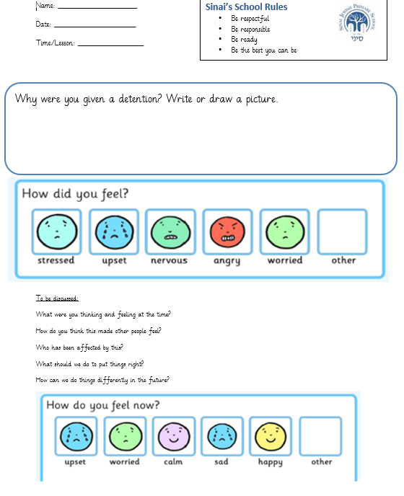

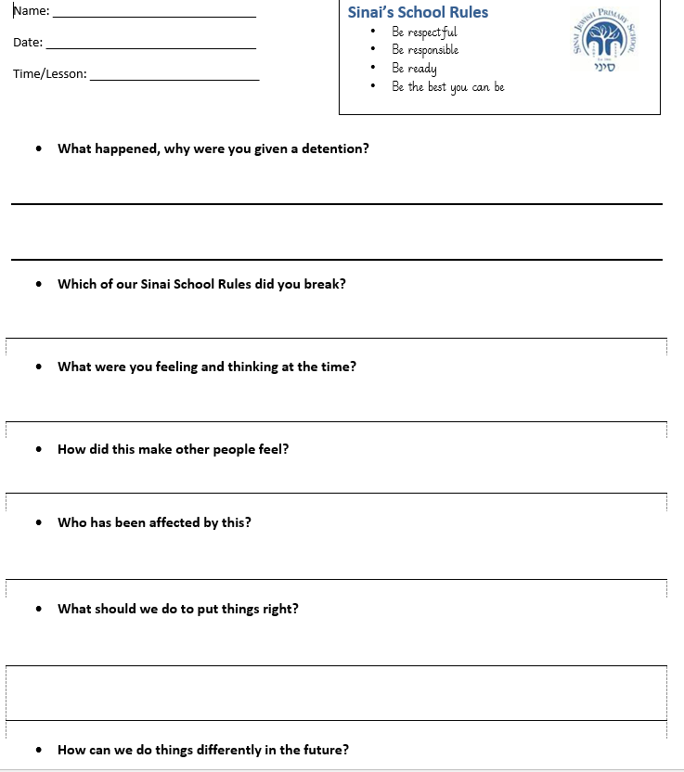

Behaviour consequence display for classrooms

Verbal warning
Fidgeting
Inappropriate uniform e.g. shirt not tucked in
Calling out in class
Not lining up correctly
Talking when someone else is
Not participating in Tefillah
Making silly noises
Disturbing others
Out of your seat during focused work time
Not moving around the school quietly
Talking at inappropriate times e.g. whilst instructions are being given
Not handing in homework (first offence only)
Talking during assembly / Tefillah
Homework diary not signed (first offence only)
No PE Kit (first offence only)

Negative Dojo
Answering back to an adult
Drawing/writing on another child’s work

Teacher meeting
Not following instructions
Not completing enough work
Hiding other pupils belongings
Name Calling
Not cooperating/ Noncompliance with instructions
Swearing
Arguing with an adult
Being rude to an adult

Lunchtime detention
Fighting
Kicking
Physical violence, including retaliation
Stealing
Violently throwing items across a classroom

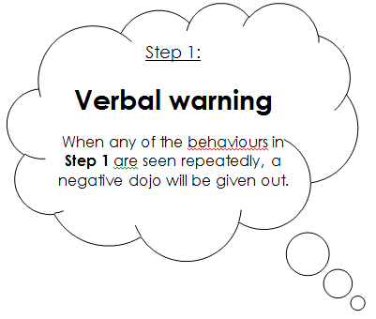
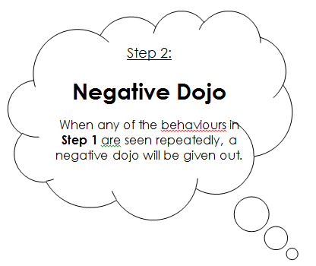

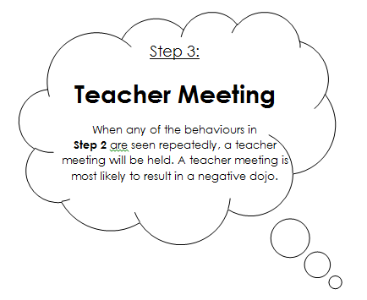
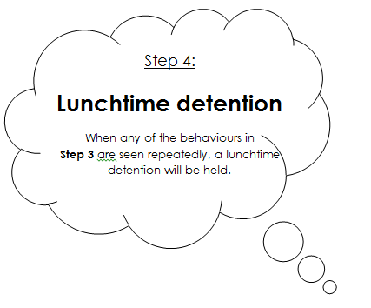

Verbal praise and thanks
Showing Kindness
Showing good listening
Being on task
Trying your best
Looking smart
Being well equipped for your lesson
Being responsible
Showing independence
Changing your behavior following a warning
Participating in Tefillah/benching
Good manners
Presentation of work
Holding the door open for peers/teachers
Teamwork
Good contributions to lesson

Positive Dojo
Persevering with challenging tasks
Consistent good manners
Consistently trying your best
Consistent high level presentation of work
Exceptional teamwork
Excellent contribution to lessons
Showing the Middah of the month

Assistant Headteacher or Deputy Headteacher recognition
Consistently showing behaviours in Step1 or 2
Exceptional work
Exceptional work ethic
Extraordinary Kindness
Headteacher recognition, recognition in achievement assembly
Outstanding achievement
Outstanding effort

Step 1:
Verbal praise and thanks

When any of the behaviours listed are seen your teacher will positively acknowledge this.

Step 2:
Positive Dojo

When any of the behaviours listed are seen a positive dojo may be rewarded.

The child in each class who earns the most dojos will be invited to the monthly Headteacher’s Dojo Tea party.

Step 3:
Deputy Headteacher or Assistant Headteacher recognition

You may receive one of these rewards or recognitions if you have demonstrated the behaviours listed in Step 3.

Step 4:
Headteacher recognition, recognition in achievement assembly

You may receive recognition if you have demonstrated the behaviours listed in Step 4.

