Sinai Jewish Primary School Addition & Subtraction Calculation Policy

Addition
Vocabulary: add, addition, total, plus, more than, altogether, increase, is equal to, tens, ones, hundreds, thousands etc., sum, parts, whole, part-whole model, place value, commutative, number bond, calculation,
Calculation Stage | Objective and Strategies | Concrete | Pictorial | Abstract
Stage 1:  Concrete objects and pictorial representations. | To use one to one correspondence when counting objects. | 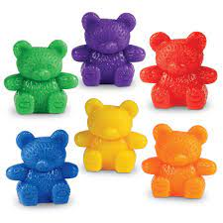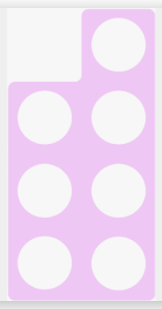 | 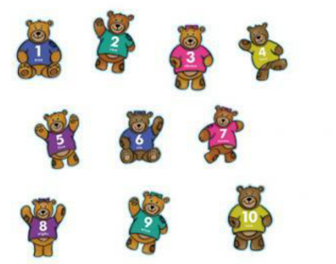 | 1, 2, 3, 4, 5, 6, 7, 8, 9. 10
 | Comparing quantities up to 10 and identifying ‘greater than’. | 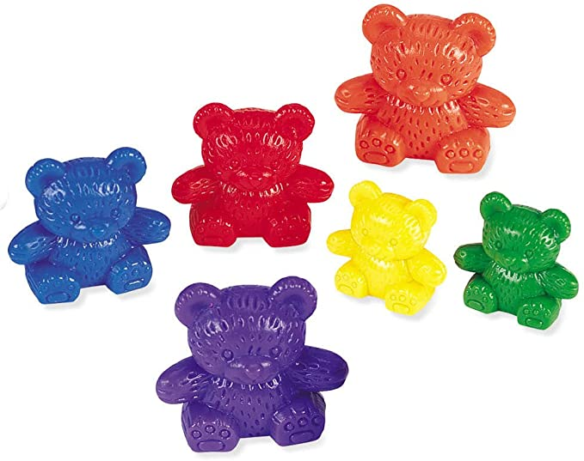  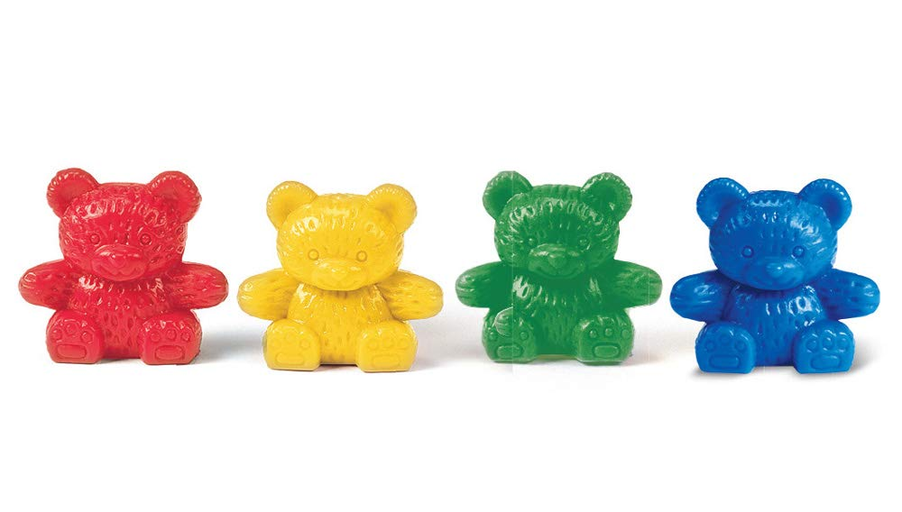 | 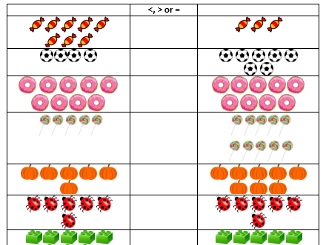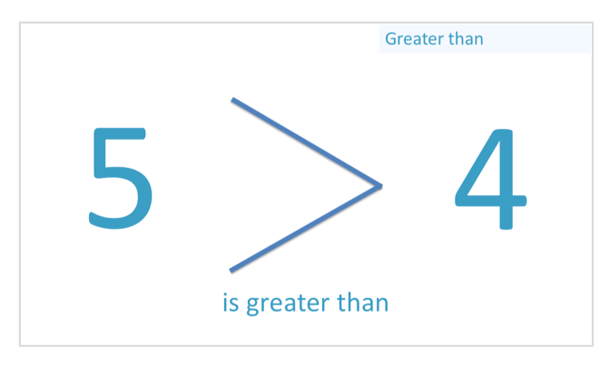 | 5 is greater than 2.  Later on develop to using ‘>’ symbol.  7 > 3  10 > 2
 | Combining two parts to make a whole: part-whole model | 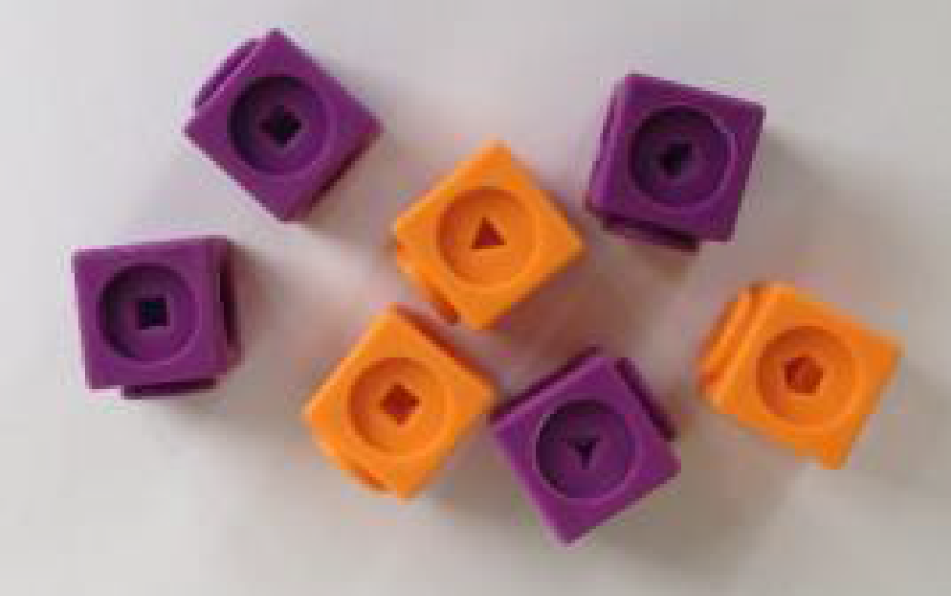  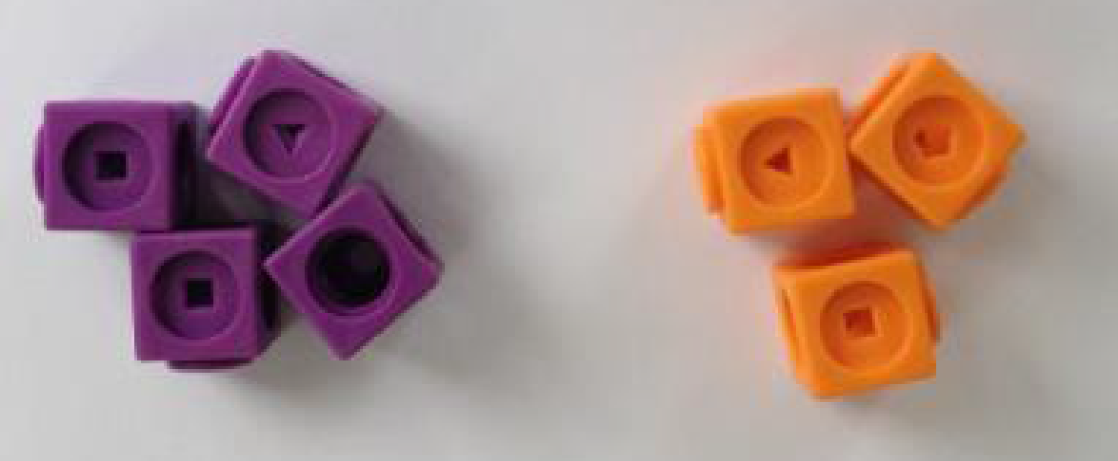  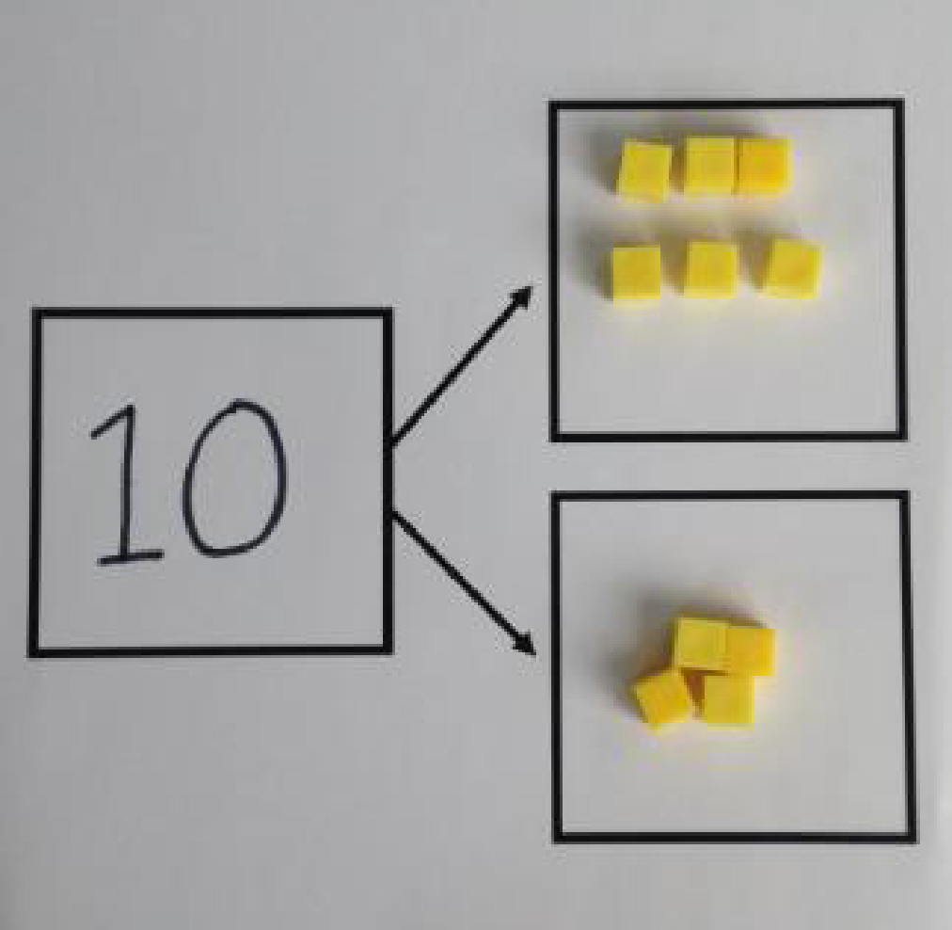  Use cubes to add two numbers together as a group or in a bar. | 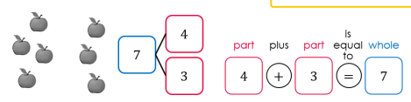  Use pictures to add two numbers together as a group or in a bar. | 5 + 3 = 8  8 = 5 + 3  5  3  Use the part-part whole as shown above to move onto the abstract.
 | Identifying number bonds to 10. | 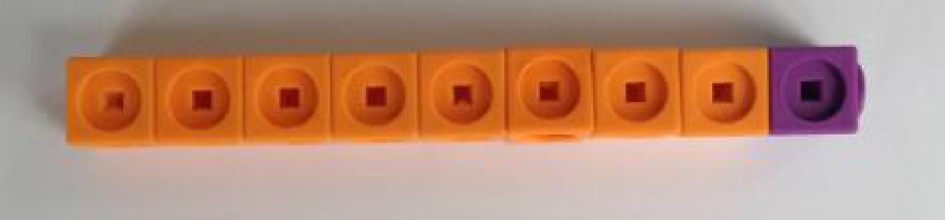 | Identifying and drawing groups of ten. | 8 + 2 = 10  5 + 5 = 10  7 + 3 = 10
 | To know and recall doubling facts up to 20. | 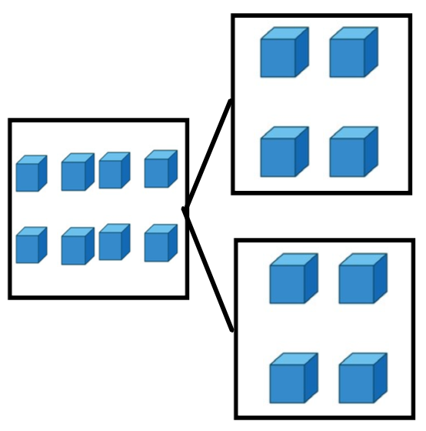  Double 4 is equal to 8. | 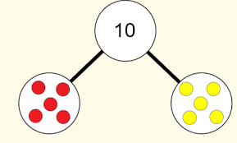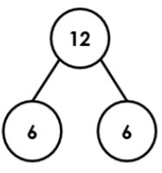 | 6 + 6 = 12  Double 6 = 12  5 + 5 = 10  Double 5 = 10
Stage 2:  Number lines and 100 squares | Starting at the bigger number and counting on | Start with the larger number on the bead string and then count on to the smaller number 1 by 1 to find the answer. | 12 + 5 = 17  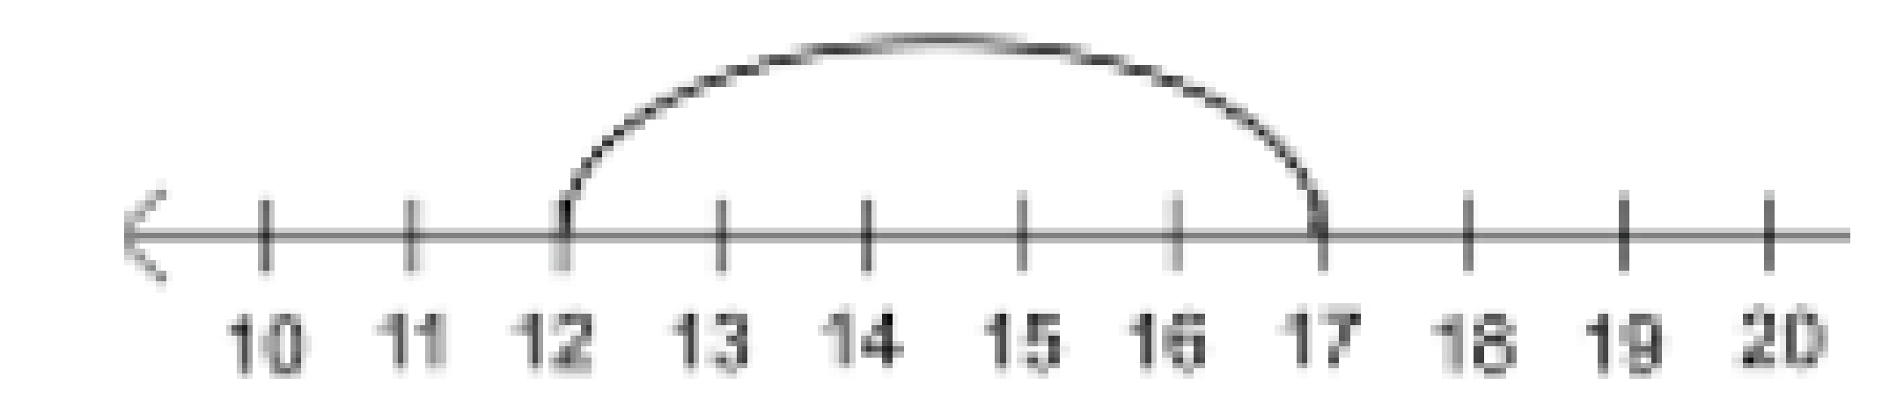  Start at the larger number on the number line and count on in ones or in one jump to find the answer. | 12 + 5 = 17  Place the larger number in your head and count on the smaller number to find your answer.
 | Using a 100 square – adding 10s by dropping down | 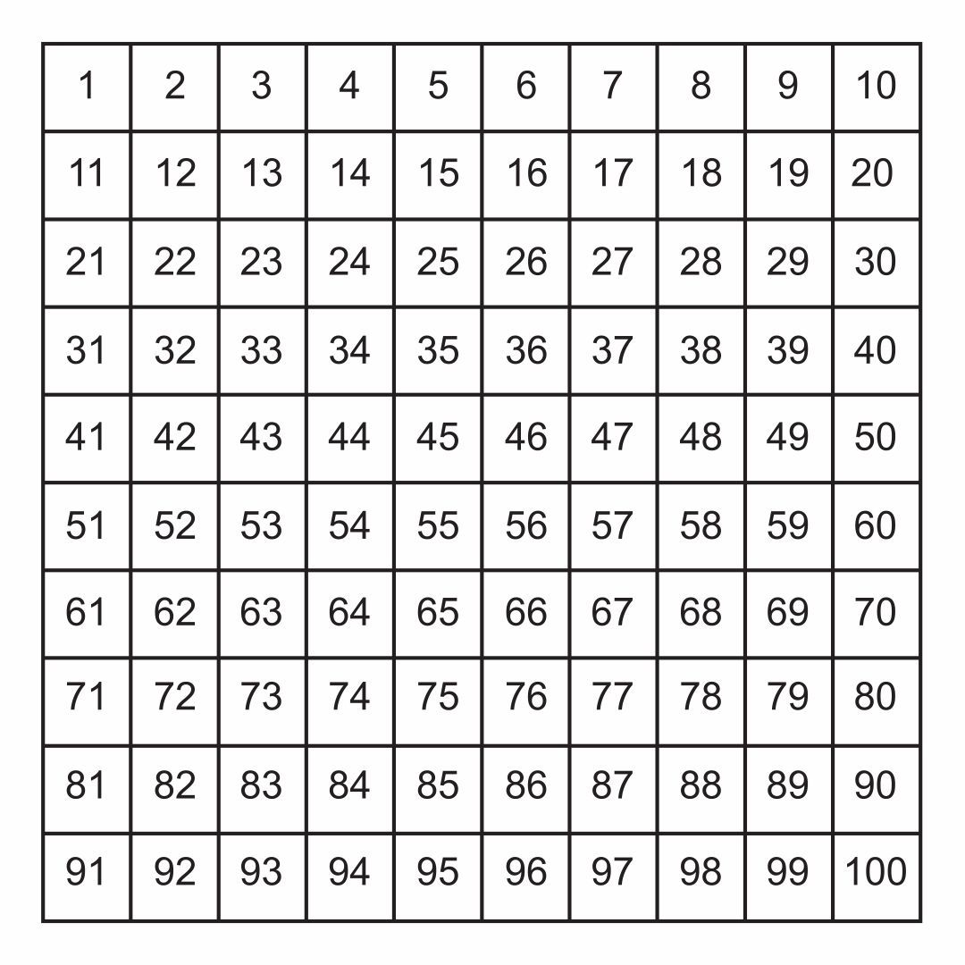  Count on using a 100 square using counters.  Drop down to add 10. | 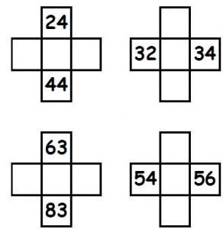  Find missing numbers from a 100 square by using knowledge and pre-existing skills.  Drop down, count on and use pictorial representations. | 17 + 11 = 28  Drop down and count on jumps.
Stage 3:  Mental methods evolving into written methods | Regrouping to make 10. | 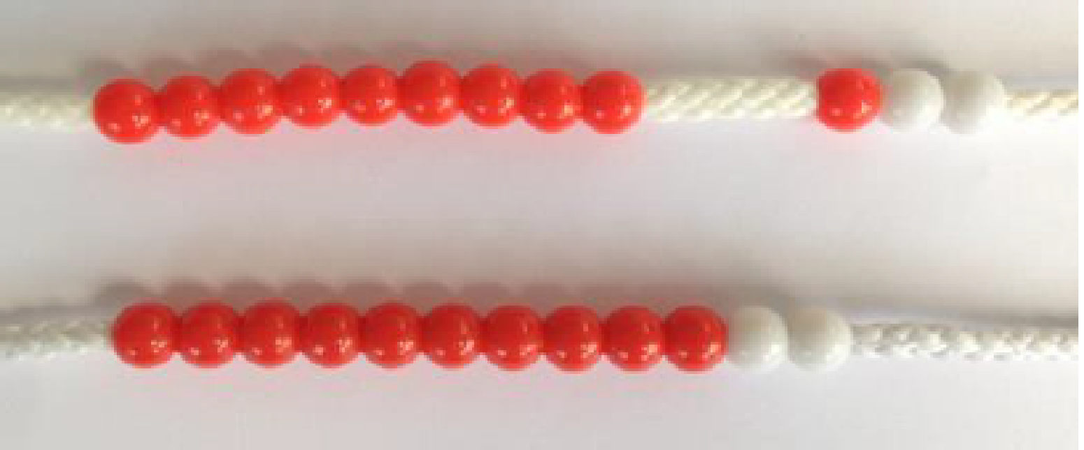  6 + 5 = 11  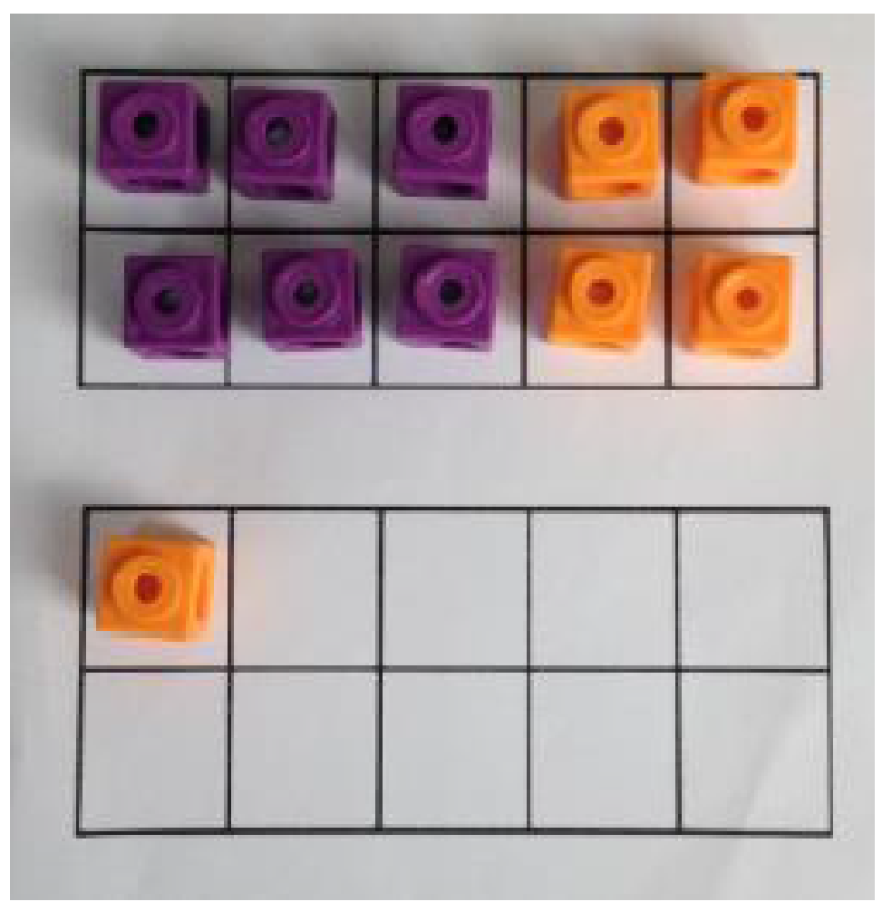  Start with the bigger number and use the smaller number to make 10. | 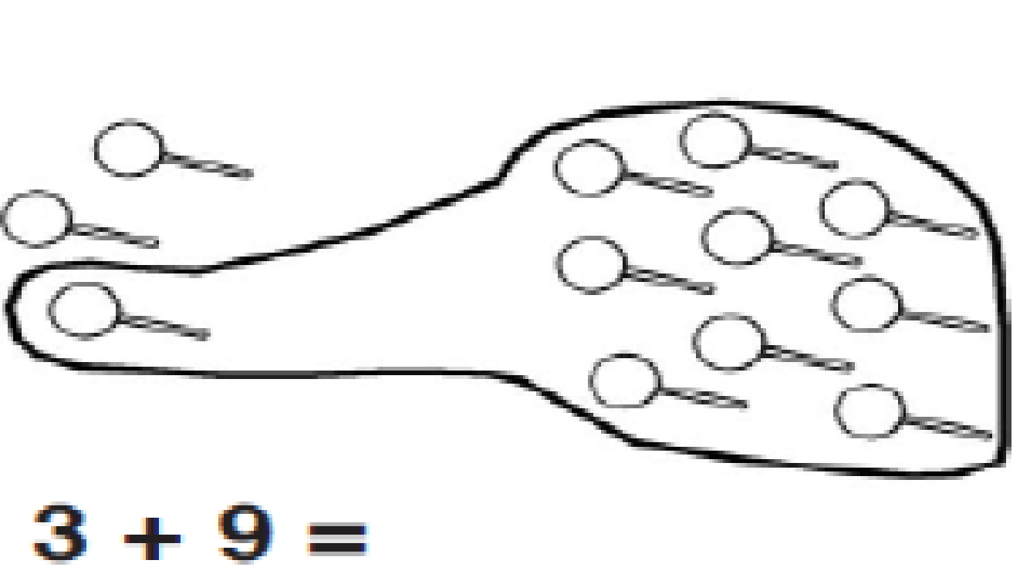  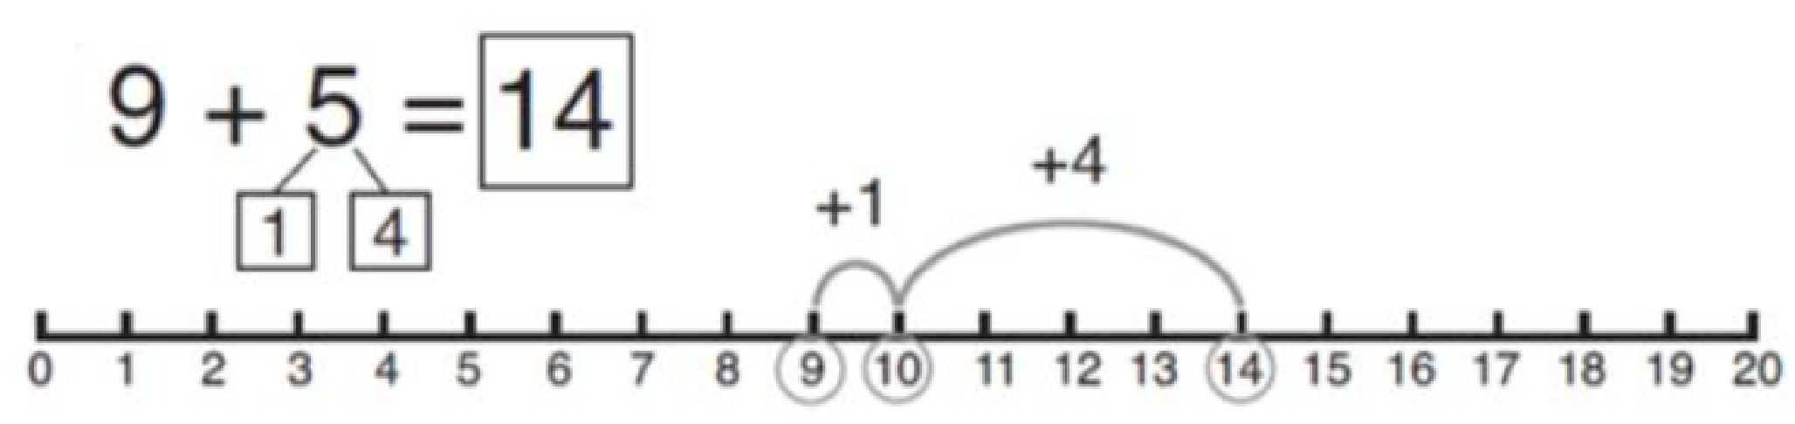  Use pictures or a number line. Regroup or partition the smaller number to make 10. | 7 + 4 = 11  If I am at seven, how many more do I need to make 10. How many more do I add on now?
 | Adding three single digits | 4 + 7 + 6 = 17  Put 4 and 6 together to make 10. Add on 7.  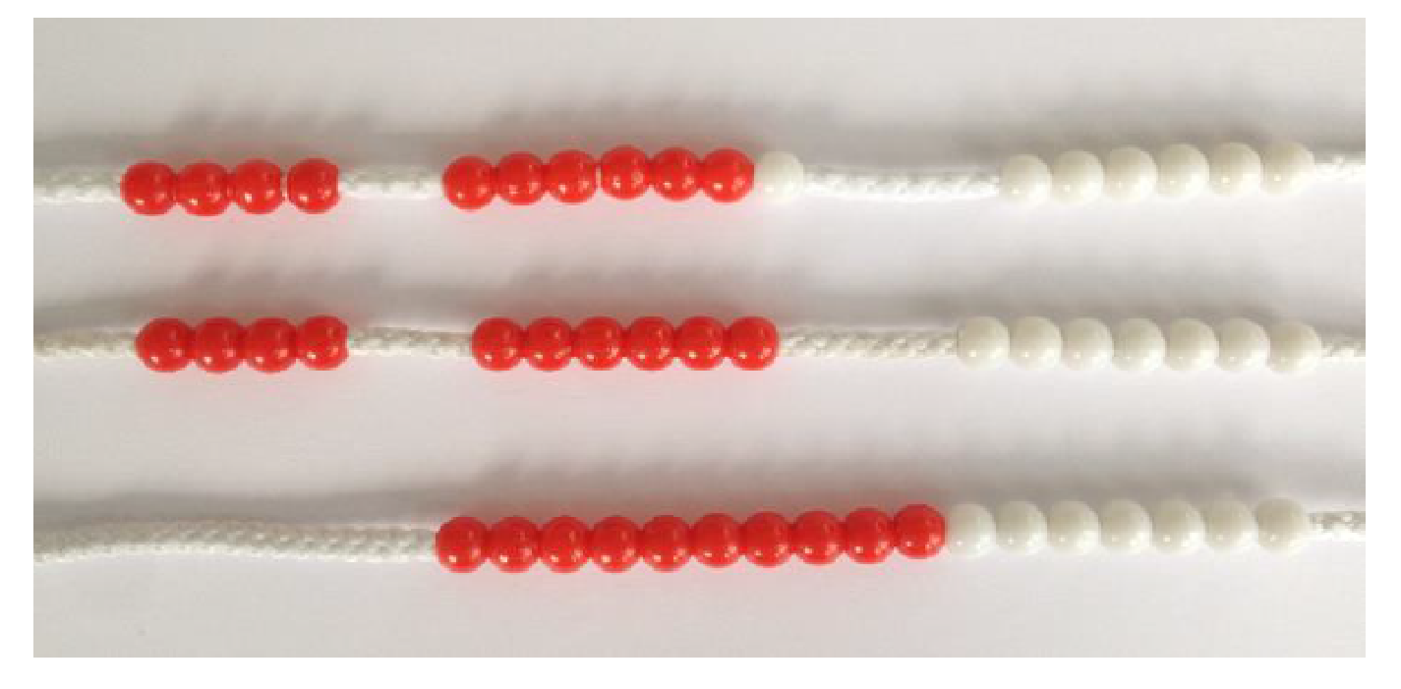  Following on from making 10, make 10 with 2 of the digits (if possible) then add on the third digit.  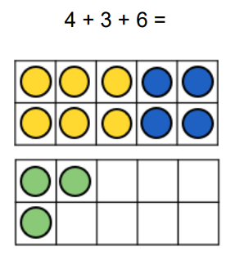 | 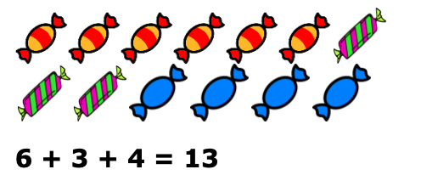  Add together three groups of objects. Draw a picture to recombine the groups to make 10. | 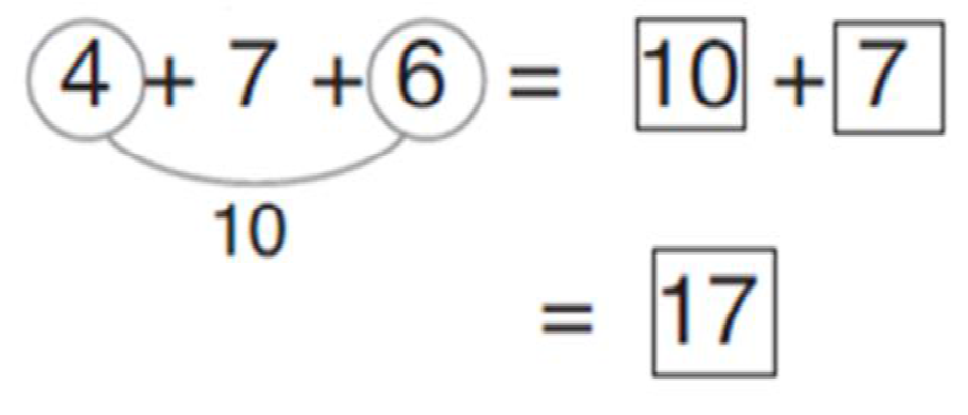  Combine the two numbers that make 10 and then add on the remaining single digit.
 | Using if ‘I know, then I know…’ to add two 2-digit numbers without regrouping | 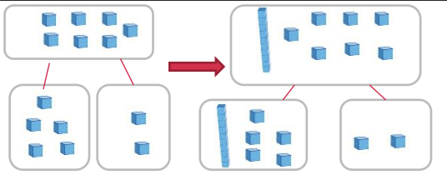 | 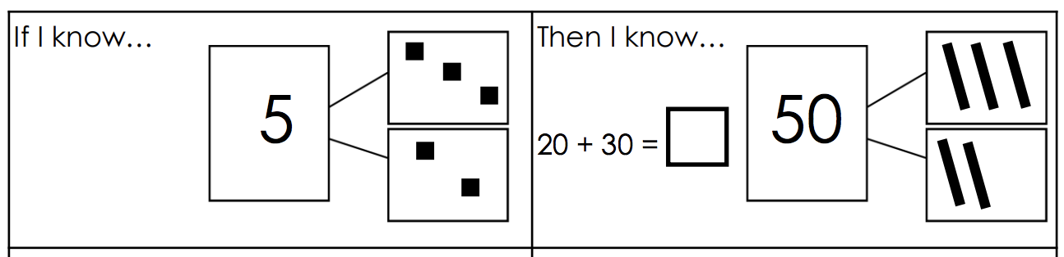 | 23 + 41 = 64  If I know that… 2 + 4 = 6,  then I know that… 20 + 40 = 60.  and I know that… 3 + 1 = 4  60 + 4 = 64
 | Adding two 2-digit numbers without grouping |  | 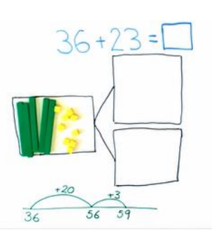
 | Adding two 2-digit numbers using regrouping | 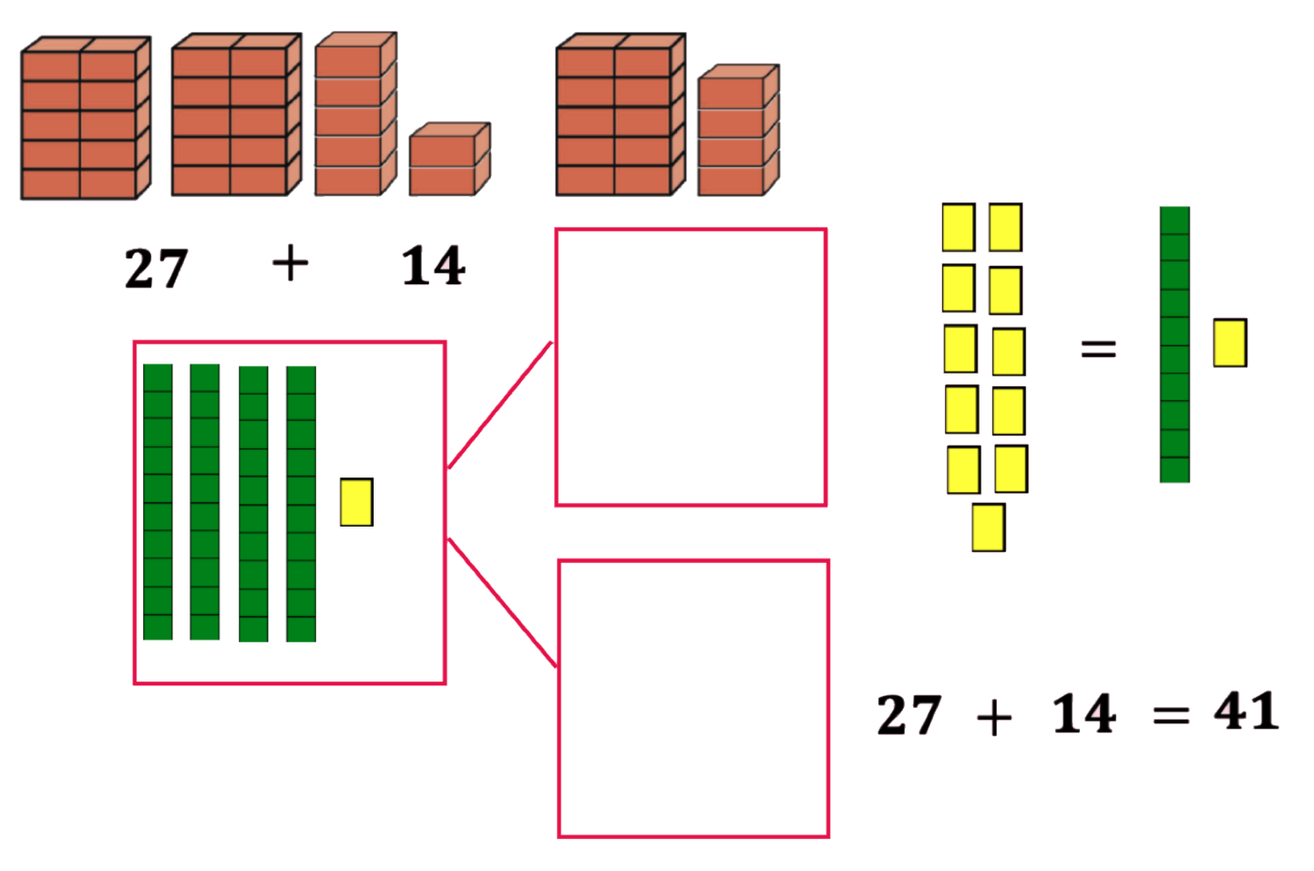 | 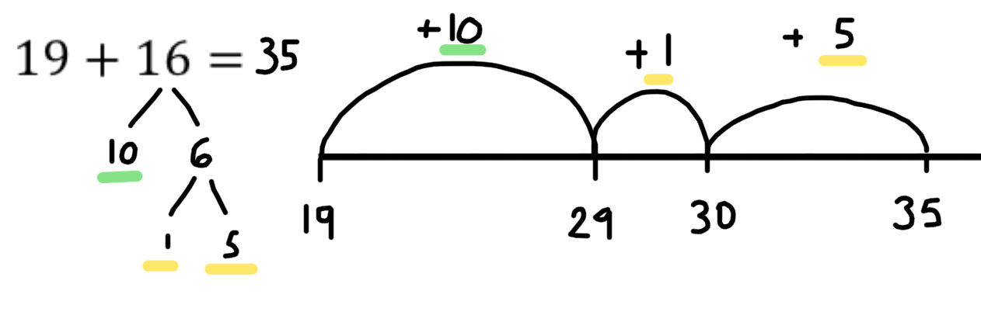 | 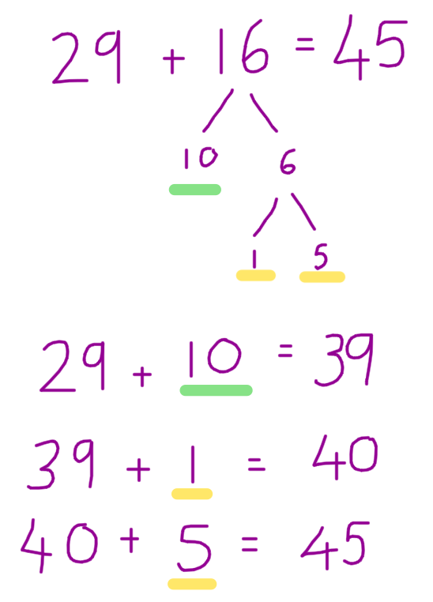
 | Adding two 2-digit numbers using regroup and adjust |  | 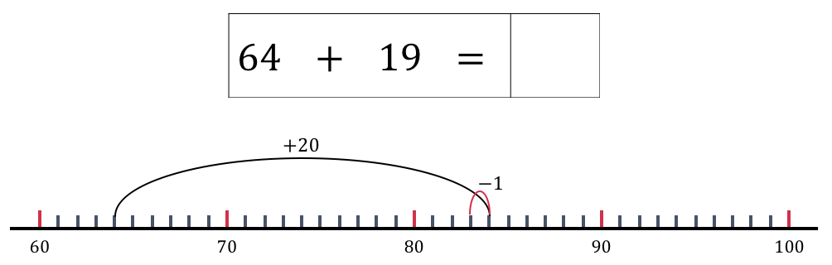 | 64 + 19 = 83  64 + 20 = 84  84 - 1 = 83
 | Adding two 2-digit numbers using near doubles. | 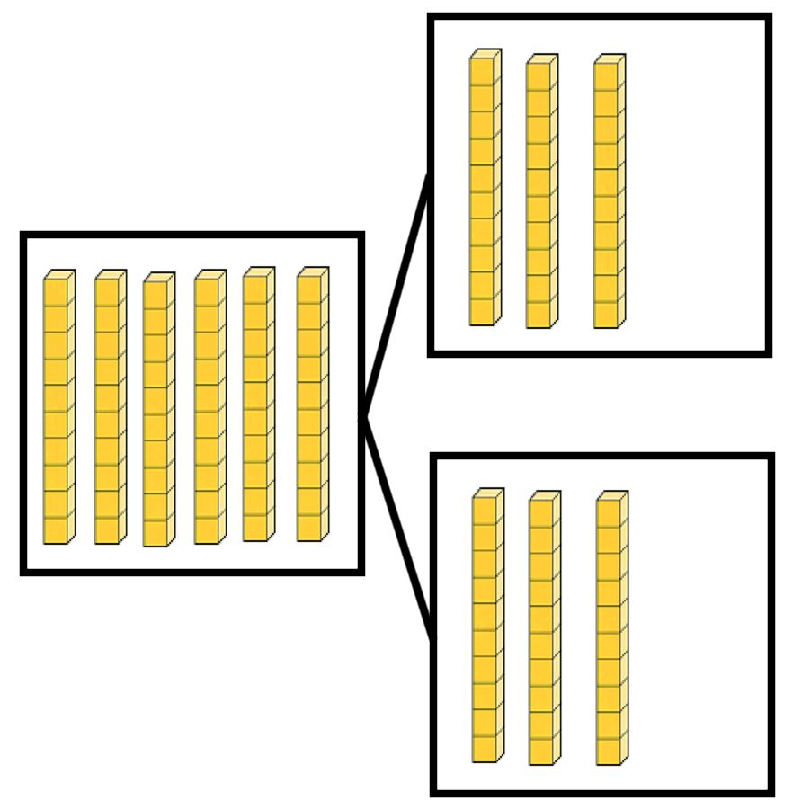 | 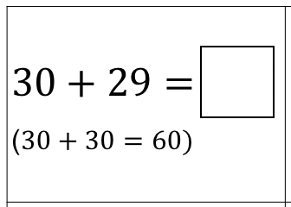 | If I know that 3 + 3 = 6, then I know that 30 + 30 = 60  60 - 1 = 59
 | Column method- no regrouping | 24 + 15=  Add together the ones first then add the tens. Use the Dienes blocks first before moving onto place value counters. | After practically using the Dienes blocks and place value counters, children can draw the counters to help them to solve additions.  T O | 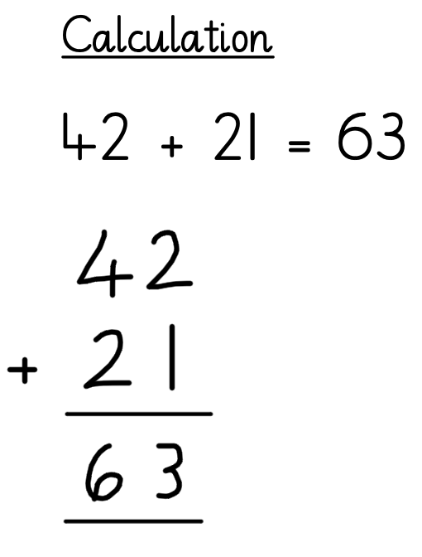
 | Partitioning to add numbers mentally | Use Dienes to represent numbers in their partitioned stages  Then, add the tens together, then the ones. | Children move on to Dienes blocks and place value counters | 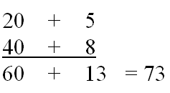
Stage 4:  Column Method | Column method - regrouping | Make both numbers on a place value grid.  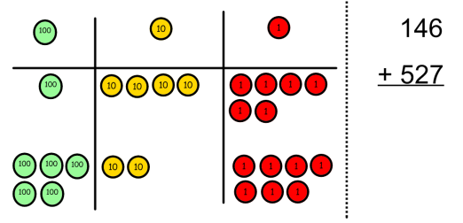  Add up the ones and exchange 10 ones for one 10.  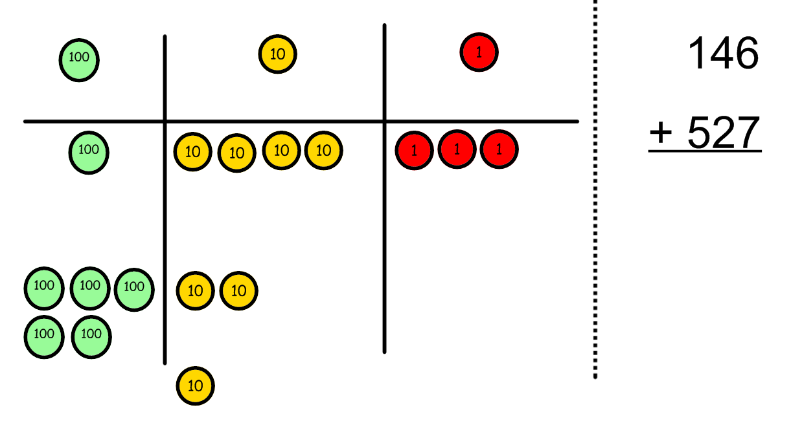  Add up the rest of the columns, exchanging the 10 counters from one column for the next place value column until every column has been added.  This can also be done with Dienes to help children clearly see that 10 ones is equal to 1 ten and 10 tens is equal to 100.  As children move on to decimals, money and decimal place value counters can be used to support learning. | 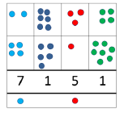  Children can draw a pictorial representation of the columns and place value counters to further support their learning and understanding. | Start by partitioning the numbers before moving on to clearly show the regroup & exchange below the addition.  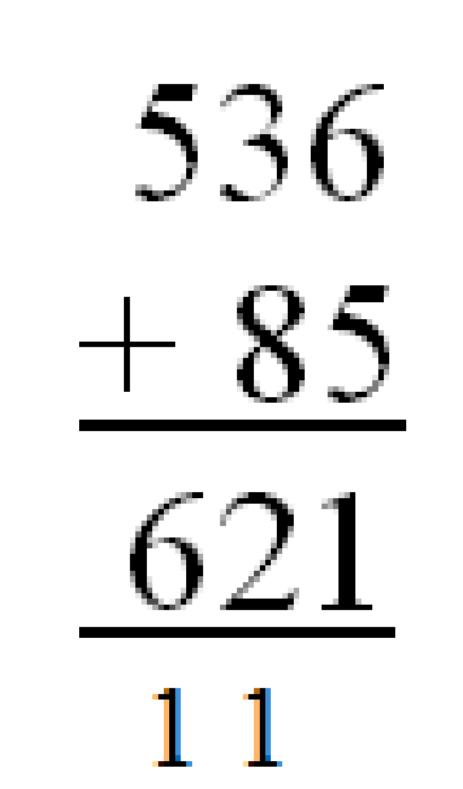  As the children move on, introduce decimals with the same number of decimal places and different. Money can be used here.
Stage 5:  Column addition, moving to decimals and larger numbers. | Column method moving to decimals and larger numbers/multiple numbers. | As above, use physical representations such as large decimal points on a WB, using a line of children are s numbers. | As with above, show another column with striking decimal points. | 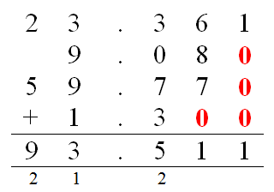  Use and represent 0 as a place holder in step one. Units of measurement come as final steps.

Subtraction
Vocabulary: Subtract, subtraction, take away, minus, less than, difference, decrease, fewer than, how many are left.
Calculation Stage | Objective and Strategies | Concrete | Pictorial | Abstract
Stage 1:  Concrete objects and pictorial representations | To use one to one correspondence when subtracting a group of objects. | 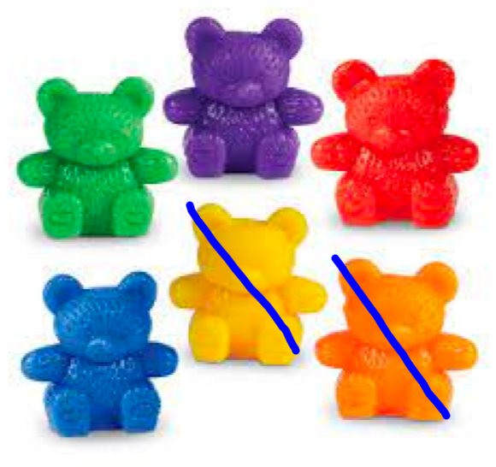 | 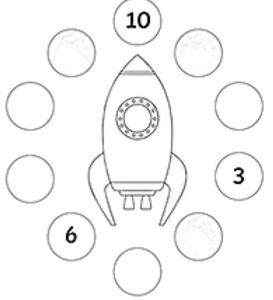 | 10, 9, 8, 7, 6, 5, 4, 3, 2, 1, 0
 | Comparing quantities up to 10 and identifying ‘less than’. | 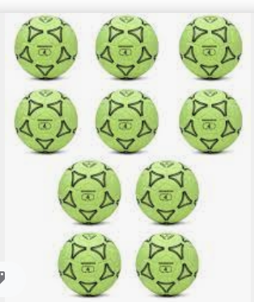 | 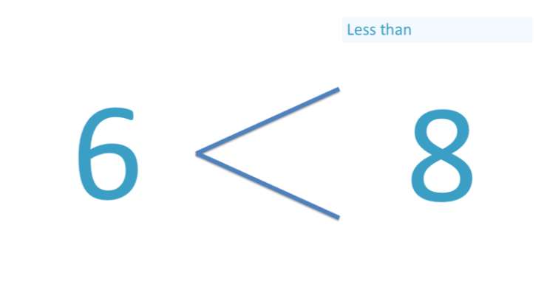 | 3 is less than 8.  Later on, children move on to using the ‘<’ symbol.  3 < 8  21 < 35
Stage 2: | Taking away ones | Use physical objects, counters, cubes etc to show how objects can be taken away.  6 – 2 = 4  4 - 2 = 2 | 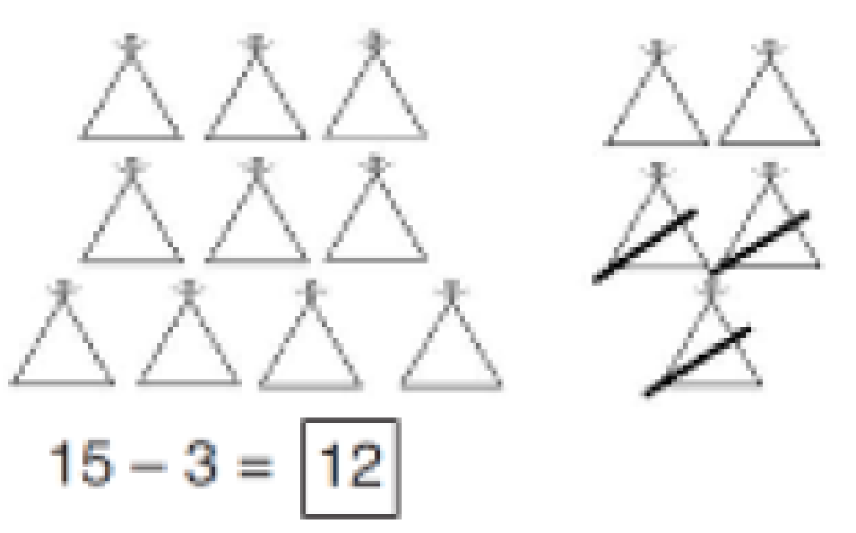  Cross out drawn objects to show what has been taken away. | 18 - 3 = 15  8 – 2 = 6
 | Counting back | Make the greater number in your subtraction equation. Move the beads along your bead string as you count backwards in ones.  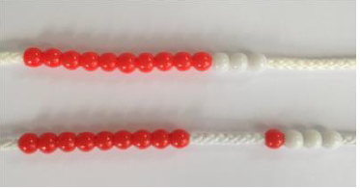  13 – 4  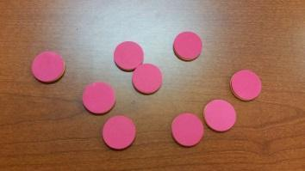  Use counters and move them away from the group as you take them away counting backwards as you go. | Count back on a number line or number track  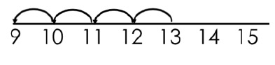  Start at the greater number and count back, showing the jumps on the number line.  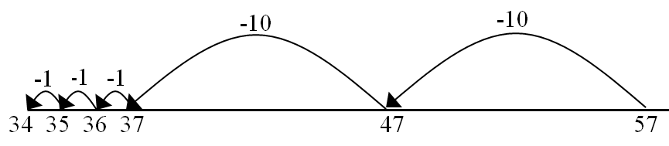  This can progress all the way to counting back using two 2 digit numbers. | Put 13 in your head, count back 4. What number are you at?  Use your manipulatives to help.
 | Subtract a 1-digit number from a teens number using known facts | 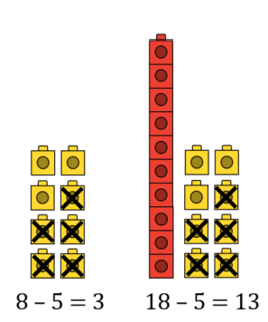 |  | If I know that 7 - 3 = 4, then I know that 17 - 3 = 14
 | To know and recall halving facts to 20. | Half of 8 is equal to 4. | 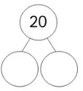 | ½ of 8 = 4  ½ of 20 = 10
Stage 2: Number lines and 100 squares | Find the difference | Compare amounts and objects to find the difference.  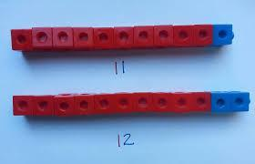  Use cubes to build towers or make bars to find the difference.  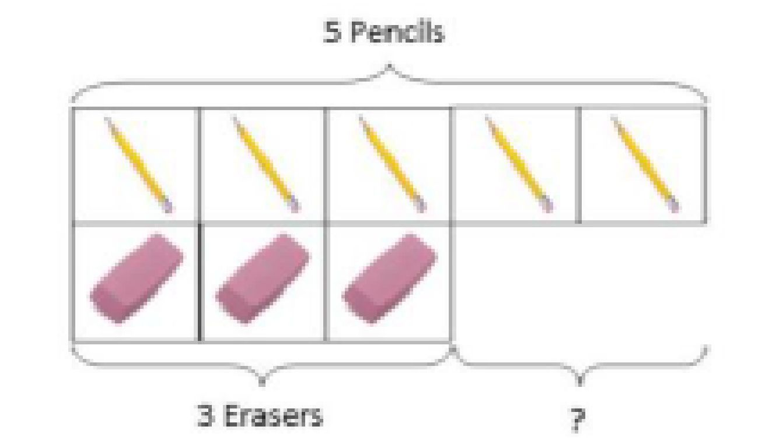  Use basic bar models with items to find the difference | 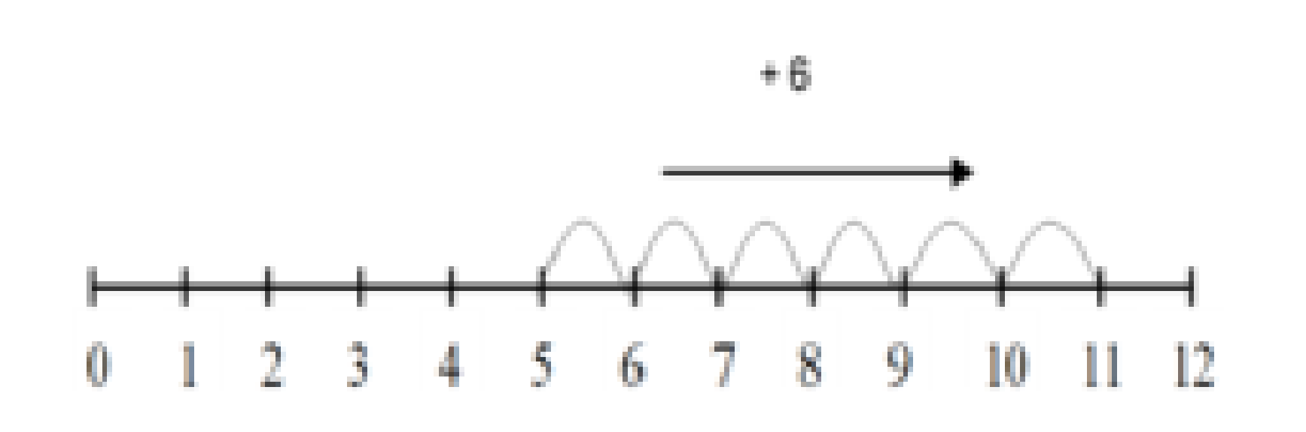  Count on to find the difference.  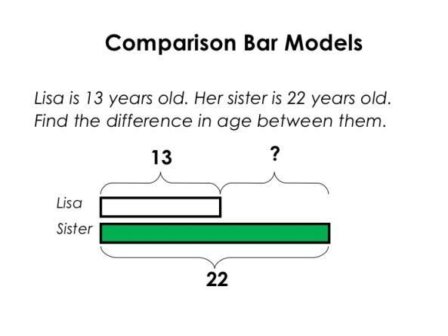  Draw bars to find  the difference between 2 numbers. | Hannah has 23 sandwiches, Helen has 15 sandwiches. Find the difference between the number of sandwiches.
 | Part - Part Whole Model | 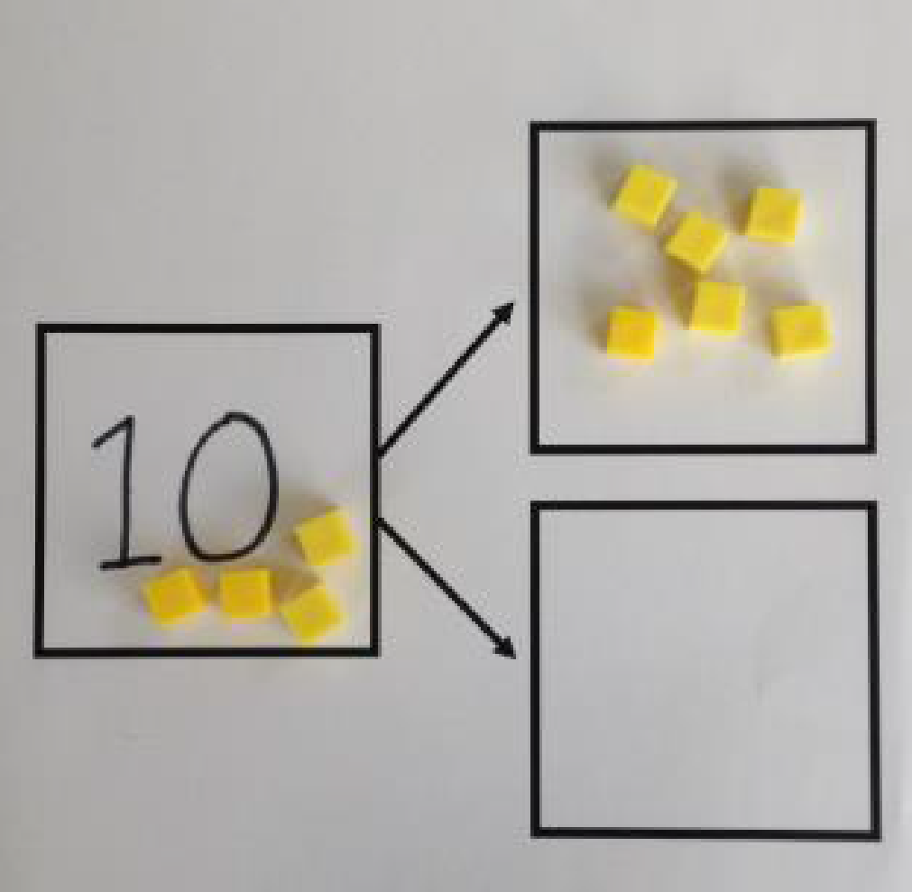  Link to addition - use the part whole model to help explain the inverse between addition and subtraction.  If 10 is the whole and 6 is one of the parts. What is the other part?  10 - 6 = | Use a pictorial representation of objects to show the part-part whole model. | 10  5  Move to using numbers within the part-whole model.  10 - 5 = 5
Stage 3: Linking concrete to abstract to decompose | Make 10 | 14 – 9 =  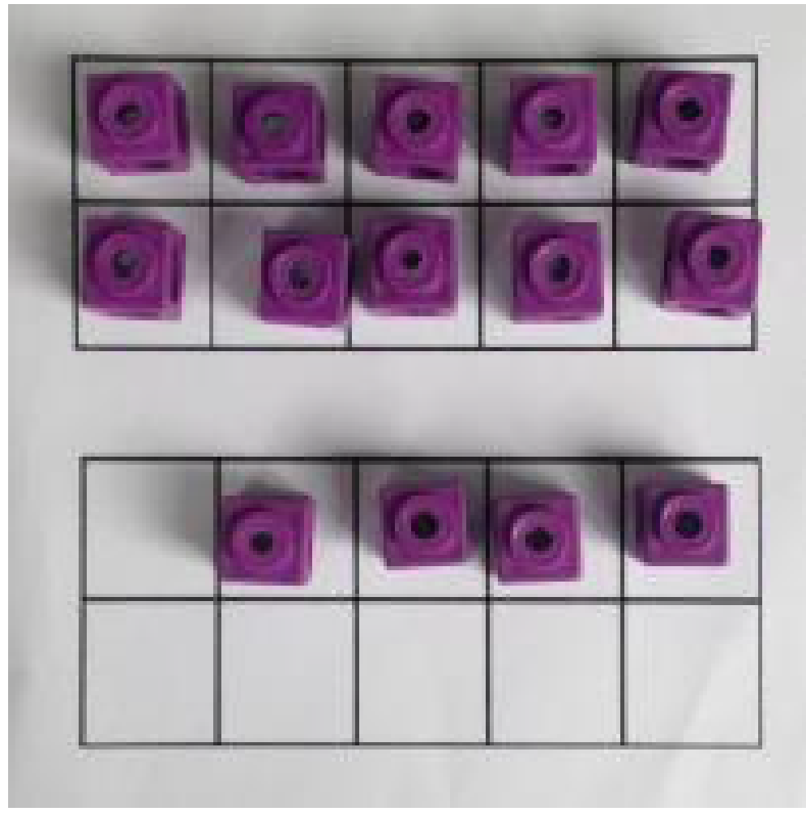  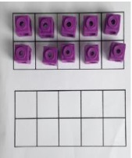  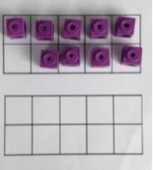  Make 14 on the ten frame. Take away the four first to make 10 and then takeaway one more so you have taken away 5. You are left with the answer of 9. | 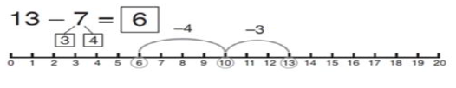  Start at 13. Take away 3 to reach 10. Then take away the remaining 4 so you have taken away 7 altogether. You have reached your answer. | 16 – 8=  What do we need to partition the 8 into and why?  How many do we take off to reach the next 10?  How many do we have left to take off?
 | Column method without regrouping - starting with expanded method | 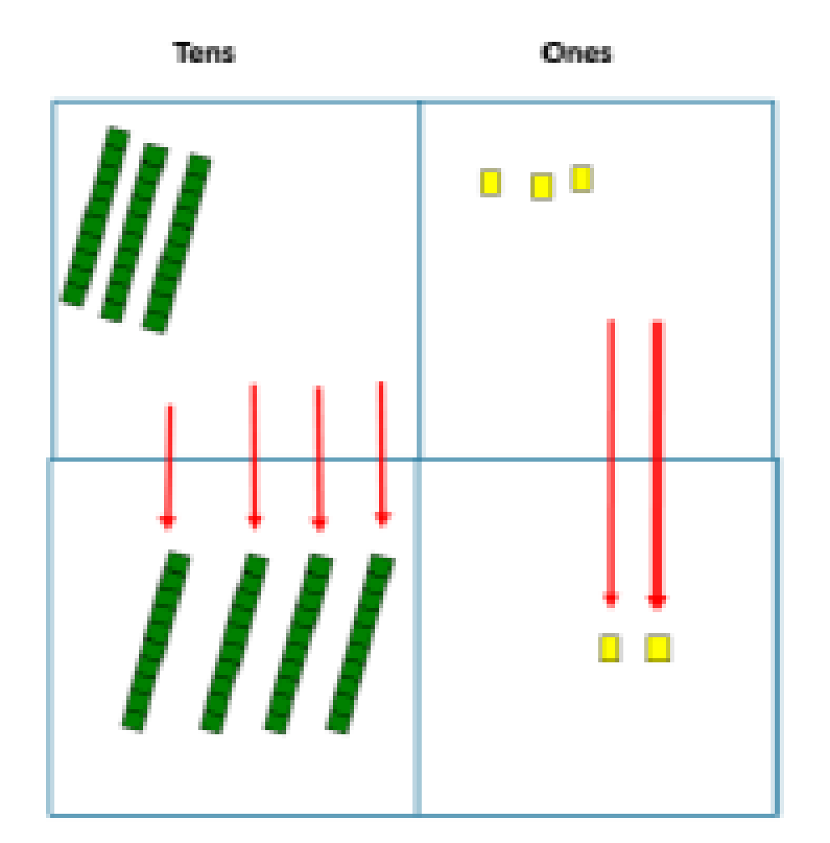  Use Dienes to make the bigger number then take the smaller number away, starting with the ones.  Show how you partition numbers to subtract. Again make the larger number first.  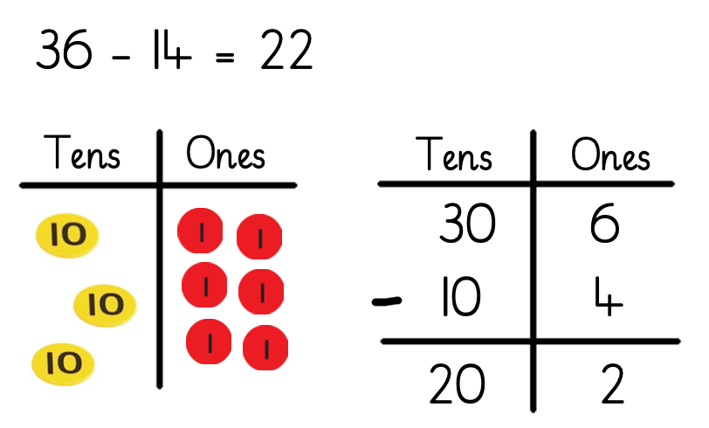 | Draw the Dienes or place value counters alongside the written calculation to help to show working. | 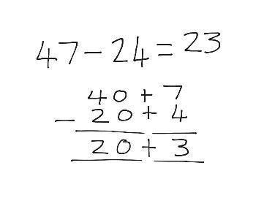  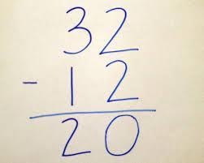  This will lead to a clear written column subtraction.
Stage 4: Compact decomposition, moving to larger numbers and decimals | Column method with regrouping | Use Dienes to start with before moving on to place value counters. Start with one exchange before moving onto subtractions with 2 exchanges.  Make the larger number with the place value counters  Start with the ones, can I take away 8 from 4 easily? I need to exchange one of my tens for ten ones.  Now I can subtract my ones.  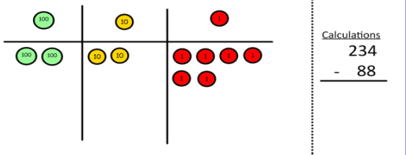  Now look at the tens, can I take away 8 tens easily? I need to exchange one hundred for ten tens.  Now I can take away eight tens and complete my subtraction  Show children how the concrete method links to the written method alongside your working. Cross out the numbers when exchanging and show where we write our new amount. | 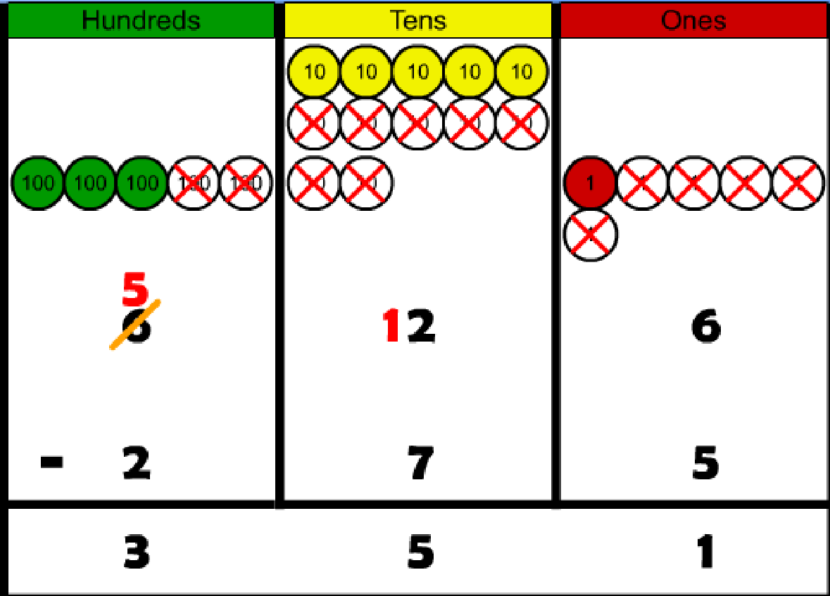  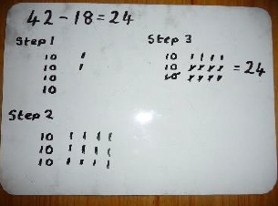  Draw the counters onto a place value grid and show what you have taken away by crossing the counters out as well as clearly showing the exchanges you make.  When confident, children can find their own way to record the exchange/regrouping.  Just writing the numbers as shown here shows that the child understands the method and knows when to exchange/regroup. | 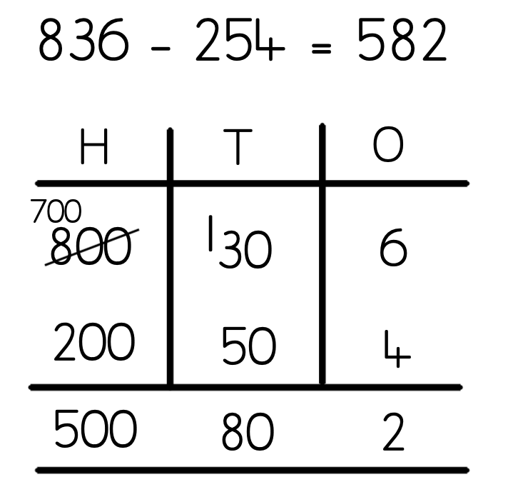  Children can start their formal written method by partitioning the number into clear place value columns.  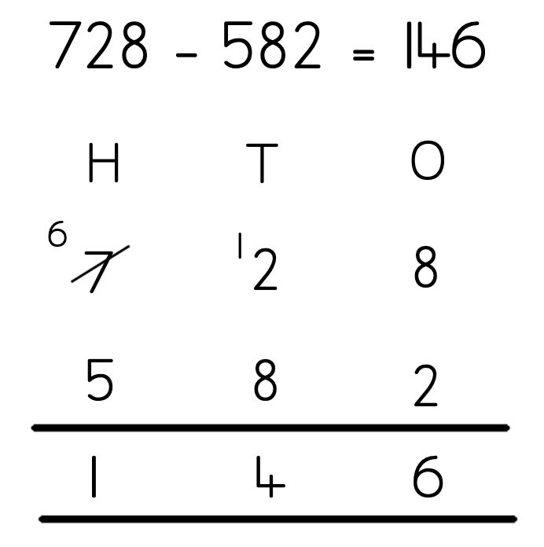  Moving forward the children use a more compact method.  This will lead to an understanding of subtracting any number including decimals.  