Behaviour and Exclusions Policy

Sinai Jewish Primary School
June 2021

Behaviour and Exclusion Policy
"Good behaviour is a necessary condition for effective teaching to take place."
(Education Observed 5 - DES 1987)
Aims of the Policy

Sinai Jewish Primary School is committed to creating an environment where exemplary behaviour is at the heart of productive learning. Everyone is expected to maintain the highest standards of personal conduct, to accept responsibility for their behaviour and encourage others to do the same. Our behaviour policy guides staff to teach self-regulation and discipline, not compliance. We aim to promote good behaviour through a culture of mutual respect, placing an emphasis on respectful behaviour, strong partnerships and dynamic interventions.

Everyone is responsible for good behaviour in the school. This includes children, staff, parents and governors. It forms part of the whole school ethos with everyone sharing the same high expectations.

This policy is based on advice from the Department for Education (DfE) on:
- Behaviour and discipline in schools
- Searching, screening and confiscation at school
- The Equality Act 2010
- Use of reasonable force in schools
- Supporting pupils with medical conditions at school
It is also based on the special educational needs and disability (SEND) code of practice.
- Section 175 of the Education Act 2002, which outlines a school’s duty to safeguard and promote the welfare of its pupils
- Sections 88-94 of the Education and Inspections Act 2006, which require schools to regulate pupils’ behaviour and publish a behaviour policy and written statement of behaviour principles, and give schools the authority to confiscate pupils’ property

Roles and responsibilities

The Governors
The governors are responsible for reviewing and approving the written statement of behaviour principles (appendix 1). The governors will also review this behaviour policy in conjunction with the Headteacher and Deputy Headteachers and monitor the policy’s effectiveness, holding the Headteacher to account for its implementation.

The Headteacher
The Headteacher is responsible for reviewing this behaviour policy in conjunction with the governors.
The Headteacher and Deputy Headteachers will ensure that the school environment encourages positive behaviour and that staff deal effectively with poor behaviour, and will monitor how staff implement this policy to ensure rewards and sanctions are applied consistently.

Staff
Staff are responsible for:
- Implementing the behaviour policy consistently
- Modelling positive behaviour
- Providing a personalised approach to the specific behavioural needs of particular pupils
- Recording significant behaviour incidents on CPOMs
The senior leadership team will support staff in responding to behaviour incidents.

All staff are provided with training on managing behaviour as part of their induction process. Behaviour management will also form part of continuing professional development.

Parents
Parents are expected to:
- Support their child in adhering to the home/school agreement
- Inform the school of any changes in circumstances that may affect their child’s behaviour
- Discuss any behavioural concerns with the class teacher promptly
- Support the school in implementing this policy

Sinai’s School Rules

- Be respectful
- Be responsible
- Be ready
- Be the best you can be

At the beginning of the year all children must be given the opportunity to discuss how they are going to follow Sinai’s school rules. These rules must be clearly displayed in each room and referred to regularly so that children and parents know what is expected at all times. At the beginning of every term children are reminded of the school rules and behaviour expectations.

The Curriculum and Learning

We believe that an appropriately structured curriculum contributes to effective learning and good behaviour. Thorough planning for the needs of individual pupils, the active involvement of pupils in their own learning, and structured feed-back will result in positive behaviour being maximised.
It follows that lessons should have clear objectives and steps to success that are explained and understood by the children, and differentiated to meet the needs of all children. All lessons should contain regular opportunities for assessment for learning. Marking is both a supportive activity, providing feed-back to the children on their progress and achievements, and a signal that the children's efforts are valued and that progress matters.

Growth Mindset
With Growth Mindset being an important part of our learning ethos, all children will be fully aware that success, however defined, is achieved through hard work, perseverance and focused practice based on seeking and responding to feedback. Sinai School students learn to be resilient, welcome challenge and understand that failure is a necessary part of the journey to success. We believe that there are no upper limits to what our students can achieve if they have the right attitude to learning and display the behaviours necessary for success.

We believe praise should be specific and focus on the process that students have gone through to achieve high levels of attainment and on positive behaviour and effort.

PSHE Programme/JS Curriculum

Creating a positive school culture and ethos where children are aware of expectations and rules is paramount. A clearly planned, well-structured PSHE and JS Curriculum form the basis of preventative work and ensure consistency and involvement for all. They create opportunities for children to develop positive values and understand and respect both difference and diversity. This is reinforced through the Midah of the month. It must be remembered that staff are pivotal in leading and modelling positive behaviour and interactions.

Through the curriculum children are given a wide range of opportunities to develop their knowledge and understanding of diversity and should be clearly taught how to interact with each other. They are given a variety of strategies to deal with unknown situations and to protect themselves from bullying. Children are taught to understand the appropriate ways to behave and strategies to manage their own relationships. They have appropriate behaviour modelled to them and the opportunities to role play strategies for dealing with conflict. Children are actively encouraged to take responsibility for their own actions and make ‘smart’ decisions. They are given opportunities to discuss the use of language and differences between banter and behaviour that makes people feel threatened or hurt.

The PSHE program takes into consideration the data gathered from the behaviour analysis and aims to teach the children the most appropriate ways to behave and improve their behaviour.

Bullying

Bullying is a continuum of behaviour rather than a separate issue. Bullying is;
“behaviour by an individual or a group, repeated over time that intentionally hurts another individual either physically or emotionally” (DfE “Preventing and Tackling Bullying”, July 2017)

Bullying is defined as the repetitive, intentional harming of one person or group by another person or group, where the relationship involves an imbalance of power.
Bullying is, therefore:
- Deliberately hurtful
- Repeated, often over a period of time
- Difficult to defend against

Bullying can include; emotional, physical, racial, sexual, direct or indirect verbal or cyber-bullying. This differs from teasing/falling out between friends or other types of aggressive behaviour. Bullying can be when there is a deliberate intention to hurt or humiliate, there is a power imbalance that makes it hard for the victim to defend themselves, and is usually persistent.

The safety of the children is paramount. If a child hurts or bullies another pupil, the adult dealing with the situation must record this. The School does not tolerate bullying of any kind. If an act of bullying or intimidation has taken place, staff will act immediately to stop any further occurrences of such behaviour.

Sinai provides a secure environment where children know how to, and feel safe to, report any incidents of inappropriate behaviour, bullying or allegations relating to safe guarding.

If a child makes an allegation against another child relating to safeguarding it must be reported to the designated safe guarding officer who will investigate and deal with as appropriate.

Incidents of bullying are carefully recorded on CPOMs and analysed for trends.
(Details of our school’s approach to preventing and addressing bullying are set out in our Anti-Bullying Policy)

Expectations, Rewards and Sanctions

Sinai Jewish Primary School has a very specific system of rewards and sanctions applied across the school to ensure that there is mutual respect between all members of staff and pupils.
(see appendices)

Expectations for Good Work:

Good work is recognised as:
- Giving thoughtful, considered answers
- Working to their full potential
- Working collaboratively: sharing ideas and taking turns
- Using steps to success to meet learning objectives
- Achieving individual targets
- Achieving group/class targets
- Striving for neat presentation

Expectations for Good Behaviour:

Good behaviour is recognised as following Sinai’s School Rules.

Classroom management
Teaching and support staff are responsible for setting the tone and context for positive behaviour within the classroom.
They will:
- Create and maintain a stimulating environment that encourages pupils to be engaged
- Display the school rules and their own classroom rules
- Develop a positive relationship with pupils, which may include:
  - Greeting pupils in the morning/at the start of lessons
  - Establishing clear routines
  - Communicating expectations of behaviour in ways other than verbally
  - Highlighting and promoting good behaviour
  - Concluding the day positively and starting the next day afresh
  - Having a plan for dealing with low-level disruption
  - Using positive reinforcement

Behaviour expectations outside the classroom

In the Playground

Pupils are expected to:

- Follow Sinai’s School Rules
- Include other children in their games and ensure no child is excluded.
- Treat playground equipment with care.
- Report any accidents/ incidents to one of the adults on duty.

Staff are expected to:
- Ensure all playground areas are supervised by appropriate adults during playtimes.
- Staff must take responsibility for being on time and organise cover if they are going to be absent.
- All staff on duty must be vigilant at all times and patrol all areas of the playground.
- Staff must wear Hi-Vis jackets so children can clearly identify them.
- Listen to and deal with behaviour appropriately; i.e. give out warnings. Pass on all incidents resulting in a negative dojo, or a more serious consequence to the class teacher at the end of play. (see also playground rules/policy)

Lunchtime (including dining room and playground)

- All staff, including lunchtime staff are encouraged to praise good behaviour.
- All lunchtime staff to deal with inappropriate behaviour by talking to the children concerned.
- Lunchtime staff to inform lead supervisor of any inappropriate behaviour during lunchtime. Lead supervisor to inform class teachers if necessary.

Transition from playground to classroom
- At the end of playtime the whistle will be blown twice.
- On the first whistle all children must: stand still, stop talking, climb down from the adventure playground and hold still any play equipment.
- All teachers should be out in the playground at this time (after first and last break) to collect their children.
- On the second whistle all children are expected to quietly and sensibly walk straight to their lines.
- Children must line up, in register order, one behind the other without talking.

School Building
- Pupils play outside before school and during school playtimes unless given specific permission by a teacher or member of SLT.
- Similarly parents should drop off and collect children from the playground and not be inside the building unless they have a meeting with a member of staff, in this instance parents should go to the office and not straight up to the classroom.
- Sinai is a calm, orderly place at all times. Therefore, the children should be taught and encouraged to show respect in everything they do. For safeguarding reasons children and parents should not be in the school building without prior permission and then signing in at the front desk.
- Pupils must respect and look after the fabric of the building and all school property. Parents may be asked to pay for any deliberate damage incurred.

Toilets and cloakrooms
- Children are expected to behave appropriately, respect the privacy of others and maintain a high standard of hygiene.
- Pupils must ask permission before going to the toilets or cloakroom during lesson times.

Behaviour Outside School (Coach/School Trips/Off-Site Activities/Clubs):
We expect all pupils to uphold the high standards expected at school when taking part in an off-site activity. These are carefully planned by the staff and will extend the curriculum for the children. We would not wish to exclude any child from such an activity.
The welfare and safety of all the children in a group is our prime concern, so if a child is not able to demonstrate responsible behaviour in school, it is possible that this could pose a problem for the child or the group as a whole whilst off-site, and the teacher may have to exclude a pupil from a trip if there are problems with general behaviour. In certain circumstances, it may be possible to include a child if the parent accompanies the child.
Sanctions may be applied where a pupil has misbehaved off-site when representing the school, such as on a school trip or on the bus on the way to or from school.
A behaviour agreement / contract will be put into place for all children ahead of residential ‘overnight’ trips. This is to ensure that all children take a personal responsibility to ensure their behaviour is of a good enough standard to enjoy the benefits of a residential trip. It also ensures they understand that continued good behaviour is expected both before, during and after any trip.
Children who attend clubs run by external providers are expected to follow the schools behaviour policy. The school reserves the right to exclude a child if his/her behaviour disrupts the group as a whole and we receive complaints from a supplier.
Children who take all school transport to / from school must continue to uphold the school’s high expectations for behaviour whilst they are on the coach and whilst waiting for the coach. If they fail to do so then they may be excluded from using the coach.
Rewards

Our emphasis is on rewards to reinforce good behaviour, rather than on failures. We believe that rewards have a motivational role, helping children to see that good behaviour is valued. The most common reward is praise, informal and formal, public and private, to individuals and groups. It is earned by the maintenance of good standards as well as by particularly noteworthy achievements, in school work and homework. Rates of praise for behaviour should be as high as for hard work.

Rewards for good behaviour and good work:

- Verbal praise
- Children to receive a Dojo for good behaviour.
- For significant achievements children will visit SLT for praise and a reward.
- Star of the week is given in recognition for good behaviour. Every class will have a star of the week each week to celebrate significant achievements of individual pupils.
- Midah of the month certificate to celebrate children who have shown the months Midah/value
- Postcard from Headteacher - each week the Head teacher will recognise good behaviour, kindness, achievement and effort. Individual postcards are written and posted to nominated children in each class every week.

Achievement Assembly
At the end of every term, there will be an achievement assembly to celebrate a wide range of achievements. These may include:
- Work Ethic and Effort
- Achievement
- Subject specific awards are given at the end of the year (including French, Science, PE)
- JS awards
- Sporting achievements, club or competition team winners
- Attendance

Sanctions

When children have not met the behavioural expectations (ie following Sinai’s School Rules) the following actions will be taken – see behaviours appendix:

- Verbal warning
- Negative Dojo
- Teacher meeting (restorative conversations)
- Lunch time detention
It is not acceptable for any pupil to be sent to stand in a corner of the classroom or outside the classroom at any time.
It is also not acceptable for a child to be required to work on their own in a classroom unless there is a member of staff with them at all times.
COVID-19-related incidents
All staff will be vigilant of any pupils who wilfully refuse to adhere to arrangements of social distancing and deliberately cough or spit at pupils or staff, putting them at risk.
A member of the SLT will be informed immediately if any such incident takes place. The Head Teacher will make an informed decision regarding appropriate sanctions, up to and including exclusion.
Verbal Warning
- It must be clear why the warning is given.
- It must be made clear what changes in behaviour are required to avoid further punishment (where necessary an opportunity to move away from disruptions or nearer to teacher should be given).
Negative Dojo
- A verbal warning must be given before each negative dojo.
- Negative dojos will be recorded on class dojo.

Teacher meeting
- Children may be asked to attend a pupil teacher meeting immediately after the lesson where there has been repetitive negative behaviour.
- This is an opportunity for the teacher and child to discuss inappropriate behaviours in a restorative way. Restorative approaches help to develop a healthier learning environment, where children take responsibility over their own behaviours and learning. The process will involve children reflecting on their behaviour and how it affected others. Using specific restorative questions may be asked/ Such as; what happened, what were you thinking/feeling at the time? How did this make other people feel? Who has been affected by this? What should we do to put things right? How can we do things differently in the future?
- Where appropriate parents will be informed of this measure.

Lunch time detention
- Children will be put on Lunchtime detention for more extreme behaviours (this is most likely to be if children have physically hurt another person, used inappropriate language or seriously damaged property).
- The adult who has been involved with the incident will inform the class teacher and the class teacher, JS, PE, French teacher will be responsible for organising the detention.
- The class teacher, JS, PE, French teacher will then contact the parent/s involved to inform them of the incident and the actions being taken. The names of other children involved will be confidential and not shared with parents.
- Children must attend lunchtime detention on the day of unacceptable behaviour or the next day if the unacceptable behaviour happens in the afternoon.
- Lunchtime detention will take place for 20 minutes.
- Children on Lunchtime detention to; FS/Yr1 – fill in a reflection form with support then read, Yr2 upwards to fill in a consequence form. Once the forms are completed the teacher will have a discussion with child and consider alternative ways of behaving to avoid having a detention. The child then has time to reflect on their own behaviour, if necessary a child may be put a Behaviour Support Plan if the behaviours persist.

- Parents/ guardians will be called to meet and discuss their child’s behaviour if it continues to be persistently disruptive.

- All significant behaviour incident must be recorded on CPOMs. This data is then analysed monthly by members of SLT.
- SLT may decide to put a child on report if their behaviour has become a cause for concern. This report will consist of specific targets to support the child’s behaviour and learning. The report will checked with a member of SLT daily and where necessary a time for reflection may take place.

Physical restraint
In some circumstances, staff may use reasonable force to restrain a pupil to prevent them:
- Causing disorder
- Hurting themselves or others
- Damaging property
Incidents of physical restraint must:
- Always be used as a last resort
- Only be used by trained members of staff, unless a child is in imminent danger of serious harm
- Be applied using the minimum amount of force and for the minimum amount of time possible
- Be used in a way that maintains the safety and dignity of all concerned
- Never be used as a form of punishment
- Be recorded and reported to parents on CPOMs
(see Positive Handling policy)

Confiscation
Any prohibited items (knives or weapons, alcohol, illegal drugs, stolen items, tobacco, and cigarette papers, fireworks, pornographic images, any article a staff member reasonably suspects has been, or is likely to be, used to commit an offence, or to cause personal injury to, or damage to the property of, any person, including the pupil)) found in pupils’ possession will be confiscated. These items will not be returned to pupils.
We will also confiscate any item which is harmful or detrimental to school discipline (phones and other devices). These items will be returned to pupils after discussion with senior leaders and parents, if appropriate. Searching and screening pupils is conducted in line with the DfE’s latest guidance on searching, screening and confiscation.

Malicious allegations
Where a pupil makes an accusation against a member of staff and that accusation is shown to have been malicious, the Headteacher will discipline the pupil in accordance with this policy. Please refer to our [safeguarding policy/statement of procedures for dealing with allegations of abuse against staff] for more information on responding to allegations of abuse.
The Headteacher will also consider the pastoral needs of staff accused of misconduct.

Children with identified Special Educational Needs and Disabilities
In some specific cases, where the identified needs of individual children may conflict with the ethos of the Behaviour Policy, some alternative arrangements may be put in place, at the discretion of the Senior Leadership Team, teachers and the SENDCo. For example, class teachers may discuss with the SENDCo whether a certain course of action would be appropriate or if, in this case, it could be counterproductive. In relevant cases the SENDCo would work with the teachers and other involved professionals to develop an ongoing appropriate system of rewards and sanctions.

If alternative arrangements need to be implemented, these must be reflected in the child’s ISP/BSP.

Pupil support
The school recognises its legal duty under the Equality Act 2010 to prevent pupils with a protected characteristic from being at a disadvantage. Consequently, our approach to challenging behaviour may be differentiated to cater to the needs of the pupil.
The school’s Inclusion Leader will evaluate a pupil who exhibits challenging behaviour to determine whether they have any underlying needs that are not currently being met.
Where necessary, support and advice will also be sought from specialist teachers, an educational psychologist, medical practitioners and/or others, to identify or support specific needs.
When acute needs are identified in a pupil, we will liaise with external agencies and plan support programmes for that child. We will work with parents to create the plan and review it on a regular basis.

The school has a well-equipped sensory room. It has been specially designed to provide a sensory experience for children with a wide variety of different needs. The sensory room is used for relaxation and de-escalation, when children with special educational needs, emotional and behavioural difficulties find themselves overwhelmed and in need of a safe and distracting place to return to a state of calm.

There are also a range of clubs hosted at lunch time for the same reasons i.e. Lego Therapy, Social Skills groups, Sporting activities etc. For those children who may find being on the playground challenging.

Pupil Premium children
Children who have been identified as pupil premium should not be given negative dojos for lack of uniform or equipment without a discussion with parents. Teachers should offer parents support and suggest that they speak to the School Business Manager or a member of SLT to ascertain whether we can provide any additional support, including items of school uniform, places at school clubs and/or subsidised trips.

Behaviour Support Plan
- A Behaviour Support Plan (BSP) is designed to assist individual students who have experienced harm, are at risk of harm, or have caused harm to others. Targeted plans will be developed by the SENDCo. These will have clear procedures taking account of triggers and providing proactive strategies.
- Staff must complete ABC forms following behaviour incidents for all children with a BSP. All completed forms to be kept in a folder in the classroom. These will be analysed by SENDco prior to termly reviews and shared with SLT as necessary.
- Regular meetings will be held to discuss the child’s progress towards behaviour targets recorded in the BSP. Those involved in the meetings may be: parents, SENDCo, teachers, child and other involved professionals such as Specialist Teacher, Social Worker and Parent Partnership Support Worker.

Pastoral Support Plan
- A Pastoral Support Plan (PSP) will be put into place if a child’s negative behaviour becomes persistent. Parents will be informed of this decision.
- Children will be given a personal report card with an achievable target/s. Children will report to a member of SLT at the end of every day to discuss their report card. Targets will be reviewed after 6 weeks.
- If behaviour continues to breach the behaviour policy or is unmanageable to the school a referral may be made to the Brent Inclusion and Alternative Education Service.

External Exclusion
- In our school it is rare that school sanctions do not bring the desired impact on behaviour, however the school will exclude pupils for persistent abusive, disrespectful or violent behaviour or repeated and escalating disruptive behaviour.
- It is our ethos that we will make every provision for a child to achieve socially and emotionally but if, in spite of this, behaviours are risky, unsafe, violent and prevent the efficient education of others the Headteacher may deem it necessary to consider exclusion. We abide by the DfE guidance on this and report any exclusions routinely to Brent LA following local and national guidance.
- Suspensions are deemed as serious by the school, parents will be informed immediately through a telephone call home to parents and a formal letter which provides all parties’ rights, responsibilities and details of the suspension. If a pupil is suspended for a period of 5 days or less, the school will provide academic work for the pupil to complete at home and return to school. It is the parent’s responsibility to ensure that the pupil completes this work.
- Following a suspension, in most instances a reintegration meeting will be held with the pupil and relevant staff to which parents are required to attend. During this meeting, the incidents that lead to the suspension will be reflected upon and planning for the future will be discussed so that agreements can be made to avoid a similar situation arising again. If parents do not attend the reintegration meeting, alternative measures will be taken to assist their full participation. The school keeps a record of any pupil who is suspended for a fixed-term, or who is permanently excluded.
- Permanent exclusion is extremely rare and is only ever used if it has not been possible to secure a Managed Move to an alternative school setting. In the case of vulnerable pupils e.g. for those who are ‘Looked After’ by the Local Authority or who have complex SEND, permanent exclusion can only be sanctioned as a very last resort. In the event of a permanent exclusion the Local Authority will contact parents. Wherever possible the school works with other education provisions to facilitate referrals to alternative provision which may make permanent exclusion unnecessary.
- The Headteacher informs the Governing Board about any fixed-term or permanent exclusions.

Appendix 1: written statement of behaviour principles
- Every pupil understands they have the right to feel safe, valued and respected, and learn free from the disruption of others
- All pupils, staff and visitors are free from any form of discrimination
- Staff and volunteers set an excellent example to pupils at all times
- Rewards, sanctions and reasonable force are used consistently by staff, in line with the behaviour policy
- The behaviour policy is understood by pupils and staff
- The exclusions policy explains that exclusions will only be used as a last resort, and outlines the processes involved in permanent and fixed-term exclusions
- Pupils are helped to take responsibility for their actions
- Families are involved in behaviour incidents to foster good relationships between the school and pupils’ home life

The governing board also emphasises that violence or threatening behaviour will not be tolerated in any circumstances.
This written statement of behaviour principles is reviewed and approved by the full governing board and the Curriculum and Standards Committee of the governing board every 2 years.

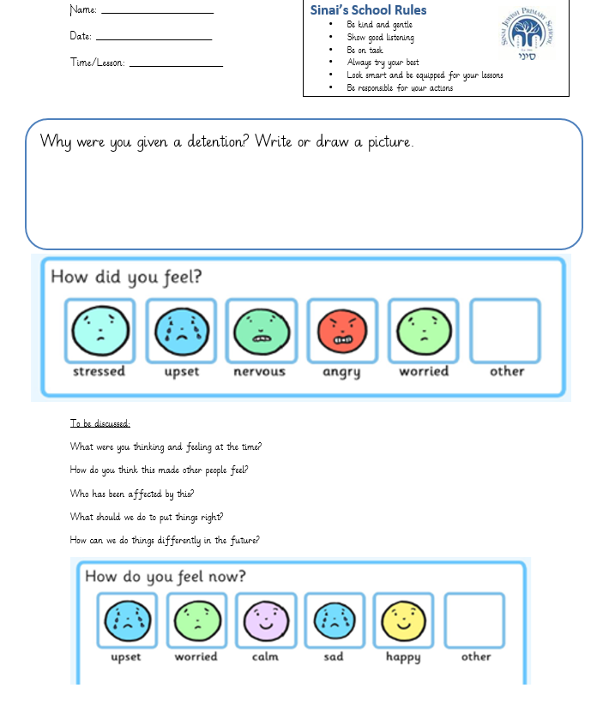

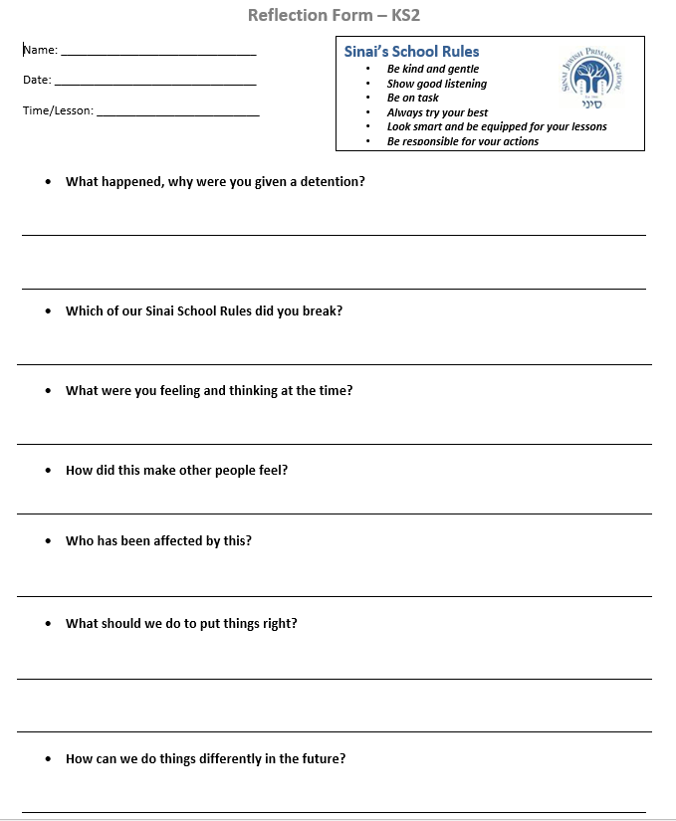

Behaviour consequence display for classrooms

Verbal warning
Fidgeting
Inappropriate uniform e.g. shirt not tucked in
Calling out in class
Not lining up correctly
Talking when someone else is
Not participating in Tefillah
Making silly noises
Disturbing others
Out of your seat during focused work time
Not moving around the school quietly
Talking at inappropriate times e.g. whilst instructions are being given
Not handing in homework (first offence only)
Talking during assembly / Tefillah
Homework diary not signed (first offence only)
No PE Kit (first offence only)

Negative Dojo
Answering back to an adult
Drawing/writing on another child’s work

Teacher meeting
Not following instructions
Not completing enough work
Hiding other pupils belongings
Name Calling
Not cooperating/ Noncompliance with instructions
Swearing
Arguing with an adult
Being rude to an adult

Lunchtime detention
Fighting
Kicking
Physical violence, including retaliation
Stealing
Violently throwing items across a classroom

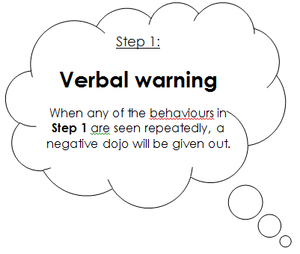
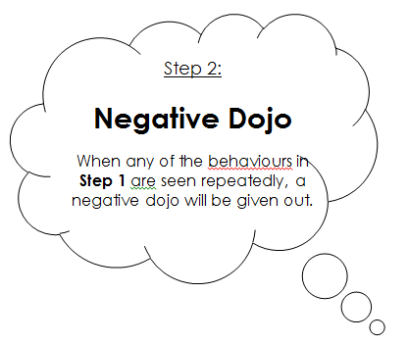

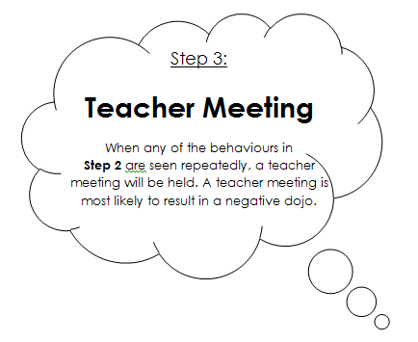
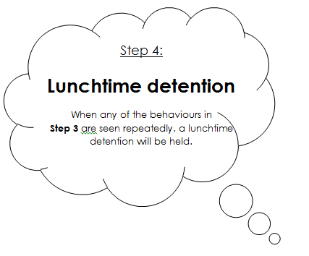

Verbal praise and thanks
Showing Kindness
Showing good listening
Being on task
Trying your best
Looking smart
Being well equipped for your lesson
Being responsible
Showing independence
Changing your behavior following a warning
Participating in Tefillah/benching
Good manners
Presentation of work
Holding the door open for peers/teachers
Teamwork
Good contributions to lesson

Positive Dojo
Persevering with challenging tasks
Consistent good manners
Consistently trying your best
Consistent high level presentation of work
Exceptional teamwork
Excellent contribution to lessons
Showing the Middah of the month

Star of the week, Joseph Pinnick, Key Stage Leader or Assistant Headteacher recognition
Consistently showing behaviours in Step1 or 2
Exceptional work
Exceptional work ethic
Extraordinary Kindness
Headteacher recognition, recognition in achievement assembly
Outstanding achievement
Outstanding effort

Step 1:
Verbal praise and thanks

When any of the behaviours listed are seen your teacher will positively acknowledge this.

Step 2:
Positive Dojo

When any of the behaviours listed are seen a positive dojo may be rewarded.

The child in each class who earns the most dojos will be invited to the monthly Headteacher’s Dojo Tea party.

Step 3:
Star of the week, Joseph Pinnick, Key Stage Leader or Assistant Headteacher recognition

You may receive one of these rewards or recognitions if you have demonstrated the behaviours listed in Step 3.

Step 4:
Headteacher recognition, recognition in achievement assembly

You may receive recognition if you have demonstrated the behaviours listed in Step 4.

