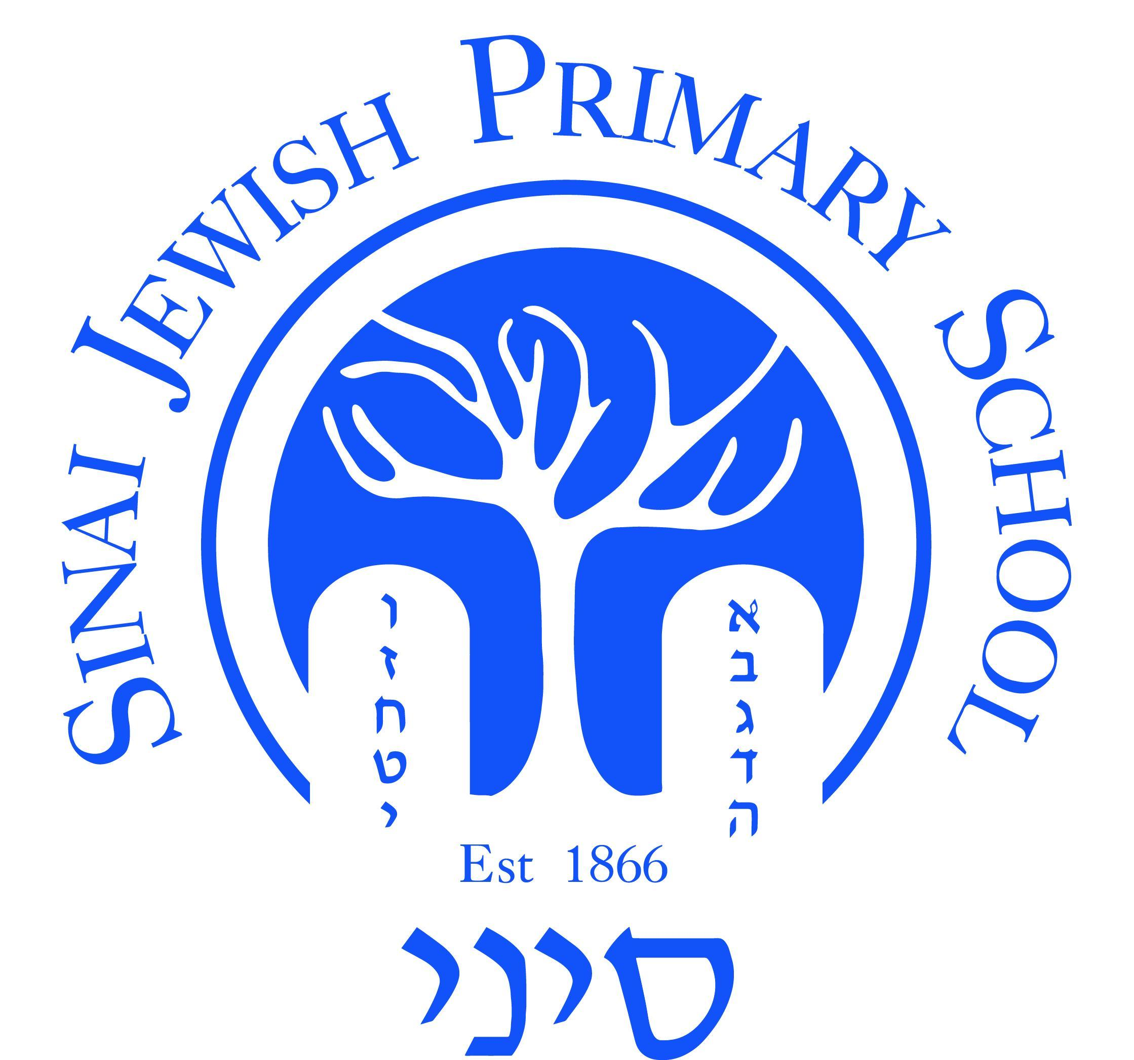

EYFS POLICY

# Sinai Jewish Primary School

2024-25

**SINAI JEWISH PRIMARY SCHOOL MISSION STATEMENT AND AIMS**

This policy is based on the requirements set out in the [2024 statutory framework for the Early Years Foundation Stage (EYFS).](https://assets.publishing.service.gov.uk/media/670fa42a30536cb92748328f/EYFS_statutory_framework_for_group_and_school_-_based_providers.pdf)

**“Every child is an individual to be respected and taught to the best of her or his ability.”**

The Early Years Foundation Stage (EYFS) applies to children from birth to the end of the Reception year. At Sinai Jewish Primary School, children join the Nursery in the year they turn four and the Reception classes in the year that they turn five. In partnership with parents and carers we enable the children to begin the process of becoming active learners for life.

To fulfil this aim all children in EYFS should:

* Feel safe and secure;
* Be challenged to reach the highest standards;
* Feel valued, respected and treated fairly;
* Feel enthusiastic and happy about coming to Sinai;
* Develop a sense of confidence and responsibility for their own learning.

Sinai provides an Early Years environment where:

* The whole school community is enriched by each child’s uniqueness;
* We develop good community links;
* Pupils are encouraged to have high aspirations;
* Pupils are encouraged to have a growth mind set;
* All are encouraged to make a positive contribution;
* All are encouraged to appreciate and enjoy our history and spacious grounds;
* Habits of good learning are established for life.

# Aim of the EYFS Policy

We endeavour to ensure that every child deserves the best possible start in life and the support that enables them to fulfil their potential. Children develop quickly in the early years and a child’s experiences between birth and age five have a major impact on their future life chances. A secure, safe and happy childhood is important in its own right. Good parenting and high quality early learning together provide the foundation children need to make the most of their abilities and talents as they grow up. (Statutory framework for EYFS 2024)

The EYFS is based upon four principles:

• A unique child – developing resilient, capable, confident and self-assured individuals.

• Positive relationships – supporting the children in becoming strong and independent.

• Enabling environments – where opportunities and experiences respond to the individual needs of the child by developing a strong partnership between practitioners, parents/carers and the child.

• Learning and developing – An acknowledgement that children learn in different ways and at different rates.

**Structure of EYFS at Sinai Jewish Primary School**

Our early years setting follows the curriculum as outlined in the latest version of the EYFS statutory framework that applies from November 2024 and provides for Nursery and Reception children. Nursery children are 3 turning 4 and Reception children are 4 turning 5.

Our nursery has key groups where each child is designated a key worker. There is a nursery teacher and a nursery manager.

Nursery children have 3 options available to them as follows:-

8.45am-11.45 which is covered by the government 15 free hours so there is no fee 8.45am-1pm (staying for lunch) and then going home which involves fees for lunchtime

8.45am-3.00pm (all day) which involves a fee for the afternoon.

Our reception has 3 classes and in each class there is a class teacher and teaching assistant.

Reception children are in school from 8:40am – 3:00pm.

**A Unique Child**

We recognise that every child is a competent learner who can be resilient, capable, confident and self-assured. We recognise that children develop in individual ways, at varying rates. Children’s attitudes and dispositions to learning are influenced by feedback from others; we use praise and encouragement to encourage children to develop a positive attitude to learning.

**Positive Relationships**

At Sinai Jewish Primary School we recognise that children learn to be strong and independent from secure relationships. We aim to develop caring, respectful, professional relationships with the children and their families.

**Parents as Partners**

We recognise that parents are children’s first and most enduring educators and we value the contribution they make. We recognise the role that parents have played, and their future role, in educating their children. We do this through:

* An opportunity to talk to the Foundation Stage team and representatives from other areas of school life.
* Asking parents to complete an admissions form, a medical form and any other information.
* Asking parents to sign permission slips for visits out of school, photographs of their child for assessment purposes and using the internet at school.
* An information evening for parents in June/ July where they receive information which highlights school start and finish times, uniform and informs the parents of the schools vision and aims.
* Ensuring children have the opportunity to spend time with their teacher before starting school during transfer sessions.
* Giving children the opportunity to spend time in their new setting before starting school during ‘preschool visit sessions’.
* Talking to parents about their child before their child starts in our school in 1:1 interviews.
* Encouraging parents to talk to their child’s teacher if there are concerns.
* Inviting parents to attend informal meetings providing information about other areas of the curriculum, eg Early Reading and Phonics.
* Setting a written contact through reading diaries (in Reception) as well as the acknowledgement that parents can ring / email school to contact staff and the EYFS Leader.
* Setting formal meetings for parents at which the teacher and the parent discuss the child’s progress in private. Parents receive a report on their child’s attainment and progress at the end of each school year.
* Organising a range of activities throughout the year that encourage collaboration between child, school and parents / carers: Open afternoons, End of year shows, Sports Day etc;
* Offering parents / carers regular opportunities to talk about their child’s progress in our nursery and reception classes and allowing free access to the children’s ‘Learning Journal’ files and classroom displays;
* Keeping Parents / carers informed of the curriculum and ongoing activities through weekly newsletter and curriculum guidance.

In the Nursery the ‘Key Worker’ acts as the main point of contact for parents and children; taking responsibility for the children’s welfare and ensuring good communication between home and school.

In Reception the class teachers take overall responsibility for teaching and learning and academic progress for the children in their class and will be parent’s main point of contact.

However, all staff in the EYFS will develop good relationships with all children, interacting positively with them and taking time to listen to them.

**Enabling Environments**

Children learn and develop well in enabling environments, in which their experiences respond to their individual needs and there is a strong partnership between practitioners and parents and carers. We provide an environment which values all people and values learning.

We create an attractive and stimulating learning environment where children feel confident, secure and challenged. All children have daily access to an indoor and outdoor environment that is set up for all areas of learning with planned continuous provision. The classroom outside covers all learning areas, where children are able to find and locate equipment and resources independently.

We offer a range of play based learning and children direct their own learning from carefully planned opportunities provided by staff. Staff will enhance play and extend as needed to further individual learning. We also provide opportunities for Teachers and Early Years practitioners to work in focussed learning groups with the children to extend their learning.

**Learning and Development**

*A* ***unique child****,* ***positive relationships*** *and an* ***enabling environment*** *leads to learning and development.*

**Planning**

The EYFS framework includes seven areas of learning and development that are equally important and interconnected. There are three “prime areas,” and four “specific areas.”

The prime areas are:

* Communication and language
* Physical development
* Personal, social and emotional development.

The specific areas are:

* Literacy
* Mathematics
* Understanding of the world and
* Expressive arts and design

In our school Jewish Studies forms the 8th area of learning, ensuring it is an integral part of the children’s learning and development following the same principles of their learning development.

Staff plan activities and experiences for children around the areas of learning that enable them to develop and learn effectively. Staff also take into account the individual needs, interests, and stage of development of each child in their care, and use this information to plan a challenging and enjoyable experience. Where a child may have a special educational need or disability, staff consider whether specialist support is required, linking with relevant services from other agencies, where appropriate.

In planning and guiding children’s activities, staff reflect on the different ways that children learn and include these in their practice.

**Teaching**

At Sinai Jewish Primary School each area of learning and development is implemented through planned, purposeful play, and through a mix of adult-led and child-initiated activities. Staff respond to each child’s emerging needs and interests, guiding their development through warm, positive interaction.

As children grow older, and as their development allows, the balance gradually shifts towards more adult-led activities to help children prepare for more formal learning, ready for Year 1.

At Sinai we provide children with opportunities by using the three characteristics of effective teaching and learning. These are;

* **Playing and exploring** - children investigate and experience things, and ‘have a go’;
* **Active learning** - children concentrate and keep on trying if they encounter difficulties, and enjoy achievements; and
* **Creating and thinking critically** - children have and develop their own ideas, make links between ideas, and develop strategies for doing things.

**Reading and Phonics**

At Sinai Jewish Primary School, we follow Essential Letters and Sounds (ELS). This allows for the children to have a consistent approach from Nursery through into KS1 of the teaching of phonics. The phonics scheme is linked directly to the reading scheme and each phonics phase is connected to the books the children take home to read. Regular assessments take place using ELS to ensure any gaps in the children’s phonics are closed before they move onto the next phase.

From Nursery the children begin to learn phonics initially understanding sounds around them and then beginning to recognise letters. We aim for children in our nursery to leave knowing Phase 2 phonics ready for Reception.

**Assessment**

At Sinai, ongoing assessment is an integral part of the learning and development processes. Staff observe pupils to identify their level of achievement, interests and learning styles. These observations are used to shape future planning. Staff also take into account observations shared by parents and/or carers.

Progress checks are made at the end of every term in Nursery and Reception, highlighting areas in which the child is progressing well and areas in which additional support is needed. Throughout the term evidence is collated in our online learning journal (Tapestry). In Reception this is also recorded in Maths and Literacy books.

Within the first 6 weeks that a child starts Reception, staff will administer the Reception Baseline Assessment (RBA).

At the **end of the EYFS**, staff complete the EYFS profile for each child. Pupils are assessed against the 17 early learning goals, indicating whether they are:

* Meeting expected levels of development
* Not yet reaching expected levels (‘emerging’)

The profile reflects ongoing observations, and discussions with parents and/or carers. The results of the profile are shared with parents and/or carers for their child.

The profile is moderated internally (**referring to the Development Matters** [**guidance**](https://www.gov.uk/government/publications/development-matters--2)) and in partnership with other local schools, to ensure consistent assessment judgements. EYFS profile data is submitted to the local authority.

**Inclusion**

All children and their families are valued at Sinai Jewish Primary School. Children are treated as individuals and have equal access to all provisions available. All children are encouraged to achieve their personal best and planning is adapted to meet the needs of all groups and abilities. Assessments take into account contributions from a range of perspectives to ensure that any child with potential special educational needs is identified at the earliest possible opportunity. Early identification of special needs is crucial to enable staff to support the development of each child. Concerns are always discussed with parents/carers at an early stage.

**We meet the needs of all our children through:**

* Planning opportunities that build upon and extend children’s knowledge, experience and interests, and develop their self-esteem and confidence;
* Using a wide range of teaching strategies based on children’s learning needs;
* Providing a wide range of opportunities to motivate and support children and to help them to learn effectively;
* Providing a safe and supportive learning environment in which the contribution of all children is valued;
* Using resources which reflect diversity and are free from discrimination and stereotyping;
* Planning challenging activities for children whose ability and understanding are in advance of their language and communication skills;
* Monitoring children’s progress and taking action to provide support as necessary.

**Equal Opportunities**

All members of the school are treated as individuals. We aim to meet the needs of all, taking account of gender, ability, ethnicity, culture, religion, language, special educational needs, disability, and social circumstances. All staff are aware of the need for the curriculum to reflect cultural diversity and the need to prepare pupils for life in a diverse and multi-faith society.

**Health and Safety**

At Sinai Jewish Primary School there are clear procedures in place.

We believe that the health and safety of children is of paramount importance. We make our setting a safe and healthy place for children, parents, staff and volunteers by assessing and minimising the hazards and risks to enable the children to thrive in a healthy and safe environment.

At Sinai Jewish Primary School in line with the EYFS statutory framework 2024 we;

* Ensure that there are systems in place to ensure that medicines and the systems for obtaining information about a child’s needs for medication are kept up to date. Medicines will not be administered unless they have been prescribed by a doctor and we have written consent from a parent.
* Provide training for staff where the administration of medicine requires medical or technical knowledge. Medicines (both prescription and non-prescription) are only administered to a child where written permission for that particular medicine has been obtained from the child’s parent and/or carer.
* A written record is kept each time a medicine is administered to a child.

We ensure that;

* Fresh drinking water is available at all times.
* Children’s’ dietary needs are recorded and acted upon when required.
* Fruit is available during the morning session (and afternoon session for afternoon nursery)
* A first aider is accessible at all times and a record of accidents and injuries are kept.
* A fire and emergency evacuation procedure and policy is in place for the whole school including EYFS

# Safeguarding and welfare procedures

It is important that all children in our school are safe. We aim to educate children on boundaries, rules and limits and to help them understand why they exist. We provide children with choices to help them develop these important life skills. Children should be allowed to take risks, but need to be taught how to recognise and avoid hazards.

We promote good oral health, as well as good health in general, in the early years for example by talking to children about:

* The effects of eating too many sweet things
* The importance of brushing your teeth

We follow [statutory guidance](https://www.gov.uk/government/publications/covid-19-supervised-toothbrushing-programmes) for safety around supervised tooth brushing.

We aim to protect the physical and psychological well-being of all our children.

At Sinai we know that children learn best when they are healthy, safe and secure, when their individual needs are met and when they have positive relationships with the adults caring for them. We comply with Safeguarding and welfare requirements as stated in the Statutory Framework for Early Years Foundation Stage 2024 in order to keep children safe and promote their welfare.

We understand that we are required to:

* promote the welfare and safeguarding of children.
* promote good health, preventing the spread of infection and taking appropriate action when children are ill.
* manage behaviour effectively in a manner appropriate for the children’s stage of development and individual needs.
* ensure all adults who look after the children or who have unsupervised access to them are suitable to do so.
* ensure that the premises, furniture and equipment are safe and suitable for purpose
* ensure that every child receives enjoyable and challenging learning and development experiences tailored to meet their needs.
* Maintain records, policies and procedures required for safe efficient management of the setting and to meet the needs of the children.

In Early Years we ensure that staff ratios meet the requirements as set out in the Early Years Framework 2024

Our safeguarding and welfare procedures are outlined in our safeguarding policy.

**Acceptable Use of Mobile Phones & Camera Policy** – see separate policy

Productions/Outings

Photographs maybe taken during productions/outings if permission has been granted.

**Transition**

During the summer term prior to a child’s entry into the Nursery or Reception year, the following procedures have been put into place to ensure successful transition

* Parents are invited to a meeting to ensure they know about school procedures and allocation of classes and any concerns they may want to express.
* Staff visit the preschools and playgroups to find out information about the child.
* Documentation is requested from previous settings
* Children attend a session in their new class

**From Reception Class to Key Stage 1**

During the final term in Reception, the EYFS Profile is completed for each child. The Profile provides parents and carers, staff and teachers with a well-rounded picture of a child’s knowledge, understanding and abilities, their progress against expected levels, and their readiness for Year 1.

The children’s Tapestry profiles and assessment files include on-going observation.

Each child’s level of development is assessed against the early learning goals. The profile indicates whether children are meeting expected levels of development, or if they are exceeding expected levels, or not yet reaching expected levels (‘emerging’).

Year 1 teachers are given a copy of the Profile report following a handover meeting where each child’s development and needs are discussed. This dialogue between Reception and Year 1 teachers assist with the planning of activities in Year 1 to meet the children’s learning needs.

# Monitoring arrangements

This policy will be reviewed and approved by Laura Lane EYFS Lead every year.

At every review, the policy will be shared with the governing board.

Appendix 1. List of statutory policies and procedures for the EYFS

This checklist lists the policies and procedures that we must have according to the EYFS statutory framework 2024.

|  |  |
| --- | --- |
| Statutory policy and procedures | Where can it be found? |
| Safeguarding policy and procedures (to include use of mobile phones and cameras) | Safeguarding policy |
| Procedure for responding to illness | First-aid policy/Administration of medicines policy |
| Administering medicines policy | Administration of medicines policy |
| Emergency evacuation procedure | Security Operations Plan |
| Procedure for checking the identity of visitors | Safeguarding policy |
| Procedures for a parent failing to collect a child and for missing children | Attendance and Punctuality Policy |
| Procedure for dealing with concerns and complaints. | Complaints policy |