Sinai Jewish Primary School Multiplication and Division Calculation Policy

Multiplication
Vocabulary: Multiply, multiplication, multiple, times, lots of, groups of, product, __times.
Calculation Stage | Objective and Strategies | Concrete | Pictorial | Abstract
Stage 1: Concrete objects and pictorial representations | Doubling | 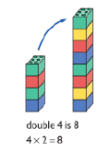  Use manipulatives (e.g. cubes) to show how to double a number. | 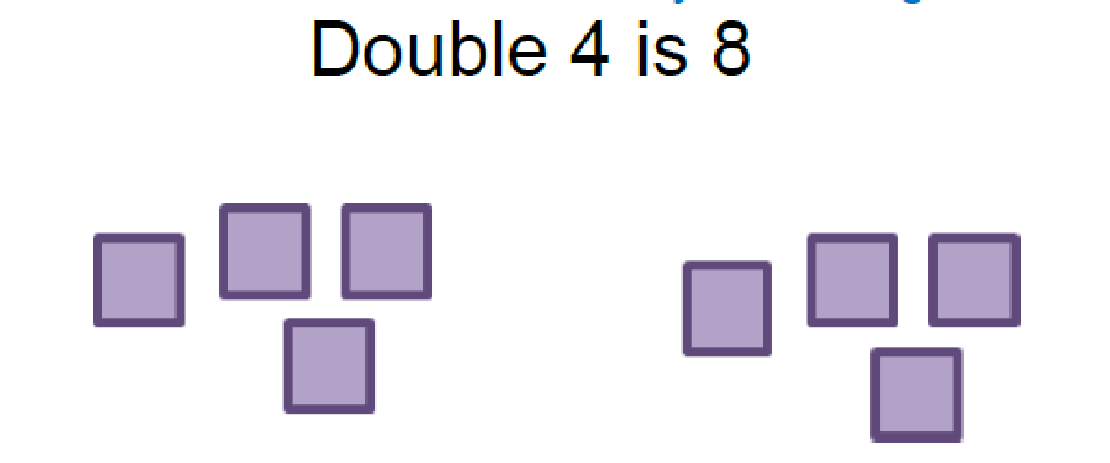  Draw pictures to show how to double a number. | Children draw arrays to represent doubling as 2 equal groups.  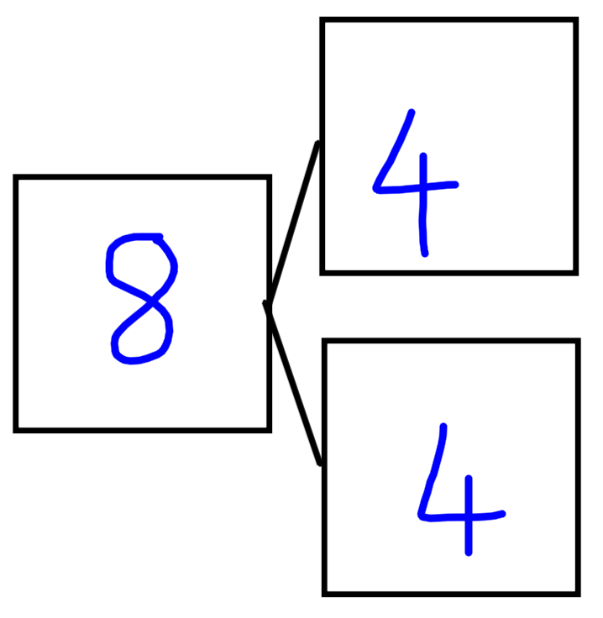  Children use part-whole models to show doubling as 2 equal groups making the whole.
 | Counting in multiples | 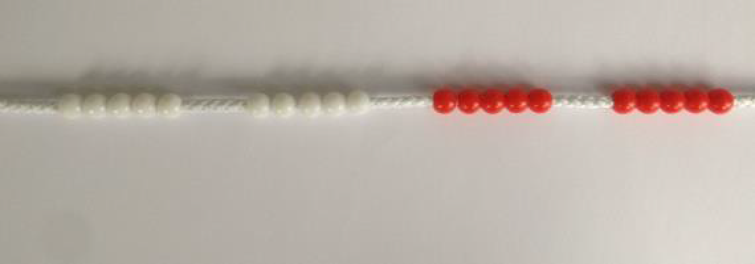  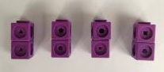  Count in multiples of 1s, 2s, 5s and 10s supported by concrete objects such as cubes, bead strings, Dienes in equal groups. | 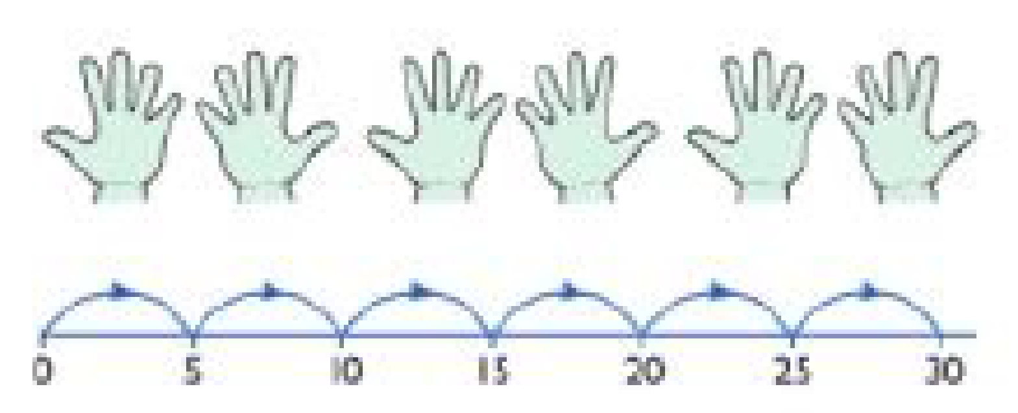  Use a number line or pictures to continue support in counting in multiples. | Count in multiples of a number aloud.  Write sequences with multiples of numbers.  2, 4, 6, 8, 10  5, 10, 15, 20, 25 , 30
Stage 2: Arrays  Stage 3: Repeated addition linking to practical apparatus | Repeated addition | 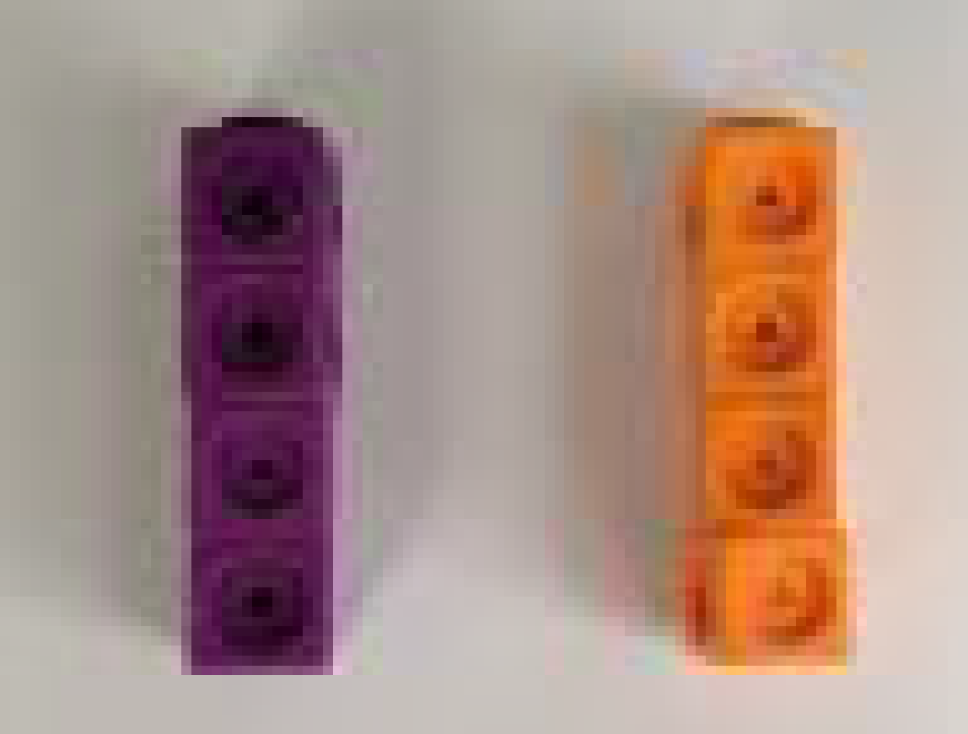  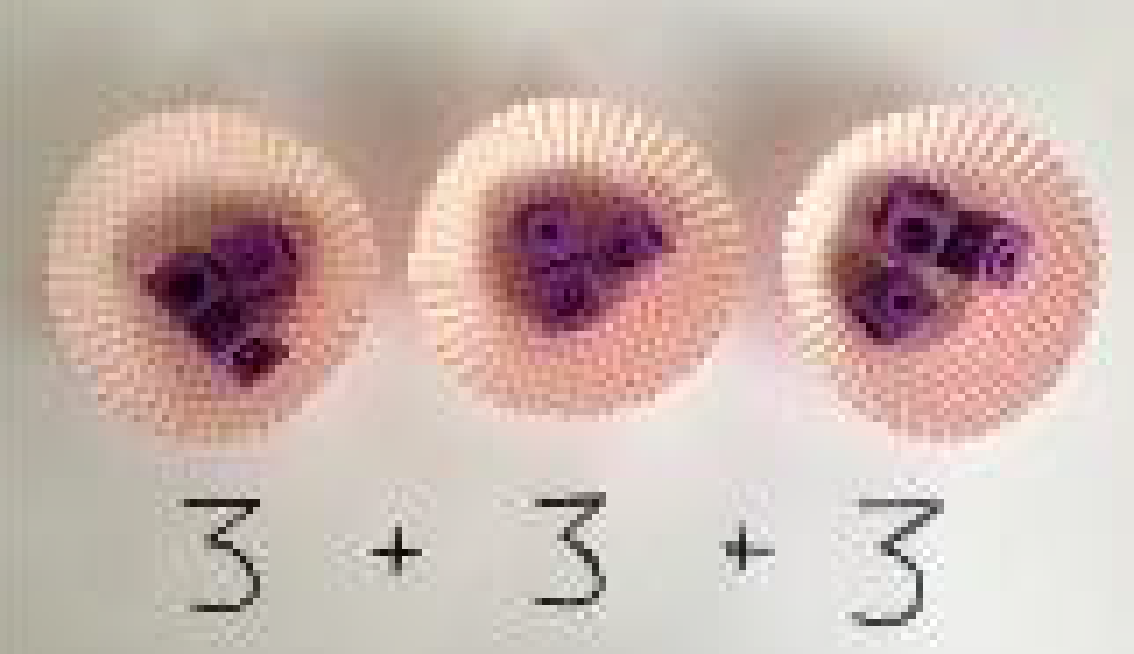  Use different objects to add equal groups. | 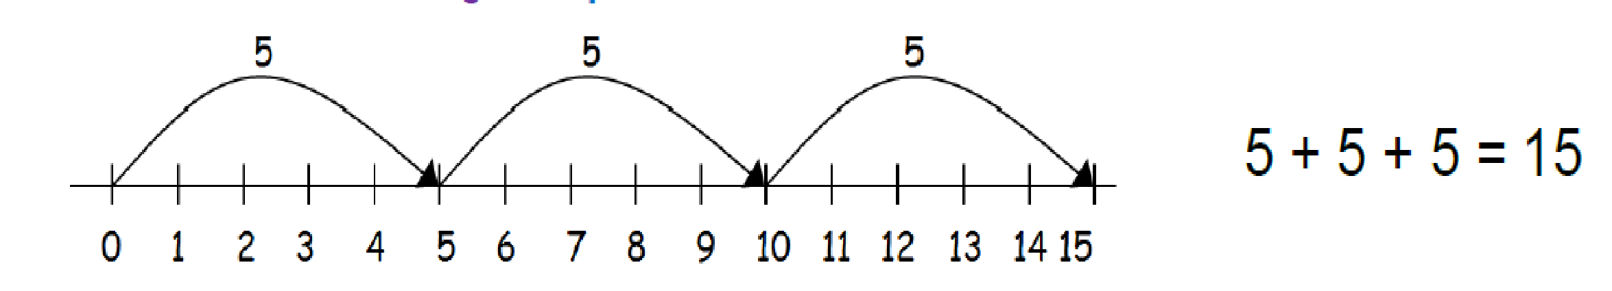 | 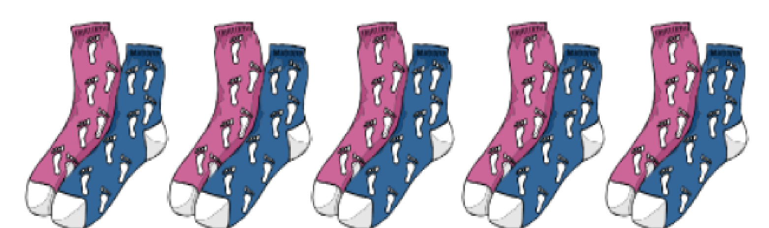  Write addition sentences to describe objects and pictures.  2 + 2 + 2 + 2 + 2 = 10  5 x 2 = 10
 | Arrays- showing commutative multiplication | Create arrays using counters/ cubes to show multiplication sentences.  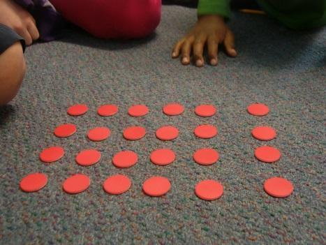  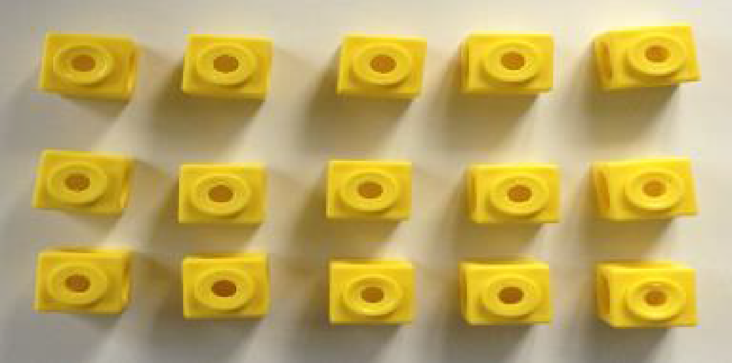 | Draw arrays in different rotations to find commutative multiplication sentences.  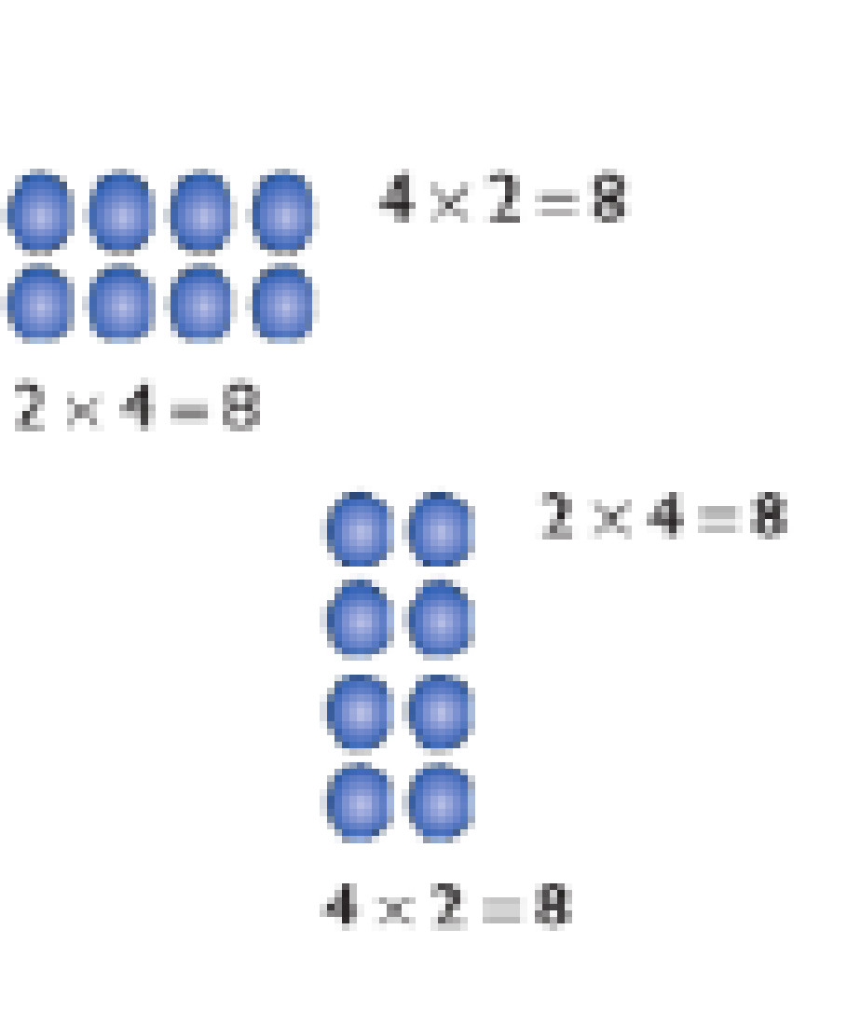  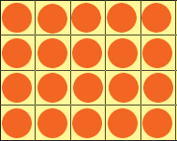 | Use an array to write multiplication sentences and reinforce repeated addition.  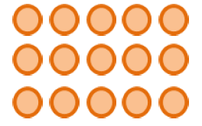  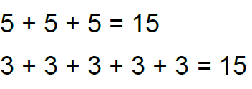  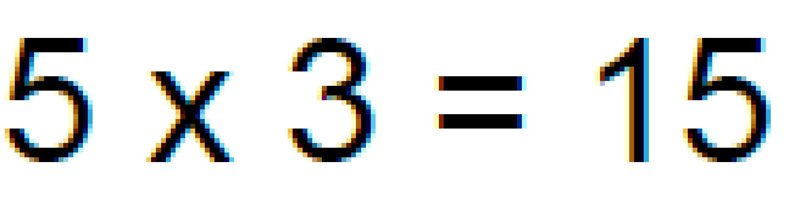  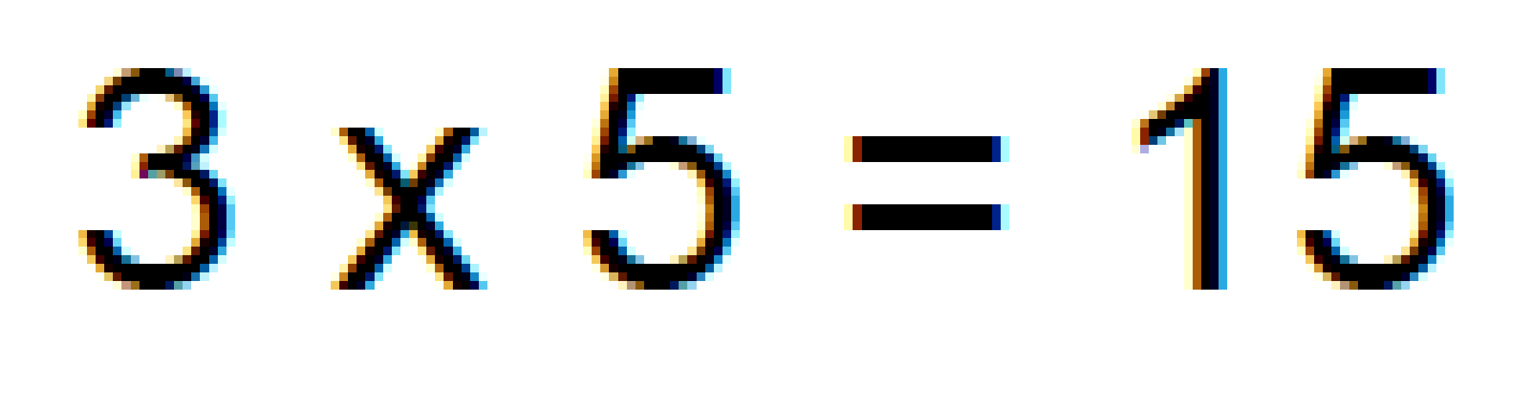
Stage 4: Expanded method |  | Use place value counters to represent numbers.  Represent the same number again.  e.g. if 13 x 4 = ___, you make 4 rows of 13 (10 + 3)  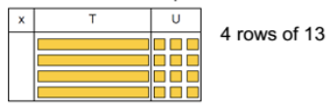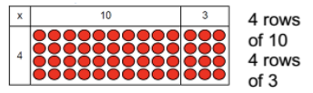 | Children draw tens and ones to represent the numbers they are multiplying. They will partition the numbers into tens and ones.  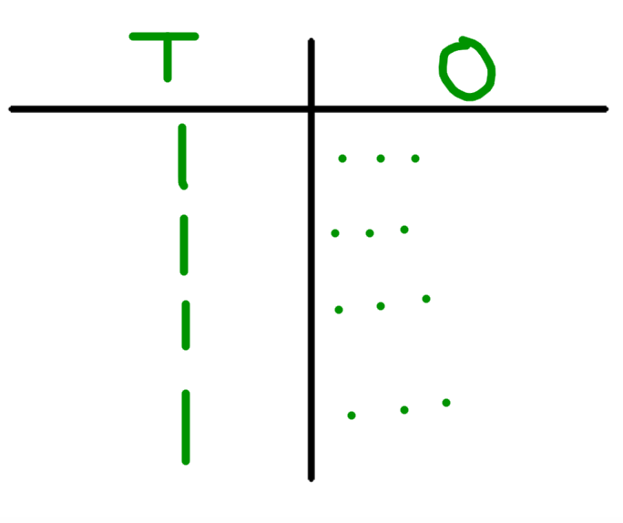 | Use place value chart to write multiplication sentences.  13 x 4 = 52  4 x 13 = 52
Stage 5: Compact method 2x1 and 3x1 | Column multiplication | 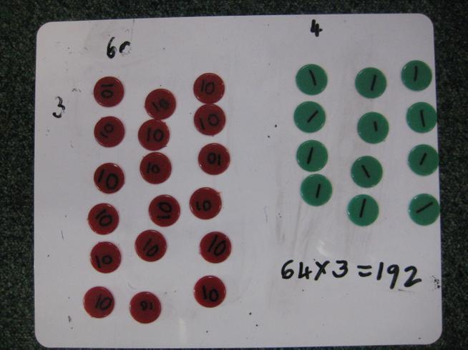  Children can continue to be supported by place value counters at this stage of multiplication.  It is important at this stage that they always multiply the ones first and note down their answer followed by the tens which they note below. | Bar modelling and number lines can support learners when solving problems with multiplication alongside the formal written methods.  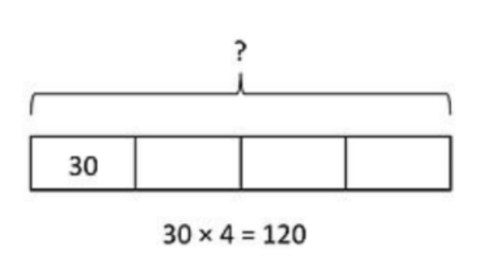  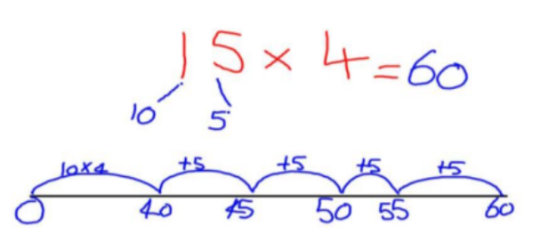 | H T O  4 7 6  X  4  1 9 0 4  3 2  Numbers are carried underneath. Label columns if needed.  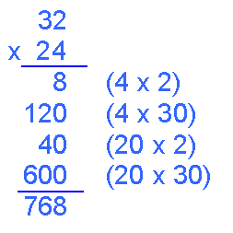  If it helps, children can write out what they are solving next to their answer.
Stage 6: Compact method 2x2 and 3x2 and beyond |  |  |  | With long multiplication, remind the children about lining up their numbers clearly in columns.  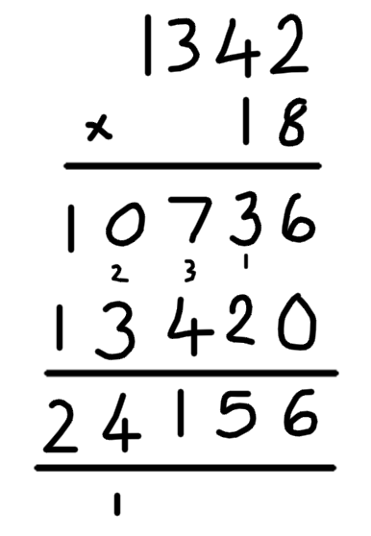
Multiply one digit number by one digit numbers with up to two decimal places |  |  | Estimate first! Try 3 x 5  to get a feel for what the  answer may be.  3x5=15 then you can  check against your  answer. If the decimal  point was in the wrong  place it would be 135 or  1.35. Both of these are  not near our estimate so  we know that 13.5 is  correct! | Use compact short multiplication to  multiply decimal number by whole  number.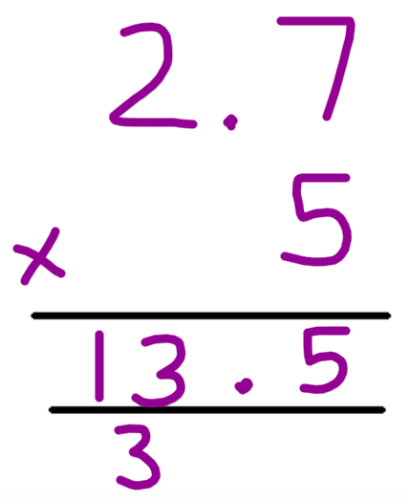

Division
Vocabulary: division, divide, share, groups of, equal groups, parts, whole
Calculation Stage | Objective and Strategies | Concrete | Pictorial | Abstract
Stage 1: Concrete objects and pictorial representations | Sharing objects into groups | 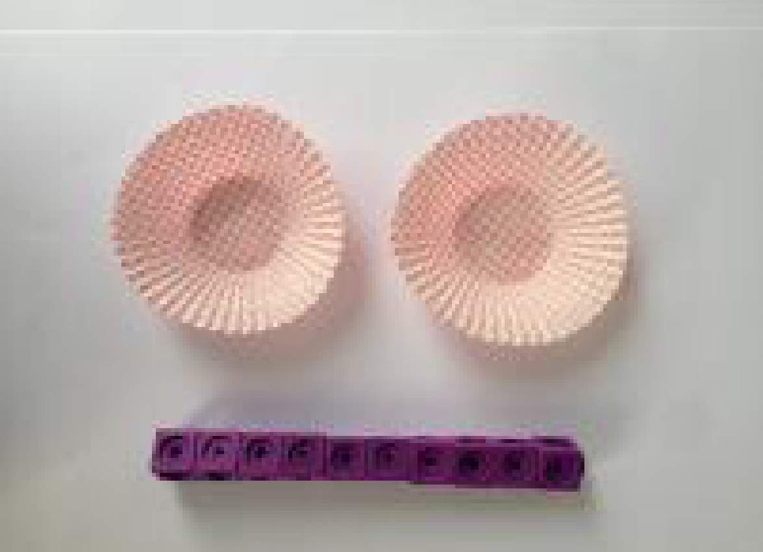  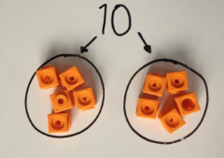  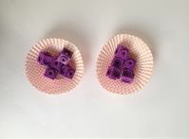  I have 10 cubes, can you share them equally in 2 groups? | Children use pictures or shapes to share quantities.  8 ÷ 2 = 4 | Share 9 buns between three people.  9 ÷ 3 = 3
Stage 2: Grouping or repeated subtraction | Division as grouping | Divide quantities into equal groups.  Use cubes, counters, objects or place value counters to aid understanding.  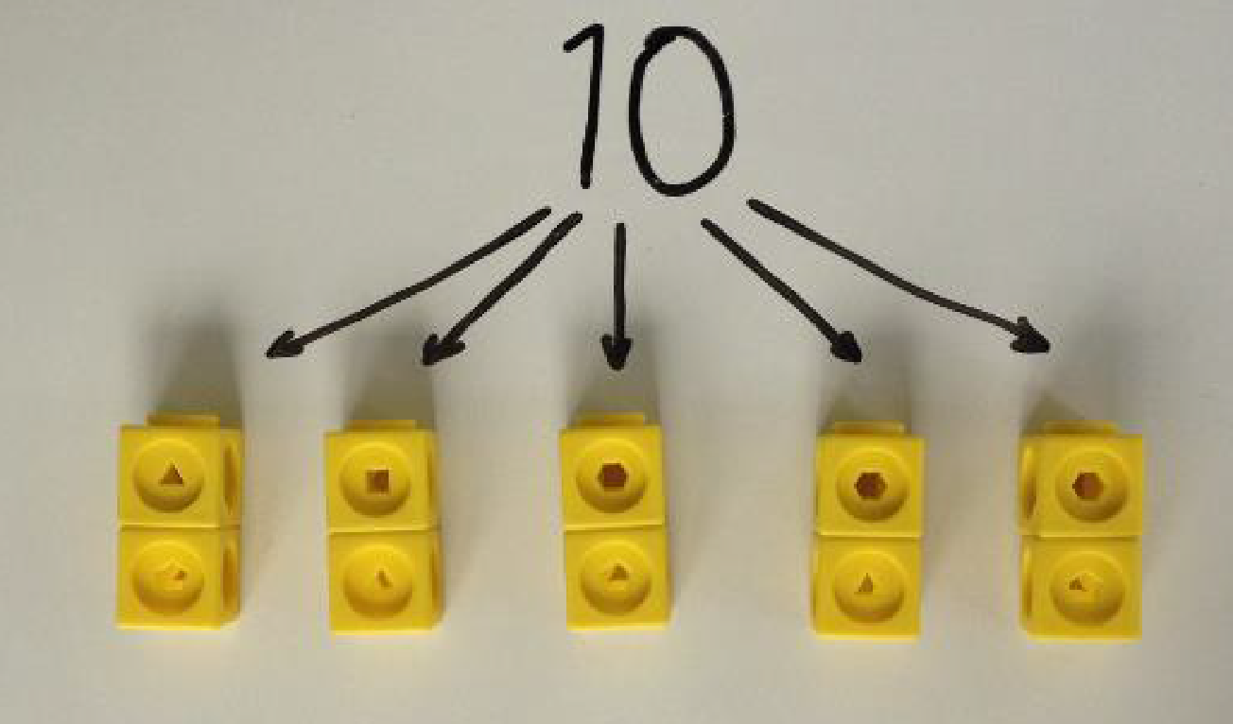  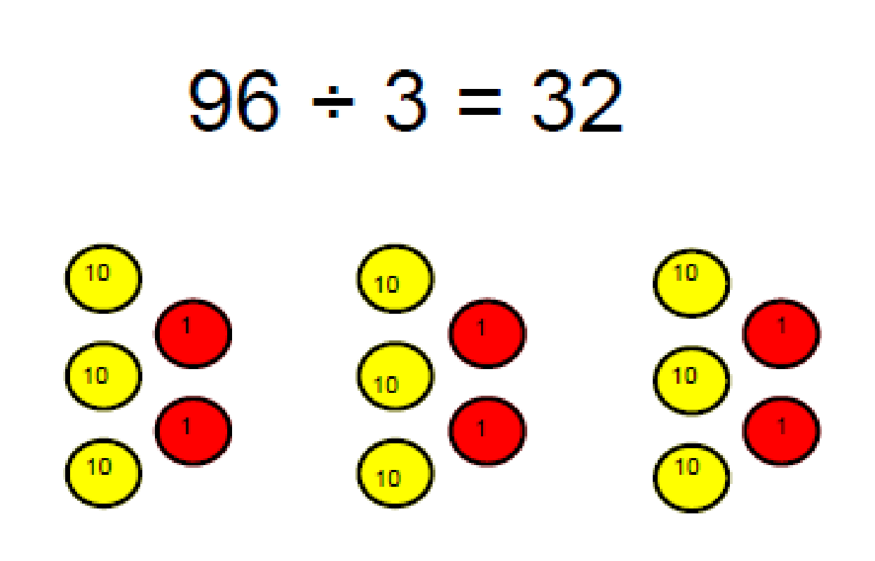  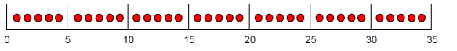 | Use a number line to show jumps in groups. The number of jumps equals the number of groups.  Think of the bar as a whole. Split it into the number of groups you are dividing by and work out how many would be within each group.  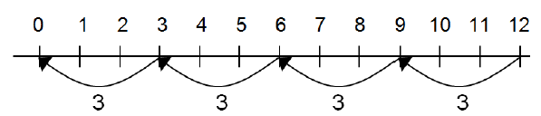 | 28 ÷ 7 = 4  Divide 28 into 7 groups. How many are in each group?
 | Division within arrays | 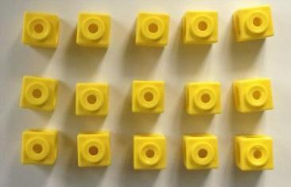  Link division to multiplication by creating an array and thinking about the number sentences that can be created.  Eg 15 ÷ 3 = 5 5 x 3 = 15  15 ÷ 5 = 3 3 x 5 = 15 | 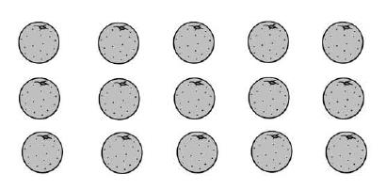  Draw an array and use lines to split the array into groups to make multiplication and division sentences. | Find the inverse of multiplication and division sentences by creating four linking number sentences.  7 x 4 = 28  4 x 7 = 28  28 ÷ 7 = 4  28 ÷ 4 = 7
 | Division with a remainder | 14 ÷ 3 =  Divide objects between groups and see how much is left over  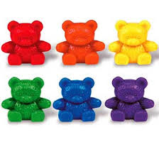 | Jump forward in equal jumps on a number line then see how many more you need to jump to find a remainder.  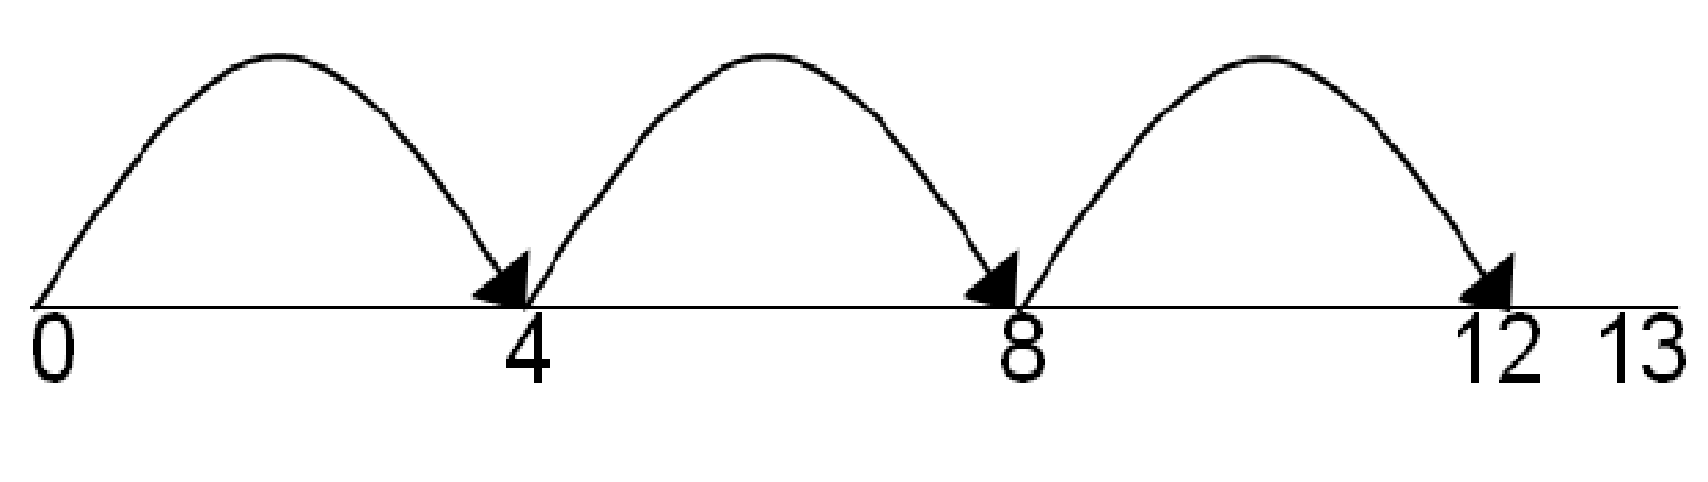  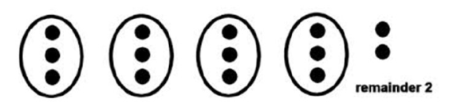  Draw dots and group them to divide an amount and clearly show a remainder. | Complete written divisions and show the remainder using r.  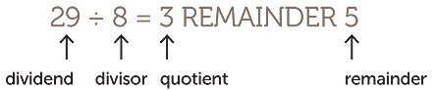
Stage 3: Short division (Bus stop) | Short division | Use place value counters to divide using the bus stop method alongside  42 ÷ 3=  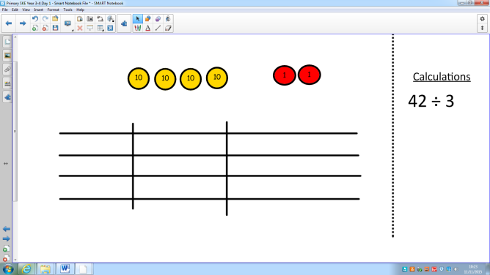  Start with the biggest place value, we are sharing 40 into three groups. We can put 1 ten in each group and we have 1 ten left over.  We exchange this ten for ten ones and then share the ones equally among the groups.  We look at how much in 1 group so the answer is 14. | Students can continue to use drawn diagrams with dots or circles to help them divide numbers into equal groups.  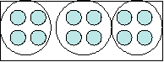  To show the remainder as a decimal relies upon children’s knowledge of decimal fraction equivalents. | 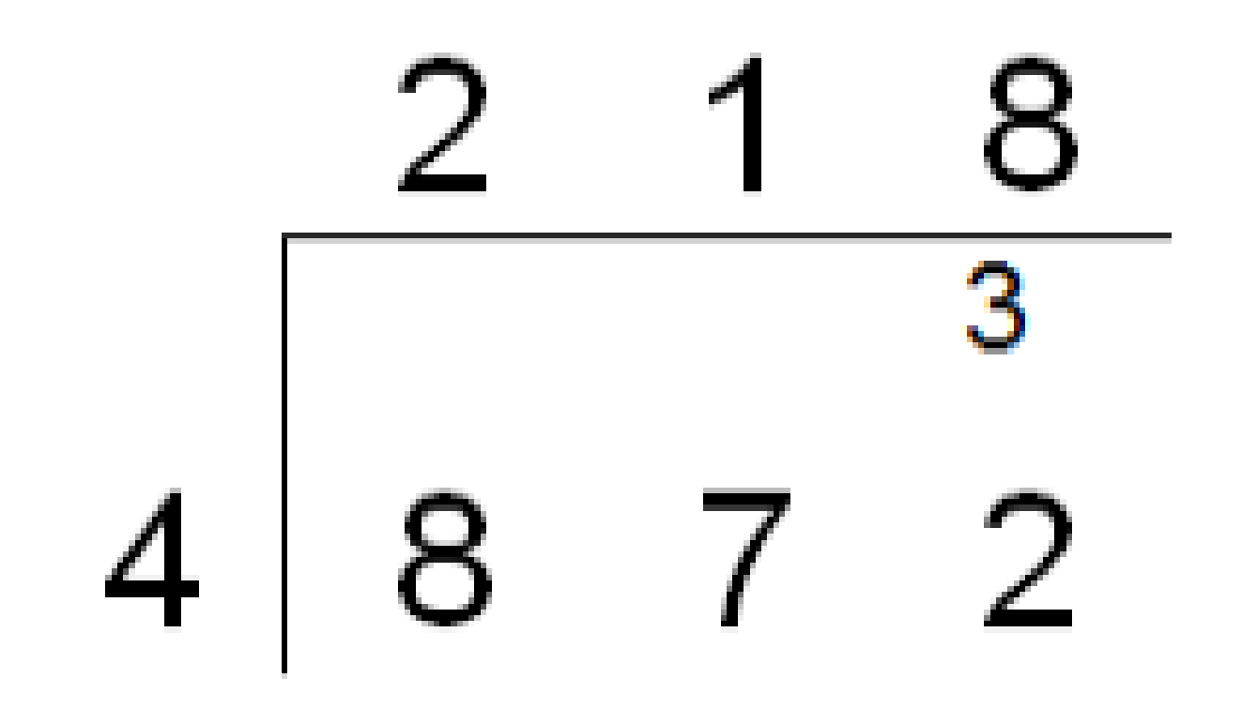  Begin with divisions that divide equally with no remainder.  Move onto divisions with a remainder.  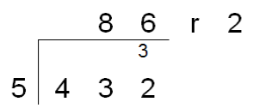  Once children understand remainders, begin to express them as a fraction or decimal according to the text.  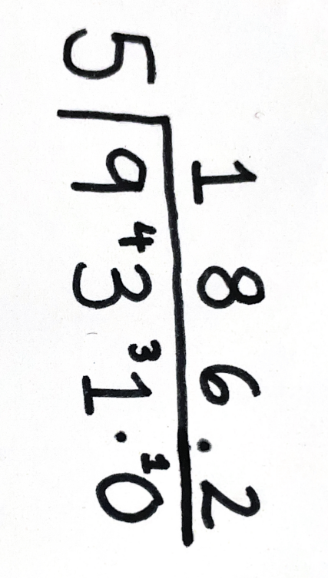
Stage 4: Long division | Long division - no remainder |  | Encourage them to move towards counting in multiples to divide more efficiently.  Write down higher multiplication tables to help with trickier numbers:  12  24  36  48  60  72  84  96  108 | 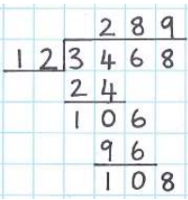  Children will use long division to divide numbers with up to 4 digits by 2 digit numbers.
 | Long division - decimal remainders |  |  | Where the remainder is written as a decimal, children add zeros after the decimal point.