**Year 1 JS LTP 2024-2025** 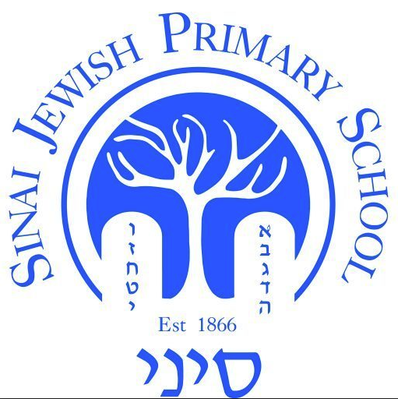

| **Year Group:**  **Year 1** | **Autumn 1** | **Autumn 2** | **Spring 1** | **Spring 2** | **Summer 1** | **Summer 2** |
| --- | --- | --- | --- | --- | --- | --- |
| **Hebrew Reading** | Review previous learning  Read two syllable words (CVCVC) with **Sh’va Na at beginning** and any of the following vowels: Kamatz, Patach, Tzeireh or Segol | Read two syllable words with **Sh’va Nach at the end** with any of the following vowels: and any of Kamatz, Patach, Tzeireh or Segol | Read **three** syllable words with any of Kamatz, Patach, Tzeireh, Segol, Sh’va or Cholam vowels **with a reasonable degree of fluency** | Read three syllable words with any of Kamatz, Patach, Tzeireh, Segol, Sh’va, Cholam or **Chirik vowels** | Read three syllable words with any of Kamatz, Patach, Tzeireh, Segol, Sh’va, Cholam, Chirik **Kubutz or Shorok** vowels | Read with accuracy selected words in the Siddur that appear in known Tefillota with any of Kamatz, Patach, Tzeireh, Segol, Sh’va , Cholam, Chirik, Kubutz or Shuruk vowels  Name all known vowels |
| **Torah** | *No Parashah until after Simchat Torah* | Weekly parashah and middah (Jewish value) | | | | |
| **Jewish****Living** | Rosh Hashanah  Yom Kippur  Succot  Weekly Oneg Shabbat + Havdalah  Sefer Torah assembly | Chanukah  Weekly Oneg Shabbat + Havdalah  Sefer Torah assembly  Jewish Life Skills Week | Tu BiShevat  Weekly Oneg Shabbat + Havdalah  Sefer Torah assembly  Jewish Life Skills Week  Chagigat HaSiddur | Purim  Pesach  Weekly Oneg Shabbat + Havdalah  Sefer Torah assembly  Model Seder | Counting the Omer  Yom Ha'atzmaut  Lag BaOmer  Yom Yerushalayim  Shavuot  Weekly Oneg Shabbat + Havdalah  Sefer Torah assembly | Days of Fasting  The Three Weeks    Weekly Oneg Shabbat + Havdalah  Sefer Torah assembly |
| **Tefillah** | Asher Yatsar  Birchot HaTorah 1 + 3 + Yevarechechah  Hallel: berachah + Hodu chorus | Shema para 3  Hallel: Ana Hashem | Complete Shema para 3  Start Birkat HaMazon berachah 2  Oseh Shalom | Shirat HaYam  Develop Birkat HaMazon berachah 2 | Elokai Neshamah  Continue to develop Birkat HaMazon berachah 2 | Mah Tov – all lines  Complete Birkat HaMazon berachah 2 |