**Year 3 JS LTP 2024-2025** 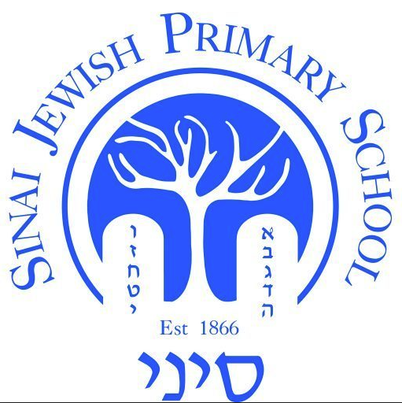

| **Year Group:**  **Year 3** | **Autumn 1** | **Autumn 2** | **Spring 1** | **Spring 2** | **Summer 1** | **Summer 2** |
| --- | --- | --- | --- | --- | --- | --- |
| **Hebrew Reading, Writing and Language** | Review Hebrew letters and vowels and previous learning  Chataf vowels  Final kaf vs final chaf | Read words with:  Patach yud   Double sheva  Kamatz yud vav | **Introduce script letters**  Read two-syllable words in script  Write script letters: Yud, Vav, Aleph, Bet, Gimmel & Zayin  Read familiar Chumash words and phrases accurately in a text that has **no**Ta’ameiHaMikra**except**etnachta and sof pasuk | Script letters: Aleph-Mem  Read multi-syllable words in script  Read familiar Chumash words and phrases accurately in a text that has **no**Ta’ameiHaMikra**except**etnachta and sofpasuk  Differnce between Cholam Maleh and a Vav with a Cholam | Script letters: Mem-Fey  Read with accuracy and fluency texts in script (including own handwriting)  Read with accuracy and fluency familiar weekday prayers in Siddur  Read familiar words and phrases accurately in a Chumash text that **has** all Ta’ameiHaMikra | Script letters: Fey-Taf  Read with accuracy and fluency Shabbat prayers in Siddur  Read familiar pesukim accurately and fluently in a Chumash text that **has** all Ta’ameiHaMikra |
| **Torah (Parasha)** | *No Parashah until after Simchat Torah* | Weekly Parashah and middah (Jewish value) | | | | |
| **Torah (Chumash)** | Chumash Readiness | | Chumash Bereshit - Lech Lecha: Avram goes to the Land | | Chumash Bereshit - Lech Lecha continued | |
| **JewishLiving** | Rosh Hashanah  Yom Kippur  Succot  Shemini Atzeret  Simchat Torah  Weekly Oneg Shabbat + Havdalah  Sefer Torah assembly | Chanukah  Weekly Oneg Shabbat + Havdalah  Sefer Torah assembly  Jewish Life Skills Week  ChagigatHaChumash | Tu BiShevat  Weekly Oneg Shabbat + Havdalah  Sefer Torah assembly  Jewish Life Skills Week | Purim  Pesach  Weekly Oneg Shabbat + Havdalah  Sefer Torah assembly  Model Seder | Counting the Omer  Yom Ha’atzmaut  Lag BaOmer  Yom Yerushalayim  Shavuot  Weekly Oneg Shabbat + Havdalah  Sefer Torah assembly | The Three Weeks  Weekly Oneg Shabbat + Havdalah  Sefer Torah assembly |
| **Tefillah** | Hallel: Keli Attah | Etz Chaim  Acheinu  Baruch Sheamar | Birchot Hashachar | | Develop Shema Paragraph 2  Birchot Hashachar | Complete Shema Paragraph 2  Complete Birchot Hashachar |