**Year 4 JS LTP 2024-25** 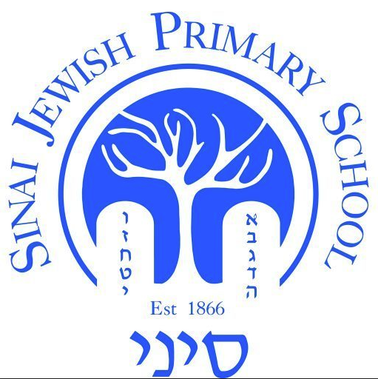

| **Year Group:**  **Year 4** | **Autumn 1** | **Autumn 2** | **Spring 1** | **Spring 2** | **Summer 1** | **Summer 2** |
| --- | --- | --- | --- | --- | --- | --- |
| **Hebrew Reading, Writing and Language** | Read with accuracy and fluency **familiar** prayers in the Siddur, applying the meteg symbol shown in the Siddur and accentuating syllables correctly (milra and mil’ayl) | Read **familiar** pesukim accurately and fluently in a Chumash text, accentuating syllables correctly and pausing at the etnachta and sof pasuk | Name and sound the 18 Rashi script letters that are similar to block letters | Name and sound the 9 Rashi script letters that are different to block letters | Read one-syllable words in Rashi script  Read two-syllable words in Rashi script | Read multi-syllable words in Rashi script |
| **Torah (Parasha)** | *No Parashah until after Simchat Torah* | Weekly Parashah and middah (Jewish value) | | | | |
| **Torah (Chumash)** | Chumash Bereshit 13: 5 - 13 (Lech Lecha: Avraham and Lot part company) | | Chumash Bereshit 18: 1 – 8 (Vayera: Avraham welcomes visitors) | | Chumash Bereshit 21: 1 – 13 (Vayera: The birth of Yitschak) | |
| **Jewish****Living** | Rosh Hashanah  Yom Kippur  Succot  Weekly Oneg Shabbat + Havdalah  Sefer Torah assembly  Succah visit | Chanukah  Weekly Oneg Shabbat + Havdalah  Sefer Torah assembly  Jewish Life Skills Week: Shabbat  Chanukah candlelighting | Tu BiShevat  Weekly Oneg Shabbat + Havdalah  Sefer Torah assembly  Jewish Life Skills Week: Clean Speech | Purim  Pesach  Weekly Oneg Shabbat + Havdalah  Sefer Torah assembly  Purim Day  Model Seder | Counting the Omer  Yom Ha'Atzmaut  Lag BaOmer  Yom Yerushalayim  Shavuot  Weekly Oneg Shabbat + Havdalah  Sefer Torah assembly | The 3 Weeks  Tisha Be’Av  Weekly Oneg Shabbat + Havdalah  Sefer Torah assembly  Jewish Life Skills Week: Kashrut |
| **Tefillah** | Hallel: Hashem Zecharanu | Sefer Torah assembly songs: Vayehi Binsoa, Gadlu | Shema paragraph 2 | Shema paragraph 2 | Birchot HaTorah berachah 2  Tehillim 121 | Yishtabach |