**Year 5 JS LTP 2023-2024** 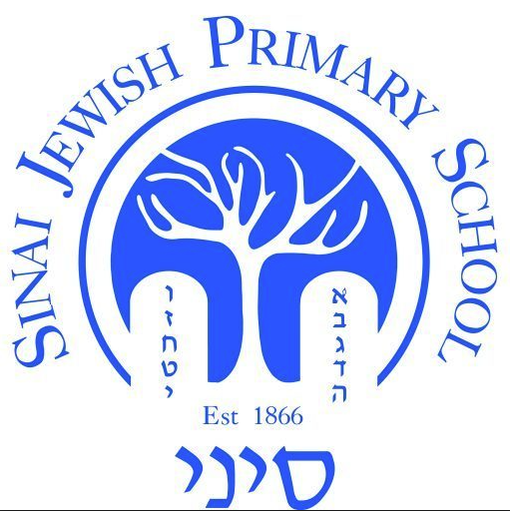

| **Year Group:**  **Year 5** | **Autumn 1** | **Autumn 2** | **Spring 1** | **Spring 2** | **Summer 1** | **Summer 2** |
| --- | --- | --- | --- | --- | --- | --- |
| **Hebrew Reading, Writing and Language** | Review previous learning  sh’vanach (middle of word) + writing on lines/vowels underneath (especially final nun/chaf)   sh’vana/nach in middle of word (dagesh/no dagesh)  Patach yud  Kamatz yud vav  patach genuva/ final chaf with kamatz | Read **unfamiliar** pesukim accurately and fluently in a Chumash text, accentuating syllables correctly and pausing at the etnachta and sofpasuk  Cholam chaser/sharing with shin  vowels + yud | Read **unfamiliar** pesukim accurately and fluently in a Chumash text, accentuating syllables correctly and pausing at the etnachta and sof pasuk  Block - script - Rashi transfer skills. | Read with accuracy and fluency assorted **classical** texts (eg Haggadah, Megillah) in different fonts  Font as written in classical texts e.g. Megillah/ Torah and recognising tricky letters e.g. chet. | Read with accuracy and fluency familiar whole sentences in Rashi script | Read with accuracy and fluency familiar whole sentences in Rashi script  Rashi + reviewing script writing and letter formation. |
| **Torah (Parasha)** | *No Parashah until after Simchat Torah* | Weekly Parashah and middah (Jewish value) | | | | |
| **Torah (Chumash)** | Review of Bereshit 18: 1 – 8 (Avraham welcomes three men) & 21: 1 – 13 (The birth of Yitzchak) | Bereshit 24: 1 – 24  (Chayei Sarah: Choosing a wife for Yitzchak) | Bereshit 25: 19 – 28 (Toledot: The birth of Yaakov and Esav) | | Bereshit 25: 29 – 34 (Toledot: The Bechorah) | |
| **JewishLiving** | Elul- Teshuvah  Rosh Hashanah  Yom Kippur  Succot  ***J General Knowledge Topics***  Jewish Calendar  Weekly Oneg Shabbat and havdalah  Sefer Torah assembly | Chanukah  ***J General Knowledge Topics***  Jewish Calendar  Numbers & Gematria  Tanach  Weekly Oneg Shabbat and havdalah  Sefer Torah assembly  Jewish Life Skills Week | Tu BiShevat  ***J General Knowledge Topics***  Shabbat  Kashrut  Mishkan  Weekly Oneg Shabbat and Havdalah  Sefer Torah assembly  Jewish Life Skills Week  Shabbaton residential  Clean Speech | Purim  Pesach  ***J General Knowledge Topics***  Tanach  Jewish Calendar  Weekly Oneg Shabbat and havdalah  Sefer Torah assembly  Model Seder | Counting the Omer  Yom Ha'atzmaut  Lag Ba’Omer  Yom Yerushalayim  Shavuot  ***J General Knowledge Topics***  Jewish Calendar  Jewish History  Israel  Mitzvot  Weekly Oneg Shabbat and havdalah  Sefer Torah assembly | Fast Days  The 3 Weeks  ***J General Knowledge Topics***  Jewish Calendar  Mishna  Tefillah  Tzitzit  Brachot    Weekly Oneg Shabbat and havdalah    Sefer Torah assembly  Etgar event  Jewish Life Skills Week: Kashrut |
| **Tefillah** | Hallel  Ya’aleh v’Yavo | Complete Birkat Hamazon – Harachamans + Bamarom  Hallel - Ana | Amidah: choreography  Brachot Rishonot & Acharonot | Hallel: B’tzeit Yisrael  Amidah: Elokai N’tzur | Amidah: Bracha 2 | Amidah: Bracha 19 |