Sinai Jewish Primary School
Remote Education Provision
Information for Parents 2021

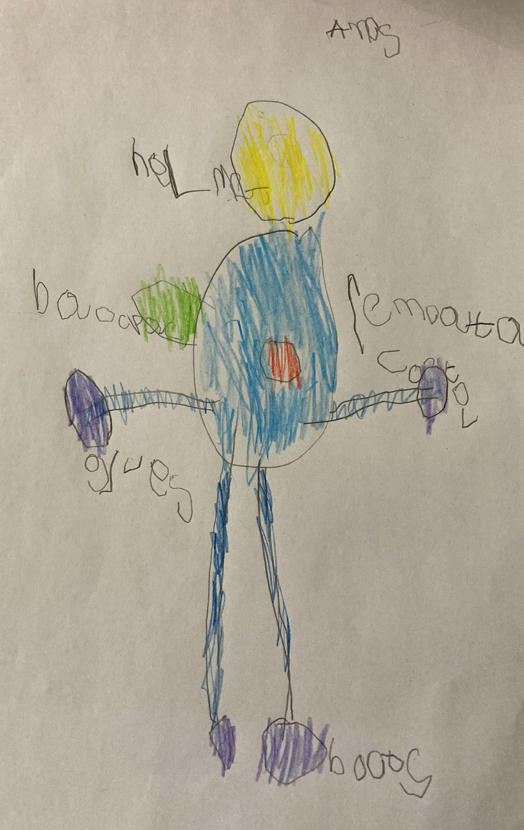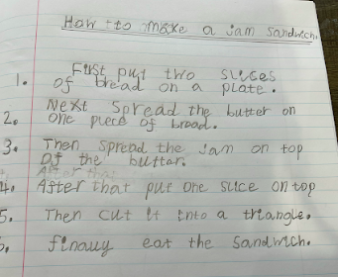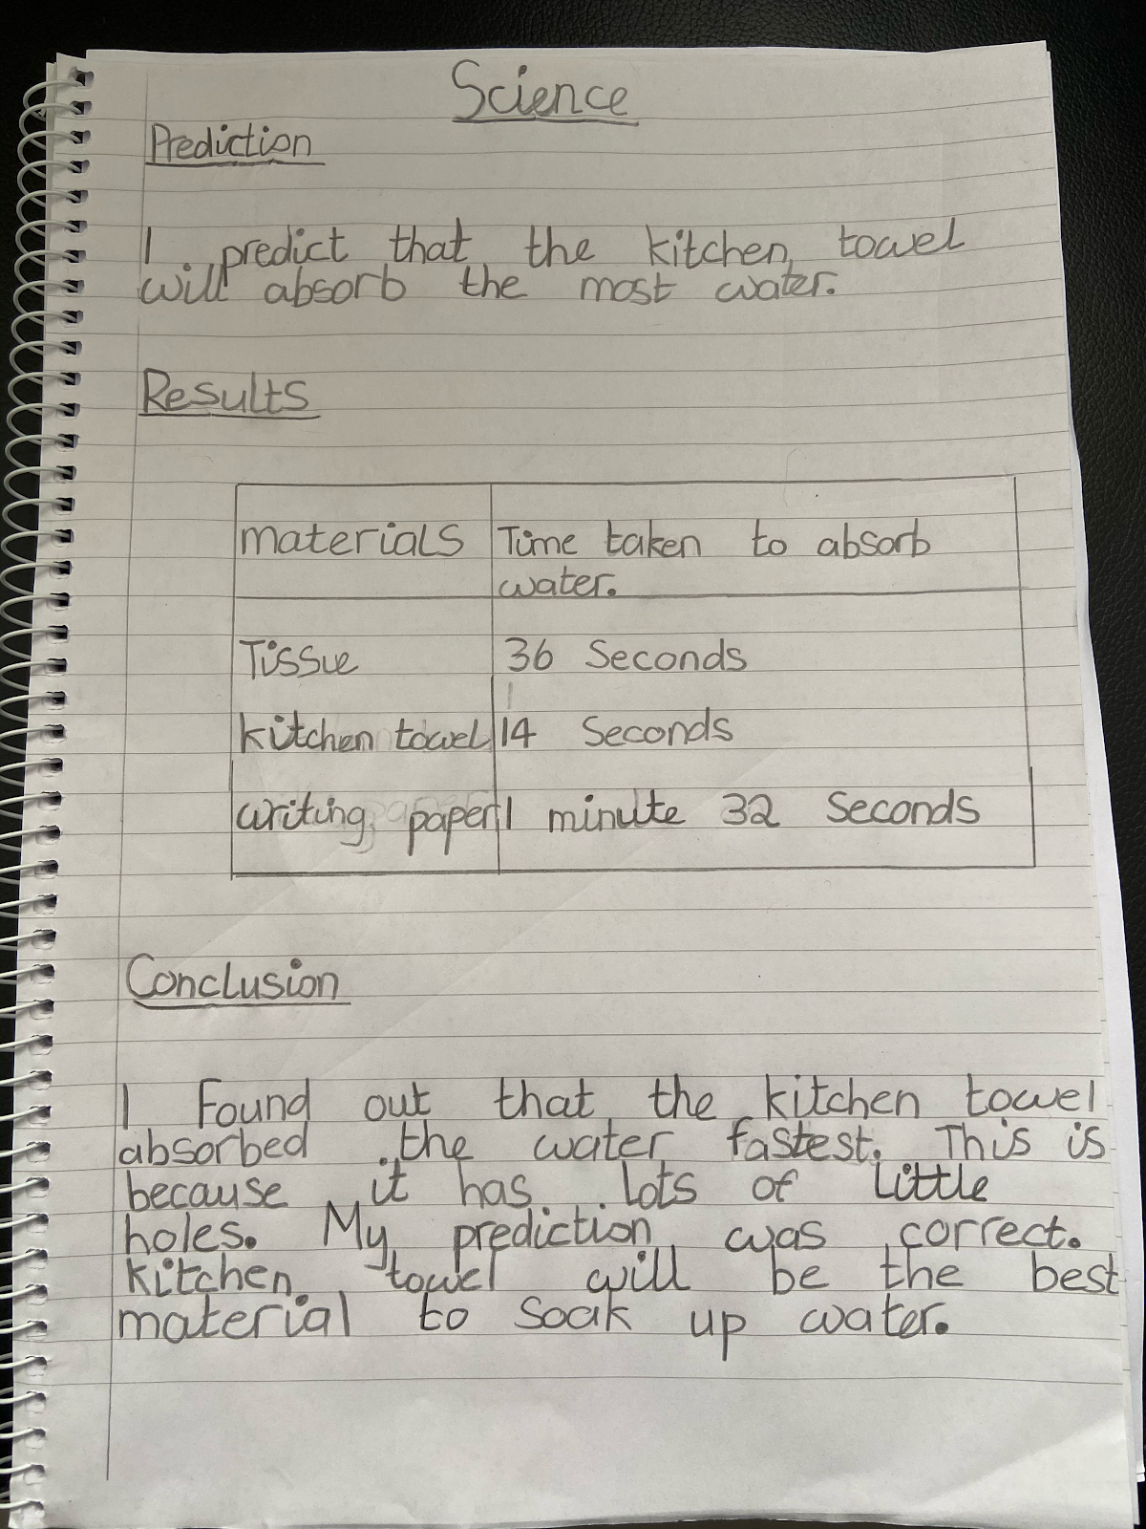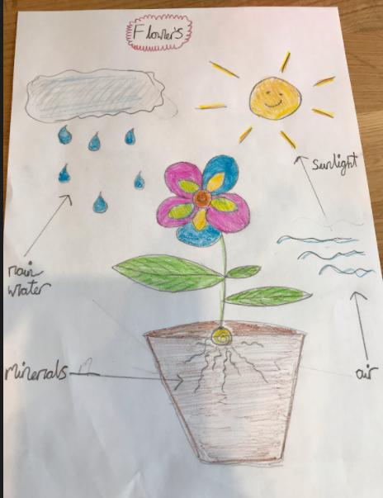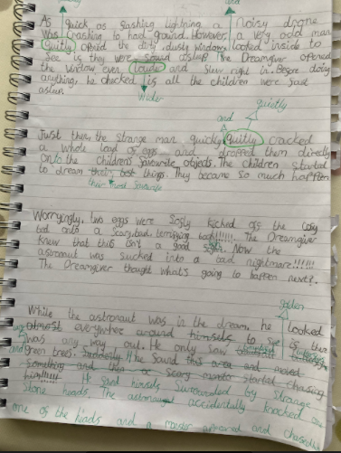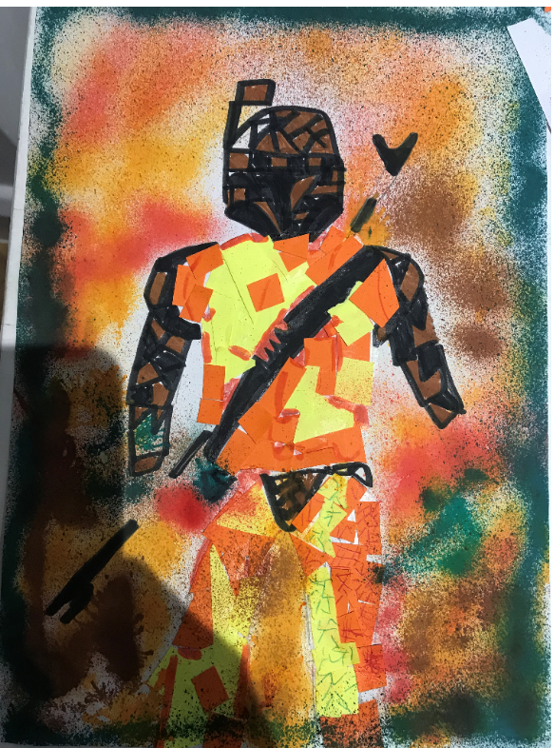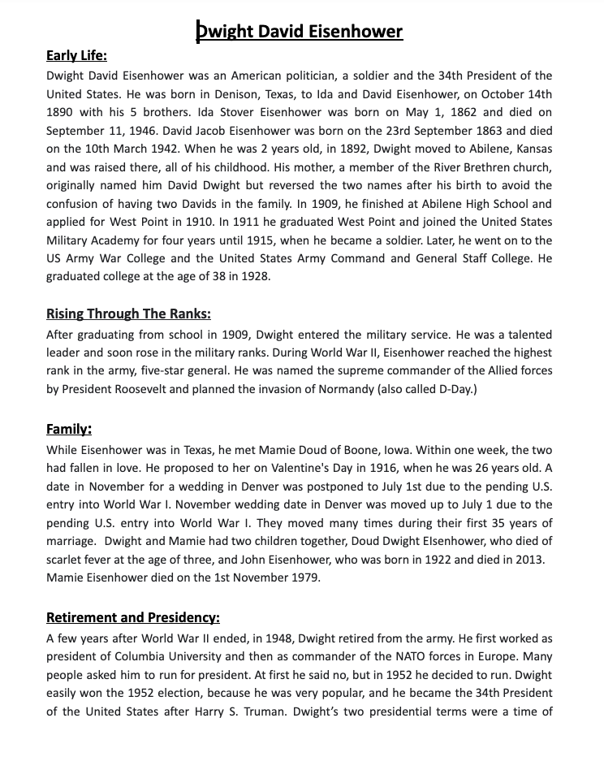
Examples of work completed remotely during lockdown

This information is intended to provide clarity and transparency to pupils and parents or carers about what to expect from remote education where national or local restrictions require entire cohorts to remain at home. (Please also refer to the Remote Learning Policy.)

Please see the end of this document for guidance relating to children/cohorts who have to self -isolate.

Accessing remote education

How will my child access online remote education the school is providing?
All online learning will be on the Google Classroom, every child has a Google Classroom login and is familiar with how to use this. They have had experience with this platform as it is used for weekly homework tasks while school is open.
There is a balance between live sessions and pre-recorded lessons. All live sessions have pre-made slides that allow the children to revisit some parts of the lesson to support their understanding. These slides can be accessed at any time.

If my child does not have digital or online access at home, how will you support them to access remote education?
We recognise that some pupils may not have suitable online access at home. We take the following approaches to support those pupils to access remote education:
A questionnaire was sent out to all parents to ascertain which families needed additional support with online access at home. Families that do not have a suitable working device can contact the school to request one. Where possible, your child will be loaned a laptop for the duration of their isolation.
The Senior Leadership Team regularly phone all vulnerable and disadvantaged children to monitor which children need additional support with devices or internet access (routers, dongles, data cards).
Pupils without internet and/or computer access will be provided with paper packs. These can be collected at school on a weekly basis or in some cases hand delivered. Class teachers will mark the work once it has been completed.
In some cases, children who are unable to access learning at home will be invited into the Critical worker provision.

Remote teaching and study time each day

How long can I expect work set by the school to take my child each day?

EYFS
We have not set a time expectation for children in EYFS as they benefit from learning through their play. Children are provided with;
- Daily live lessons (15-20 mins) – two maths, two English and one PSHE
- Teachers remain on the zoom to answer questions while the children work independently on the tasks set after the lesson
- Weekly live JS lesson
- Weekly small group guided reading
- Daily check-in including Tefillah, Oneg and opportunities to enhance communication and language as well as PSED.
- Recorded lessons for all other curriculum subjects including Jewish Studies, phonics, links to the topic through: Understanding the World (UW) and Expressive Art and design (EAD)
- PE links
- Weekly stories with prompt questions

Have a look at a sample phonics lesson from one of our reception teachers:
https://www.loom.com/share/14a6100105e84c558be4072313cb4cb9​

Key Stage 1
We expect the children to work for a minimum of 3 hours a day – including live lessons, additional remote learning provision and independent set work;
- Daily live lessons – two maths, two English and one PSHE
- Teachers remain on the zoom after live lessons to answer questions while the children work independently immediately after the lesson
- Weekly live JS lesson and 1:1 Hebrew Reading support
- Weekly small group guided reading
- Daily check-in including Tefillah, Oneg, maths meetings and phonics
- Recorded lessons for all other curriculum subjects including Jewish studies, phonics, History, Geography, Guided reading and art.
- Scheduled activities on Purple Mash for computing and Charanga for music.
- PE links
- Friday fun activity (e.g. fun fruit animals, baking, secret missions, making music instruments)

An example of a year 1 suggested timetable:
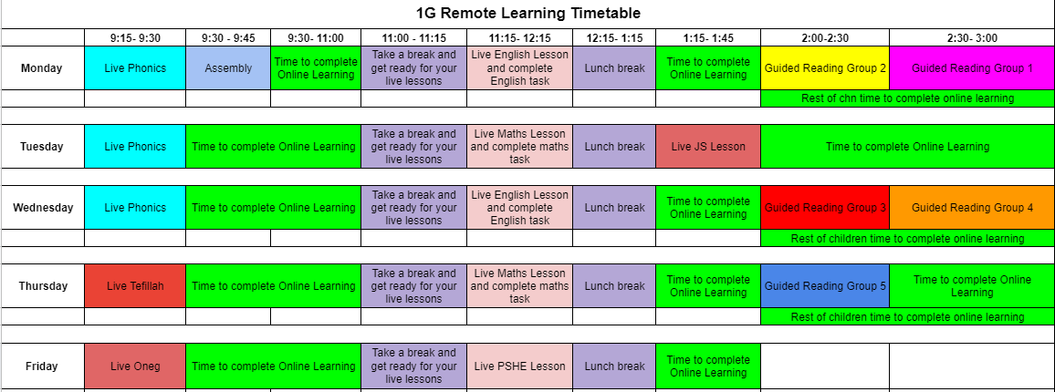
Have a look at a sample maths lesson and maths meeting from one of our year 2 teachers:
Maths Meeting - https://edpuzzle.com/media/5ffd9ed235ce1f4242ea01df
Maths Lesson - https://www.loom.com/share/1e622df45cd643b98ba9782c1944e825​

Key Stage 2
We expect the children to work for a minimum of 4 hours a day – including live lessons, additional remote learning provision and independent set work;
- Daily live maths lessons
- Four live English lessons a week (one recorded comprehension lesson)
- Teachers remain on the zoom to answer questions while the children work independently immediately after the lesson
- Weekly live JS lesson and 1:1 Hebrew Reading support
- Daily check-in including Tefillah, Oneg, maths meetings and spellings
- Recorded lessons for all other curriculum subjects including Jewish studies, History, Geography, French, PSHE, Guided reading and art.
- Scheduled activities on Purple Mash for computing and Charanga for music.
- PE links
- Friday fun activity

An example of a year 4 suggested timetable:
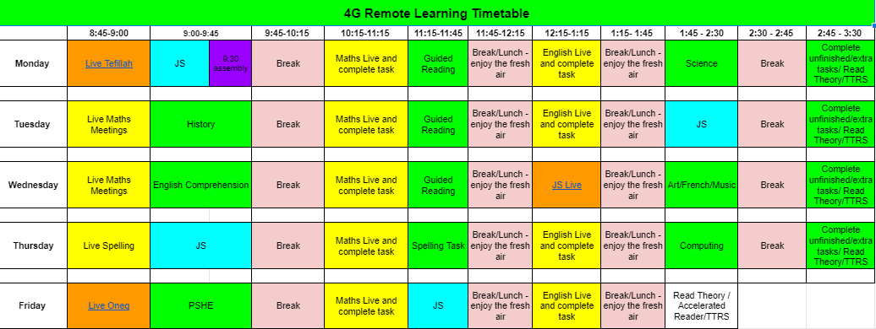

Have a look at a sample English lesson from one of our year 6 teachers and a Guided reading from one of our year 3 teachers:

Year 3 Guided reading - https://www.loom.com/share/7d833c935f5341adae43a2b1f7334741​
Year 6 English lesson - https://www.loom.com/share/5ff838aaa0104ab38f4e9dcecf2452bd​

Examples of additional remote learning:
- Weekly assemblies linked to key events and building the children’s cultural capital eg Martin Luther King Day, Holocaust Memorial day, E–Safety and Children’s Mental Health wellbeing assembly.
- Wellbeing Wednesday’s – activities to support children’s wellbeing are posted every Wednesday in the steam on Google Classroom.
- Celebrating Jewish Holidays - activities and challenges to engage children in Jewish holidays such as Tu Bishvat e.g. cooking, arts and crafts, story telling
- Virtual school library – an author profile and video and free books
- Baking or cooking activities - https://padlet.com/gkaye1304/154b92k62k5pedrw
- Picture News – opportunities to read the news and activities which develop their British values.
- Keep fit videos
- Wow Work – children recognised for their hard work and effort with a sticker from Mrs Lipshaw.

How will my child be taught remotely?
We use a combination of the following approaches to teach pupils remotely:
- live teaching (online lessons)
- recorded teaching (video/audio recordings made by teachers)
- recorded lessons with intermittent questions for the children to respond to (Edpuzzle)
- Follow-up activities including written tasks, Google slides and Google Forms
- Assignments on additional platforms - Purple Mash for Computing and Charanga for Music

Engagement and feedback
We expect all pupils to be fully engaged with all remote learning by participating in all live lessons and watching the recordings of all other lessons and completing the set tasks following the suggested timetable or at a convenient time during the day. All assignments should be completed and submitted to class teachers. Expectations of pupils, parents/ carers and staff have been made clear in our Remote Learning Policy and our Remote learning responsible Usage Agreement.

Ensure that an adult is always present in the room when your child logs onto their live lesson or feedback session.

Ensure your child has access to stationary for all lessons e.g. pencil and paper

Ensure your child completes the remote learning assignments that have been set for them and clicks turn in.

Ensure your child uploads a photo of any written work to the assignment in Google Classroom and clicks turn in.

Please ensure your child is punctual for any live sessions to minimise disruption to the session

Children must be dressed appropriately for their live sessions e.g. not in pyjamas

During their live lessons, children must not use additional devices to e.g. take photos/videos or communicate with friends.

Parents should avoid communicating with teachers during live lessons.

We know that younger children in particular may need support in accessing online materials and staying focused with their independent learning. We ask that you help them with engaging with their remote learning as much as you can.

Distinguish between weekdays and weekends and make it clear when the school day is over, to separate home and school life.

Try to plan breaks and exercise into the day to help keep your child active.

How will you check whether my child is engaging with their work and how will I be informed if there are concerns?
Staff will take a daily register of pupils attending the live morning ‘check-in’ sessions and registers recorded from all lessons.
Teachers will check and record who has submitted assignments. This is marked and feedback is given on a daily basis.
Parents/ carers of any pupils who are not engaging with their work will be contacted by a member of the teacher in the first instance and a member of the Senior Leadership Team if this continues.
SLT analyse the daily and weekly engagement of all pupils across the school - including attendance at live sessions and completion of independent work.

How will you assess my child’s work and progress?
Teachers will look over all submitted assignments daily after pupils have completed them. Feedback can take many forms and we use a number of approaches;
- Verbal feedback, this may include next steps
- Whole class feedback - where a whole class issue is identified, this will be addressed with the whole group in a following session
- Results of quizzes marked through google forms and Edpuzzle
- Writing conferencing (working with small groups or 1:1)
- Asking children to stay on after the live sessions to clarify misconceptions
- Individual feedback may be provided if there is an error/ misconception

Additional support for pupils with particular needs

How will you work with me to help my child who needs additional support from adults at home to access remote education?
We recognise that some pupils, for example pupils with special educational needs and disabilities (SEND), may not be able to access remote education without support from adults at home. We acknowledge the difficulties this may place on families, and we will work with parents and carers to support those pupils in the following ways:
- Pupils with EHCPs will be contacted by the SENDCo and a risk assessment will be carried out and regularly reviewed.
- Pupils with EHCPs will be contacted daily by their 1:1 teaching assistant to ensure they are able to access the remote learning and to provide support where necessary. All pupils with an EHCP will receive daily 1:1 remote support by their teaching assistant, focusing on English, Maths and specific EHCP targets.
- As a school, we will work with parents and carers to best support their child. The Inclusion Team will hold regular virtual meetings and phone calls with parents and carers to check on the wellbeing of pupils with SEND and to discuss if further support is needed. Where appropriate, adaptations will be made in discussion with the school SENDCo and your child’s class teacher.
- For SEND pupils’ differentiated learning will be uploaded onto Google Classroom or a personalised programme will be put into place in a format that works best for the individual based on their risk assessment and individual support plan - e.g. via email, paper packs or project work, 1:1 remote sessions with a Teaching Assistant, additional daily 1:1 support/group sessions with Class Teacher/Jewish Studies teacher.
- Tangible resources are provided for children who do not have the equipment at home.
- Parents are invited to regular support sessions held by Brent Inclusion Services. Where possible, support from external professionals involved with SEND pupils will continue to be provided remotely.
- When necessary, pupil’s with SEND needs will be invited into Key Worker Provision and will receive additional 1:1 support from staff.

Remote education for self-isolating pupils
Where individual pupils need to self-isolate but the majority of their peer group remains in school, how remote education is provided will likely differ from the approach for whole groups. This is due to the challenges of teaching pupils both at home and in school. Therefore teachers will share the lessons that they are teaching throughout the day in school via the Google Classroom so that no child misses out.
If my child is not in school because they are self-isolating, how will their remote education differ from the approaches described above?
- Teachers will upload the lessons for the day on the Google Classroom for children to access at home.
- Work should include Maths, English, Jewish Studies and one other subject.
- Work should be assigned to the individual children who are off school using the date as the topic name.
- Children should be able to complete work directly on the Google Slides.
- 1:1 Sessions arranged with the SEND Co/TA for SEND children.
- All teachers will be contactable via email and will endeavour to reply before the end of the day.
- All work will be checked daily to ensure it has been completed and there are no misconceptions.
- All work will be marked within 48 hours

What should my child expect from immediate remote education in the first day or two of pupils being sent home?

A pupil’s first day or two of being educated remotely might look different from our standard approach, while we take all necessary actions to prepare for a longer period of remote teaching.
We will endeavour to begin our remote provision from the first day that children are off if the entire cohort is off school.
If an individual child or small group of children are off school then work will be provided by the end of the first day of absence.

Following the first few days of remote education, will my child be taught broadly the same curriculum as they would if they were in school?

- We teach the same curriculum remotely as we do in school wherever possible and appropriate. However, we may need to make some adaptations in some subjects.
- As you can see from the suggested timetables above and the additional examples below we have offered a broad and balanced curriculum to the children which matches our long term plans.