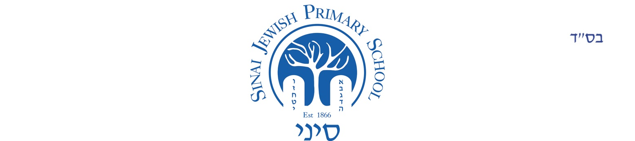

Home/School Agreement

‘Inspiring Individual Excellence’

Name of child:

Date of birth:

At Sinai, we recognise each child as an individual, and aim to give all children every opportunity to realise their full potential. This involves a partnership between parents/guardians, staff, pupils and governors. The school provides a happy, caring and purposeful atmosphere where children are encouraged to be independent and develop their natural talents and abilities. We have high standards of behaviour based on respect for others. We aim to instil a commitment to modern orthodox Judaism and love of our Jewish ethos, culture and the State of Israel. We strive to develop our pupils as responsible individuals to be confident, articulate, caring and enthusiastic and to foster respectful behaviour, tolerance of others and awareness of the wider world. We hope when they leave Sinai they will have a passion for learning, be a credit to themselves, their parents and the school and be happy, and proud of their Jewish and British cultures and heritage. We are committed to safeguarding and promoting the welfare of all children in our school. All adults working or volunteering in school have a valid DBS clearance.

The aim of this agreement is to spell out what we expect of our pupils and their parents, and what they in turn can expect from us. We therefore ask all parents and children to sign up to our Home/School Agreement.

The Responsibilities of the School

At Sinai, the staff will aim to:

- provide a secure, happy and stimulating learning environment where our Jewish faith leads our way, encouraging your child to develop spiritual awareness and understand their role in the wider community and to become responsible British citizens;
- know your child as an individual. This means where they are in their learning, how they learn and the best way to support them;
- help your child to acquire skills in Reading, Writing, Maths, Science and all the areas identified as necessary and important by Sinai and the National Curriculum and to set regular and appropriate homework for your child in line with Sinai’s Homework Policy;
- encourage your child to think for themselves, develop their own opinions, and to organise their time and resources effectively, with support from the teacher;
- allow your child safe and secure use of the Internet through a combination of site filtering, supervision and by fostering a responsible attitude;
- encourage confidence, self-esteem and positive relationships with other children and adults and to abide by Sinai’s Behaviour Policy, ensuring a safe, caring environment for all;
- form positive relationships with the parents of the children they teach, so that there is a shared understanding. Children learn best when school and home work together for the benefit of the child;
- keep you informed about your child’s progress and behaviour, as well as their termly curriculum.

REMEMBER: Every child is different and the teacher is trying to do their best in all the ways mentioned above for up to 30 children every day.

Signed: ………………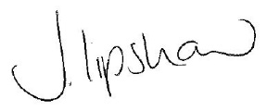…………………………………………… Juliette Lipshaw, Headteacher
On behalf of Sinai Jewish Primary School

Date: …………21 February 2020………………………..
The Responsibilities of the Parents/Guardians
All parents/guardians will:
- accept and respect the school’s aims and Jewish values, positively supporting the school;
- ensure that your child attends school every day during term time, unless there is a good reason for absence (e.g. illness), on time, prepared and ready to learn. Children need to concentrate to learn, and therefore need to be fit and well, to have had enough sleep and to have eaten;
- support Sinai’s policies and guidelines including Behaviour, Homework, Special Educational Needs and Attendance policies and the dress code;
- ensure your child is wearing clothing in line with school uniform recommendations and that their PE kit is in school for each sports lesson;
- encourage good behaviour, politeness, self-respect and respect for others and their property;
- attend parents meetings and open evenings to discuss your child’s progress with the class teacher and support your child with their homework;
- keep us informed of where to contact you in case of emergency;
- Promptly inform the school of any concerns or problems that may affect your child’s learning, behaviour or happiness at school, including special or medical needs;
- support Sinai in the teaching of safe and secure Internet use at home;
- Support Sinai with disciplinary sanctions;
- Conduct themselves in a respectful way within the school grounds.

Name of Parent/Guardian: ……………………………………………………..

Signed: …………………………………………………………… Date ………………………………

Name of Parent/Guardian: ……………………………………………………..

Signed: …………………………………………………………… Date ………………………………

The Responsibility of the Child

I will try my best to:

- follow our school, class and playground rules and set a good example to others;
- do all my classwork and homework to the best of my ability, asking questions when I don’t understand;
- listen when asked and wait my turn, to work hard, not waste time and allow other children to do the same;
- take responsibility for my own actions;
- respect the feelings of others and behave in a safe and responsible way and learn to sort out difficulties without using physical or emotional violence;
- be kind, helpful, forgiving and honest;
- take care of my own belongings and the property of others;
- use the Internet safely as I have been taught in class.

Signed in class by the child, when in each year as follows:

Reception .……………………………………………………………………………………………………………………………………………………

Keystage 1 .……………………………………….…………………………….…………………………………………………………………..………..

Keystage 2 ………………………………….……………………………………..………………………………………………………………..………..

The Responsibilities of the Governing Body:
The Governing Body will ensure:
- that school policies provide care for every pupil;
- that funding received by the school will be used responsibly to provide the curriculum and support services;
- that it meets regularly to carry out its function;
- that Governors will visit the school regularly.

Signed: …………………………………………………………… Rosalind Goulden, Chair of Governors
On behalf of the Governing Body

Date: ………21 February 2020…………………………..

