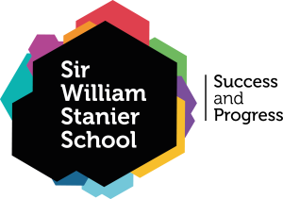 | NHS MENTAL HEALTH HELPLINE  0300 303 3972

The Local NHS Trust, Cheshire and Wirral Partnership (CWP), has launched a new mental health helpline for residents of Cheshire West, Cheshire East and Wirral.
Open 24 hours a day, seven-days a week, it is open to people of all ages including children and young people who require urgent mental health support.
What to do if you need urgent mental health help:
- Please call 0300 303 3972 and the dedicated local NHS staff will support you to access the help you need.

- The helpline is open 24 hours a day, seven days a week and is open to people of all ages – including children and young people.

- The helpline is now the first place to seek mental health support – it is operated by people in your local area who will know how best to help you. If you call NHS 111 you may have to wait longer for help and will be re-directed to this local service – so please use this number.

- Please note, A&E and 999 are not the best places to get help for the majority of mental health problems – call 0300 303 3972 to be directed to the best local service to support you.

- You should still call 999 or go to A&E if you have an immediate, life-threatening emergency requiring mental or physical health assistance.

- For non-urgent help and general wellbeing advice, the CWP website contains information and links to resources to support people with anxiety, low mood, and worries relating to the current Covid-19 pandemic www.cwp.nhs.uk

- For children and young people there is also a dedicated website MyMind.org.uk

