

Special Educational
Needs and Disabilities (SEND) Policy

Sir William Stanier School


Approved by: | R.Davies | Date: 08/01/2026
Last reviewed on: | January 2026
Next review due by: | September 2026

Contents

Aims and objectives of this policy……………………………………………………………………….……3

Vision and Principles…………………………………………………………………………………………….3

Legislation and guidance………………………………………………………………………………………..3
- Inclusion and equal opportunities……………………………………………………………………………..4
- Definitions………………………………………………………………………………………………………….4
- Our approach to supporting children with emerging difficulties and SEN…………………………….6
- Roles and responsibilities………………………………………………………………………………………8
- SEN Information Report……………………………………………………………………..…………………11
- Our approach to providing SEND support………………………………………………………………….11
- Expertise and training of staff ………………………………………………………………..………………13
- Links with external professional agencies………………………………………………….………………13
- Admission and accessibility arrangements………………………………………………………………..14
- Complaints about SEND provision…………………………………………………………………………..14
- Monitoring and evaluation arrangements……………………………………………..……………………14
- Links with other policies and documents…………………………………………….…………………….15
- Glossary of acronyms…………………………………………………………………………………………….15

1. Aims and objectives of this policy
Our special educational needs and disabilities (SEND) policy aims to:
- Ensure our school fully implements national legislation and guidance regarding pupils with SEND
- Set out how our school will:
- Support and make provision for pupils with special educational needs and disabilities
- Provide pupils with SEND access to all aspects of school life so they can engage in the activities of the school alongside pupils who do not have SEND
- Help pupils with SEND fulfil their aspirations and achieve their best
- Help pupils with SEND become confident individuals living fulfilling lives
- Help pupils with SEND make a successful transition into adulthood
- Communicate with pupils with SEND and their parents or carers and involve them in discussions and decisions about support and provision for the pupil
- Communicate with, and involve, pupils with SEND and their parents or carers in discussions and decisions about support and provision for the pupil
- Explain the roles and responsibilities of everyone involved in providing for pupils with SEND

2. Vision and principles
Our aim is for every pupil to fulfil their potential in all areas of development. We achieve this via early needs identification and providing support as necessary in response to these needs. We believe that all teachers are teachers of SEND, and we place parental and student voice at the heart of everything we do to ensure a truly collaborative and inclusive approach.
Principles:
- To identify, at the earliest opportunity, barriers to learning and participation.
- To enable all children, whatever their special educational need or disability, to receive appropriate educational provision through a broad, balanced curriculum.
- To involve parents/carers in planning and supporting at all stages of their child’s development.
- To ensure that pupils with SEND have a voice and are given opportunities to express an opinion and that this opinion will be taken into account in matters affecting them.
- To work closely with external support agencies, where appropriate, to support the needs of individual pupils.

3. Legislation and guidance
This policy is based on the statutory Special Educational Needs and Disability (SEND) Code of Practice (2015) and the following legislation:
- Part 3 of the Children and Families Act 2014, which sets out schools’ responsibilities for pupils with SEND
- The Special Educational Needs and Disability Regulations 2014, which set out local authorities’ and schools’ responsibilities for education, health and care (EHC) plans, SEN co-ordinators (SENCOs) and the special educational needs (SEN) information report
- The Equality Act 2010 (section 20), which sets out the school’s duties to make reasonable adjustments for pupils with disabilities
- The Public Sector Equality Duty (section 149 of the Equality Act 2010), which set out the school’s responsibilities to eliminate discrimination, harassment and victimisation; and advance equality of opportunity and foster good relations between people who share a protected characteristic (which includes having a disability) and those who don’t share it
- The Governance Handbook, which sets out governors’ responsibilities for pupils with SEND
- The School Admissions Code, which sets out the school’s obligation to admit all pupils whose education, health and care (EHC) plan names the school, and its duty not to disadvantage unfairly children with a disability or with special educational needs
This policy also complies with our funding agreement and articles of association.

4. Inclusion and equal opportunities
At our school we strive to create an inclusive teaching environment that offers all pupils, no matter their needs and abilities, a broad, balanced and challenging curriculum. We are committed to offering all pupils the chance to thrive and fulfil their aspirations. Our school policies can be found here- School Policies | Sir William Stanier School
We will achieve this by making reasonable adjustments to teaching, the curriculum and the school environment to make sure that pupils with SEND are included in all aspects of school life.
At our School we recognise the need to communicate with agencies that provide support for vulnerable children. This group includes: looked after children, care leavers, children in alternative provision, children who are in hospital, children of service personnel and children in youth custody. Our aim is that vulnerable children receive effective joined-up provision that can help them achieve good outcomes. We support integrated working and record sharing in line with the specific guidelines given in chapter 10 of the Code of Practice.

5. Definitions
5.1 Special educational needs
A pupil has SEN if they have a learning difficulty or disability that requires special educational provision to be made for them.
They have a learning difficulty or disability if they have:
- A significantly greater difficulty in learning than most others of the same age, or
- A disability which prevents or hinders them from making use of facilities of a kind generally provided for others of the same age in mainstream schools
Special educational provision is educational or training provision that is additional to, or different from, that made generally for other children or young people of the same age by mainstream schools.
5.2 Disability
Pupils are considered to have a disability if they have a physical or mental impairment that has a substantial and long-term adverse effect on their ability to do normal daily activities.
Many children and young people who have a Special Educational Need (SEN) may also have a disability under the 2010 Equality Act. Children and young people with a disability do not necessarily have a SEN, but there is a significant overlap between disabled children and young people and those with SEN. Where a disabled child or young person requires special educational provision they will also be covered by the SEN definition in this policy.
The school will make reasonable adjustments for pupils with disabilities, so that they are not at a substantial disadvantage compared with their peers.
5.3 Medical conditions
At Sir William Stanier School we recognise that students at school with medical conditions should be properly supported so that they have full access to education, including school trips and physical education. Having a medical condition does not mean a child automatically requires special educational provision to be made for them however some children with medical conditions may be disabled and where this is the case the school will comply with its duties under the Equality Act 2010. Some students with medical conditions may have SEN or may have an Education, Health and Care Plan (EHC) which brings together health and social care needs, as well as their special educational provision. The school’s policy on medical needs and medication can be found here- School Policies | Sir William Stanier School
5.4 The 4 areas of need
The needs of pupils with SEND are grouped into 4 broad areas. Pupils can have needs that cut across more than 1 area, and their needs may change over time.
Interventions will be selected that are appropriate for the pupil’s particular area(s) of need, at the relevant time.
Area of need
Communication and interaction | Pupils with needs in this area have difficulty communicating with others. They may have difficulty understanding what is being said to them, have trouble expressing themselves, or do not understand or use the social rules of communication.  Pupils who are on the autism spectrum often have needs that fall in this category.
Cognition and learning | Pupils with learning difficulties usually learn at a slower pace than their peers.  A wide range of needs are grouped in this area, including:  - Specific learning difficulties, which impact 1 or more specific aspects of learning, such as: dyslexia, dyscalculia and dyspraxia  - Moderate learning difficulties  - Severe learning difficulties  - Profound and multiple learning difficulties, which is where pupils are likely to have severe and complex learning difficulties as well as a physical disability or sensory impairment
Social, emotional and mental health | These needs may reflect a wide range of underlying difficulties or disorders. Pupils may have:  - Mental health difficulties such as anxiety, depression or an eating disorder  - Attention deficit disorder, attention deficit hyperactive disorder or attachment disorder  These needs can manifest in many ways, for example as challenging, disruptive or disturbing behaviour, or by the pupil becoming withdrawn or isolated.
Sensory and/or physical | Pupils with these needs have a disability that hinders them from accessing the educational facilities generally provided.  Pupils may have:  - A sensory impairment such as vision impairment, hearing impairment or multi-sensory impairment  - A physical impairment  These pupils may need ongoing additional support and equipment to access all the opportunities available to their peers.

6. Our approach to supporting children with emerging difficulties and SEN
Identifying pupils with SEND, assessing their needs and deciding on the level of support they require
We assess each pupil’s current skills and levels of attainment when they start at the school as a normal part of our provision. We use information from previous settings and Key Stages, where appropriate. We also consider any evidence that the pupil may have a disability and if so, what reasonable adjustments the school may need to make.
Class teachers will regularly assess the progress of all pupils and identify any whose progress:
- Is significantly slower than that of their peers starting from the same baseline
- Fails to match or better their previous rate of progress
- Fails to close the attainment gap between them and their peers
- Widens the attainment gap
This may include progress in areas other than attainment, for example, wider development or social needs.
The school has adopted an Early Identification Pathway:
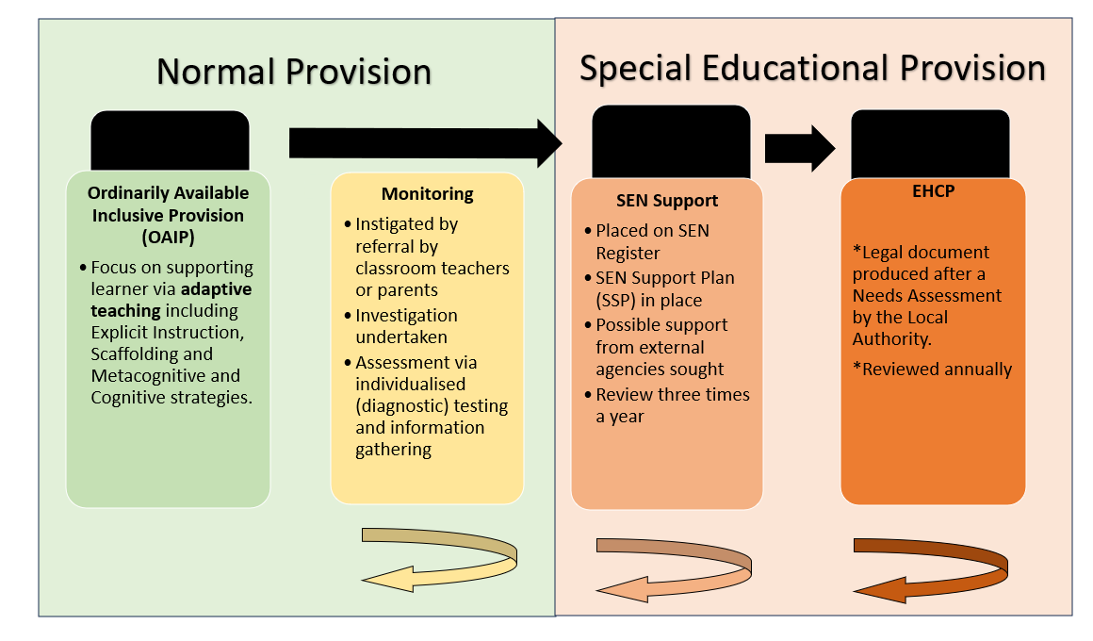
Ordinarily Available Inclusive Provision (OAIP)
When teachers identify an area where a pupil is making slow progress, they will support the pupil’s area of weakness with adaptive, high-quality teaching. At this stage children are not classified as having a Special Educational Need. Most children’s needs can be met with this type of adaptive teaching support.
Monitoring
If progress does not improve, the teacher will raise the issue with the school’s Special Educational Needs Coordinator (SENDCo). At this stage further assessment will take place (this may include diagnostic assessments including YARC, WRAT5, Boxall Profile etc, and/or the gathering of information from the teacher and other adults). These emerging needs are monitored (over a term) to ascertain whether or not the child’s lack of progress is due to a Special Education Need. At this stage pupils are not classified as having a Special Educational Need but assessment is taking place to consider whether the child may require special educational provision.
Slow progress and low attainment will not automatically mean a pupil is recorded as having SEN. Other potential short-term causes of impact on performance or behaviour will also be considered, such as attendance, bereavement or bullying. Staff will take particular care in identifying and assessing SEN for pupils whose first language is not English.
When deciding whether the pupil needs special educational provision, we will start with the desired outcomes, including the expected progress and attainment, and the views and the wishes of the pupil and their parents. We will use this to determine the support that is needed and whether we can provide it by adapting our normal, core offer of support, or whether something different or additional is needed.
SEN Support
As per our definition of SEN a child has Special Educational Needs if they require support that it additional to, or different from, our normal provision.
If a pupil is joining the school, and:
- Their previous setting has already identified that they have SEN;
- They have an education, health and care plan (EHCP);
Then the school will work in a multi-agency way to make sure we get relevant information before the pupil starts at school, so that support can be put in place as early as possible
Pupils receiving SEN provision will have their name placed on the school’s SEND register. These pupils have needs that can be met by the school through the graduated approach (see section 9).
The provision for pupils with SEN is funded through the school’s notional SEND budget. On the census these pupils will be marked with the code K.
Where the pupil’s needs cannot be adequately met with in-house expertise, staff will consider involving an external specialist as soon as possible.
Education, Health and Care (EHC) Plan
Pupils who need more support than is available through the school’s SEN provision may require an EHC plan. The plan is a legal document that describes the needs of the pupil, the provision that will be put in place, and the outcomes sought.
The provision for these pupils will be funded from the school’s notional SEND budget, and potentially partially from the LA (from the high-level needs funding block of the dedicated schools grant). Education, health and care plans (EHCPs) are created by the Local Authority following a Needs Assessment that considers a range of evidence that a child’s needs cannot be met from within school resources.
On the census these pupils will be marked with the code E.

7. Roles and responsibilities
7.1 The SENDCo
The SENDCo at our school is Rebecca Ellis. The Assistant SENDCo at our school is Lydia Chapleo. Their contact details are as follows:
SENDCo- rebecca.ellis@sws.cheshire.sch.uk
Assistant SENDCo- lydia.chapleo@sws.cheshire.sch.uk
Both can be contacted via telephone at the end of the school day. The school phone number is 01270 660880.
They will:
- Inform any parents that their child may have SEN and then liaise with them about the pupil’s needs and any provision made
- Work with the headteacher and SEN governor to determine the strategic development of the SEND policy and provision in the school
- Have day-to-day responsibility for the operation of this SEND policy and the co-ordination of specific provision made to support individual pupils with SEN, including those who have EHC plans
- Liaise with teachers and the school’s Mental Wellbeing Lead, Attendance Lead and Safeguarding Lead to develop a full understanding of a child’s needs and ascertain whether special educational provision is required to meet these needs.
- Provide professional guidance to colleagues and liaise and work with staff, parents, and other agencies to make sure that pupils with SEN receive appropriate support and high-quality teaching
- Work alongside the Deputy Headteacher for Quality of Education and the Assistant Headteacher for Inclusion to advise on the use of adaptive practice to providing SEN support and differentiated teaching methods appropriate for individual pupils
- Advise on the deployment of the school’s delegated budget and other resources to meet pupils’ needs effectively
- Be a point of contact for external agencies, especially the local authority (LA) and its support services, and work with external agencies to ensure that appropriate provision is provided
- Liaise with potential next providers of education to make sure that the pupil and their parents are informed about options and that a smooth transition is planned
- When a pupil moves to a different school or institution: Make sure that all relevant information about a pupil’s SEN and the provision for them are sent to the appropriate authority, school or institution in a timely manner
- Work with the headteacher and school governors to make sure the school meets its responsibilities under the Equality Act 2010 with regard to reasonable adjustments and access arrangements
- Make sure the school keeps its records of all pupils with SEND up to date and accurate
- With the headteacher, monitor to identify any staff who have specific training needs regarding SEN, and incorporate this into the school’s plan for continuous professional development.
- Prepare and review information for inclusion in the school’s SEN information report and any updates to this policy
- With the headteacher and teaching staff, identify any patterns in the school’s identification of SEN, both within the school and in comparison with national data, and use these to reflect on and reinforce the quality of teaching
7.2 The Quality of Education
Research indicates that there are a range of approaches which teachers can employ to support learning and improve outcomes for all pupils, including those with Special Educational Needs. The Deputy Headteacher for Quality of Education and the Assistant Headteacher for Inclusion, alongside the SENDCo, will:
- Recommend appropriate teaching strategies to teachers that could be used to support children with emerging difficulties (i.e, when concerns initially emerge and are raised at the OAIP stage and during the information gathering stage of ‘Monitoring’)
- Liaise with the school’s SENDCo during the ‘Monitoring’ stage to ascertain whether a child’s needs can be met from the core offer of support or whether special educational provision is required.
7.3 The governing board
The governing board is responsible for making sure the following duties are carried out, though the duties can be delegated to a committee or an individual:
- Co-operate with the LA in reviewing the provision that is available locally and developing the local offer
- Do all it can to make sure that every pupil with SEND gets the support they need
- Make sure that pupils with SEND engage in the activities of the school alongside pupils who don’t have SEND
- Inform parents when the school is making special educational provision for their child
- Make sure that the school has arrangements in place to support any pupils with medical conditions
- Provide access to a broad and balanced curriculum
- Have a clear approach to identifying and responding to SEND
- Provide an annual report for parents on their child’s progress
- Record accurately and keep up to date the provision made for pupils with SEND
- Publish information on the school website about how the school is implementing its SEND policy, in a SEN information report
- Publish information about the arrangements for the admission of disabled children, the steps taken to prevent disabled children being treated less favourably than others, the facilities provided to assist access of disabled children, and the school’s accessibility plans
- Make sure that there is a qualified teacher designated as SENDCo for the school and that the key responsibilities of the role are set out, and monitor the effectiveness of how these are carried out
- Determine their approach to using their resources to support the progress of pupils with SEND
- Make sure that all pupils from year 8 until year 11 are provided with independent careers advice
7.4 The SEND link governor
The SEND link governor is Lisa Hodgkinson.
The SEND governor will:
- Help to raise awareness of SEND issues at governing board meetings
- Monitor the quality and effectiveness of SEND provision within the school and update the governing board on this
- Work with the headteacher and SENDCo to determine the strategic development of the SEND policy and provision in the school
7.5 The headteacher
The headteacher will:
- Work with the SENDCo and SEND link governor to determine the strategic development of the SEND policy and provision within the school
- Work with the SENDCo and school governors to make sure the school meets its responsibilities under the Equality Act 2010 with regard to reasonable adjustments and access arrangements
- Have overall responsibility for, and awareness of, the provision for pupils with SEND, and their progress
- Have responsibility for monitoring the school’s notional SEND budget and any additional funding allocated by the LA to support individual pupils
- Make sure that the SENDCo has enough time to carry out their duties
- Have an overview of the needs of the current cohort of pupils on the SEND register
- Advise the LA when a pupil needs an EHC needs assessment, or when an EHC plan needs an early review
- With the SENDCo, monitor to identify any staff who have specific training needs regarding SEN, and incorporate this into the school’s plan for continuous professional development
- With the SENDCo, regularly review and evaluate the breadth and impact of the SEND support the school offers or can access, and co-operate with the LA in reviewing the provision that is available locally and in developing the local offer
- With the SENDCo and teaching staff, identify any patterns in the school’s identification of SEN, both within the school and in comparison with national data, and use these to reflect on and reinforce the quality of teaching
7.6 Class teachers
Each class teacher is responsible for:
- Planning and providing high-quality teaching that is differentiated to meet pupil needs through a graduated approach
- The progress and development of every pupil in their class
- Working closely with any teaching assistants or specialist staff to plan and assess the impact of support and interventions, and consider how they can be linked to classroom teaching
- Working with the SENDCo to review each pupil’s progress and development, and decide on any changes to provision
- Ensuring they follow this SEND policy and the SEN information report
- Communicating with parents regularly to:
- Set clear outcomes and review progress towards them
- Discuss the activities and support that will help achieve the set outcomes
- Identify the responsibilities of the parent, the pupil and the school
- Listen to the parents’ concerns and agree their aspirations for the pupil
7.7 Parents or carers
Parents or carers should inform the school if they have any concerns about their child’s progress or development.
Parents or carers of a pupil on the SEND register will always be given the opportunity to provide information and express their views about the pupil’s SEND and the support provided. They will be invited to participate in discussions and decisions about this support. They will be:
- invited to take part in regular meetings and discussions to review the provision in place for their child. These may take place via phone, email, or in-person meetings, and may be formal, scheduled reviews or ad hoc conversations in response to changing needs as part of the graduated approach to SEND.
- Asked to provide information about the impact of SEN support outside school and any changes in the pupil’s needs
- Given the opportunity to share their concerns and, with school staff, agree their aspirations for the pupil
- Given an annual report on the pupil’s progress
The school will take into account the views of the parent or carer in any decisions made about the pupil.
7.8 The pupil
Pupils will always be given the opportunity to provide information and express their views about their SEND and the support provided. They will be invited to participate in discussions and decisions about this support.
This might involve the pupil:
- Explaining what their strengths and difficulties are
- Contributing to setting targets or outcomes
- Attending review meetings
- Giving feedback on the effectiveness of interventions
The pupil’s views will be taken into account in making decisions that affect them, whenever possible.

8. SEN information report
The school publishes an SEN information report on its website, which sets out how this policy is implemented in the school.
The information report will be updated annually and as soon as possible after any changes to the information it contains.
The SEN information report can be found here- SEND & Inclusion | Sir William Stanier School

9. Our approach to providing SEND support
9.1 Consulting and involving pupils and parents
At Sir William Stanier School, we value both pupil and parent voice and will communicate regular via email, over the phone or in person.
The school will put the pupil and their parents at the heart of all decisions made about special educational provision.
When we are aiming to identify whether a pupil needs special education provision, we will have an early discussion with the pupil and their parents. These conversations will make sure that:
- Everyone develops a good understanding of the pupil’s areas of strength and difficulty
- We take into account any concerns the parents have
- Everyone understands the agreed outcomes sought for the child
- Everyone is clear on what the next steps are
Notes of these early discussions will be added to the pupil’s record and given to their parents.
We will formally notify parents if it is decided that a pupil will receive special educational provision.
9.2 The graduated approach to SEN support
Once a pupil has been identified as having SEN, we will take action to remove any barriers to learning, and put effective special educational provision in place. This support will be delivered through successive rounds of a 4-part cycle known as the graduated approach.

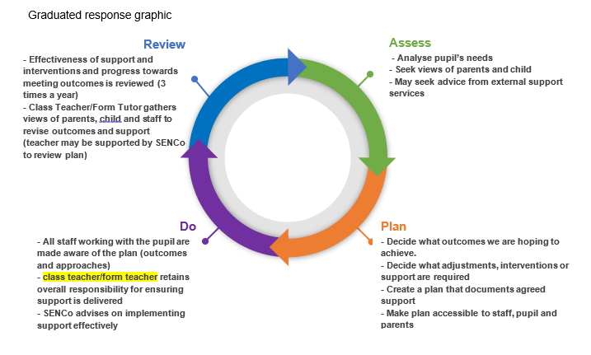

- Assess
The pupil’s class teacher and the SENDCo will carry out a clear analysis of the pupil’s needs. The views of the pupil and their parents will be taken into account. The school may also seek advice from external support services.
The assessment will be reviewed regularly to help make sure that the support in place is matched to the pupil’s need. For many pupils, the most reliable way to identify needs is to observe the way they respond to an intervention.
- Plan
In consultation with the parents and the pupil, the teacher and the SENDCo will decide which adjustments, interventions and support will be put into place, the expected outcomes, and a clear date for review.
All staff who work with the pupil will be made aware of the pupil’s needs, the outcomes sought, the support provided and any teaching strategies or approaches that are needed. This information will be recorded on our management information system, Arbor, and will be made accessible to staff in a Student Passport.
Parents will be made fully aware of the planned support and interventions, and may be asked to reinforce or contribute to progress at home.
- Do
The pupil’s subject teacher retains overall responsibility for their progress.
Where the plan involves group or 1-to-1 teaching away from the main class or subject teacher, the teacher still retains responsibility for the pupil. They will work closely with any teaching assistants or specialist staff involved, to plan and assess the impact of support and interventions and how they can be linked to classroom teaching.
The SENDCo will support the teacher in further assessing the pupil’s particular strengths and weaknesses, in problem solving and advising on how to implement support effectively.
- Review
The effectiveness of the support and interventions and their impact on the pupil’s progress will be reviewed in line with the agreed date.
We will evaluate the impact and quality of the support and interventions. This evaluation will be based on:
- The views of the parents and pupils
- The level of progress the pupil has made towards their outcomes
- The views of teaching staff who work with the pupil
The teacher and the SENDCo will revise the outcomes and support in light of the pupil’s progress and development, and in consultation with the pupil and their parents.
9.3 Evaluating the effectiveness of SEN provision
We evaluate the effectiveness of provision for pupils with SEN by:
- Tracking pupils’ progress, including using assessments to monitor progress over time
- Carrying out the review stage of the graduated approach in every cycle of SEN support
- Liaising with outside agencies that are involved to support with next steps
- Using pupil questionnaires
- Monitoring by the SENDCo
- Holding annual reviews for pupils with EHC plans
- Getting feedback from the pupil and their parents

10. Expertise and training of staff
Training will regularly be provided to teaching and support staff. The headteacher and the SENDCo will continuously monitor to identify any staff who have specific training needs and will incorporate this into the school’s plan for continuous professional development.

11. Links with external professional agencies
The school recognises that it may not be able to meet all the needs of every pupil. Whenever necessary the school will work with external support services such as:
- TLP SENDCo clusters
- Speech and language therapists
- Specialist teachers or support services
- Educational psychologists
- Occupational therapists, including the Sensory Processing Occupational Therapy Support Service
- General practitioners or paediatricians
- Child and adolescent mental health services (CAMHS)
- Education welfare officers
- Social services
- Cheshire East Autism Team

12. Admission and accessibility arrangements
12.1 Admission arrangements
Sir William Stanier School is part of The Learning Partnership and the academy’s Local Governing Board is the admissions authority. The admissions policy has been designed to comply with the Schools Admissions Code 2021 and all relevant legislation and can be found here- - School Policies | Sir William Stanier School. Places will be allocated on the basis of applications received through the Cheshire East admissions system.
Neither a student’s abilities or their learning difficulties feature in the admission of a student, unless they have a Statement or an Education, Health and Care Plan (EHCP) which names this school as the one they should attend. For further information see the school’s admission policy.
12.2 Accessibility arrangements
The school publishes an accessibility plan that covers how we intend to:
- Increase the extent to which disabled pupils can participate in the curriculum
- Improve the physical environment to enable disabled pupils, parents, staff and stakeholders to take better advantage of the education, benefits, facilities and services we provide
- Improve the availability of accessible information.
The school’s accessibility plan can be found here- School Policies | Sir William Stanier School.

13. Complaints about SEND provision
Where parents have concerns about our school’s SEND provision, they should first raise their concerns informally with the class teacher if at a subject-specific level, or the SENDCo if at a universal level. We will try to resolve the complaint informally in the first instance. If this does not resolve their concerns, parents are welcome to submit their complaint formally.
Formal complaints about SEND provision in our school should be made to the headteacher in the first instance. They will be handled in line with the school’s complaints policy, which is available here- School Policies | Sir William Stanier School
If the parent or carer is not satisfied with the school’s response, they can escalate the complaint. In some circumstances, this right also applies to the pupil themselves.
To see a full explanation of suitable avenues for complaint, see pages 246 and 247 of the SEN Code of Practice.

14. Monitoring and evaluation arrangements
14.1 Evaluating the effectiveness of the policy
We are constantly looking for ways to improve our SEND policy. We will do this by evaluating whether or not we are meeting our objectives set out in section 1.
We will evaluate how effective our SEND provision is with regards to:
- All staff’s awareness of pupils with SEND at the start of the autumn term
- How early pupils are identified as having SEND
- Pupils’ progress and attainment once they have been identified as having SEND
- Whether pupils with SEND feel safe, valued and included in the school community
- Comments and feedback from pupils and their parents
14.2 Monitoring the policy
This policy will be reviewed by the SENDCo every year. It will also be updated when any new legislation, requirements or changes in procedure occur during the year.
It will be approved by the full governing board.

15. Links with other policies and documents
This policy links various other policies and documents, all of which can be found here- School Policies | Sir William Stanier School

16. Glossary of acronyms
- SEND- Special Educational Needs and Disabilities
- SENDCo- Special Educational Needs Coordinator
- LA- Local Authority
- EHCNA- Education, Health & Care Needs Assessment
- EHCP- Education, Health & Care Plan
- OAIP- Ordinarily Available Inclusive Provision
- YARC- York Assessment for Reading Comprehension
- WRAT5- Wide Range Achievement Test, 5th Edition
- SEN Code K- SEN Support
- SEN Code E- EHCP

