Uniform
- Plain white collared shirt/blouse tucked into trousers or skirt.
- Plain charcoal grey, or black tailored trousers or tailored shorts or a skirt. Skirts must be at a respectful and appropriate length, they must be a standard school skirt and not lycra. No tight fitting (“slim/ skinny fit”) trousers are permitted (even though they can be found in some uniform sections of some stores). Jeans, tracksuit bottoms, leggings or jeggings are not permitted.
This: 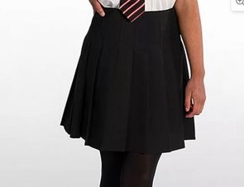 Not this:
These: 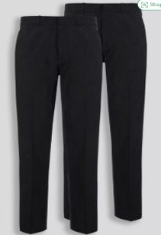 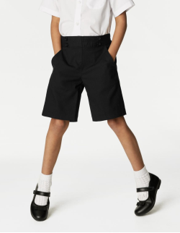
Not these: 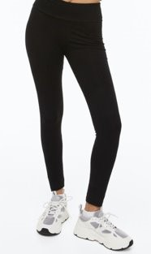 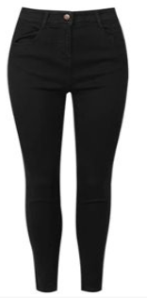 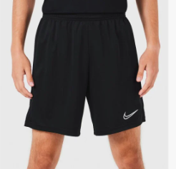
- A black SWS V-necked school jumper. No hoodies!! No other alternative, non-school jumpers.
This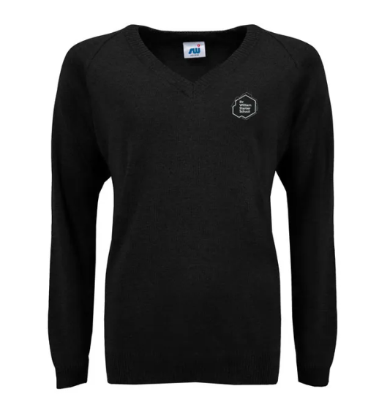

Not these 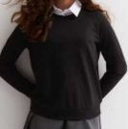 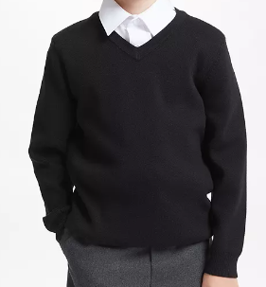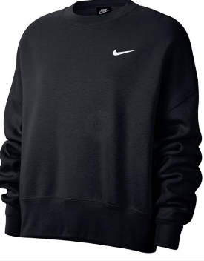

- SWS school tie which has a different colour for each year group. Please note that Year 7 and year 11 students will receive their ties on the first day back in September.

- Sensible plain black shoes or plain black trainers. No colours at all on the black trainers. No different coloured soles or different coloured brand logos. No dark grey trainers.
These: 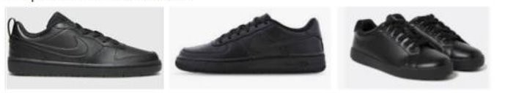

Not these: 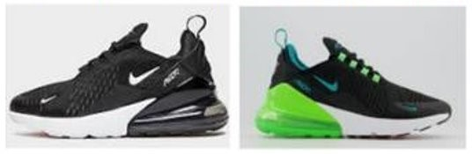
- Pierced ears should have stud earrings only, no hooped or dangly earrings. One small nose stud (not two) is permitted. No nose rings at all. No other piercings or jewellery are permitted; this includes rings, necklaces and bracelets.
This: 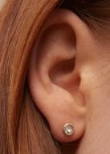 Not this: 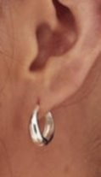

This: 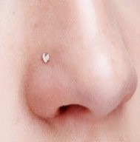 Not this:
Not this: 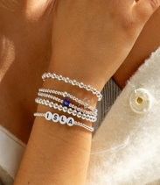

- Nail polish, acrylic or false nails are only permitted if they are natural in colour (no colours including white) and of an appropriate length, no more than half a centimetre of length beyond the finger tip.

This: 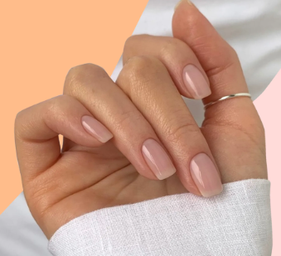 Not this: 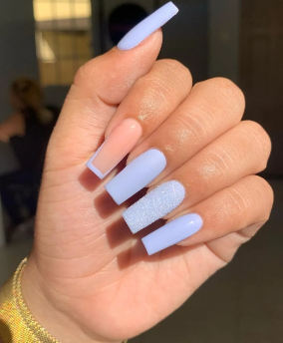

- Extreme hair colours or styles are not permitted.
- Subtle, natural looking make-up is permitted. No false eyelashes.

PE Kit

- PE Top
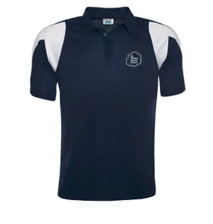
- Navy PE Shorts or skort
These: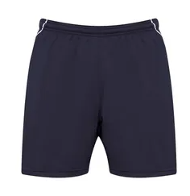 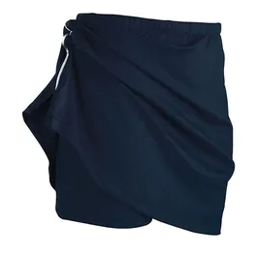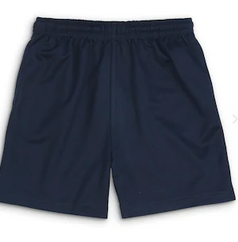

Not these: 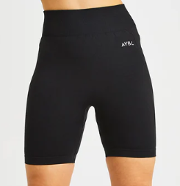 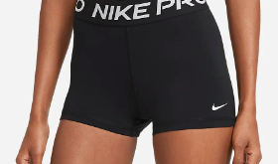

Bags/ Equipment
- Students are required to bring a bag to school with them daily to hold their homework, stationary and PE kit. The bag must be big enough to carry A4 sized items in it.
This: 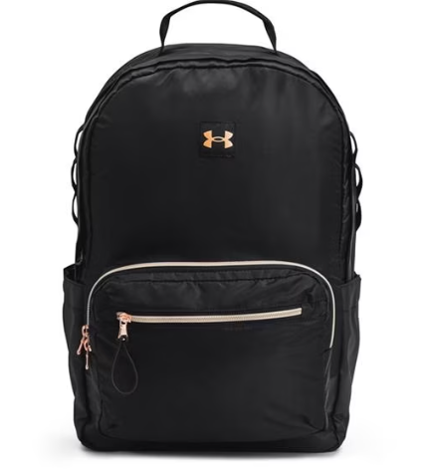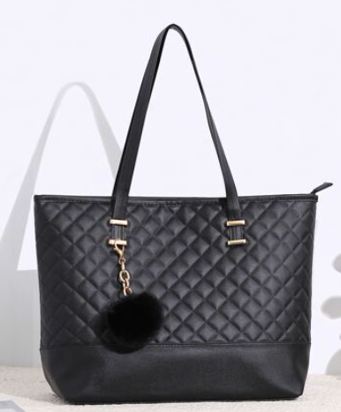Not these: 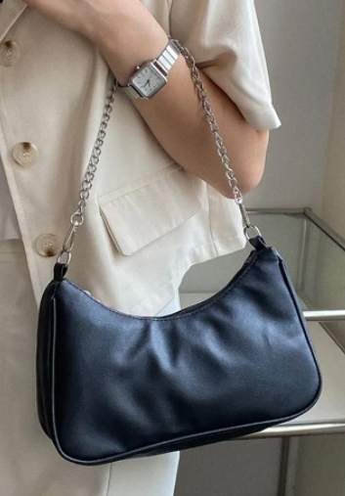 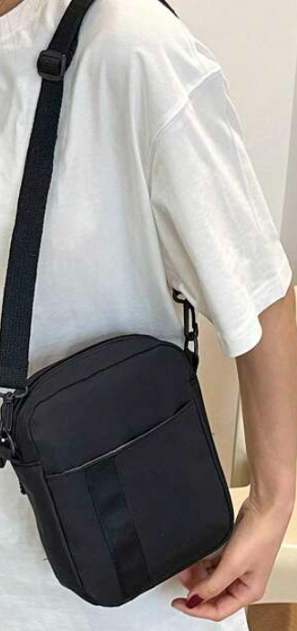

- Students are required to bring a pen, pencil, ruler and a highlighter with them as a minimum.

Phones
- Mobiles phones should not be visible at any time on the school site. This includes having phones tucked into waistbands of skirts/ trousers or in their hands. Phones should be switched off and in bags. If a mobile phone is seen then it will be confiscated as per the school mobile phone policy.

Branded uniform items can be purchased online at SWI:
https://www.swischoolwear.co.uk/school/sir-william-stanier-community-school-cu-0005528

Every year 7 student will receive a voucher enabling you to purchase one school jumper, one school tie plus a PE kit (top and bottoms).

