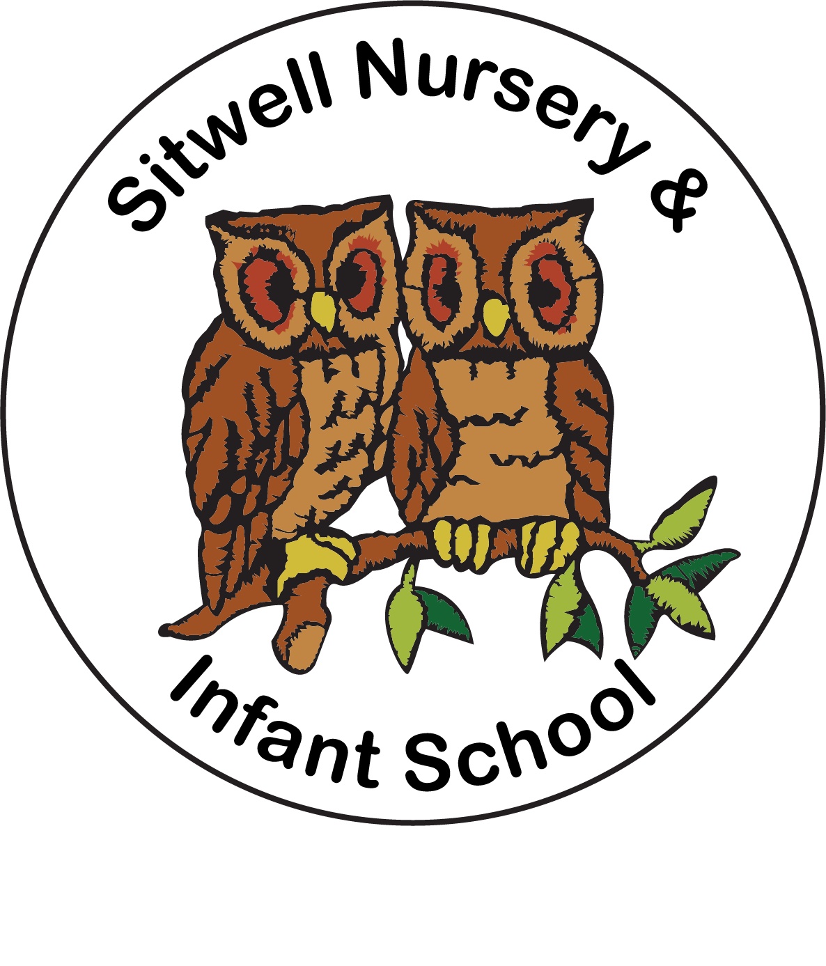

Consultation on a proposal for Sitwell Nursery & Infant School to convert to Academy status and join a Multi-Academy Trust (MAT)

Name ____________________________________________________________

Relationship to school ______________________________________________

Feedback and/or question
___________________________________________________________________________________________________________________________________________________________________________________________________________________________________________________________________________________________________________________________________________________________________________________________________________________________________________________________________________________________________________________________________________________________________________

Thank you for responding to this consultation.

Please return completed responses to office@sitwellinfantschool.co.uk

