Literacy | 08 | Comprehension  Demonstrate understanding of what has been read to them by retelling stories and narratives using their own words and recently introduced vocabulary. Anticipate (where appropriate) key events in stories. Use and understand recently introduced vocabulary during discussions about stories, nonfiction, rhymes and poems and during role play.
Literacy | 09 | Word Reading  Say a sound for each letter in the alphabet and at least 10 digraphs. Read words consistent with their phonic knowledge by sound-blending. Read aloud simple sentences and books that are consistent with their phonic knowledge, including some common exception words.
Literacy | 10 | Writing  Write recognisable letters, most of which are correctly formed. Spell words by identifying sounds in them and representing the sounds with a letter or letters. Write simple phrases and sentences that can be read by others.
Mathematics | 11 | Number  Have a deep understanding of number to 10, including the composition of each number. Subitise (recognise quantities without counting) up to 5. Automatically recall (without reference to rhymes, counting or other aids) number bonds up to 5 (including subtraction facts) and some number bonds to 10, including double facts.
Mathematics | 12 | Numerical patterns  Verbally count beyond 20, recognising the pattern of the counting system. Compare quantities up to 10 in different contexts, recognising when one quantity is greater than, less than or the same as the other quantity. Explore and represent patterns within numbers up to 10, including evens and odds, double facts and how quantities can be distributed equally.
Understanding the World | 13 | People, Communities & Culture  Describe their immediate environment using knowledge from observation, discussion, stories, non-fiction texts and maps. Know some similarities and differences between different religious and cultural communities in this country, drawing on their experiences and what has been read in class. Explain some similarities and differences between life in this country and life in other countries, drawing on knowledge from stories, non-fiction texts and (when appropriate) maps.
Understanding the World | 14 | The Natural World  Explore the natural world around them, making observations and drawing pictures of animals and plants. Know some similarities and differences between the natural world around them and contrasting environments, drawing on their experiences and what has been read in class. Understand some important processes and changes in the natural world around them, including the seasons and changing states of matter.
Understanding the World | 15 | Past & Present  Talk about the lives of the people around them and their roles in society. Know some similarities and differences between things in the past and now, drawing on their experiences and what has been read in class. Understand the past through settings, characters and events encountered in books read in class and storytelling.
Expressive Arts & Design | 16 | Creating with Materials  Safely use and explore a variety of materials, tools and techniques, experimenting with colour, design, texture, form and function. Share their creations, explaining the process they have used. Make use of props and materials when role playing characters in narratives and stories.
Expressive Arts & Design | 17 | Being Imaginative  Invent, adapt and recount narratives and stories with peers and their teacher. Sing a range of well-known nursery rhymes and songs. Perform songs, rhymes, poems and stories with others, and (when appropriate) try to move in time with music.
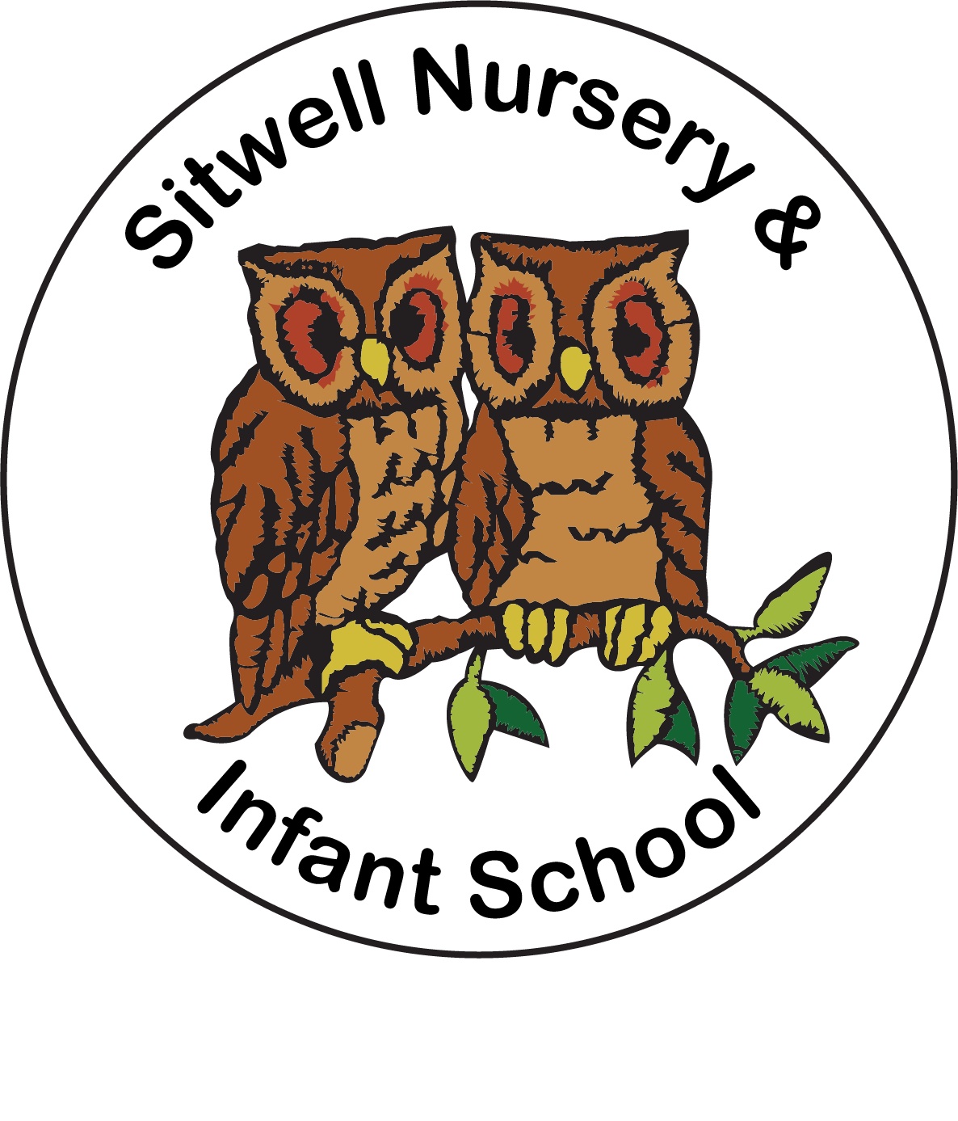

End of Year Expectations for Foundation 2

This booklet provides information for parents and carers on the end of year expectations for children in our school. The Early Years Framework outlines these expectations as being the minimum requirements your child must meet in order to ensure continued progress.

The EYFS curriculum is progressive and class teachers work through the Development Matters document to support children to reach the Early Learning Goals. Any extra support you can provide in helping your children to achieve these is greatly valued. Please take a look at ‘What to expect… when’ for great ideas about activities to support your child’s development: https://foundationyears.org.uk/what-to-expect-when/

If you have any queries regarding the content of this booklet or want support in knowing how best to help your child, please talk to your child’s class teacher.

Communication and Language | 01 | Listening, Attention & Understanding  Listen attentively and respond to what they hear with relevant questions, comments and actions when being read to and during whole class discussions and small group interactions. Make comments about what they have heard and ask questions to clarify their understanding. Hold conversation when engaged in back-and forth exchanges with their teacher and peers.
Communication and Language | 02 | Speaking  Participate in small group, class and one-to-one discussions, offering their own ideas, using recently introduced vocabulary. Offer explanations for why things might happen, making use of recently introduced vocabulary from stories, non-fiction, rhymes and poems when appropriate. Express their ideas and feelings about their  experiences using full sentences, including use of past, present and future tenses and making use of conjunctions, with modelling and support from their teacher.
Physical Development | 03 | Gross motor skills  Negotiate space and obstacles safely, with consideration for themselves and others. Demonstrate strength, balance and coordination when playing. Move energetically, such as running, jumping, dancing, hopping, skipping and climbing.
Physical Development | 04 | Fine motor skills  Hold a pencil effectively in preparation for fluent writing – using the tripod grip in almost all cases. Use a range of small tools, including scissors, paintbrushes and cutlery. Begin to show accuracy and care when drawing.
Personal, Social and Emotional Development | 05 | Building Relationships  Work and play cooperatively and take turns with others. Form positive attachments to adults and friendships with peers. Show sensitivity to their own and to others’ needs
Personal, Social and Emotional Development | 06 | Managing Self  Be confident to try new activities and show independence, resilience and perseverance in the face of challenge. Explain the reasons for rules, know right from  wrong and try to behave accordingly. Manage their own basic hygiene and personal  needs, including dressing, going to the toilet and understanding the importance of healthy food choices.
Personal, Social and Emotional Development | 07 | Self Regulation  Show an understanding of their own feelings and those of others, and begin to regulate their behaviour accordingly. Set and work towards simple goals, being able  to wait for what they want and control their immediate impulses when appropriate.  Give focused attention to what the teacher says, responding appropriately even when engaged in activity, and show an ability to follow instructions involving several ideas or actions.

Your child’s achievement will be assessed against the
17 Early Learning Goals (ELGs) as set out in the Early Year Foundation Stage (EYFS) 2020 curriculum. Our judgements are made from observations of consistent, sustained and independent behaviour, in both child and adult initiated activities.

The ELGs set out the expected progress for children at the end of their time in Reception. Your child will have a grading of either ‘Emerging’ or ‘Expected’ for each of the ELGs:

Emerging | Will describe children who are still progressing towards the early learning goals.
Expected | Will describe an expected level of development for a child at the end of Foundation 2.

Please note within the new curriculum framework, there is no ‘Exceeding’ judgement.

Characteristics of Learning
In addition to assessing your child against the Early Learning Goals in Foundation 2, we also provide comments against their ‘Characteristics of Learning’. These are:
- Playing and Exploring
- Active Learning
- Creating and Thinking Critically

The Early Learning Goals are divided into two sections – the Prime areas – Personal, Social & Emotional Development, Communication & Language & Physical Development; and the Specific areas – Literacy, Numeracy, Understanding the World & Expressive Arts & Design.

