Sitwell Infant School
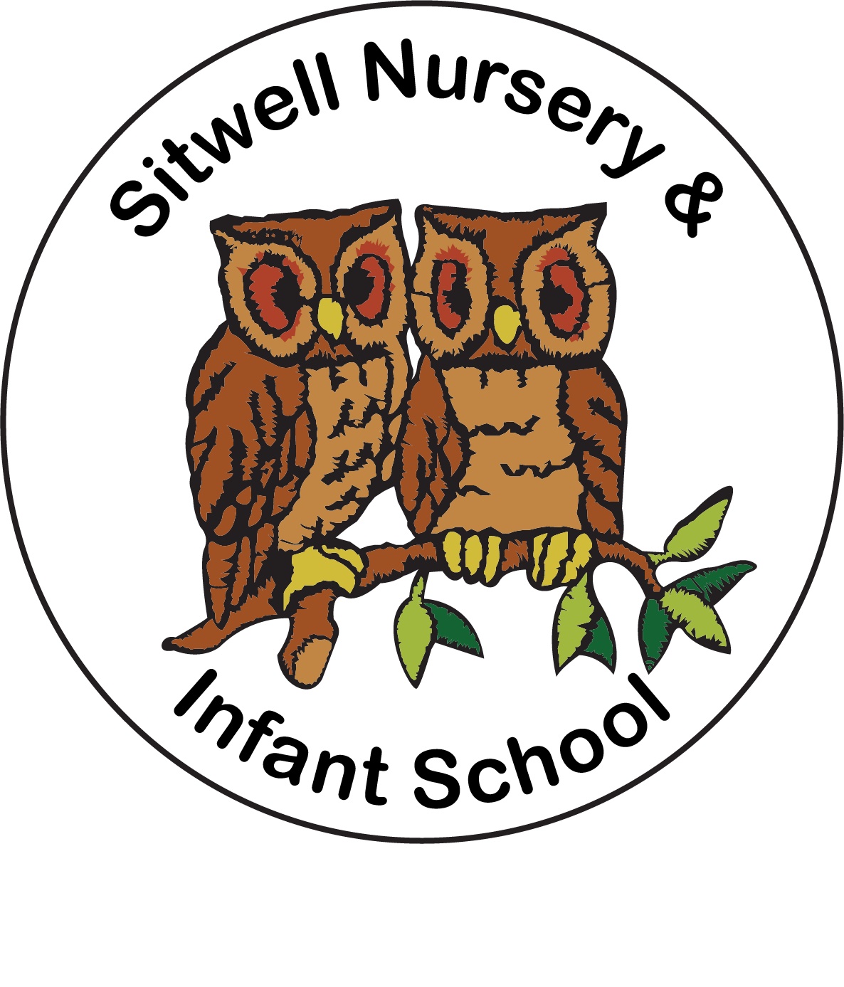

School Uniform Policy

Statement of intent
Sitwell Nursery & Infant School believes that a consistent school uniform policy is vital for:
- Promoting the ethos of a school.
- Providing a sense of belonging and identity.
- Setting an appropriate tone for education.

For the purposes of this policy, “uniform” includes the following elements of pupils’ appearance:
- Clothing, including the school uniform itself, variations of the school uniform such as PE kits, and other clothing worn at school, e.g. non-uniform.
- Hairstyles and headwear.
- Jewellery and other accessories.
- Cosmetics such as makeup and nail polish.

This policy lays out the measures the school has taken to ensure a consistent, fair and inclusive uniform policy, and to implement a uniform that reflects the needs of all children, and is affordable and the best value for money for the school and families.

We believe that children learn most effectively and achieve their best outcomes when they are comfortable, able to be themselves, and dressed in such a way that sets an appropriate tone for education.

In writing and updating this policy, the school will:
- Engage with parents and children.
- Consider how this policy might affect groups represented in the school, especially those who share protected characteristics as defined by the Equality Act 2010.
- Consider how comfortable the uniform will be for children.
- Take a sensible approach to allow for exceptions to be made, e.g. during adverse weather.
- Ensure that the uniform is suitable and safe for children who walk or cycle to school.
- Choose a PE kit which is practical, comfortable, appropriate to the activity involved and affordable.
- Ensure the policy is easy to access and understand.

Legal framework
This policy has due regard to all relevant legislation and statutory guidance including, but not limited to, the following:
- Education and Inspections Act 2006
- Education Act 2011
- Human Rights Act 1998
- Equality Act 2010
- The UK General Data Protection Regulation (UK GDPR)
- Data Protection Act 2018
- Education (Guidance about Costs of School Uniforms) Act 2021
- DfE ‘Cost of school uniforms’
- DfE ‘School Admissions Code’
- DfE ‘Developing school uniform policy’’
- Equality and Human Rights Commission ‘Preventing hair discrimination in schools’

This policy operates in conjunction with the following school policies:
- Complaints Procedures Policy
- Behaviour Policy

Roles and responsibilities
The governing board is responsible for:
- Establishing, in consultation with the Headteacher and school community, a practical and smart school uniform that accurately reflects the school’s vision and values.
- Ensuring that the school’s uniform is accessible and inclusive, and does not disadvantage any child by virtue of their protected characteristics or socio-economic status.
- Listening to the opinions and wishes of parents, children and the wider school community regarding changes to the school’s uniform.
- Ensuring that the school’s uniform is appropriate, practical, accessible and affordable.
- Demonstrating how best value for money has been achieved.
- Ensuring compliance with the DfE’s ‘Cost of school uniforms’ guidance.
- Ensuring compliance with obligations under the Human Rights Act 1998 and the Equality Act 2010.

The Headteacher is responsible for:
- Enforcing the school’s uniform on a day-to-day basis.
- Ensuring that teachers understand this policy and what to do if a child is in breach of the policy.
- Listening to the opinions and wishes of the school community in regard to the school’s uniform and making appropriate recommendations to the governing board.

Staff are responsible for:
- Ensuring that children dress in accordance with this policy at all times.
- Ensuring that children understand why having a consistent and practical school uniform is important, e.g. school identity.

Parents are responsible for:
- Providing their children with the correct school uniform as detailed in this policy.
- Informing the Headteacher if their child requires a more relaxed uniform policy for a period of time, including why.
- Ensuring that their child’s uniform is clean and presentable.

Children are responsible for:
- Wearing the correct uniform at all times, unless the Headteacher has granted an exemption.
- Looking after their uniform as appropriate.
- Understanding and respecting why a school uniform is important to the school, e.g. school identity and community.

Cost principles
The school is committed to ensuring that its school uniform is affordable and accessible to all children, and does not place an unreasonable financial burden on parents. The school will develop its uniform policy in relation to the following starting principles:
- The school will seek to ensure that the uniform is affordable. In so doing, the school will consider the total cost of school uniforms, considering all items of uniform or clothing parents will need to provide while their child is at the school.
- The use of branded uniform items will be minimised in accordance with the branded items section of this policy.
- The school will seek to ensure that uniform supplier arrangements give the highest priority to cost and value for money, including the quality and durability of the garment.
- The school will seek to ensure that second-hand uniforms are available for parents to acquire. Information on second hand uniforms and when they will be available to be purchased will be published on the school’s website.

Principles in practice
In accordance with the ‘School Admissions Code’, the Headteacher will ensure that the school’s uniform policy does not discourage parents from applying for a place for their child.

The school will assess the overall cost implications of its uniform policy regularly, including prior to making any changes to the school uniform. When evaluating whether costs are reasonable and proportionate, the school will take into account the opinions and situations of:
- Economically disadvantaged parents.
- Parents with multiple children who are, or will be in the future, children at the school.
- Parents of younger children, as they are likely to grow quickly and require new sets of uniform more frequently.
- Parents of children with protected characteristics that may impact their ability to access the uniform due to costs.
- Looked After Children (LAC) and Previously Looked After Children (PLAC).

The school will evaluate the cost of its uniform based on the overall collection of uniform items that parents would need to purchase for a child, rather than on the cost effectiveness of individual items; this will include consideration of the fact that parents will need to purchase multiples of certain items, e.g. shirts, to ensure their child can come to school in clean uniform every day.

The school will meet the DfE’s requirements and recommendations on costs and value for money. Care will be taken to ensure that school uniform is affordable for all current and prospective pupils, and that the best value for money is secured through reputable suppliers.

The school works with multiple suppliers to obtain the best value for money possible. Any savings negotiated are passed to parents where possible and does not enter into exclusive single supplier contracts or cash-back arrangements. More information on supplier processes can be found in the ‘School uniform supplier’ section of this policy.

The school will not amend uniform requirements regularly and will take the views of parents and children into account when considering any changes to school uniforms. The above consideration to cost will also apply to the school’s PE kit, as no pupil should feel unable to fully participate in PE or represent their class or the school because the PE kit is too expensive.

Branded items
As of September 2026, the school will limit its branded items of uniform and PE kit to three or fewer.

The school will confirm with parents and children which branded uniforms will be compulsory within the above limit and the specification of other optional branded items. All branded items, whether compulsory or optional, will be kept to a minimum and generic alternatives will be permitted.

Parents will be informed of any requirements for generic alternatives of non-branded uniform, e.g. the colour, shade, fabric or fit, so that these items can be purchased appropriately.

A branded item will be deemed compulsory if a child is required to have or wear the item:
- For general use at the school.
- To travel to or from the school.
- To take part in any lesson, club or activity facilitated by the school.

The limit on branded items will apply to any branded bags, and any items required only at particular times of the year, e.g. summer uniform. Where children are able to choose between different branded items, e.g. being able to choose between wearing branded skirts or branded trousers, this will only count as one item as the pupil is only required to have one of those items.

When making decisions about compulsory branded items, the school will consider how it can maintain the benefits of a branded item while also keeping costs low. This may involve using sew-on or iron-on labels or limited branded items to longer-lasting items such as ties, rather than items that need to be purchased more frequently or in larger quantities, e.g. shirts.
Sew-on or iron-on logos applied to uniform items will be considered branded items and included within the school’s prescribed limit of compulsory branded items.

All loaned or gifted branded items will be captured within the limit if they are required to be worn. Additional branded items may be loaned, given out, or made available for sale by the school; however, wearing such items will be optional.

Where optional branded items are made available, wearing an equivalent unbranded version of that item will also be permitted.

Generic unbranded items worn by children will still need meet the requirements of this policy and should be fit for purpose.

For sporting activities and competitions, children will not be required to wear branded items to take part in an activity, unless these items count towards the limit on branded items. The school may give out free additional branded items for sporting competitions and events.
If a child is unable to wear a loaned branded item, e.g. for a medical or health reason, the school will allow them to wear a suitable alternative.

Equality principles
The school takes its legal obligation to avoid discriminating against any protected characteristic unlawfully very seriously, and aims to ensure that the uniform policy is as inclusive as possible so that all children are supported to access a school uniform which is comfortable, suitable for their needs, and reflects who they are, while avoiding any direct or indirect discrimination on the basis of protected characteristics or socio-economic status.

The relevant protected characteristics are:
- Sex
- Sexual orientation
- Religion or belief
- Race (including colour, nationality, ethnic or national origin)
- Disability
- Gender reassignment
- Pregnancy

The school will work to ensure that school uniform’s cost does not disproportionately affect any children by ensuring that uniforms for all genders are as equal in price as possible and by adhering to the cost principles. The school will ensure that parents and children are consulted over any changes to school uniform, and that views and advice is sought specifically from children, and parents of children, who:
- Are transgender, including non-binary children.
- Have SEND and/or sensory needs.
- Are of a religious or cultural background that has dress requirements.

The school implements a gender-neutral uniform, meaning that children are not required to wear specific items based on their gender, and may wear any of the uniform items listed in the ‘School uniform’ section of this policy regardless of the legal sex recorded on the school’s records.

The school ensures that children who are required to follow certain dress requirements, e.g. by virtue of their membership of a particular religious or cultural group, are afforded flexibility to allow them to wear a uniform that adheres to their requirements as far as possible. The school endeavours to meet all requests for amendments to the uniform for these purposes; however, will ensure that the needs and rights of individual children are weighed against any health and safety concerns for the entire school community.

Parents’ concerns and requests regarding religious clothing are dealt with on a case-by-case basis by the Headteacher and governing board, and always in accordance with the school’s Complaints Procedures Policy.

The school ensures that the needs of children with SEND and/or sensory difficulties are considered in the uniform policy, e.g. ensuring soft, stretchy fabrics and avoiding intricate buttons or hard seams; however, where the needs of these children cannot be met in the standard uniform policy, individual adaptations to the uniform will be considered and permitted wherever possible.

Complaints and challenges
The school endeavours to resolve all uniform complaints and challenges locally and informally, in accordance with the school’s Complaints Procedures Policy. To make a complaint, parents should refer to the Complaints Procedures Policy and follow the stipulations outlined.

When a complaint is received, the school works with parents to arrive at a mutually acceptable outcome. Governors are willing to consider reasonable requests for flexibility to allow a child to accommodate particular social and cultural circumstances.

School uniform supplier
Our current school uniform supplier is:

Name of supplier: Price & Buckland
Address of supplier: Benneworth Close, Hucknall, Nottingham, NG15 6EL
Telephone: 0115 759 1416

The governing board will ensure that a written contract is in place with the supplier for branded items. The school will retender the uniform contract every five years, whether changes to the uniform are made or not. The governing board will be able to demonstrate how uniform is procured at the best value for money. The Headteacher will work to ensure that the items are procured as cheaply as possible without compromising on the quality, e.g. by requesting standard-style items from the supplier rather than more intricate and unique designs.

The school does not sign contracts with suppliers before requesting visualisations of proposed uniform, as well as fabric samples. Finding and consulting suppliers
If the school is considering changing its suppliers and seeks a list of available suppliers, it will consider the following options:
- Consulting an industry body, e.g. Schoolwear Association
- Researching local suppliers
- Consulting with other schools and networks
- Having informal discussions with potential suppliers to help determine the school’s own needs

If the school prepares to request bids from potential suppliers, it will consider the following elements:
- What products parents will need
- Existing contractual commitments
- Length of tender process
- The school’s evaluation process

The school will consider the environmental impact and sustainability of the uniform and how they are sourced.

Uniform assistance
The school supports vulnerable families in meeting the costs of uniforms. The budget for the school uniform assistance scheme comes from pupil premium funds. To claim assistance for school uniform, parents should be eligible for free school meals (FSM). Families who meet the criteria are contacted by school at the beginning of every school year and offered the free uniform package.

The school holds recycled school uniform in school for parents to access; the second hand rail is made available every morning at the school entrance. Recycled uniform is also made available to parents at regular times throughout the school year, such as at parents’ evenings and PTA events. Parents are invited to donate their child’s uniform when they no longer need it.

School uniform
School colours
Our school colours are as follows: Kingfisher green & navy blue

Clothing
The school uniform is as follows:

Item | Optional or required | Branding | How to acquire | Cost per item from school supplier
Regular school uniform
Kingfisher green sweatshirt or cardigan | Required | School logo on left-hand side | Branded sweatshirt and cardigan available from school supplier and recycled from school office (if stock). | £11.50 (sweatshirt)  £12.00 (cardigan)
Navy blue polo shirt | Required | School logo on left-hand side | Available from school supplier, recycled from school office and available from regular retailers. | £7.50
White polo shirt (5 pack) | Required | No branding | Available from School supplier, recycled from school office and available from regular retailers. | £10.00
Grey or black trousers, shorts or skirt | Required | No branding | Available recycled from school office and available from regular retailers. | N/A
Summer dress | Optional | No branding | Available recycled from school office and available from regular retailers. | N/A
Sensible, plain black shoes/trainers | Required | No branding | Available from regular retailers. | N/A
PE kit
Plain white t-shirt | Required | No branding | Available from school and regular suppliers. | £4.00
Plain black shorts | Required | No branding | Available from school and regular suppliers. | £4.50
|Kingfisher green PE hoodie | Required | School logo on left hand side | Children are provided these free of charge when they join school. | N/A
Accessories
School book bag | Required | School logo | Available from school supplier. | £4.00  (first book bag provided free of charge)
School PE bag | Required | School logo | Available from school supplier. | £4.50  (first PE bag provided free of charge)

Parents are responsible for ensuring their child brings their PE kit to school when needed.

Jewellery
Permitted jewellery that may be worn is:
- One pair of stud earrings.
- A smart and sensible wrist watch (smart watches are not permitted).

Jewellery is the responsibility of the child and not the school. Lost or damaged items will not be refunded. Smart watches are not permitted. Jewellery must not be worn on PE days. Parents are responsible for ensuring that children do not have their ears pierced at a time which would impact on a child being able to take part in PE lessons.
School bags
School expects that only school book bags and PE kit bags are used in school.

All children should bring their school book bag to school every day to carry books and equipment. We expect book bags to be taken home and brought back each day so that children can read their book at home and change it when needed. School PE kits should be in school on the days that children have their PE lessons. These are shared with parents via normal communication channels.

School book bags and PE kit bags are provided free of charge when children start school and a new one can be purchased when needed.

Adverse weather
All children are required to wear weather-appropriate clothing that covers as much of their skin as possible during adverse weather.

For hot temperatures, this includes wearing:
- Loose-fitting and lightweight shirts and dresses with sleeves and collars or covered necklines.
- Shorts or skirts.
- Children are advised not to wear any jumpers during heatwaves. If outside during break times, children not wearing sun-safe clothing are advised to stay in an area protected from the sun, or spare clothing is provided.

For cold temperatures, this includes wearing:
- Scarfs, gloves, coats and hats when they are outside.
- Warm jumpers that conform to the school’s uniform policy.
- Trousers, or thick tights with skirts.

Labelling
All children’s clothing and footwear should always be clearly labelled with their name by their parents or carers. Any lost clothing is taken to the lost property box in the school reception area. Items that are lost but are labelled are returned to the child when found.

All lost property is retained for one month and is disposed of or made available as recycled uniform if it is not collected within this time.

This policy will be reviewed biannually in the Autumn term.
Spring 2026

