**Friday 10th January 2025**

Dear Parent/Carers

Happy new year to you all and welcome back to term 3, we hope you all had a lovely break.

Are focus texts this term are:

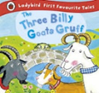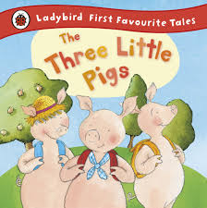

We will also be sharing lots of other stories, poems and texts. Please see this term’s curriculum web which gives more details about what children will be learning across all areas of learning and development.

**Reminders**

Please ensure that your child brings their water bottle to nursery every day. In line with the EYFS framework we ask that these contain **water only**. Please send your child to nursery in sensible clothing and footwear that is easy to take on and off, **please no lace up shoes/trainers or dungarees.** This supports children to become independent at dressing. Children should bring a spare change of clothes in a carrier bag which can stay in nursery. As we play outside everyday it is important that your child wears a warm, waterproof coat to nursery.

**Uniform**

We encourage all our nursery children to wear our uniform which is practical. This consists of a bottle green polo shirt, bottle green sweatshirt and sensible bottoms. Uniform with the Southbroom logo can be purchased from OHM or Scholars. A lot of parents have said that they like the uniform option because children do tend to get messy at nursery while they're having fun playing and learning. If you don't choose the uniform option, please send your child in clothing that is practical for nursery and that they can take on and off themselves.

**Book Bags**

Book bags need to be in school on a Friday so that we can change the children’s library books. These can then be kept at home until the following Friday.

**Diary Date**

Thursday 13th February Learning Journey sharing event. More details to follow.

**Sway**

This term will we will continue to keep you up dated with what children have been doing in preschool via the weekly Sway newsletter which is easily accessible on a mobile device.

**Wow Slips**

As you know as a school, we are no longer using Tapestry. With this in mind last term we introduced Wow Slips that can be filled in and added to your child’s learning journey. These slips are designed to share wow moments from home. This term there will be a basket of these slips placed just by the door, please help yourselves.

Thank you for your continued support, I hope you have all the information that you need for the term ahead. If you have any questions or queries, please do not hesitate to speak to me at either the beginning or end of the school day.

Yours faithfully,

The Nursery Team