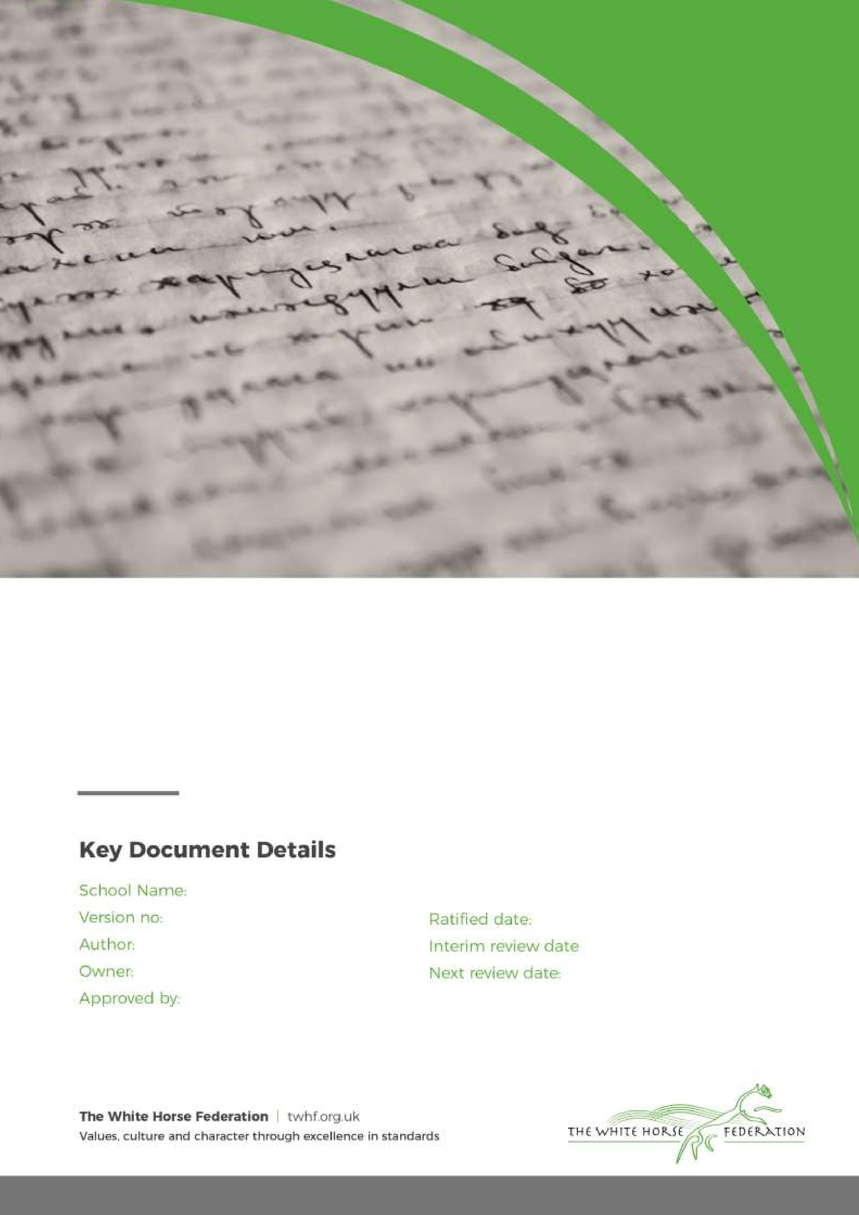

Anti-Bullying Policy

1

Amy Edwards

Amy Edwards

Head of School

September 2024

Southbroom Infant School

n/a
September 2023

Introduction
This Policy should be read in conjunction with the Policies for IT and Online Safety, Behaviour and Safeguarding Policies
Bullying is action taken by one or more children with the deliberate intention of hurting another child, either physically or emotionally.
The school deems bullying as;
• Deliberately hurtful behaviour
• Repeated often over a period of time.
As a school we recognise that bullying can take many forms, but several main types are:
• physical assault
• teasing
• making threats
• name calling
• Cyberbullying - bullying via mobile phone or online (for example via email, social networks and chat rooms on gaming platforms)
• Racist and Religious Bullying: A range of hurtful behaviour, both physical and psychological, that makes a person feel unwelcome, marginalised, excluded, powerless or worthless because of their colour, ethnicity, culture, faith community, national origin or national status;
• Sexual, Sexist and Transphobic Bullying: includes any behaviour, whether physical or non-physical, where sexuality is used as a weapon by boys or girls;
• Homophobic Bullying: targets someone because of their sexual orientation (or perceived sexual orientation);
• Disablist Bullying: targets a young person based on their disability, special needs or health needs. This can include manipulative bullying where a perpetrator forces the victim to act in a certain way or exploiting a certain aspect of the victim’s disability.
Aims and objectives
Pupils who attend our school have the right to learn in safety. We do not tolerate bullying of any kind and will challenge derogatory language and behaviour towards others.
▪ Pupils are made aware that the school does not tolerate any form of bullying (see Appendix 2)
▪ Pupils are reassured that any accusation of bullying will be looked in to.
▪ Staff members will record all instances of bullying on CPOMS.
▪ These incidents will be appropriate tagged to help the school monitor and track different forms of bullying so that the PSHE/RSE curriculum can be tailored to meet ongoing needs.
▪ The school will inform parents and carers of bullying via telephone or in face-to-face contact
▪ address every instance of bullying, in line with the Federation Anti-Bullying Policy, with each child or young person involved taking responsibility for his/her actions, apologising and agreeing to stop/change the behaviour causing concern
▪ will support children and young people to develop age-appropriate level e-literacy so that they are able to keep themselves safe on-line and report cyber-bullying. This policy aims to produce a consistent school response to any bullying incidents that may occur. We aim to make all those connected with the school aware of our opposition to bullying, and we make clear each person’s responsibilities with regard to the eradication of bullying in our school.
A flow chart has been produced to support staff in dealing with allegations of bullying; and to help communicate with parents/carers how incidents are dealt with (Appendix 1)
The role of Governors
The governing body supports the Principal in all attempts to eliminate bullying from our school. This policy statement makes it very clear that the governing body does not allow bullying to take place in our school, and that any incidents of bullying that do occur are taken very seriously and dealt with appropriately.
The governing body monitors any incidents of bullying reported to them and reviews the effectiveness of the school policy every 2 years. The governors require the Principal to keep accurate records of all incidents of formal and recognised bullying and to report to the governors on request about the effectiveness of school anti-bullying strategies. The governing body responds within ten days to any request from a parent to investigate incidents of bullying. In all cases, the governing body notifies the Principal and asks him/her to conduct an investigation into the case and to report back to a representative of the governing body.

The role of the Principal
It is the responsibility of the operational school principal to implement the school anti-bullying strategy and to ensure that all staff (both teaching and nonteaching) are aware of the school policy and know how to deal with incidents of bullying. The Principal reports to the governing body about the effectiveness of the anti-bullying policy on request.
The school Principal ensures that all children know that bullying is wrong, and that it is unacceptable behaviour in this school. The Principal draws the attention of children to this fact at suitable moments. For example, if an incident occurs, the Principal may decide to use assembly as a forum in which to discuss with other children why this behaviour was unacceptable, and why a pupil is in receipt of a consequence. “What is Bullying” posters are displayed around the school to help children identify what is/isn’t acceptable behaviour (Appendix 2)
The school Principal ensures that all staff receive sufficient” in house” support and development to be equipped to deal with all incidents of bullying.
The school Principal sets the school climate of mutual support and praise for success, so making bullying less likely. When children feel they are important and belong to a friendly and welcoming school, bullying is far less likely to be part of their behaviour.

The role of the teacher (including teaching assistants; trainees and support staff)
Teachers in our school take all forms of bullying seriously, and intervene to prevent incidents from taking place. They keep records of all incidents that happen in their class and that they are aware of in the school. When dealing with incidents which could be deemed as bullying, all staff are to follow the school’s “Approach to tackling incidents/ claims of bullying flow chart” (Appendix 1)
If teachers witness an act of bullying, they do all they can to support the child who is being bullied. If a child is being bullied over a period of time, then, after consultation with the Principal, the teacher informs the child’s parents.
If, as teachers, we become aware of any bullying taking place between members of a class, we deal with the issue immediately. This may involve counselling and support for the victim of the bullying, and consequence for the child who has carried out the bullying. We spend time talking to the child who has been bullied: we explain why the action of the child was wrong, and we endeavour to help the child change their behaviour in future. If a child is repeatedly involved in bullying other children, we inform the Principal and the special needs co-ordinator. We then invite the child’s parents into the school to discuss the situation. In more extreme cases, for example where these initial discussions have proven ineffective, the Principal may contact external support agencies such as children/social services.
Teachers attempt to support all children in their class and to establish a climate of trust and respect for all. By praising, rewarding and celebrating the success of all children, we aim to prevent incidents of bullying.

The role of parents
Parents who are concerned that their child might be being bullied, or who suspect that their child may be the perpetrator of bullying, should contact their child’s class teacher immediately. Parents have a responsibility to support the school’s anti-bullying policy and to actively encourage their child to be a positive member of the school.

Monitoring and review
This policy is monitored on a day-to-day basis by the school Principal, who reports to governors about the effectiveness of the policy on request.

Anti-bullying Policy
This anti-bullying policy is the governors’ responsibility and they review its effectiveness every 2 years. They do this by examining the school’s management of incident log (CPOMS) to see if a bullying issue has been recorded, by responding to parental requests and through the school Principal’s report to governors and by discussion with staff members.
Signed:

Amy Edwards
School Principal

Review date: 09/2024

Appendix 1
Southbroom Infant School; Approach to tackling incidents/ claims of bullying flow chart
STEP 1 STEP 2 STEP 3
Determine if it is a repeated incident or a potential first report bullying incident
Determine it is a one off incident
Determine it is a friendship group issue

Class teacher agrees with the potential victim the name of a trusted adult in the school that the pupil can talk to
Agree sanctions and monitor the situation
Hold a circle time session with all pupils involved

If it happens again?

Agree causes of the issue and resolution behaviours

Trusted adult undertakes a 1-2 week monitoring period to ascertain the nature of the issue. Parents will be kept notified

Record this in writing

If it happens again?
If a clear pattern emerges, and agreed plan of action will be put together with the alleged victim. This may include:
- Mediation
- Sanctions, inline with school behaviour policy
- External guidance and support
The monitoring will continue, with a review monthly. This will be logged on CPOMS

Any claims of bullying are taken seriously and are approached using the above flow chart. It is the responsibility of the class teacher to initiate actions in Step 1 and Step 2. Any actions taken in Step 1 and Step 2 should be recorded in CPOMS. The school principal should also be alerted.
Step 1 and Step 2 actions should be tagged initially as Behaviour Log. If after investigation (Step 3) a clear pattern emerges and it is deemed that bullying has taken place any actions should be logged in CPOMS under the tag Bullying alongside the appropriate sub-category (physical, verbal, sexual, racial).
It is crucial that the appropriate tagging is used to support the schools tracking and monitoring of Behaviour and Bullying incidents.
The above flow chart is in line with the school’s Anti-Bullying Policy
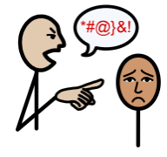
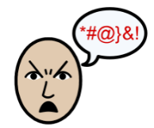
Is it bullying?
Bullying at Southbroom Infant School is unacceptable. If you feel you are being bullied, tell an adult straight away.
EVERYONE HAS THE RIGHT TO FEEL SAFE AT SCHOOL.
When someone says or does something intentionally hurtful and they keep doing it even when you’ve asked them to stop or show them you’re upset – that’s BULLYING.
When someone says or does something intentionally hurtful and they do it once, that’s MEAN.
When someone does something unintentionally hurtful and they do it once, that’s RUDE.

