w

Curriculum Intent

Our curriculum design for Computing is broken down into four key parts: knowledge, skills, understanding and vocabulary. These areas have been sequenced in each year group ensuring they are progressive and everyone understands the intended end-points. Computing makes up part of our outer curriculum and reflects our embedded values including respect and responsibility, especially in regards to our online safety curriculum.

Our Computing curriculum aims to provide a high-quality computing education that equips all children to use computational thinking and creativity to understand and contribute positively to the world around them. We recognise that our children’s lives, both socially and vocationally, will increasingly take place within a digital medium and therefore, this subject is seen as vital in developing a broad range of skills that will enable not only digital competence but also an understanding of how to be a responsible online citizen. Our curriculum therefore places equal emphasis on teaching ‘Online Safety’ in line with the expectations of Keeping Children Safe in Education 2022.

Our Computing curriculum is broad, balanced and carefully planned and sequenced in units to build on prior learning. Objectives are ambitious for all, across the four strands of our computing curriculum; Computer Systems and Networks, Programming, Data and information and Creating Media. These four strands build upon the three core aspects of Computing; Computer Science, Information Technology and Digital Literacy, which are the three main strands of our curriculum in EYFS. Our curriculum promotes high levels of achievement and behaviour through interesting and progressive lessons that are well adapted to meet the needs of children with SEND and those who are disadvantaged.

Like other foundation subjects, Computing lessons have a clear process which involves recapping learning, exploring Computing as a subject, presenting a clear objective and key vocabulary as well as summarising the knowledge and skills the children will learn.

Curriculum Implementation

Computing is taught weekly in KS1 and is interlaced within the early year’s curriculum through continuous provision. Online safety follows the Project Evolve curriculum and is taught weekly in KS1 and when appropriate in EYFS.

Each lesson is designed using the aims of the national curriculum broken down into progressive lessons, over 4 units, outlined in the ‘Teach Computing’ Curriculum. In every lesson, children will receive quality first teaching and take part in well sequenced, well-resourced and engaging lessons. Each lesson will start with a discussion about what Computing is, followed by an online safety starter and an introduction to the learning objective. Key vocabulary will be discussed before the input for the learning. Learning will often be project based and allow time for children to practice skills before applying them.

Teachers will scaffold the learning for learners with additional needs – this may be through extra resources, pre-teaching key vocabulary and ensuring each lesson builds upon prior knowledge.

Programming will be taught for two terms per year and adopts the PRIMM approach to ensure children have a robust understanding of the programming curriculum.

Computing

in a Nutshell

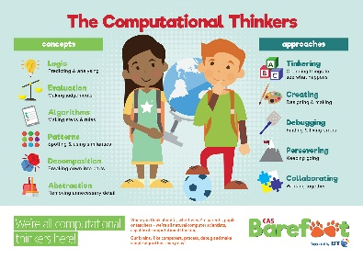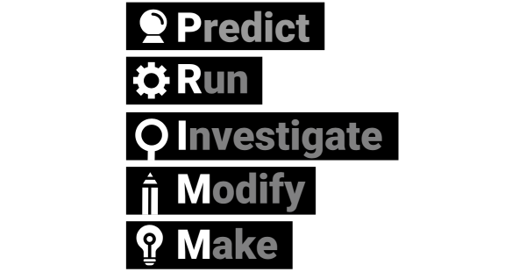2024/25

Curriculum Impact

Children will become confident users of technology and have a clear understanding of how to use it safely. Children will create a range of content across a number of different apps and will evaluate their learning effectively. Children will understand what an algorithm is and be able to use computational thinking to create and debug programs to complete a task.