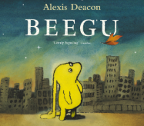
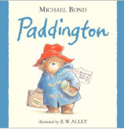
PSHE: Healthy Me
In our six puzzle pieces this term, we will focus on keeping clean and healthy, and as be creating a ‘The Happy Healthy Me Recipe Book’.
Maths
We will be continuing to learn about both addition and subtraction facts for teen numbers (17, 18, 19, and 20), begin to learn about the fractions a half and a quarter and use this knowledge to find a fraction of a shape and a number, and learning, and learning, the mathematical language to describe position.

English
We will be using the texts ‘Beegu’ and ‘Paddington’ as our focus books. We will be writing in full sentences, using the connective word ‘and’, and challenging ourselves to use adjectives. At the end of each unit, we will be retelling a part of the ‘Beegu’ story, and writing a diary entry as Paddington.

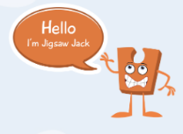
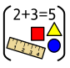

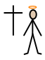

Year One Curriculum Overview
Term 4
2025/2026
DT: Puppets
We will be exploring different joining techniques for making a puppet, joining two fabrics together accurately, using a template so our hands into our created puppets.
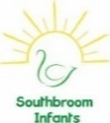
PE

In PE the children will be learning how to play team games with our PE coach.

RE

Our BIG question this term is: Why was Jesus welcomed like a king or celebrity by the crowds on Palm Sunday?


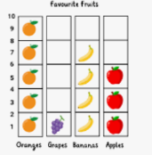
Science: Seasonal Changes
We will be learning about the four seasons and be observing changes across them. We will discuss how the weather changes across the four seasons and different weather types.

Geography
We will be learning about the frozen regions of the world, focusing on the Arctic and Antarctic circles. We will be identifying land and sea on a map of the world, and start to learn the names and locations of the worlds five oceans.
Computing
We will be focusing on data and information We will be creating groups, labels for these groups, sorting objects into these groups, before asking and answering questions about the data.



Value of the term:
Understanding

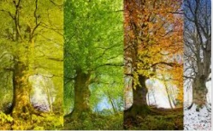


Music
We will be learning about timbre and rhythmic patterns in well-known Fairy Tales.

