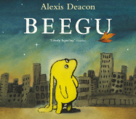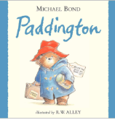

**PSHE: Healthy Me**

In our six puzzle pieces this term, we will focus on keeping clean and healthy, and as be creating a ‘The Happy Healthy Me Recipe Book’.

**Maths**

We will be continuing to learn about both addition and subtraction facts for teen numbers (17, 18, 19, and 20), begin to learn about the fractions a half and a quarter and use this knowledge to find a fraction of a shape and a number, learning about the order of the days and months of the year, as well as 3D shapes and their properties.

**English**

We will be using the texts ‘Beegu’ and ‘Paddington’ as our focus books. We will be writing in full sentences, using the connective word ‘and’ , and challenging ourselves to use adjectives. At the end of each unit we will be retelling a part of the ‘Beegu’ story, and writing a diary entry as Paddington.

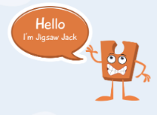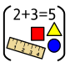

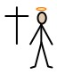

**Year One Curriculum Overview**

**Term 4**

**2024/2025**

**DT: Puppets**

We will be exploring different joining techniques for making a puppet, joining two fabrics together accurately, using a template so our hands into our created puppets.



**PE**

In PE the children will be learning how to play team games with our PE coach.

**RE**

Our BIG question this term is: Why was Jesus welcomed like a king or celebrity by the crowds on Palm Sunday?



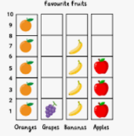

**Science: Seasonal Changes**

We will be learning about the four seasons and be observing changes across them. We will discuss how the weather changes across the four seasons and different weather types.

**Geography**

We will be learning about the frozen regions of the world, focusing on the Arctic and Antarctic circles. We will be identifying land and sea on a map of the world, and start to learn the names and locations of the worlds five oceans.

**Computing**

We will be focusing on data and information We will be creating groups, labels for these groups, sorting objects into these groups, before asking and answering questions about the data.



**Value of the term:**

Understanding

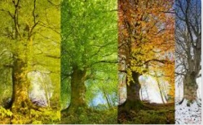



**Music**

We will be learning about timbre and rhythmic patterns in well-known Fairy Tales.