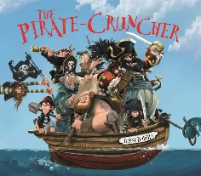 

English:

Our texts for the term will be ‘The Pirate Cruncher’ by Jonny Duddle and the ‘Clean Up’ by Nathan Bryon.

* Daily phonics/spelling lessons
* Reading skills taught daily
* Active learning building oracy
* Grammar rules taught explicitly
* Write a narrative based on ‘The Pirate Cruncher’ (with a focus on setting).
* Write a set of instructions on how we can help keep our beaches clean, inspired by the book ‘Clean Up’.

RE:

We will be learning more about Sikhism this term and about why Sikhs admire their Gurus.

Design Technology:

This term we will be learning all about structures. Our end product will be making a strong and stable chair for Baby Bear. To be able to do this, we need to:

-identify man-made and natural structures

-identify the features of a stable chair

-design a stable chair which will be able to hold weight

their own simple mode

PSHE: This term our focus is ‘Relationships’.

We will be exploring different families, what it means to be a happy family and how we can ensure our friendships are strong. We will be learning about who we trust and what a good relationship looks like.

Maths:

* Calculating change from 50p and £1.
* Creating tally charts and using them to create pictograms.
* Interpreting and constructing pictograms and using them to answer questions.
* Interpreting and constructing block diagrams.
* Measuring and comparing capacity using ml and l.
* Ordering capacity using <, > and =.
* Measuring temperature.

Value of the term:

Thoughtfulness



**Year Two Curriculum Overview**

**Term 5 2024/2025**



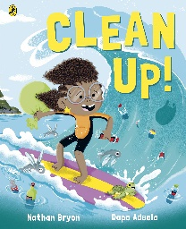

Science:

In Science we will begin our Plants focus. This term we will begin to explore:

* The difference between garden and wild plants.
* The names of a variety of common plants and trees.
* The difference between a bulb and a seed.

Music:

We will go on a musical safari; using instruments with contrasting dynamics (volume) to represent animals, learning call and response with instruments by copying sound patterns and progressing to creating and performing their own animal-based call and response.

Computing:

* Online safety
* Information Technology: Digital Music

Geography:

* To know where Africa is on the world map and the names of some countries in Africa.
* Research features of a contrasting location (country in Africa).
* Compare 2 different locations (UK/location in Africa).
* Present information about a place (Africa).