Maths:

* Time – Knowing units of time, telling the time to the hour, half past, quarter past and quarter to. Drawing the hands on a clock face to show time. Sequencing intervals of time.
* Money - recognise and use symbols for pounds (£) and pence (p); combine amounts to make a particular value. Find different combinations of coins that equal the same amounts of money. Solve simple problems in a practical context involving addition and subtraction of money of the same unit, including giving change
* Measurement - choose and use appropriate standard units to estimate and measure length/height in any direction (m/cm); mass (kg/g); temperature (°C); capacity (litres/ml). Compare and order lengths, mass, volume/capacity and record the results using >, < and =.

RE:

How important is it to Christians that Jesus came back to life after his crucifixion?

Hook for Learning:

Design a lunch for Mr. Grinling

History:

We will be learning about the seaside during the Victorian era and comparing it to the seaside today.

Science: Animals, including humans.

* Notice that animals, including humans, have offspring which grow into adults.
* Find out about and describe the basic needs of animals, including humans, for survival (water, food and air)
* Describe the importance for humans of exercise, eating the right amounts of different types of food, and hygiene

**Year Two Curriculum Overview**

**Term 4 2024/2025**



ICT skills in Computing:

* E-safety
* Data and information- Pictograms

Music:

Myths and Legends- Composing music with several layers

PSHE: Healthy me

We will be learning about being healthy, how to be relaxed, medicine safety and healthy eating.

English: Our text for the term will be ‘The Lighthouse Keeper’s Lunch’ by Ronda & David Armitage

* Daily phonics/spelling sessions
* Reading skills taught daily
* Role play
* Grammar rules taught explicitly
* Newspaper report
* Fairy tale writing
* Sequel narrative to the Lighthouse Keeper’s Lunch
* Diary entry
* Instructions

Art: Expressive painting

We will be learning about artists who use expressive painting and also exploring different brush types.

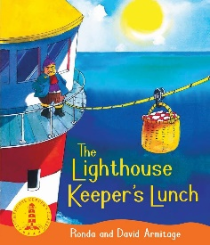



Value of the term:

Understanding