Maths:
- Time – Knowing units of time, telling the time to the hour, half past, quarter past and quarter to. Drawing the hands on a clock face to show time. Sequencing intervals of time.
- Money - recognise and use symbols for pounds (£) and pence (p); combine amounts to make a particular value. Find different combinations of coins that equal the same amounts of money. Solve simple problems in a practical context involving addition and subtraction of money of the same unit, including giving change
- Fractions – finding 1/3 and 2/4 of shapes, objects and numbers
RE:
How important is it to Christians that Jesus came back to life after his crucifixion?

Hook for Learning:
Design a lunch for Mr. Grinling

History:
We will be learning about the seaside during the Victorian era and comparing it to the seaside today.

Science: Animals, including humans.
- Notice that animals, including humans, have offspring which grow into adults.
- Find out about and describe the basic needs of animals, including humans, for survival (water, food and air)
- Describe the importance for humans of exercise, eating the right amounts of different types of food, and hygiene

Year Two Curriculum Overview
Term 4 2026
ICT skills in Computing:
- E-safety
- Data and information- Pictograms
Music:
Myths and Legends- Composing music with several layers

PSHE: Healthy me
We will be learning about being healthy, how to be relaxed, medicine safety and healthy eating.

English: Our text for the term will be ‘The Lighthouse Keeper’s Lunch’ by Ronda & David Armitage
- Daily phonics/spelling sessions
- Reading skills taught daily
- Grammar rules taught explicitly
- Newspaper report
- Fairy tale writing
- Sequel narrative to the Lighthouse Keeper’s Lunch
- Diary entry
- Instructions
Art: Explore the work of an artist who uses Mono print.
Draw the natural world through photos. Base my drawings of small objects upon careful observational looking.

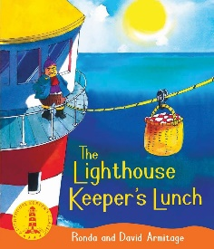

Value of the term:
Understanding

