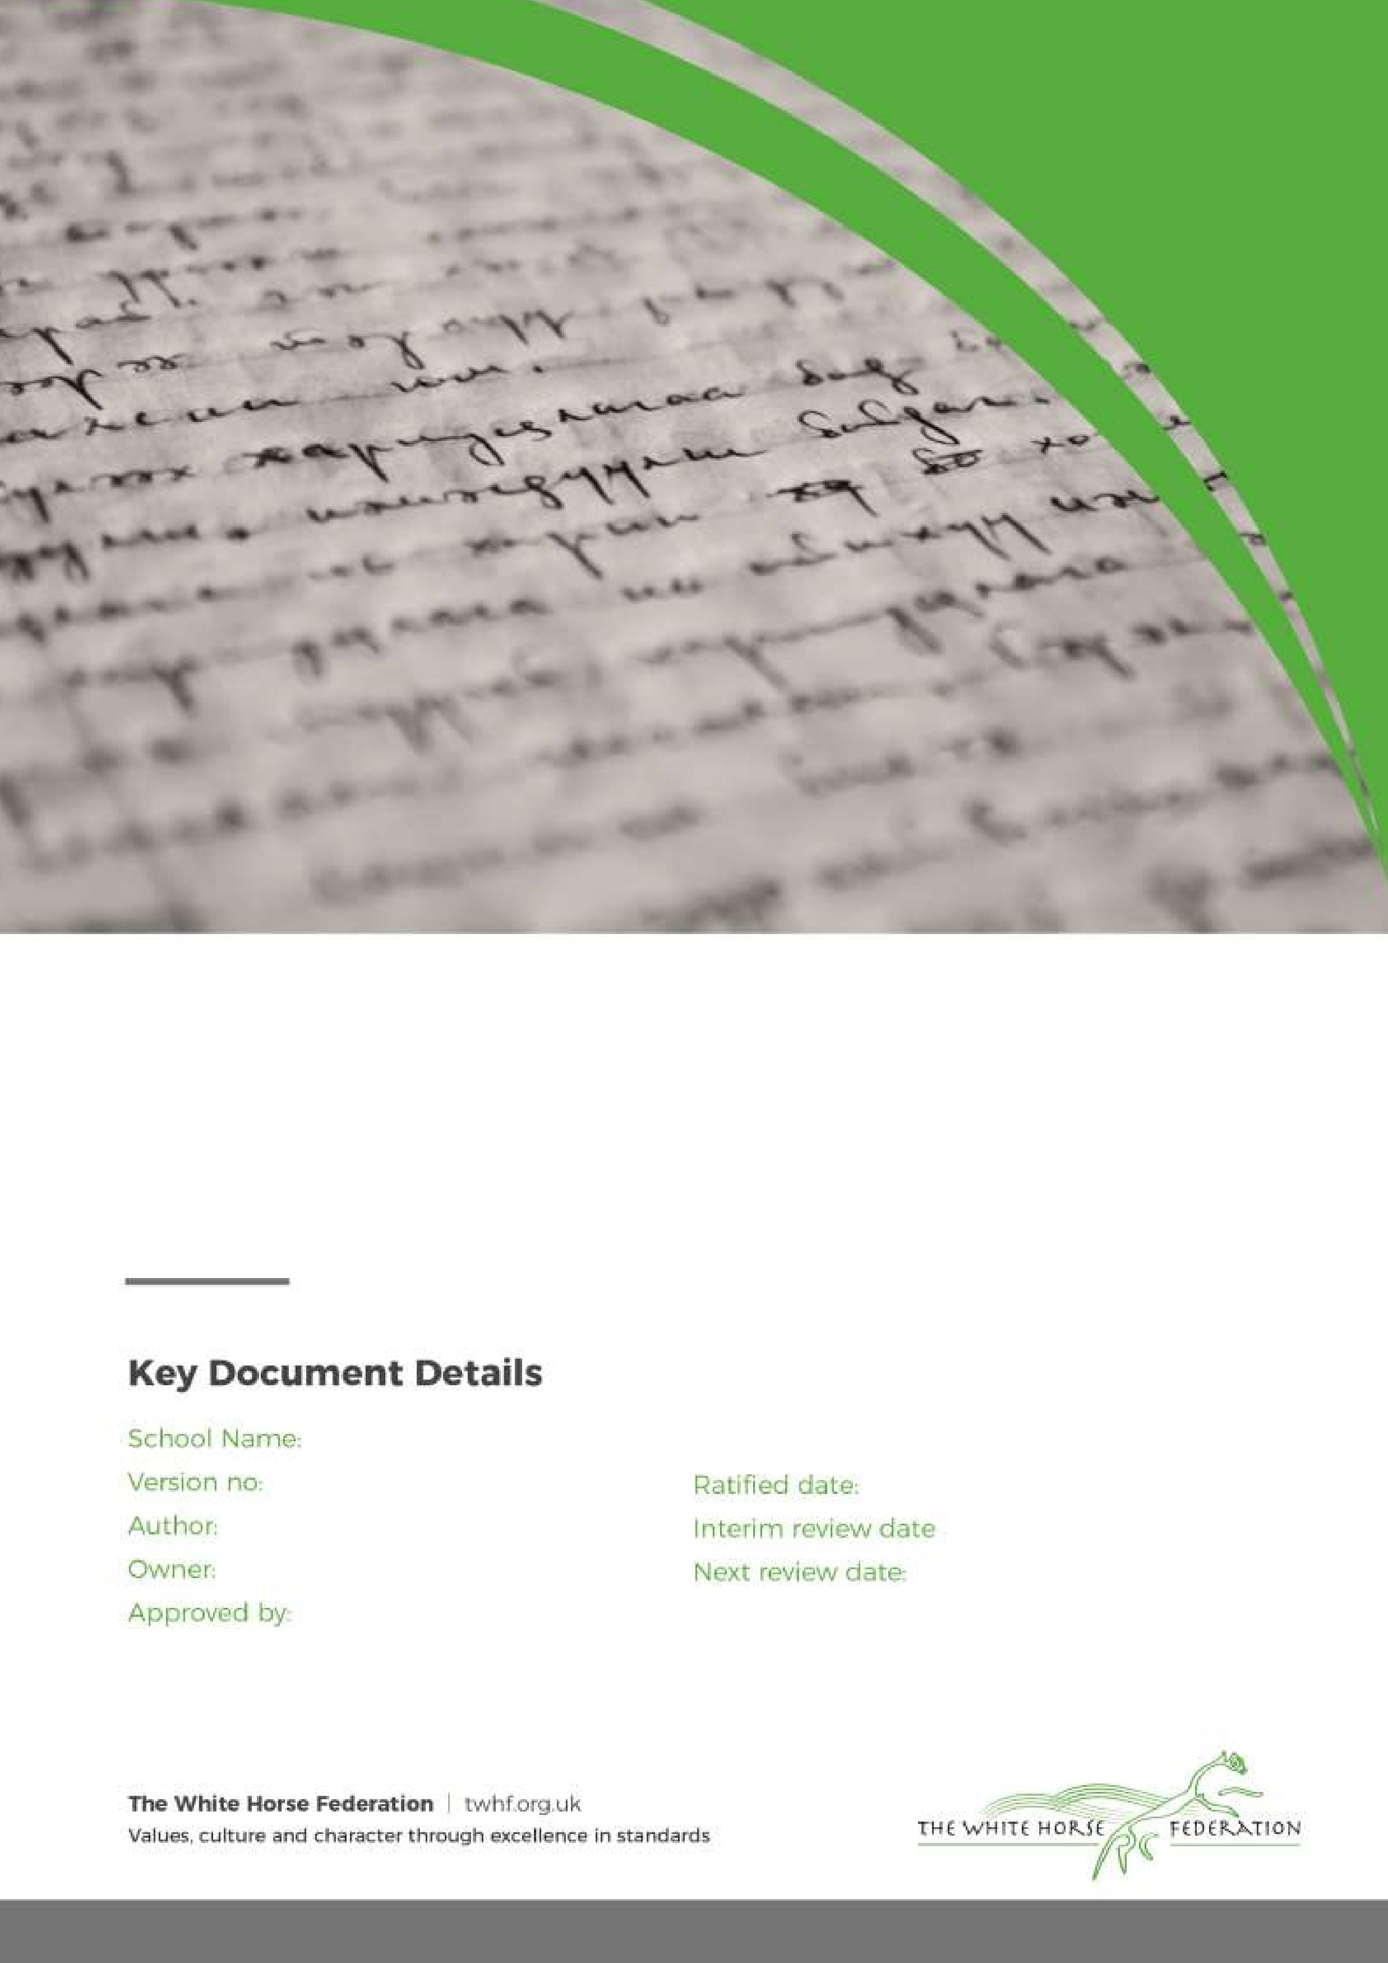

Intimate Care Policy

1

SENCO

SENCO

Headteacher

September 2024

September 2026

Southbroom Infant School

Southbroom Infant School Intimate Care Policy

**Introduction**

Intimate care is any care which involves washing, touching or carrying out an invasive procedure (such as clearing up a pupil after they have soiled themselves) to intimate personal areas. In most case, such care will involve cleaning for hygiene purposes as part of a staff member’s duty of care. In the case of a specific procedure only a person suitably trained should undertake the procedure.

The issue of intimate care is a sensitive one and will require staff to be respectful of the child’s needs. The child’s dignity should always be preserved with a high level of privacy, choice and control. There shall be a high awareness of child protection issues. Staff behaviour must be open to scrutiny and staff must work in partnership with parents/carers to provide continuity of care to children/young people wherever possible.

Southbroom Infant School is committed to ensuring that all staff responsible for the intimate care of children will undertake their duties in a professional manner at all times. Southbroom recognises that there is a need to treat all children with respect when intimate care is given. No child should be attended to in a way that causes distress or pain.

**Principles**

The management of all children with intimate care needs will be carefully planned. The child who requires intimate care is treated with respect at all times; the child’s welfare and dignity is or paramount importance.

Staff who provide intimate care are trained to do so and are fully aware of best practice. Apparatus will be provided to assist with children who need special arrangements following assessment from physiotherapist/occupational therapist as required.

The child will be supported to achieve the highest level of autonomy that is possible given their age and abilities. Staff will encourage each child to do as much for him/herself as he/she can. We see toilet training as a self-care skill that children should have the opportunity to learn with the full support and non-judgement of adults. This may mean, for example, giving the child responsibility for washing themselves. Individual intimate care plans will be drawn up for particular children of Reception age or above as appropriate to suit the needs of the child e.g. children with Special Educational Needs and Disabilities.

The child will be cared for by a known and trusted adult. The adults will be named on the personal care management plan.

This Intimate Care Policy will be shared on the school website and signposted to Nursery parents. Where possible children will be out of nappies by the time they begin Nursery. For children with Special Educational Needs and Disabilities in Reception and above, intimate care arrangements will be discussed with parents/carers on a regular basis and recorded on the child’s care plan. The needs and wishes of children and parents will be taken into account wherever possible within the constraints of staffing and equal opportunities legislation.

**The Protection of Children**

The schools Safeguarding Policy will be adhered to at all times.

All children will be taught personal safety skills carefully matched to their level of development and understanding.

Southbroom Infant School will adopt rigorous safeguarding procedures in accordance with Child Protection Policy and will apply these requirements to the Intimate Care Procedures. All staff will be vigilant for signs or symptoms of improper practice. If a child becomes distressed or unhappy about being cared for by a particular member of staff, the matter will be referred onto the Designated Safegaurding Lead (Please refer to the Safeguarding and Whistleblowing Policy. A student on placement will not change a nappy unsupervised.

If a child makes an allegation against a member of staff, all necessary procedures will be followed (see Safeguarding Policy for details).

**Children wearing nappies**

For Nursery children, parents must sign a simple agreement form, outlining who will be responsible, within the school, for changing the child and when and where this will be carried out. This agreement allows the school and the parent to be aware of all the issues surrounding this task.

Individual intimate care plans will be developed in partnership with the parents/carers of the child for children of Reception age and above who have a Special Educational Need, disability or medical need. This information will be reviewed regularly in line with developments.

**Equipment Provision**

When a child is in nappies or pull-ups, parents are responsible for providing nappies, disposal bags (for the nappy), wipes, change of clothes and a plastic bag to put the soiled clothes in.

The school is responsible for providing gloves, a bin and liners to dispose of any waste and anti bacterial cleaning spray so that all surfaces can be cleaned afterwards. It is the responsibility to all staff to ensure that all equipment is stored safely and out a children’s reach.

As identified by the DfE July 21st July 2020, children whose care routinely already involved the use of PPE due to their imitate care needs should continue to receive their care in the same way.

**Health and Safety**

Most staff in education, childcare and children’s social care settings will not require PPE beyond what they would normally need for their work, even if they are not always able to maintain a distance of 2 metres from others. (DFE July 21st 2020)

Staff should always wear a fresh pair of gloves when dealing with a child who is bleeding or soiled or when changing a soiled nappy.

Nappies must be changed in the designated area away from play facilities and away from any area where food or drink may be prepared or consumed.

When possible change the child standing up. If this is not possible there is a changing mat staff can use. The changing mat must be wiped with an anti bacterial wipe after use and put away.

Soiled nappies should be placed in a polythene waste disposal bag, which can be sealed. This bag should then be placed in a bin (complete with liner) that is specifically designated for the disposal of such waste. Staff should be aware of the school’s Health and Safety Policy.

Children’s skin should be cleaned with disposable wipes.

Hand washing facilities for staff (hand wash basin, soap, hand sanitizers and paper towels) must be available in close proximity to the nappy changing room.

Southbroom Infant School will contact the Health Visitor or appropriate external agencies if further advice is required for parents to support with toilet training.

**Providing Comfort To An Upset Or Distressed Child And Limited Touch**  
 All staff engaged in the care and education of children and young people need to exercise caution in the use of physical contact. The expectation is that staff will work in ‘limited touch’ cultures and that when physical contact is made with pupils this will be in response to the pupil’s needs at the time, will be of limited duration and will be appropriate given their age, stage of development and background.

Staff should be aware that even well intentioned physical contact might be misconstrued directly by the child, an observer or by anyone the action is describe to. Staff must therefore always be prepared to justify actions and accept that all physical contact be open to scrutiny. Children with special/additional needs may require more physical contact to assist their everyday learning. The general culture of ‘limited touch’ will be adapted where appropriate to the individual requirements of each child. The arrangements must be understood and agreed by all concerned, justified in terms of the child’s need, consistently applied and open to scrutiny. Any deviation and the justification for it should be documented and reported on CPOMS.

There may be occasions when a distressed pupil needs comfort and reassurance that may include physical touch such as a caring parent would give. Staff must remain self-aware at all times to ensure that their contact is not threatening or intrusive and not subject to misinterpretation. Judgements will need to take account of the circumstances of a pupil’s distress, their age, the extent and cause of the distress. Particular care must be taken in instances which involve the same pupil over a period of time.

Extra caution may be required where a child has suffered previous abuse or neglect. In the child’s view, physical contact might be associated with such experiences and lead to staff being vulnerable to allegations of abuse. Ensuring that a witness is present will help to protect staff from such allegations.

**Swimming**   
Our key stage one children participate in a swimming programme. Children are entitled to respect and privacy when changing their clothes, however, there must be the required level of supervision to safeguard young people with regard to health and safety considerations and ensure that unacceptable behaviour does not occur. Staff must offer effective and discrete supervision. Where a child needs additional support for changing, parental permission must be given in an individual care plan which will be drawn up as to maintain dignity but increase independence.

**Trips**   
Educational visits are an important part of our school experience. Staff should take particular care when supervising children in the less formal atmosphere of a setting or after school activity. As with extra-curricular activities, although more informal relationships in such circumstances tend to be usual, staff are still guided by our Child Protection procedures. Some specific intimate care issues may arise in a visit context – if they do then seek advice from the Principal.

**Positive Handling**

There may be occasions where it is necessary for staff to use Team Teach techniques to prevent a child from inflicting damage to either themselves, others or property. In such cases it will be carried out by those staff holding up to date Team Teach training certificates and logged on CPOMS.

**Providing First Aid**

Staff who administer first aid should ensure, wherever possible, that another adult or other child are present, e.g. on the playground or the first aid area where there are others in view. The pupil’s dignity must always be considered and where contact of a more intimate nature is required (e.g. assisting with the removal of wet/soiled clothing), another member of staff should be in the vicinity and should be aware of the task being undertaken.

**Assisting A Child Who Requires A Specific Medical Procedure**   
Parental permission must be given before any medication is dispensed in school and a care plan in place for regular medication. If required, the school staff will receive appropriate training.

**Individual Health Care Plan**  
Individual Health Care Plans will be drawn up for children requiring ongoing intimate care to suit their individual circumstances. It is vital that these plans are prepared prior to admission and, where possible, opportunities are made for the child and family to meet the staff who will be providing intimate care. The plan should be signed by all who contribute and reviewed on a regular basis. When writing the plan, whole school and classroom management considerations should be taken into account, for example:   
• The importance of working towards independence   
• School visits, swimming etc   
• Designated substitutes in case of staff absence   
• Strategies for dealing with bullying/harassment if, for example, the child has an odour   
• A system to leave the classroom with minimum disruption   
• Awareness of discomfort that may disrupt learning

Any plan should be clearly recorded to ensure clarity of roles, responsibilities and expectations. A procedure should be included to explain how concerns arising from the intimate care process will be dealt with. These will be reviewed and discussed with the parents/carers.

**Appendix 1**

**Southbroom Infant School / Parent Partnership Agreement for an Intimate Care Plan**

Name:

DOB:

Address:

Telephone:

|  |  |
| --- | --- |
| Emergency Contact |  |
| Completed by:  Date completed:  Date to be reviewed: |  |
| Storage and accesibility of equipment: | * It is the parent/carers responsibility to ensure the correct equipment is provided * The equipment will be stored in the classroom |
| Type of initmate care:  Please give details of care to be given. |  |
| Words used by the child for intimate body parts: |  |
| Words used by practitioners for intimate body parts: |  |
| Name of practitioners to deliver care. All staff should be experienced with DBS checks: |  |
| Emergency: | * In case of any concerns, notes should be made, recorded and the safeguarding lead and parent informed |
| Record Keeping: | * When staff within the school carry out intimate care they will record and file in child’s file |

I/we the undersigned have read the policy for intimate care and give permission for staff at Southbroom Infants’ School to carry out the intimate care of my/our child.

Signed by person with parental responsibility.....................................................

Relationship to child ..............................................................Date.....................

**Appendix 2**

**Record of Intimate Care Intervention**

**Child’s Name**

|  |  |  |  |  |
| --- | --- | --- | --- | --- |
| **Date:** | **Time:** | **Procedure:** | **Staff Signature:** | **Comments:** |
|  |  |  |  |  |
|  |  |  |  |  |
|  |  |  |  |  |
|  |  |  |  |  |
|  |  |  |  |  |
|  |  |  |  |  |
|  |  |  |  |  |
|  |  |  |  |  |
|  |  |  |  |  |
|  |  |  |  |  |
|  |  |  |  |  |
|  |  |  |  |  |
|  |  |  |  |  |
|  |  |  |  |  |
|  |  |  |  |  |
|  |  |  |  |  |
|  |  |  |  |  |
|  |  |  |  |  |
|  |  |  |  |  |
|  |  |  |  |  |
|  |  |  |  |  |