Intimate Care for EYFS

Policy

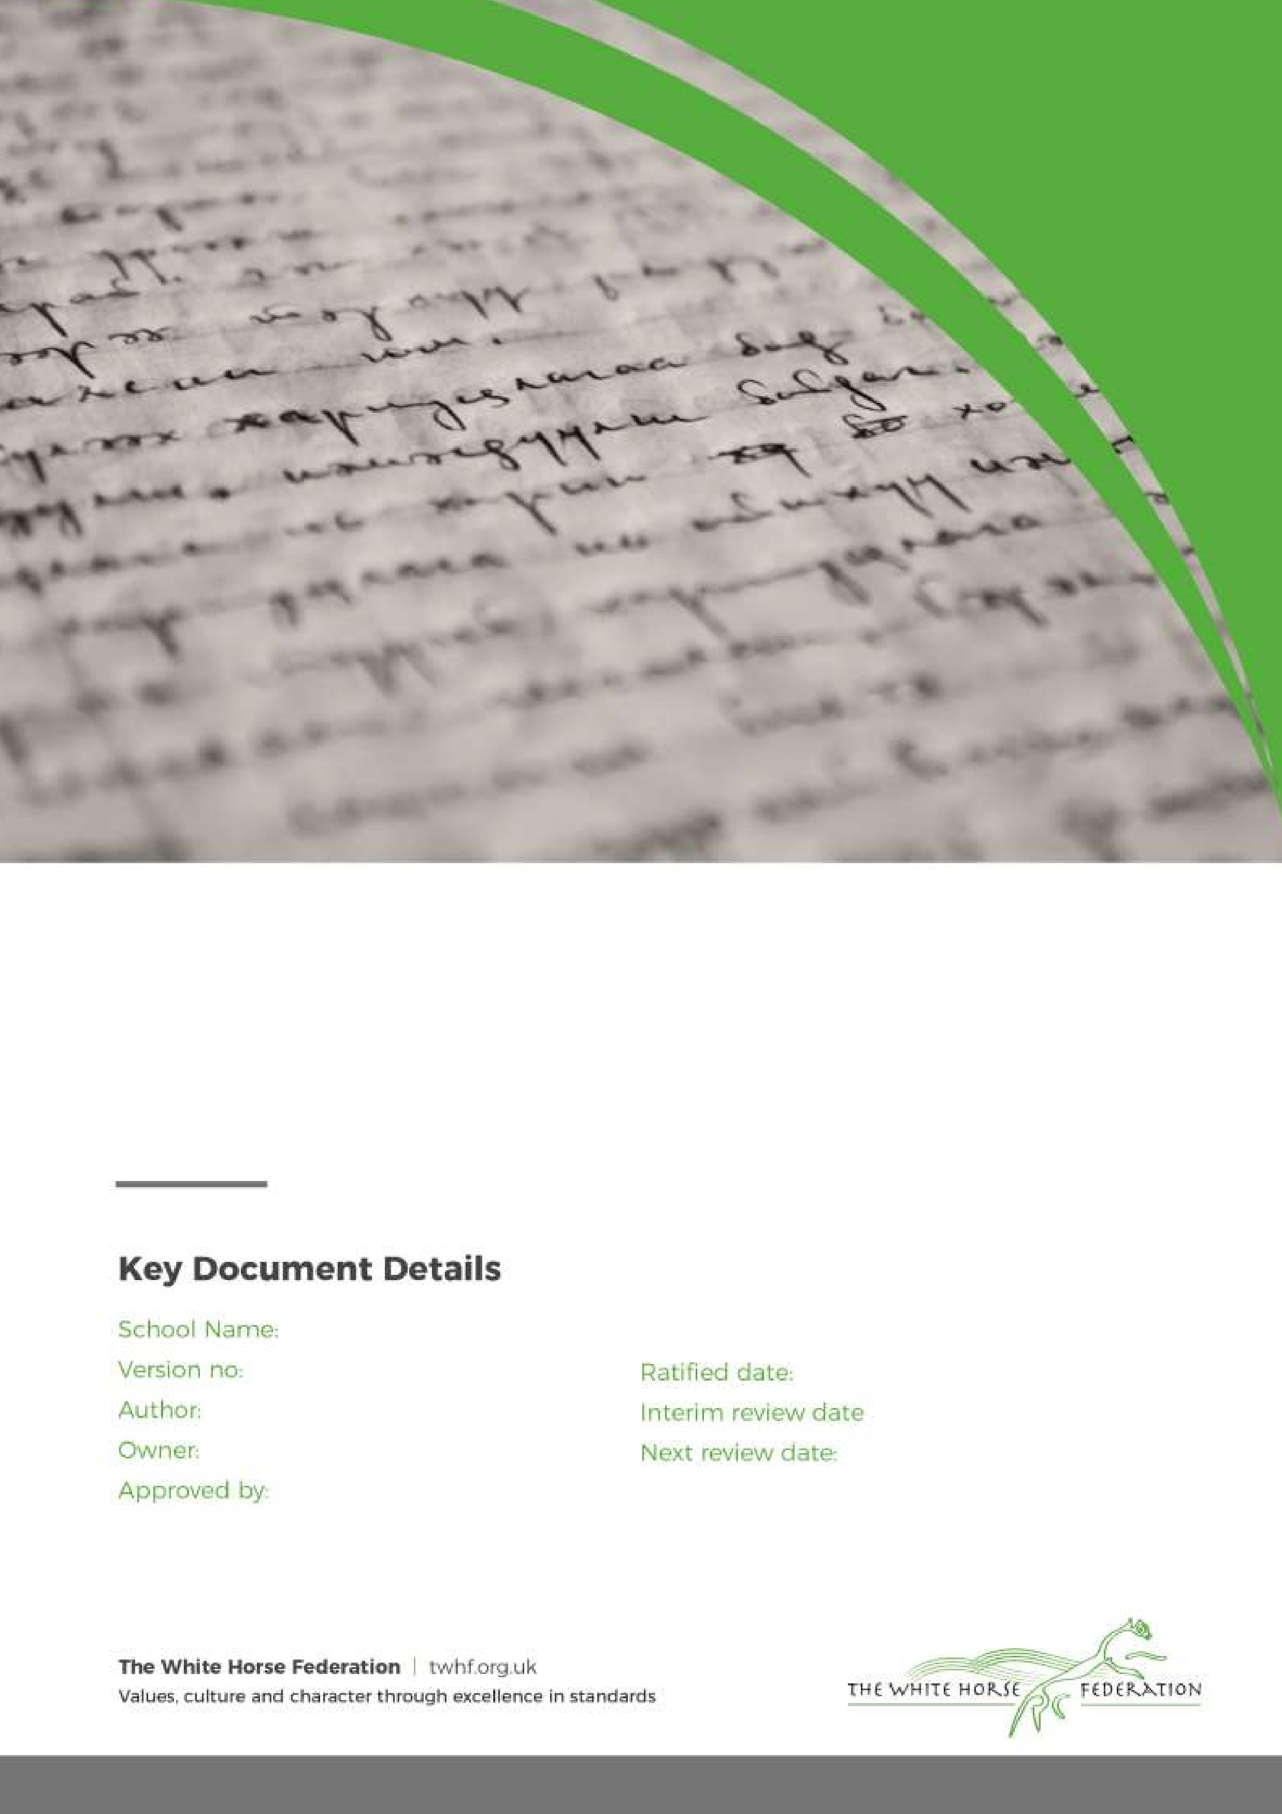

Intimate Care Policy

1

SENCO

SENCO

Head of School

September 2024

September 2026

Southbroom Infant School

**Intimate Care in the Early Years**

When parents or carers first bring their child to a school or a setting, one of their biggest worries may be about their child’s toileting habits. It is helpful for parents when their child’s key person is able to dispel anxieties. This is more likely to be successful if there is a clear, consistent policy that is understood by all members of staff.

The EYFS Statutory Framework emphasizes the importance of ‘equality of opportunity and anti-discriminatory practice, ensuring that every child is included and supported’. The following four guiding principles are endorsed in the framework:

• every child is a unique child

• children learn to be strong and independent through positive relationships

• children learn and develop well in enabling environments, in which their experiences respond to their individual needs and there is a strong partnership between practitioners and parents and/or carers

• children develop and learn in different ways and at different rates

This policy is to support practitioners in the provision of personal care for children in the Early Years Foundation Stage. It relates to all Nursery, Pre-school and Reception children at Southbroom Infants’ School. Whenever we state parents in this document, we are referring to parent and carers and when we refer to child or children we are referring to children 3 to 5 years of age. Delayed continence is not necessarily linked with learning difficulties. Children are unique in their development, health and personal circumstances. It is right to expect that some children across the entire Early Years Foundation Stage (and beyond) will be in nappies, or have occasional accidents, especially in the first few months after admission.

At Southbroom Infants’ School, we will work to ensure that every child can easily access care, play and learning experiences.

The convention on the Rights of Child states that all children are entitled to:

• privacy (article 16)

• good quality health care (article 24)

• those who have any kind of disability have the right to special care and support so that they can live full and independent lives (article 23)

The Equality Act of 2010 states that:

- pupils must not be discriminated against by not making reasonable adjustments or refusing to admit

- schools must not victimise a pupil by not affording the pupil access to a benefit, facility or service, or treat them less favourably than other pupils.

Education providers have an obligation to meet the needs of the children with delayed self-care in the same way as they would meet the individual needs of a child with any other area of delay. Children will be treated with dignity, respect and entitled to privacy.

Personal care will meet the needs of each individual child in partnership with parent, carer and child.

Personal care is any care which involves one of the following:

• Assisting a child to change his/her clothes

• Changing or washing a child who has soiled him/herself

• Assisting toileting issues

• Supervising a child involved in intimate self care

• Providing first aid assistance

• Providing comfort to an upset child

• Providing oral care to a child

• Assisting a child who requires a specific medical procedure and is not able to carry this out unaided*

* In the case of a specific procedure, only a person suitably trained should undertake the procedure.

Parents have the responsibility to advise the school of any known intimate care needs relating to their child.

**Assisting a Child to Change His/Her Clothes**

On occasions, an individual child may require some assistance with changing if they have had a toileting accident, gets wet outside, or has vomit on his/her clothes. These are more common in the early years. Staff will always encourage a child to attempt undressing and dressing unaided. However, if assistance is required this will be given.

**Changing a Child Who Has soiled Him/Herself**   
For children in the early years, the children will be supported in changing. The child will be expected to carry out as much self-care as they are able, verbal instruction will be given in the first instance.

If cleaning is required, two members of staff will be present. The child will be encouraged to clean him/herself as much as possible. Members of staff will be wearing gloves.

There will be a supply of wet wipes, towels, nappy sacks, clean underwear and spare clothes for this purpose in the nursery and reception classes. However, children should bring their clothes in a bag every day.

**Assisting Toileting Issues**

Early Years staff will support a child that has had a toileting accident. The child will be encouraged to be as independent as possible and support will be given as necessary. The child will be asked if they would like some assistance. Staff will use their professional judgement if any further support is required. If a child requires help cleaning themselves, and has requested help, staff will wear gloves to help the child.

Assisting an early years child that has had an accident will not necessarily require two members of staff to assist; expect when showering is necessary. Changing will always take place in a bathroom visible from the classroom. Verbal instruction will always be the first support given.

**Nappy Changing**

Children that are not yet toilet trained will have their nappy changed if it becomes soiled or obviously wet. It is the parent’s responsibility to ensure that a child arrives to us wearing a fresh nappy or pull-up and that spares are available in their child’s bag.

Toilet training will be encouraged.

Changing a nappy will not necessarily require two members of staff. Gloves will be worn by staff. Nappies will be disposed of in the general waste bin which is emptied daily.

**Supervising a Child Involved in Intimate Self Care**

A child will be asked if they are able to clean themselves in the first instance. If they are unable to, the child will be given verbal instruction and signs to help them manage their own care. If it is necessary for an adult to finish cleaning a child, the adult will ask the child would they like/want the adult to clean them and will wear gloves.

**Providing First Aid**

See First Aid Policy – for reception and nursery classes.

**Providing Comfort to an Upset Child**

A child may be asked if they would like a hug, if they are upset.

**Providing Oral Care**

If a cream needs to be applied or teeth need to be checked, the member of staff will always wear gloves. Assisting a Child Who Requires a Specific Medical Procedure and is Not Able to Carry This Out Unaided See Sickness and Medicines Policy.

**Responsibilities**

**School staff will:**

* Wherever reasonably practicable, the child’s key person will assist the child in nappy changing and toileting. If the child’s key person is not available, then a member of staff who the child is familiar with will help them
* Use a separate changing area to assist children who are using nappies or equivalent. This area allows privacy for the child but also is not fully enclosed ensuring the staff are visible as they assist the child.
* Work in partnership with children and parents
* Always explain to the pupil what is happening before a care procedure begins
* Change the child, or assist them in changing themselves if they become wet, or soil themselves
* Never knowingly leave a child in wet or soiled clothing. Children will be checked regularly so they can be changed at the earliest opportunity. Spare clothes will be located in Nursery office and Reception classroom.
* React to accidents in a calm and sympathetic manner
* Encourage the child’s participation in toileting procedures wherever possible
* Discuss and take the appropriate action to respect the cultural practices of the family
* Contact parents/carers if the child refuses to be changed, or becomes distressed during the process
* Maintain excellent standards of hygiene when carrying out intimate care
* Consult with colleagues where any variation from agree procedure/care plan is necessary
* Record the justification for any variations to the agreed procedure/care plan and share this information with the pupil and their parents/carers
* Where the child is in a changing room/toilet, announce their intention of entering
* Always consider the supervision needs of the pupils and only remain in the room where their needs require this
* Clean the changing mat before each use and check regularly for any damage. The changing mat will be replaced as necessary
* Always supervise a child when they are on the changing mat
* Use changing time positively and engage in conversation with the child
* Wear a fresh disposable apron & gloves while changing a child
* Not assist with intimate or personal care tasks which the pupil is able to undertake independently
* Encourage children to take an interest in using the toilet and/or potty.
* Record incidents on CPOMs if wetting or soiling happens more frequently.

If a staff member has concerns about a colleague’s intimate care practice, they must report this to the Designated Safeguarding Lead.

**Parents will:**

* Provide their child with sufficient nappies and wipes to meet their needs. These items will be labelled with the child’s name and used only for that child as the Nursery recognises that some children are allergic or sensitive to some products. Each child will have their own peg so can keep them in their bags until required. Parents are asked to provide the Nursery with any information about product sensitivity
* Provide spare clothing to be provided by parents/carers
* Inform the school should their child have any marks/rashes
* Work with the school to develop their child’s independence where appropriate

This policy will be sent to all staff via email and they will sign to say they have read and agreed with the policy.