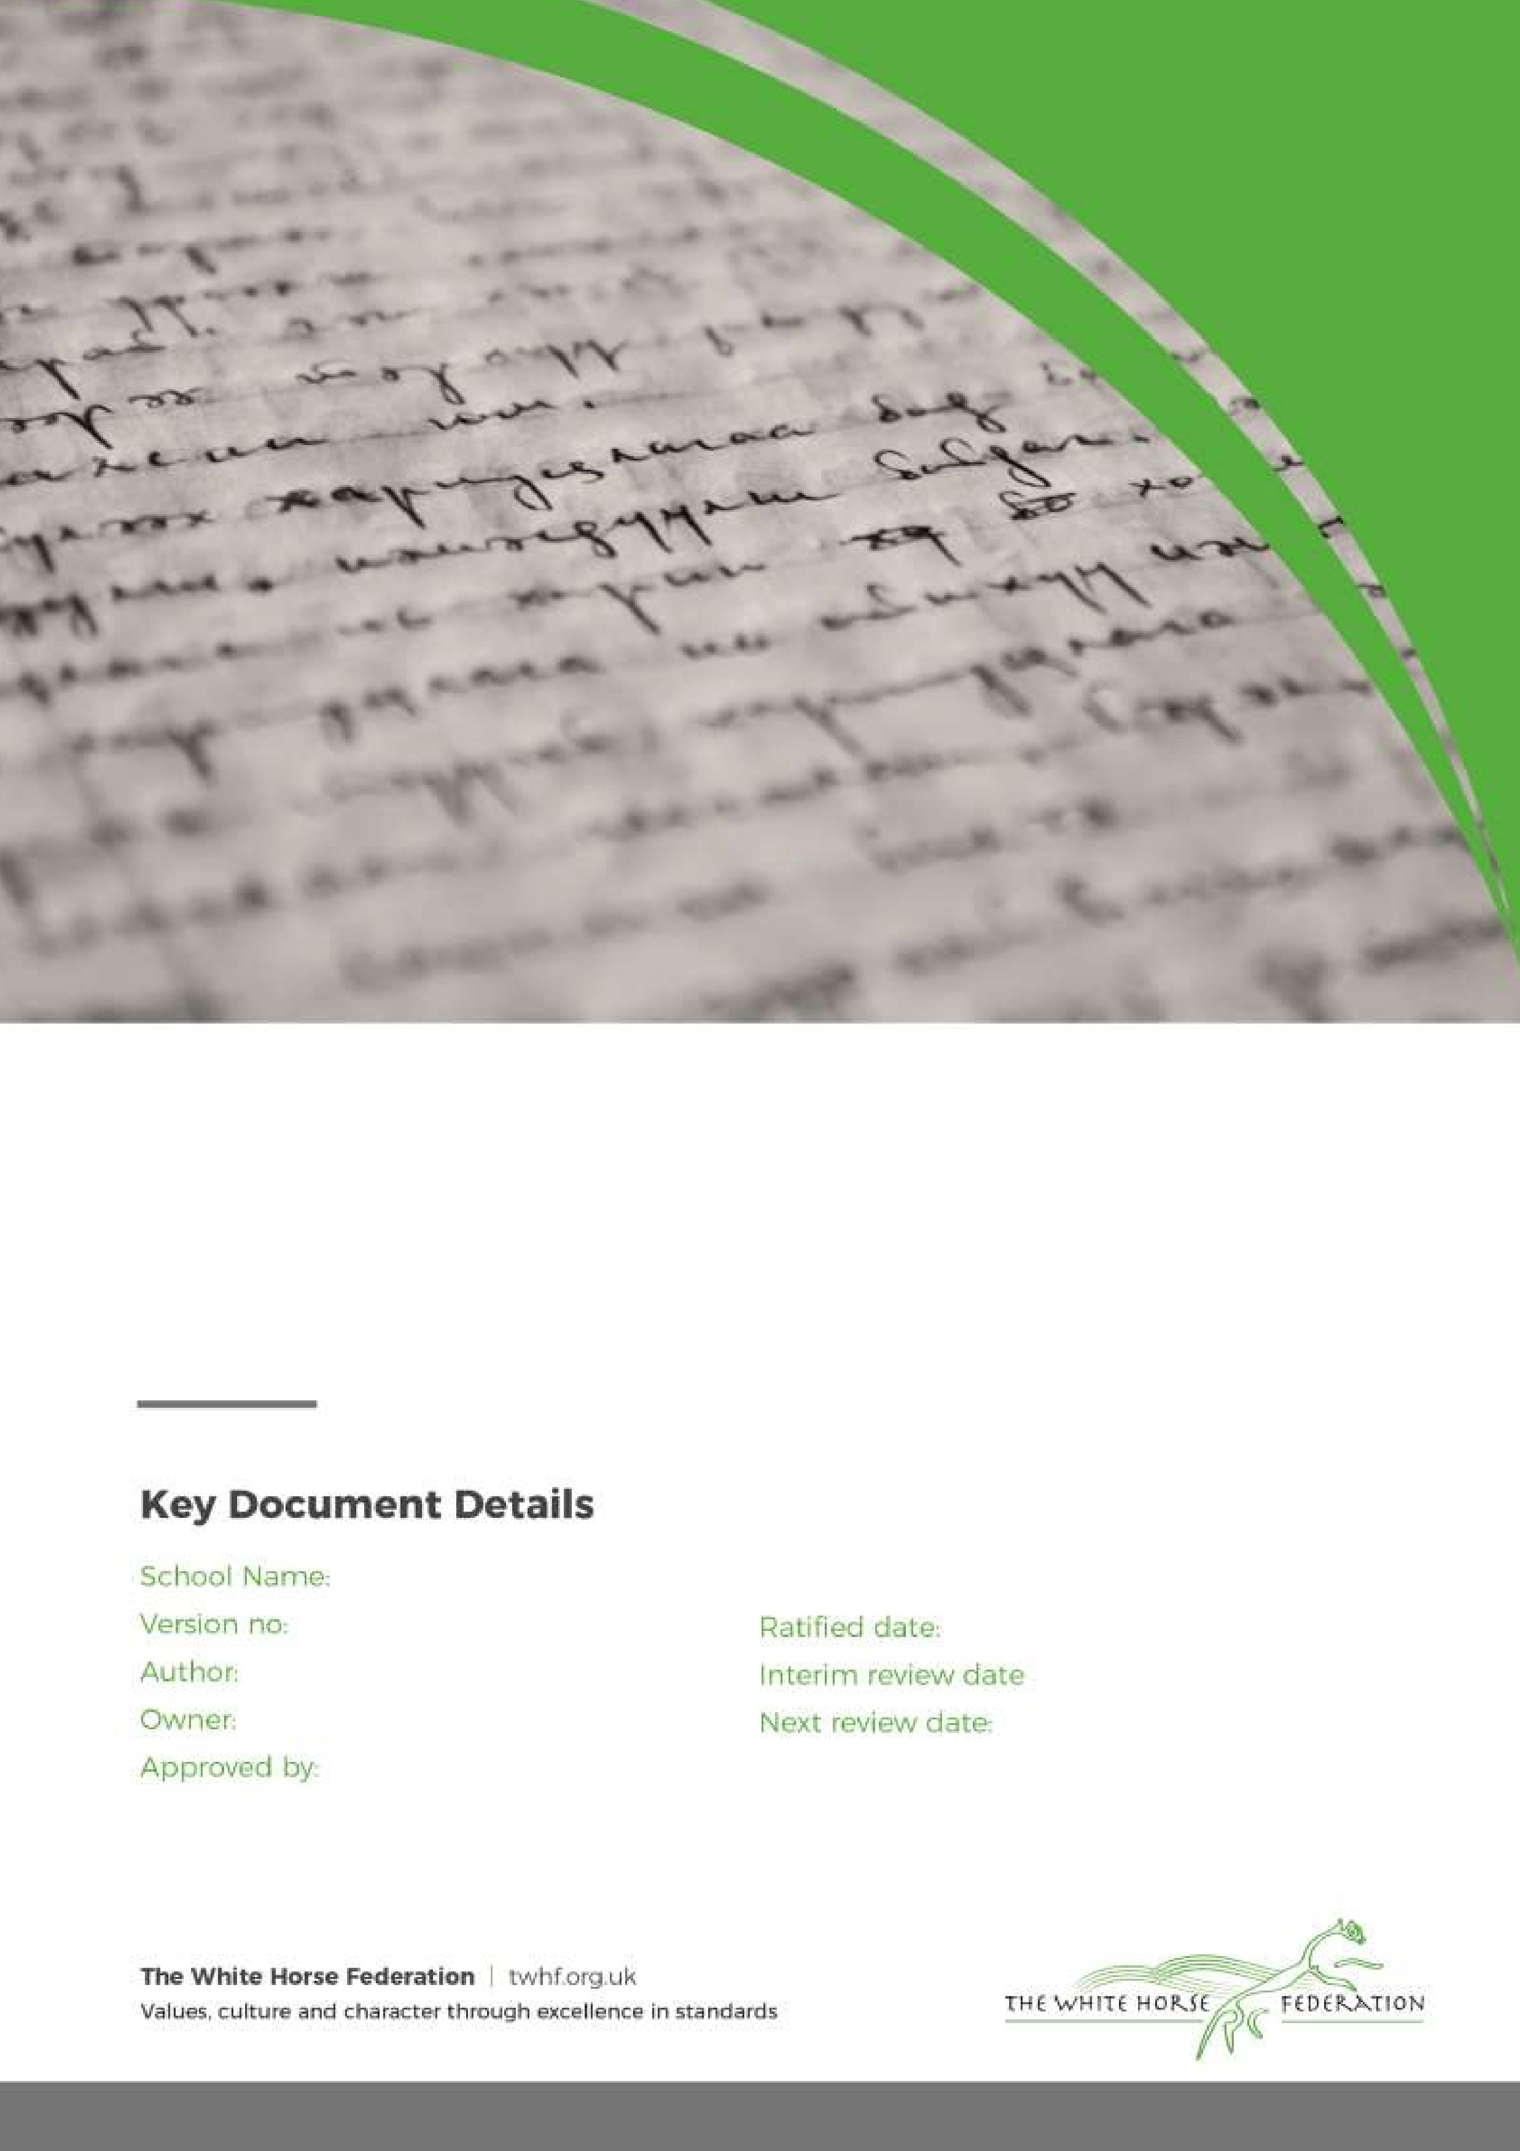

Intimate Care Policy

1

SENCO

SENCO

Head of School

September 2023

September 2024

Southbroom Infant School

Southbroom Infant School Intimate Care Policy

Introduction
Intimate care is any care which involves washing, touching or carrying out an invasive procedure (such as clearing up a pupil after they have soiled themselves) to intimate personal areas. In most case0,s such care will involve cleaning for hygiene purposes as part of a staff member’s duty of care. In the case of a specific procedure only a person suitably trained should undertake the procedure.
The issue of intimate care is a sensitive one and will require staff to be respectful of the child’s needs. The child’s dignity should always be preserved with a high level of privacy, choice and control. There shall be a high awareness of child protection issues. Staff behaviour must be open to scrutiny and staff must work in partnership with parents/carers to provide continuity of care to children/young people wherever possible.
Southbroom Infant School is committed to ensuring that all staff responsible for the intimate care of children will undertake their duties in a professional manner at all times. Southbroom recognises that there is a need to treat all children with respect when intimate care is given. No child should be attended to in a way that causes distress or pain.

Principles
The management of all children with intimate care needs will be carefully planned. The child who requires intimate care is treated with respect at all times; the child’s welfare and dignity is or paramount importance.
Staff who provide intimate care are trained to do so and are fully aware of best practice. Apparatus will be provided to assist with children who need special arrangements following assessment from physiotherapist/occupational therapist as required.
The child will be supported to achieve the highest level of autonomy that is possible given their age and abilities. Staff will encourage each child to do as much for him/herself as he/she can. We see toilet training as a self-care skill that children should have the opportunity to learn with the full support and non-judgement of adults. This may mean, for example, giving the child responsibility for washing themselves. Individual intimate care plans will be drawn up for particular children of Reception age or above as appropriate to suit the needs of the child e.g. children with Special Educational Needs and Disabilities.
The child will be cared for by a known and trusted adult. The adults will be named on the personal care management plan.

This Intimate Care Policy will be shared on the school website and signposted to Nursery parents. Where possible children will be out of nappies by the time they begin Nursery. For children with Special Educational Needs and Disabilities in Reception and above, intimate care arrangements will be discussed with parents/carers on a regular basis and recorded on the child’s care plan. The needs and wishes of children and parents will be taken into account wherever possible within the constraints of staffing and equal opportunities legislation.

The Protection of Children
The schools Safeguarding Policy will be adhered to at all times.
All children will be taught personal safety skills carefully matched to their level of development and understanding.
Southbroom Infant School will adopt rigorous safeguarding procedures in accordance with Child Protection Policy and will apply these requirements to the Intimate Care Procedures. All staff will be vigilant for signs or symptoms of improper practice. If a child becomes distressed or unhappy about being cared for by a particular member of staff, the matter will be referred onto the Designated Safegaurding Lead (Please refer to the Safeguarding and Whistleblowing Policy. A student on placement will not change a nappy unsupervised.
If a child makes an allegation against a member of staff, all necessary procedures will be followed (see Safeguarding Policy for details).

Children wearing nappies
For Nursery children, parents must sign a simple agreement form, outlining who will be responsible, within the school, for changing the child and when and where this will be carried out. This agreement allows the school and the parent to be aware of all the issues surrounding this task.
Individual intimate care plans will be developed in partnership with the parents/carers of the child for children of Reception age and above who have a Special Educational Need, disability or medical need. This information will be reviewed regularly in line with developments.

Equipment Provision
When a child is in nappies or pull-ups, parents are responsible for providing nappies, disposal bags (for the nappy), wipes, change of clothes and a plastic bag to put the soiled clothes in.
The school is responsible for providing gloves, a bin and liners to dispose of any waste and anti bacterial cleaning spray so that all surfaces can be cleaned afterwards. It is the responsibility to all staff to ensure that all equipment is stored safely and out a children’s reach.
As identified by the DfE July 21st July 2020, children whose care routinely already involved the use of PPE due to their imitate care needs should continue to receive their care in the same way.

Health and Safety
Most staff in education, childcare and children’s social care settings will not require PPE beyond what they would normally need for their work, even if they are not always able to maintain a distance of 2 metres from others. (DFE July 21st 2020)
Staff should always wear a fresh pair of gloves when dealing with a child who is bleeding or soiled or when changing a soiled nappy.

Nappies must be changed in the designated area away from play facilities and away from any area where food or drink may be prepared or consumed.
When possible change the child standing up. If this is not possible there is a changing mat staff can use. The changing mat must be wiped with an anti bacterial wipe after use and put away.
Soiled nappies should be placed in a polythene waste disposal bag, which can be sealed. This bag should then be placed in a bin (complete with liner) that is specifically designated for the disposal of such waste. Staff should be aware of the school’s Health and Safety Policy.
Children’s skin should be cleaned with disposable wipes.
Hand washing facilities for staff (hand wash basin, soap, hand sanitizers and paper towels) must be available in close proximity to the nappy changing room.
Southbroom Infant School will contact the Health Visitor or appropriate external agencies if further advice is required for parents to support with toilet training.

If a child becomes unwell with symptoms of coronavirus while in school and needs direct personal care until they can return home. A fluid-resistant surgical face mask should be worn by the supervising adult. If contact with the child or young person is necessary, then disposable gloves, a disposable apron and a fluid-resistant surgical face mask should be worn by the supervising adult. If a risk assessment determines that there is a risk of splashing to the eyes, for example from coughing, spitting, or vomiting, then eye protection should also be worn.

Appendix 1
Southbroom Infant School / Parent Partnership Agreement for an Intimate Care Plan

Child’s name: ………………………………………………………………………………………

Parental responsibility:
- I agree to provide nappies, disposal bags, wipes, a change of clothes and a bog for soiled clothes.
- I agree to make sure that my child is changed at the latest possible time before being brought into school.
- I understand and agree to the procedures that will be followed when my child is changed at school. If cream is required for a medical purpose, this will be listed below.
- I agree to inform the school if my child has any marks/rashes.
- I agree to work with the school and any external agencies, to support my child to become toilet trained and managing their needs independently.
- I agree to review arrangements, should this be necessary.

School responsibility:
- We agree to change your child should they soil themselves or become uncomfortable wet.
- We will provide staff with appropriate equipment to change your child.
- We will ensure that the contact between a member of staff and your during a nappy change it kept to a limited amount of time.
- We will inform you if your child becomes distressed or is marks/rashes are seen.
- We will let you know if more nappies etc. are needed.
- We agree to review arrangements, should this be necessary.

Parent …………………………………………………………… Date …………………………………..
Key Worker ……………………………………………………… Date …………………………………..
EYFS Lead ……………………………………………………… Date …………………………………..
Room Staff ……………………………………………………… Date …………………………………..
……………………………………………………… Date …………………………………..
……………………………………………………… Date …………………………………..
……………………………………………………… Date …………………………………..

Appendix 2
Record of Intimate Care Intervention
Child’s Name

Date: | Time: | Procedure: | Staff Signature: | Comments:

Appendix 3
Southbroom Infant School Intimate Care Plan and Consent
Name of child |  | Date of birth
Name of key worker |  | Year Group
Name of class teacher

Care requirements, including frequency

The table below outlines the member of staff responsible for carrying out your child’s intimate care programme, as well as the member of staff responsible in their absence:
Named member of staff
Named other members of staff

Where will the imitate care be carried out?

What equipment/resources will be required?

Training needs

What are the reporting procedures for parents/carers?

Any additional information?

I have read Southbroom Infant School’s Intimate Care Policy and I agree to the intimate care plan outlined above.

Signature of parent/carer |  | Date
Signature of key worker |  | Date
Signature of SENCO |  | Date

