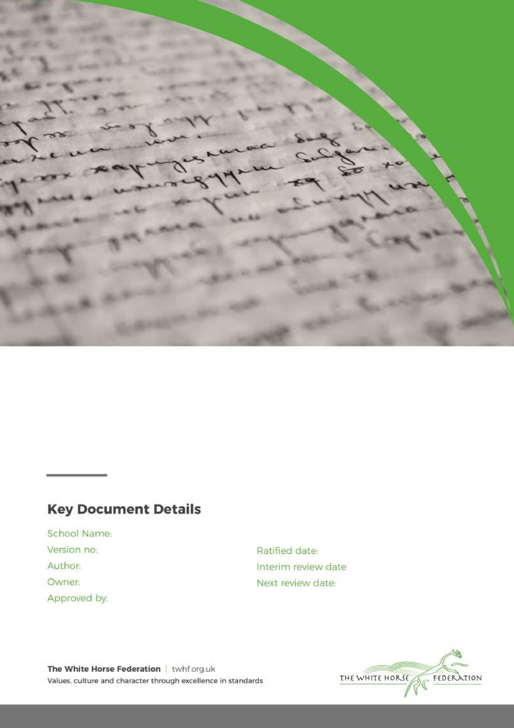

Marking & Feedback Policy

1

T.Butcher

Head of School

Simon Cowley

July 2024

n/a

July 2026

Southbroom Infant School

**Marking Guidance: Responding to Children’s Work**

Through marking and feedback, staff should seek to identify strengths and achievements and difficulties to inform assessment and planning.

**Aims:**

* To aid future planning.
* To improve motivation and self‐esteem.
* To provide additional opportunities for self‐evaluation.
* To correct and assess.
* To evaluate teaching effectiveness.
* To extend and challenge.
* To model expectations.
* To assist with the pace of progress the children make in lessons.

**Objectives:**

* Children will be able to explain what teacher’s marks mean.
* Children can comment confidently on their own work.
* Children can reflect on their own progress.
* Teachers will use assessment derived from marking to inform future planning.

**ALL** staff and pupils will be aware of marking practices and codes. These should be displayed and referred to in all classrooms and are detailed below:

**When a child works with a teacher as part of a guided session:**

* Pink pen is used by the teacher to draw ‘dots’ at the top of the child’s work – this indicates that the child has worked with a teacher and has received instant and integrated feedback during the lesson (this does not mean that the child cannot continue to work independently).
* When working in guided groups with pupils, teachers may find it useful to annotate pupils work using a pink pen during the session. Annotations should reflect the intervention and may take the form of modelling, prompting, correcting etc.
* Pink pen is used by the adult to initial pupil’s work at the bottom on completion.

**When a child works with a teaching assistant as part of a guided session:**

* Blue pen is used by the teaching assistant to draw ‘dots’ at the top of the child’s work – this indicates that the child has worked with a teaching assistant and has received instant and integrated feedback during the lesson (this does not mean that the child cannot continue to work independently).
* When working in guided groups with pupils, teachers may find it useful to annotate pupils work using a blue pen during the session. Annotations should reflect the intervention and may take the form of modelling, prompting, correcting etc.
* Blue pen is used by the adult to initial pupil’s work at the bottom on completion.

**When a child works independently of any adult intervention:**

Green pen is used by the child/teacher to draw ‘dots’ at the top of their work – this indicates that they have worked independently of an adult (they may have worked alone, with a partner or as art of a group).

* All children’s work is checked by the class teacher and stamped using coloured stamps – stickers may be used by the class teacher for rewards where appropriate.
* Where the pupil outcome is ‘as expected’ and the child has reached his/her LO, a gold stamp is used to indicate this.
* Where the pupil outcome is ‘as expected’ and the child has reached his/her LO but there are ‘minor corrections’ required, a gold stamp is used to indicate this and corrections are addressed by the teacher using a pink pen (See appendix iii for definition of ‘minor corrections’).
* When the pupil outcome is ‘not as expected’ and the child has not reached his/her LO, the child’s work is still valued and a green stamp is used to indicate this and the teacher will make a note of their planned next steps. Next steps will include a wide range of strategies including verbal feedback, change of teaching group, further challenge, support of an adult or resource for the next lesson etc. This needs not be recorded in detail, the distance marking sheet is to be used by teachers as an aide memoir.
* When a child has exceeded expectations, teachers will use the ‘Wow stamp’ (used rarely to maintain a high-status reward) to indicate to the child that they are impressed with their achievements and this will be followed up by sharing this fantastic work with the P/VP who will stamp the work with their HT stamp.

**Marking codes used to support children in up-levelling their own writing**

The following marking codes will be used to support children to up-level their own writing in Year 1 (in terms 5 and 6) and Year 2:

|  |  |
| --- | --- |
| **Code** | **Definition** |
| OT | Over teach – this identifies where a pupil has received additional practice in preparation for independent learning |
| GW | Guided Writing – this identifies where a group of pupils have worked directly with an adult to construct a piece of writing |
| SS | Sentence stems have been provided to the pupils by the teacher |
| WB | A pre-prepared word bank has been provided to the pupils by the teacher |
| SP | SP will be used where a child has not spelt an age-appropriate common exception word correctly. |
| CL | CL will be used where a child has not used capital letters correctly or consistently. |
| FS | FS will be used where a child has not used full stops correctly or consistently. |
|  | A finger space symbol will be used where a child has not used finger spaces correctly or consistently. |

Every child will have a copy of the marking policy that is accessible to them in the front of their books that they can refer to:

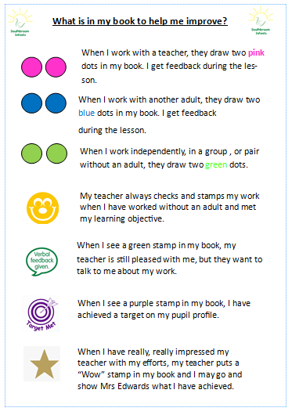

**When a child needs extra support or an intervention:**

* If an adult has to work 1:1 or in a small group with pupils after the lesson has finished to ensure he/she reaches his/her learning objective, a ‘AD’ symbol in a circle will be used to signify that the child has had adult directed support.

**Appendix (iii) Minor Corrections**

What constitutes a ‘minor correction’

* An error that is otherwise used correctly throughout the work or in previous pieces – e.g. correct use of punctuation such as speech marks, question marks, full stops etc. but one or two have been missed.
* A transcription error – e.g. a capital letter in the wrong place, reversed number, ‘t’ not crossed etc.
* An incorrect answer amongst a range of correct answers that demonstrate the child has understood a concept – e.g. a calculation error, missing unit of measure from an answer etc. Page 3 of 4 Page 4 of 4
* An odd spelling mistake that should be within the child’s expected realm of spelling capability – e.g. high frequency words, the appropriate homophone etc. Simple rule of thumb: A child should see a minor correction and think, “Oh yes, I missed that” rather than, “Oh, I didn’t know that”

NOTE: Where many minor corrections are needed when checking a pupil’s work, teachers should give careful consideration to the use of the gold stamp. Many minor errors may indicate that the child is not working with due care and attention and feedback may be required to discuss this. Pupils should always be given adequate time to self or peer check their work to limit the number of errors made and corrections needed.