Music development plan summary:
Southbroom Infant School

Overview
Detail | Information
Academic year that this summary covers | 2025-2026
Date this summary was published | September 2025
Date this summary will be reviewed | August 2026
Name of the school music lead | Becky Penny
Name of school leadership team member with responsibility for music (if different) | Becky Penny
Name of local music hub | Wiltshire Music Hub
Name of other music education organisation(s) (if partnership in place) | N/A

This is a summary of how our school delivers music education to all our pupils across three areas – curriculum music, co-curricular provision and musical experiences – and what changes we are planning in future years. This information is to help pupils and parents or carers understand what our school offers and who we work with to support our pupils’ music education.

Part A: Curriculum music
This is about what we teach in lesson time, how much time is spent teaching music
At Southbroom Infant School we believe in the unlimited potential of every child . As a result of this, we have carefully designed a curriculum which is underpinned by our 4 Golden Threads; Knowledge and Skills, Understanding, Vocabulary Rich and Experiences Rich.
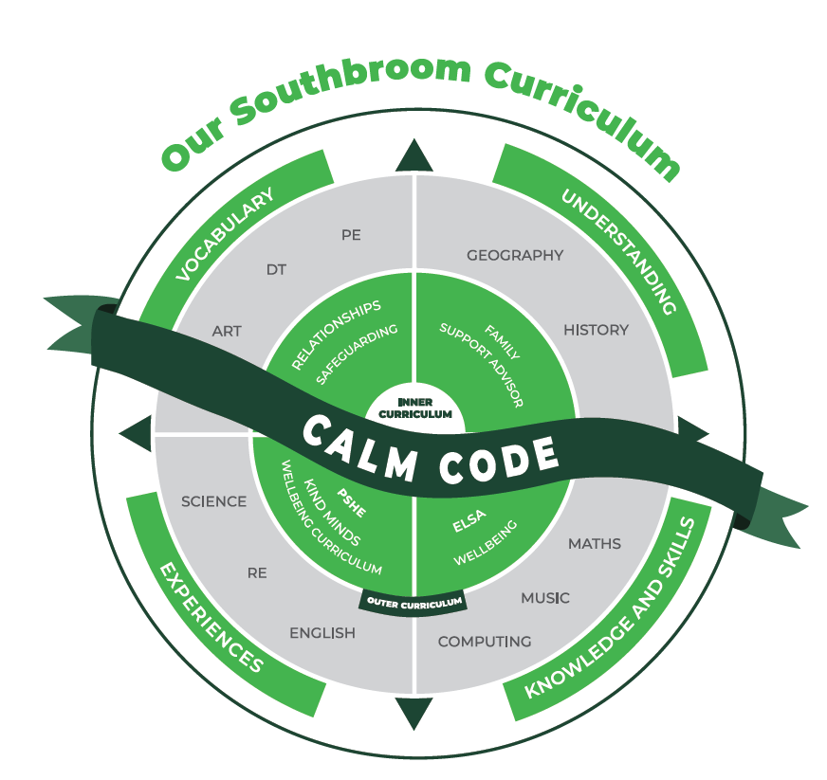
Our curriculum is broad, ambitious, carefully sequenced and relevant to the pupils of Southbroom Infant School. The curriculum intent is based around 4 key golden threads that link to the school’s context, and weave through all curriculum areas:
Knowledge and Skills
It is our intent for every child to develop mastery across the curriculum. Where possible, it is our intent that our curriculum provides cross curricular opportunities to teach and embed the required knowledge and skills. We want our children to leave Southbroom Infants with the knowledge and skills needed to equip them for the next stage of their education.
Understanding
It is our intent for every child to develop a deep understanding in the skills and knowledge they are taught. Our curriculum design ensures that learning is well sequenced and broken down into clear segments of learning which is progressive and can be built upon which enables children to deepen their understanding.

Experience Rich
It is our intent for every child Learning to be motivated, excited and curious to in their learning across all curriculum areas. By making our curriculum relevant and engaging through providing a range of experiences to enrich the learning we ensure that our children want to find out more are enthused and excited about their learning and have the opportunities to transfer their skills across the curriculum

Vocabulary Rich
It is our intent that our curriculum provides children with a wide range of ambitious and subject specific vocabulary. This will give them the tools with which to communicate their learning effectively both orally and in writing.

The Four Golden Threads are underpinned by our school values and CALM code.
Our Intent for our Music Curriculum:
Our Golden Threads underpin our curriculum intent enabling our pupils to achieve the following in Music:

At Southbroom Infants we intend for all children to feel that they are musical and to develop a life-long love of music. We focus on developing the skills, knowledge and understanding that children need in order to became confident performers, composers and listeners.

Our curriculum introduces children to music from all around the world and across generations, teaching children to respect and appreciate the music of all traditions and communities. We have a progressive curriculum throughout the Early Years Foundation Stage and Key Stage One which enables pupils to meet the end of key stage attainment targets.

Implementation:
The National Curriculum is the starting point of our curriculum design. It has been used to drive our curriculum design, in order to ensure the aims of the National Curriculum are met, and it has been used to inform the choices we have made about the content that we teach.
Our curriculum and teaching of music takes a holistic approach to music in which the individual strands below are woven together to create engaging and enriching learning experiences:

• Performing
• Listening
• Composing
• The history of music
• The inter-related dimensions of music

Each unit combines these strands within a cross curricular themed design to capture pupils’ imagination and to encourage them to explore music enthusiastically.

Over the course of the unit, children will be taught to play tuned and untuned instruments accurately and with control. They will learn to recognise and name the interrelated dimensions of music – pitch, duration, tempo, timbre, structure, texture and dynamics – and use these expressively in their own improvisations and compositions.

Impact:
After the implementation of our music teaching pupils will leave our school equipped with a range of skills to be able to enjoy and appreciate music throughout their lives.
Children will:
• Be confident performers, composers and listeners and will be able to express themselves musically at and beyond school.
• Show an appreciation and respect for a wide range of musical styles from around the world and will understand how music is influenced by the wider cultural, social and historical contexts in which it is developed.
• Understand the ways in which music can be written down to support performing and composing activities.
• Demonstrate and articulate an enthusiasm for music and be able to identify their own personal musical preferences.

Our music curriculum is published on our school website and can be accessed here: Overview | Southbroom Infants' School
Music is timetabled weekly across the school so that all children have regular access to music lessons as part of a broad and balanced curriculum offer. Assemblies are also used as additional time where children learn songs and practise singing.

Part B: Co-curricular music
This is about opportunities for pupils to sing and play music, outside of lesson time, including choirs, ensembles and bands, and how pupils can make progress in music beyond the core curriculum.
As part of our Personal Development Plan, we run an after-school Choir Club which parents can sign their children up to. Children will learn a number of songs and be given the opportunity to perform them in assemblies and school events such as the Christmas and Summer Fairs.

Part C: Musical experiences
This is about all the other musical events and opportunities that we organise, such as singing in assembly, concerts and shows, and trips to professional concerts.
Assembly time is also set aside on a weekly basis for singing. Children are introduced to new songs and enjoying practising, rehearsing and performing together. Once a term, we open our singing assembly up to parents and carers who would like to come and watch the children perform.

In the future
This is about what the school is planning for subsequent years.
It is the intention of the leadership team to:
- Plan additional opportunities for year 2 children to learn to play a musical instrument through a block of lessons taught in school.

Further information (optional)

