Personal, Social and Emotional Development:
This term we will be learning to: Show ‘effortful control’. For example, waiting for a turn and resisting the strong impulse to grab what they want or push their way to the front. Show a sense of autonomy through asserting their ideas and preferences and making choices and decisions. Is gradually learning that actions have consequences but not always the consequences the child hopes for.

-

Communication and Language
We will be learning to:
Show interest in play with sounds, songs and rhymes. Use language to share feelings, experiences and thoughts. Identifies action words by following simple instructions.

Physical Development:
We will be learning to:
Kick a stationary ball with either foot, throw a ball with increasing force and accuracy and start to catch a large ball by using two hands and their chest to trap it. Begin to understand and choose different ways of moving. Show increasing control in holding, using and manipulating a range of tools and objects such as tambourines, jugs, hammers, and mark making tools.


Value of the term:
Honesty
Expressive Arts and Design:
We will be learning to: Explore paint, using fingers and other parts of their bodies as well as brushes and other tools. Create sounds by rubbing, shaking, tapping, striking or blowing. Make simple models which express their ideas. Use our imaginations as we consider what we can do with different materials.


Nursery Curriculum Overview
Term 3 2025/2026
Literacy:
This term our focus stories are:
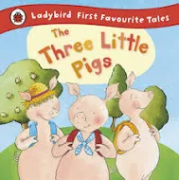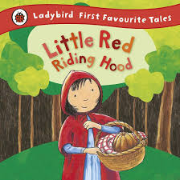
Our focus rhyme is:
Incy Wincy Spider
We will be learning to: In pre-school, we will be continuing our Little Wandle Foundation for Phonics journey where we will be taking part in adult led phonic sessions.
Repeat and uses actions, words or phrases from familiar stories. Fill in the missing word or phrase in a known rhyme, story or game.
Enjoy drawing freely.
Add some marks to drawings, which they give meaning to. For example: “That says mummy.”



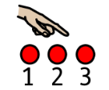
indoors and outdoors. Remembers and talks about significan experience. Talk about the differences between materials and changes they notice.
Maths:
We will be learning to: Compare and recognise changes in numbers of things, using words like more, lots or ‘same’. Count in everyday contexts, sometimes skipping numbers – ‘1,2,3,5. Take part in rhymes with numbers. Respond to some spatial and positional language. Makes simple constructions. Join in and anticipates repeated sound and action patterns.


Understanding the World:
We will be learning to: Talk about places in the local area they have been to, for example: park, shop, school. Explore natural materials, indoors and outside. Explore and respond to different natural phenomena in their setting and on trips.

.

