Personal, Social and Emotional Development:
Jigsaw PSED Healthy Me
Through this topic, we will learn about: The names for some parts of our bodies. What I need to do to be healthy. That some foods are healthier than others.
Why sleep is good for me.

Physical Development:
Physical Development
This term we will be learning to:
Grasp and release with two hands to throw and catch a large ball, beanbag or an object. Run with spatial awareness and negotiating space successfully, adjusting speed or direction to avoid obstacles. Create lines and circles pivoting from the shoulder and elbow. Use one-handed tools and equipment. Use a comfortable grip with good control when holding pens and pencils.

Communication and Language
This term, we will continue learning to:
Continue to develop our oracy skills through nursery rhymes, stories and talk.
Develop our vocabulary by learning new words linked to our stories and learning
Understand questions and instructions that have two parts, such as: “Get your coat and wait at the door”.

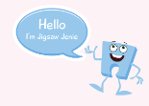

Nursery Curriculum Overview
Term 4 2025/2026
Expressive Arts and Design:
This term we are learning about the artist Frida Kahlo Paul Cézanne.
We will be learning a variety of songs and nursery rhyme.



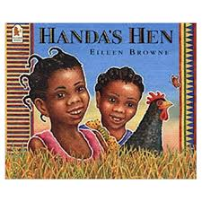
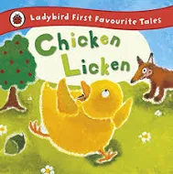

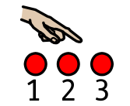
Literacy:
This term, our focus stories are:
Chicken Licken Handa’s Hen
This term, our focus nursery rhymes are:
Humpty Dumpty Hot Cross Buns
In pre-school, we will be continuing our Little Wandle Foundation for Phonics journey where we will be taking part in adult led phonic sessions. Our phonic focus this term will be ‘tuning into sounds’ with a focus on the following sounds: u r h b f l
Maths:
This term in maths, we will be learning to:
Subitise 1-3 on a dice and in everyday life.
Explore the numbers 3 and 4. Count up to 5 with finger manipulation. Use 1-1 to correspondence when counting amounts. Use positional language when talking about where things are. Talk about 3d shapes.
This term we will be learning these counting songs:
One man went to mow (up to 5).
Five Little Ducks
1,2 Buckle my shoe.



Understanding the World:
We will be learning about:
Seasonal changes – spring
Different celebrations that happen in spring.
Simple lifecycles of animals
Where animals live (habitats).

.

