**Personal, Social and Emotional Development:**

**Jigsaw PSED Relationships**

Through this topic, we will learn about: How to make friends if we feel lonely. What to say and do is someone is mean to me. How to work together and enjoy being with my friends.

**Physical Development:**

**Physical Development**

This term we will continue to:

Develop and gross and fine motor skills. Grasp and release with two hands to throw and catch a large ball, beanbag or an object. Run with spatial awareness and negotiating space successfully, adjusting speed or direction to avoid obstacles. Create lines and circles pivoting from the shoulder and elbow. Use one-handed tools and equipment. Use a comfortable grip with good control when holding pens and pencils.

**Communication and Language**

**This term, we will continue learning to:**

Continue to develop our oracy skills through nursery rhymes, stories and talk.

Develop our vocabulary by learning new words linked to our stories and learning

Understand questions and instructions that have two parts, such as: “Get your coat and wait at the door”.



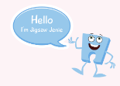

**Nursery Curriculum Overview**

**Term 5 2024/2025**

**Expressive Arts and Design:**

This term we are learning about the artist Claude Monet.

We will be learning a variety of songs and nursery rhyme.





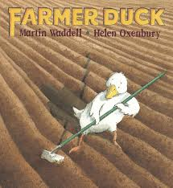

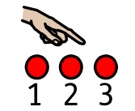

**Literacy:**

**This term, our focus stories are:**

The Three Billy Goats Gruff Farmer Duck

**This term, our focus nursery rhymes are:**

**I hear Thunder Mary Mary**

In pre-school, we will be continuing our Little Wandle Foundation for Phonics journey where we will be taking part in adult led phonic sessions.

**Maths:**

**This term in maths, we will be learning to:**

Subitise 1-3 on a dice and in everyday life.

Explore the number 5. Count up to 5 with finger manipulation. Compare numbers. Count with 1-1 correspondence. Sing a range of counting songs up to 5.



**Understanding the World:**

**We will be learning about:**

Growing plants.

.