Physical Development:
This term we will be learning to: Squiggle whilst you wiggle - Large up and down movements, anticlockwise circular movements. ). Explore mark making in different media, (chalk, pencils, pens, paint sticks) -large movements. Use lines and circles in our movements and marks. Sit comfortably on a chair with both feet on the ground. Run safely on whole foot. Show increasing control in holding, using and manipulating a range of tools and objects such as tambourines, jugs, hammers, and mark making tools

Communication and Language This term we will be learning to: . Listen with interest to the noises adults make when they read stories. Recognise and respond to many familiar sounds. Use language to share feelings, experiences and thoughts. Join in with repeated phrases in stories and rhymes.
Personal, Social and Emotional Development:
Children will be learning to: Build relationships with special people but may show anxiety in the presence of strangers.
Become more able to separate from their close carers and explore new situations with support and encouragement from another familiar adult.
Show a sense of autonomy through asserting their ideas and preferences and making choices and decisions.





Finches Nursery Curriculum Overview
Term 1 2026/2027
Expressive Arts and Design:
Focus Artist: Van Gough (Stary Night)
We will be learning to: Join in singing songs. Create sounds by rubbing, shaking, tapping, striking or blowing. Use everyday materials to explore, understand and represent their world – their ideas, interests and fascinations.
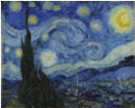


This Term’s Value: Trust


Maths:
This term in maths, we will be learning to: Compare and recognise changes in numbers of things, using words like more, lots or ‘same’. Count in everyday contexts, sometimes skipping numbers – ‘1,2,3,5. Take part in rhymes with numbers. Sort and group objects.
Our focus number rhymes are: Hickory Dickory Dock (to 1 and 2) 2 Little Dickie Birds

Literacy:
This term, our focus stories are: We’re Going on a Bear Hunt Goldilocks and the Three Bears
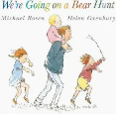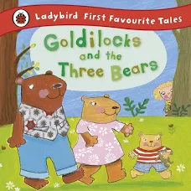
This term, our focus nursery rhyme is: Twinkle Twinkle Little Star
We will be learning to: Enjoy sharing books with an adult. Have some favourite stories, rhymes, songs, poems or jingles. Enjoy drawing freely.


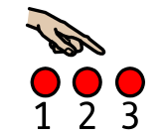

Understanding the World:
We will be learning about: Ourselves and our families.

.

