Physical Development:
Physical Development This term we will be learning to: Squiggle whilst you wiggle - Large up and down movements, anticlockwise circular movements. Use obstacle course (steps, balancing beams, jumping hoops). Climb up/ walk across/ jump off climbing equipment with support. Exploring mark making in different media, (chalk, pencils, pens, paint sticks) -large movements. To use lines and circles in our movements and marks.

Communication and Language This term we will be learning to: Understand more complex language. Listen to others in one to one or small groups. Join in with repeated refrains and anticipate key events and phrases in rhyme and stories. Use language to share experiences, feelings and thoughts. Use more complex sentences to link thoughts. Build up vocabulary.
Personal, Social and Emotional Development:
Jigsaw PSED Being Me This term we will be learning about: Who is me? How am I feeling today? Being at nursery Gentle hands Our rights Our responsibilities

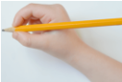

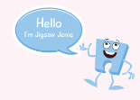
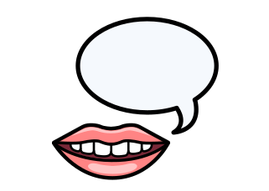

Robins Preschool Curriculum Overview
Term 1 2026/2027
Expressive Arts and Design:
Focus Artist: Van Gough (Stary Night)
We will be learning to: Recognise colours/ choose colours for a purpose. Use thick paint brushes. Mark make thick and thin lines. Paint representations of our faces Sing a range of songs/rhymes
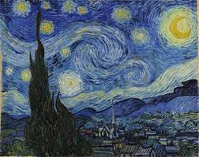

This Term’s Value: Trust



Literacy:
This term, our focus stories are: We’re Going on a Bear Hunt Goldilocks and the Three Bears
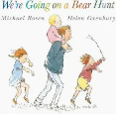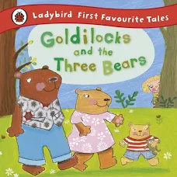
This term, our focus nursery rhymes are: Twinkle Twinkle Little Star Jack and Jill
We will be learning to develop our phonological awareness by playing listening games.
We will be learning to use a story map to orally re-tell a familiar story.

Maths:
This term in maths, we will be learning to: Count in 1s to 5 (pre-schoolers) Use fingers to represent amounts to 3/5. Compare amounts using the words ‘more’ and ‘few’. Sing simple counting songs. Use and understand the words ‘in’ and ‘on’. Use language in everyday contexts to show the passing of time. Name some 3d shapes. Use informal language to describe 3d shapes.
Our focus number rhymes are: 1,2 3.4,5 Once I Caught a Fish Alive. One Potato, Two Potato.


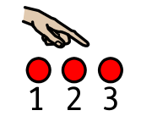

Understanding the World:
We will be learning about: Ourselves and our families.

.

