
Curriculum Intent
PSHE is at the heart of our school ethos and learning and it makes up part of our inner curriculum. Our PSHE curriculum aims to develop the whole child intellectually, morally, socially and spiritually in order to nurture rounded individuals with a strong sense of moral understanding and responsibility. This is promoted through our Southbroom CALM code. Alongside our CALM code, we promote our Southbroom values through assemblies and lessons. Our Southbroom values are: respect, friendship, honesty, responsibility, patience, happiness, trust, courage, caring, understanding, thoughtfulness and appreciation. At Southbroom Infant School, we offer a broad and balanced curriculum which promotes the spiritual, moral, cultural, mental and physical development of pupils at the school and of society. We endeavour to prepare pupils at the school for the opportunities, responsibilities and experiences of later life.
Curriculum Implementation
We use the Jigsaw scheme of work which was updated to meet the DfE statutory guidance for Health education, relationships education and RSE.
This scheme follows the key themes of:
Autumn 1: Being Me in My World
Autumn 2: Celebrating Difference (including antibullying)
Spring 1: Dreams and Goals
Spring 2: Healthy Me Summer 1: Relationships
Summer 2: Changing Me
All pupils in Nursery through to Year 2, learns about the key themes above.

PSHE
in a Nutshell

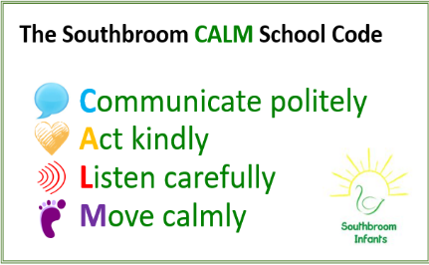

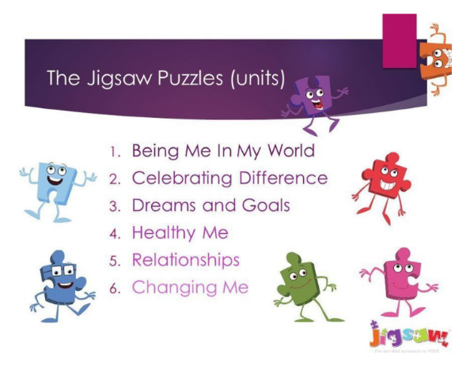

Southbroom CALM code
Our CALM code supports our pupils to grow in a safe and secure environment and to become positive, responsible and increasingly independent members of the school community who can take care of themselves, each other and the world they live in.
Curriculum Impact
Ongoing formative assessment takes place throughout the year through discussion, observations and pupil’s work. This informs teachers of pupils next steps and supports us to plan effectively for our inner curriculum.
British Values
Through assemblies, visitors to the school and lessons, we ensure the children have an awareness of the main British values. These are: democracy, the rule of law, individual liberty, mutual respect and tolerance of those with different faiths and beliefs. This helps them to become active and responsible citizens

