

Curriculum Intent

At Southbroom Infant School, we believe that all our children can become fluent readers and writers. We start teaching phonics in Nursery/Reception and follow the [*Little Wandle Letters and Sounds Revised* progression](https://www.littlewandlelettersandsounds.org.uk/wp-content/uploads/2021/06/Programme-Overview_Reception-and-Year-1.pdf), which ensures children build on their growing knowledge of the alphabetic code, mastering phonics to read and spell as they move through school.

As a result, it is our intention that all children are able to tackle any unfamiliar words as they read. At Southbroom Infant School,we also model the application of the alphabetic code through phonics in shared reading and writing, both inside and outside of the phonics lesson and across the curriculum. We have a strong focus on language development for our children because we know that speaking and listening are crucial skills for reading and writing in all subjects.

Curriculum Implementation

We follow the Little Wandle Letters and Sounds Revised programme. The Little Wandle programme is taught as a daily lesson to all children and is regularly assessed to check where the learning gaps are. At Southbroom Infants we ensure that each child feels successful in their learning so every reading book that is given to a child will be phonically decodable and will match their phonic level. We ensure that regular reading sessions are held where the children can enjoy books and adults model the importance of reading books for pleasure.

As part of this initiative, all children at Southbroom Infants choose a book for pleasure from our school library. This is a book that the children can share with a family member alongside their phonically decodable book.

When pupils are secure within phase 5 phonics, they move onto a whole class teaching of reading approach which focuses on the key reading skills; vocabulary, retrieval, inference and the continuation of developing prosody. These skills are developed through the use of high-quality texts.

|  |
| --- |
| Phonic lesson structure |
| **Revisit and Review**- Children revisit all of the GPCs, some words with previous GPCs and tricky words taught so far |
| **Teach**- Children will be taught the new GPC and matching grapheme for that lesson, including formation of the grapheme. They will also be introduced to a new tricky word |
| **Practise**- Children use the new GPC to apply it in different ways such as oral blending, reading and writing. |
| **Apply**- This will be a consolidation of the lesson using the GPC taught through either reading or writing. This will also include the new tricky word from earlier in the lesson. |

Phonics and Early Reading

in a Nutshell

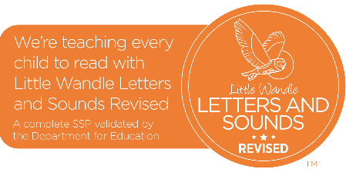2024/25

Curriculum Impact

At Southbroom Infant School we aim to ensure that children master the necessary sounds, keywords and reading skills to achieve the age-related benchmarks at appropriately mapped out time points. We aim for all pupils at Southbroom Infants to leave our school with a passion for reading and to have obtained all the skills they need to access and enjoy any book of their choosing.