
Curriculum Implementation
At Southbroom Infants we ensure that the teaching of science is supported by a clear skills and knowledge progression. This ensures that skills and knowledge are built on year by year and sequenced appropriately to maximise learning for all children. We believe that the frequency and range of children’s personal experiences increases their knowledge and sense of the world around them. Enriching opportunities such as STEM week, weekly outdoor learning in Key Stage 1 and cross curricular links ensure science is valued across our school.
Children have weekly science lessons building. Units of work are planned so that knowledge and skills and built upon, revisited and working scientifically is at the heart of science at Southbroom. Children learn to work scientifically through learning skills for pattern seeking, research, fair testing, observation over time, and identifying and classifying all within the context of the unit of study.
Curriculum Intent
At Southbroom Infants school we aim to prepare our children for their future with a “hands –on” science curriculum that enables them to confidently explore and discover the world around them. We motivate and actively engage our children, to nurture and grow their curiosity. In the early years understanding of the world is a specific area of learning which involves guiding children to make sense of their physical world around them. Core scientific knowledge is delivered through direct teaching, experimentation and exploration. As pupils progress, they are encouraged to think critically, develop a more rigorous understanding of scientific concepts and understand how the sciences shape our future and contribute to wealth of our nation.

Science
in a Nutshell

2024/25
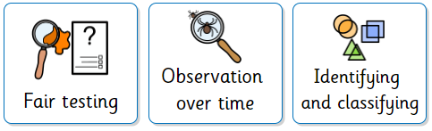
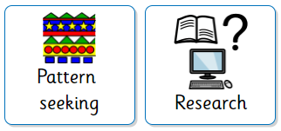
Curriculum Impact
Ongoing formative assessment takes place throughout the year via observation and pupil conferencing and assessment lessons. Teachers use this information to inform future lessons; ensuring children are supported and challenged appropriately. Age related expectation levels are reported to parents at the end of the year.

