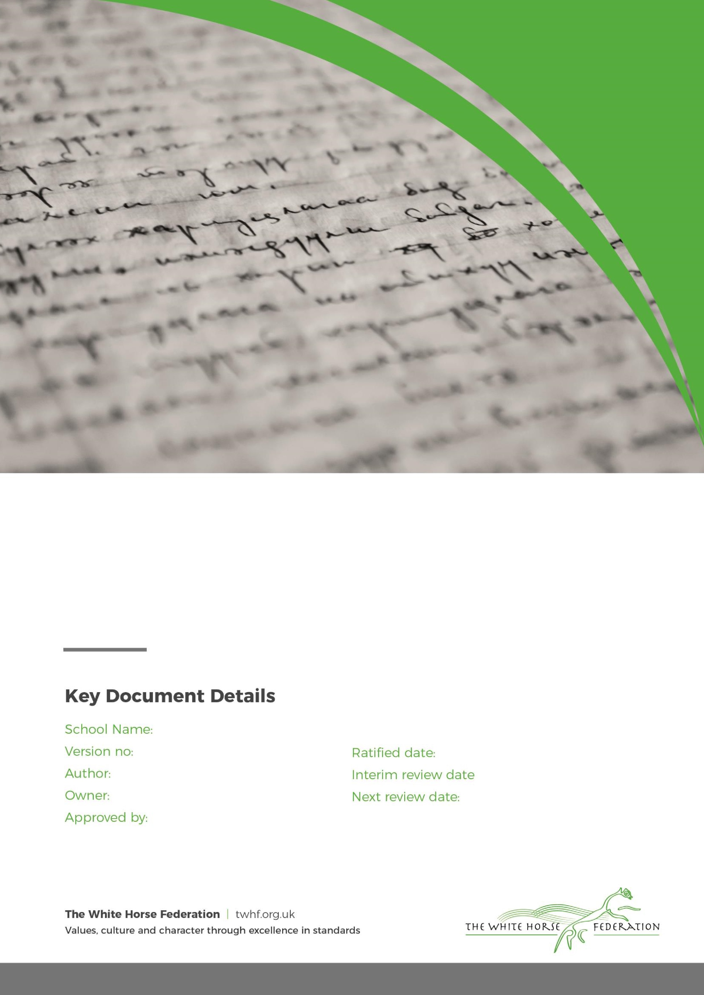

1

A Edwards

A Edwards

S Cowley

Sept 2023

n/a

Sept 2024

Southbroom Infants’ School

Introduction

The Collective Worship at Southbroom Infants’ School pays due regard to statutory requirements. In line with the Education Act 1996 (Schedule 31) teaching ‘shall reflect the fact that the religious traditions in Great Britain are in the main Christian, while taking account of the teaching and practices of the other principal religious represented in Great Britain.’

At Southbroom Infants’ School, every child matters and we foster a community that lays the foundations for academic, personal and social success. Underpinning this culture, are our school’s values: Respect, Trust, Friendship, Courage, Honesty, Care, Responsibility, Understanding, Patience, Thoughtfulness, Happiness and Appreciation.

In addition to our school’s values, we also actively promote British values though our school vision, ethos, agreed rules, curriculum and teaching. As such, we promote tolerance of, and respect for, people of all faiths (or those with no faith), cultures and lifestyles. We prepare children and young people positively for life in modern Britain by supporting them through our words, actions, and influence, not just within school, but also within the wider community. Assemblies are conducted in a manner that is sensitive to the individual faiths and beliefs of all members of the school.

At Southbroom Infants School, we believe that Collective Worship should aim to:

- Give expression to, reaffirm and practice the values of the school community and promote British values of respect for the law, democracy, equality and tolerance of different faiths and religious and other beliefs.
- Strengthen and support the school community and individual members.
- Provide an experience that promotes the social, moral, spiritual and cultural development of pupils
- Provide an opportunity for personal and shared reflection and response to fundamental questions of life
- Be based on a broadly Christian nature whilst also reflecting other faiths
- Celebrate and give thanks for achievements within the school, local and international community and occasions of significance, including festivals
- Foster a respect for self and engender a concern for the needs of others.

Collective Worship

Collective Worship can be related to the day-to-day life, aspirations and concerns of the pupils and the school, and must preserve the integrity of all its members. They can come together to affirm and celebrate experiences of worth to them all. It offers all pupils an opportunity to worship through engaging in relevant, meaningful experiences and provides opportunities for the pupils’ spiritual, moral, social and cultural development.

As an Academy school the funding agreement states that each pupil must take part in a daily act of collective worship unless their parents have withdrawn them. The collective worship must be mainly of a broadly Christian character but can reflect the religious backgrounds represented in the community, as long as the majority of provision is broadly Christian. The following principles apply:

Aims for the school:

- All pupils take part in a daily act of collective worship or reflection.
- Share common values and aims
- Celebrate achievement and special times
- Explore together the world in which we live
- Develop a community spirit
For the pupils, opportunities to:

- Take part in Collective Worship/reflection which may be held at any time during the school day, either on or off the school premises.
- Consider the whole person
- Explore own beliefs
- Develop their own spirituality
- Reinforce common ethos and values
- Reinforce positive attitudes
- Develop a sense of community spirit
- Encourage participation and response
- Reflect on what is considered worthy

The Organisation of Collective Worship

The Principal/Head of School or other members of staff normally lead assembly, but sometimes local clergy or other representatives of local religious groups are invited into the school.

- We conduct assemblies in a dignified and respectful way. Children are expected to behave in an appropriate way as this time is a period of calm reflection
- We take themes of our assemblies that link to our school’s values and of the Christian and other faiths, and we often reflect the festivals and events of the religious calendars. At other times the school RE leader will set an assembly timetable based on the PSHE and RE curriculum to reinforce the values and topics being taught across the school.
- We would like to welcome parents and Governors to attend our assemblies, however, we can only do this in phases due to space. It is valued because its promotes the community spirit of the school and is a practical demonstration of the way the home and the school work together to support the achievements of our children in all aspects of their lives. The school will set dates for parents to be invited at the beginning of each term.

Withdrawal
Parents have the right to withdraw their children from Collective Worship. This school expects that withdrawal will only be made following discussions with the Principal and followed by written confirmation of withdrawal. The school will make arrangements to supervise withdrawn children but no additional or set work will be followed during this time.

Teachers and Principals wishing to withdraw from Collective Worship must apply in writing to the Chair of Governors giving a full explanation of the reason for withdrawal. The Principal maintains statutory accountability even if the right to withdraw is granted by the governing body.

