

**Southbroom Infant School**

**Equality, Diversity & Inclusion Plan 2024-25**

**Values & Vision statement:**

At Southbroom Infants, we encourage all of our pupils to be the best versions of themselves, all of the time. We do this through teaching and living our school values which encourage our children to be life-long learners who can self-regulate and fully understand right from wrong. These values, when embedded, allow our children to be ready for the next phase of their life and to promote excellent citizens in our local community. Our values are also the vehicle to promote a sense of identity, inclusion and they support our children’s personal development, well-being and safety.

|  |  |
| --- | --- |
| **2024 - 2025** | **2025-2026** |
| Term 1 – Trust | Term 1 – Respect |
| Term 2 – Courage | Term 2 – Friendship |
| Term 3 – Caring | Term 3 – Honesty |
| Term 4 – Understanding | Term 4 – Responsibility |
| Term 5 – Thoughtfulness | Term 5 – Patience |
| Term 6 - Appreciation | Term 6 - Happiness |

Our children use the CALM Code around school and this helps maintain a safer and calmer learning environment.

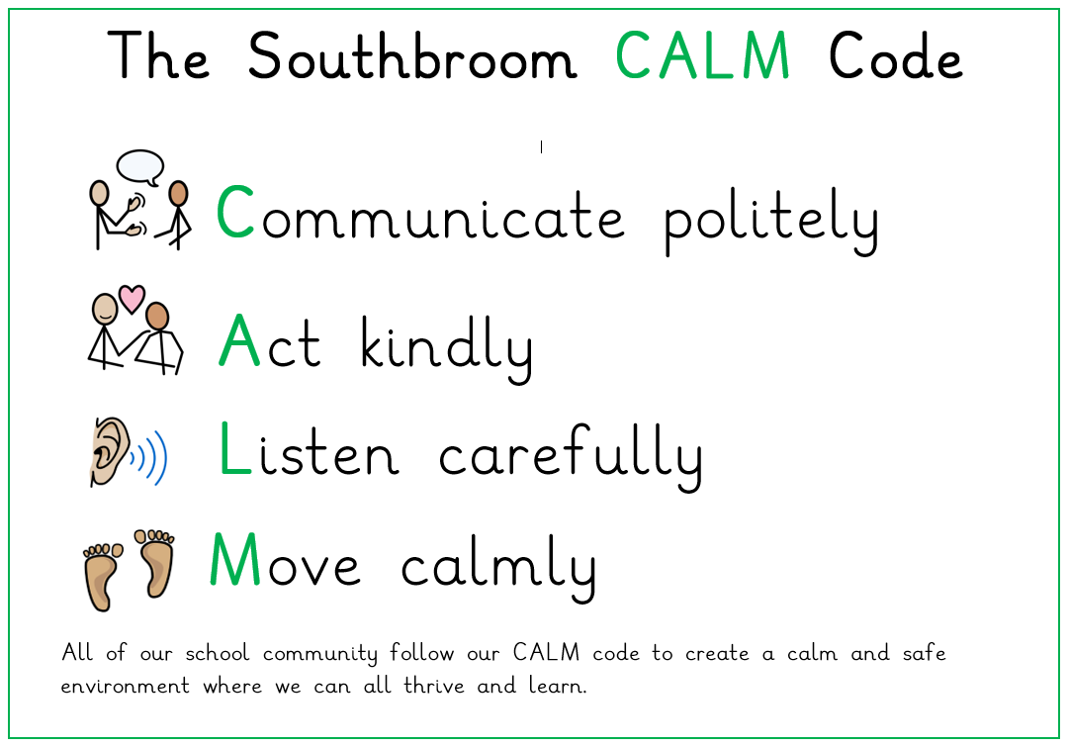

At Southbroom Infants, we aim to provide a broad and ambitious curriculum and learning environment which inspires each child’s passion for learning. Our curriculum provides a wealth of opportunities for pupils to broaden their understanding of the wider world and is underpinned by four strands, unique to our context: knowledge and skills rich, vocabulary rich, understanding rich, experience rich and with our main golden thread of our values which binds our curriculum together. Our vision, is based on the premise that all children have the right to fulfil their unlimited potential, irrespective of background, and develop into independent, healthy and confident individuals who achieve the very best that they can. We constantly seek ways to motivate and inspire children so that learning is interesting and achievement is high. It is very important that parents and the school work in partnership to provide the very best start to the children’s academic lives.

Ongoing self-evaluation is recognised by leaders as crucial to the school’s continued success.

**Mainstreaming equality into policy and practice:**

The school operates equality of opportunity in its day-to-day practice in the following ways:

**Teaching and learning**

We aim to provide all our pupils with the opportunity to succeed, and to reach the highest level of personal achievement. To do this, we will:

• Use our school’s Values as a set of core principles to underpin our pupils’ conduct, actions and behaviours;

• Use contextual data effectively to improve the ways in which we provide support to individuals and groups of pupils;

• Monitor achievement data by ethnicity, gender, SEN and disability and action any gaps;

• Take account of the achievement of all pupils when planning for future learning and setting challenging targets;

• Ensure equality of access for all pupils and prepare them for life in a diverse society;

• Use materials that reflect the diversity of the school, population and local community in terms of race, gender and disability, without stereotyping;

• Promote attitudes and values that will challenge racist and other discriminatory behaviour or prejudice;

• Provide opportunities for pupils to appreciate their own culture and celebrate the diversity of other cultures;

• Seek to involve all parents in supporting their child’s education;

• Encourage classroom and staffroom discussion of equality issues which reflect on social stereotypes, expectations and the impact on learning;

• Include teaching and classroom-based approaches appropriate for the whole school population, which are inclusive and reflective of our pupils.

**Admissions and exclusions**

Our admissions arrangements are fair and transparent and do not discriminate on race, gender, disability or socio-economic factors.

Suspensions and exclusions will always be based on the school’s Behaviour Policy. We will closely monitor suspensions and exclusions to avoid any potential adverse impact and ensure any discrepancies are identified and dealt with.

**Equal Opportunities for Staff:**

This section deals with aspects of equal opportunities relating to staff at Southbroom Infants.

We are committed to the implementation of equal opportunities principles and the monitoring and active promotion of equality in all aspects of staffing and employment.

All staff appointments and promotions are made on the basis of merit and ability and in compliance with the law. However, we are concerned to ensure wherever possible that the staffing of the school reflects the diversity of our Southbroom community.

**Employer duties:**

As an employer, we need to ensure that we eliminate discrimination and harassment in our employment practice and actively promote equality across all groups within our workforce. Equality aspects such as gender, race, disability, sexual orientation, gender re-assignment and faith or religion are considered when appointing staff and particularly when allocating Teaching and Learning Responsibilities (TLR) or re-evaluating staff structures, to ensure decisions are free of discrimination.

Actions to ensure this commitment is met include:

• Monitoring recruitment and retention, including bullying and harassment of staff;

• Continued professional development opportunities for all staff;

• Senior Leadership Team support to ensure equality of opportunity for all.

**Equality and the law:**

There are a number of statutory duties that must be met by every school in line with legislation from the Disability Equality Duty (2005), Equality Act (2006) and the Equality Act (2010) Public Sector Equality Duty.

Under the Equality Act 2010, it is unlawful to discriminate against a pupil or prospective pupil by treating them less favourably on the basis of a ‘protected characteristic.’ The protected characteristics are:

• Sex

• Race

• Disability

• Religion or belief

• Sexual orientation

• Gender reassignment

• Pregnancy or maternity

A person’s age is also a protected characteristic in relation to employment, and in regard to the provision for goods and services. It does not however apply to pupils, and so the school is free to arrange pupils in classes based on their age group with materials appropriate to them.

The Equality Act 2010 introduced a single Public Sector Equality Duty which applies to public bodies, including schools that are either LA maintained or an Academy. The school must have due regard to the need to:

• Eliminate discrimination and other conduct that is prohibited by the act.

• Advance equality and opportunity between people who share a prohibited characteristic and people who do not share it.

• Foster good relationships across all characteristics, between people who share a protected characteristic and people who do not share it.

• Having due regard in this context means that when significant decisions are being taken, thought must be given to the equality implications.

**Race Equality**

The definition of race includes colour, nationality and ethnic or national origins.

**Disability**

This section should be read in conjunction with the school’s Special Educational Needs Policy and Accessibility Strategy.

The Equality Act 2010 defines a disabled person as someone who has ‘a physical or mental impairment which has a substantial or long-term adverse effect on their ability to carry out normal day-to-day activities’.

People with HIV, multiple sclerosis and cancer (although not all cancers) are deemed disabled before they experience the long-term and substantial adverse effect on their activities.

Section 18 has been amended so that individuals with a mental illness no longer have to demonstrate that it is “clinically well-recognised”, although the person must still demonstrate a long-term and substantial adverse impact on their ability to carry out normal day-to-day activities.

**Legal duties**

The Equality Act 2010 places a general duty on schools, requiring them to have due regard for the following when carrying out and delivering services:

• Promoting equality of opportunity between disabled people and other people;

• Eliminating discrimination and harassment of disabled people that is related to their disability;

• Promoting positive attitudes towards disabled people;

• Encouraging participation in public life by disabled people;

• Taking steps to meet disabled people’s needs, even if this requires more favourable treatment. Under our specific duty, we will:

• Prepare and publish an Equality Plan, which covers the requirements for a Disability Equality Scheme, identifying our disability equality goals and actions to meet them;

• Review and revise this Scheme every three years.

**Gender Equality**

The Gender Equality Duty 2006 places a general and specific duty on schools to eliminate unlawful discrimination and harassment on the ground of gender and to promote equality of opportunity between female and male pupils and between women and men and transgender people. Under our general duty we will actively seek to:

• Eliminate unlawful discrimination and harassment on grounds of sex and gender reassignment;

• Promote equality between men and women.

Under our specific duty, we will:

• Prepare and publish an Equality Plan which covers the requirements for a Gender Equality Scheme identifying our gender equality goals and actions to meet them;

• Review and revise this Scheme every three years.

The Equality Act 2006 made provision for regulations to be introduced to extend protection against discrimination on grounds of religion or belief to sexual orientation. The Equality Act (Sexual Orientation) Regulations 2007 came into force on 30 April 2007 and makes discrimination unlawful in the area of goods, facilities and services on grounds of sexual orientation. For schools this means admissions, benefits and services for pupils and treatment of pupils.

**Community cohesion**

The Education and Inspections Act 2006 inserted a new section 21(5) to the Education Act 2002 introducing a duty on the governing bodies of state schools to promote community cohesion.

Community cohesion encompasses promoting good relations between pupils from different races, faiths / beliefs and socio-economic backgrounds. The duty came into force on 1 September 2007.

**Consultation and involvement:**

It is a requirement that the development of this plan and the actions within it have been informed by the input of staff, pupils and parents and carers. We have achieved this by using the following to shape the plan:

• Input from staff surveys or through staff meetings / INSET;

• Feedback from the School Council, PSHE/RHSE lessons or wider pupil surveys;

• Issues raised in annual reviews or reviews of progress on Individual Education Plans/Personalised Provision Maps, mentoring and support;

• Feedback at Local Governing Body meetings.

**Roles and Responsibilities:**

**The Role of Governors**

The governing body has set out its commitment to equal opportunities in this plan and it will continue to do all it can to ensure that the school is fully inclusive to pupils, and responsive to their needs based on the protected characteristics.

The governing body seeks to ensure that people are not discriminated against when applying for jobs at our school on grounds of the protected characteristics.

The governors take all reasonable steps to ensure that the school environment gives access to people with disabilities, and also strives to make school communications as inclusive as possible for parents, carers and pupils.

The governors welcome all applications to join the school, whatever a child’s socio-economic background, race, gender or disability.

The governing body ensures that no child is discriminated against whilst in our school on account of their race, sex or disability, gender, religion and belief or the fact that they may be undergoing gender reassignment.

**The Role of the Headteacher**

It is the headteacher’s role to implement the school’s Equality Plan and they are supported by the governing body in doing so.

It is the headteacher’s role to ensure that all staff are aware of the Equality Plan, and that teachers apply these guidelines fairly in all situations.

The headteacher ensures that all appointment panels give due regard to this plan, so that no-one is discriminated against when it comes to employment or training opportunities.

The headteacher promotes the principle of equal opportunity when developing the curriculum, and promotes respect for other people and equal opportunities to participate in all aspects of school life. The headteacher treats all incidents of unfair treatment and any incidents of bullying or discrimination, including racist incidents, with due seriousness.

**The role of all staff:** **teaching and non‐teaching**

All staff will ensure that all pupils are treated fairly, equally and with respect, and will maintain awareness of the school’s Equality Policy and objectives.

All staff will strive to provide material that gives positive images based on race, gender and disability, and challenges stereotypical images.

All staff will challenge any incidents of prejudice, racism or homophobia, and record any serious incidents, drawing them to the attention of the headteacher.

Teachers support the work of wider school ancillary staff or support staff and encourage them to intervene in a positive way against any discriminatory incidents.

**Tackling discrimination:**

Harassment or victimisation on account of race, gender, disability or sexual orientation, gender reassignment or pregnancy is unacceptable and is not tolerated within the school environment.

All staff are expected to deal with any discriminatory incidents that may occur. They are expected to know how to identify and challenge prejudice and stereotyping, and to support the full range of diverse needs according to a pupil’s individual circumstances.

Staff and governors should be aware of both direct and indirect discrimination and understand the differences.

**Direct discrimination** occurs when one person treats another less favourably because of a protected characteristic.

**Indirect discrimination** occurs when a ‘provision, criterion or practice’ is applied generally but has the effect of putting people with a particular characteristic at a disadvantage.

Racist and homophobic incidents and other incidents of harassment or bullying are dealt with by the member of staff present, escalating to a class teacher / headteacher where necessary. All incidents are reported to the headteacher and racist incidents are reported to the governing body and local authority on a termly basis.

**What is a discriminatory incident?**

**Harassment** is defined in the Equality Act 2010 as “unwanted conduct, related to a relevant protected characteristic, which has the purpose or effect of violating a person’s dignity or an intimidating, hostile, degrading, humiliating or offensive environment for that person”

**Victimisation** occurs when a person is treated less favourably, than they otherwise would have been because of something they have done (“a prohibited act”) in connection with the Act. Eg. Making an allegation of discrimination.

**Types of discriminatory incident**s

Types of discriminatory incidents that can occur are:

• Physical assault against a person or group because of their colour, ethnicity, nationality, disability, sexual orientation or gender;

• Use of derogatory names, insults and jokes;

• Racist, sexist, homophobic or discriminatory graffiti;

• Provocative behaviour such as wearing racist, sexist, homophobic or discriminatory badges or insignia;

• Bringing discriminatory material into school;

• Verbal abuse and threats;

• Incitement of others to discriminate or bully due to victim’s race, disability, gender or sexual orientation;

• Discriminatory comments in the course of discussion;

• Attempts to recruit others to discriminatory organisations and groups;

• Ridicule of an individual for difference e.g. food, music, religion, dress etc;

• Refusal to co-operate with other people on the grounds of race, gender, disability or sexual orientation.

**Responding to and reporting incidents**

It should be clear to pupils and staff how they report incidents. All staff, teaching and non-teaching, should view dealing with incidents as vital to the well-being of the whole school. A suggested procedure for responding and reporting is outlined below:

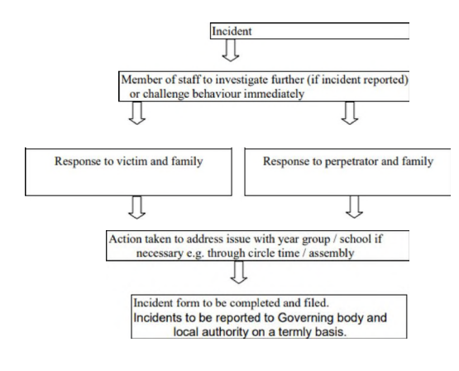

**Review of progress and impact:**

The objectives have been agreed by our Governing Body. We have a rolling programme for reviewing our school policies and their impact. In line with legislative requirements, we will review progress against our Equality objectives annually and review the entire plan and accompanying action plan on a four-year cycle.

We make regular assessments of pupils’ learning and use this information to track pupil progress.

As part of this process, we regularly monitor achievement by ethnicity, gender and disability, to ensure that all groups of pupils are making the best possible progress, and take appropriate action to address any gaps.

**Publishing the objectives and demonstrating compliance:**

In order to meet the statutory requirements to publish information to demonstrate how they are complying with the Public Sector Equality Duty and to prepare and publish objectives, we will:

• Raise awareness of the objectives through the school newsletter, assemblies, staff meetings and other communications;

• Make sure hard copies are available. Information that demonstrates how the school is complying will be published at least annually, and information on objectives at least every four years.

Publication of information in future years should include evidence of the progress made against the objectives set. The information released does not simply have to be statistical data but can for example include minutes from governing body meetings that demonstrates progress.

|  |  |  |  |
| --- | --- | --- | --- |
| **Equality Objectives 2024-2025** | | | |
| **Objective 1** | **Key actions** | **Timeframe** | **Responsible** |
| To continue to promote cultural understanding and awareness of different religious beliefs between different ethnic groups, through a broad and balanced curriculum and effective PSHE delivery. | * Implemented PSHE/RSE scheme across the school, including whole school assemblies. * Termly assemblies linking a different religion to our values. * Implementations of RE scheme. * Mark and education children on different religious celebrations and their significance. * • Continue to teach British Values through assemblies and curriculum | September 2024 – July 2025 | All Staff |
| **Objective 2** | **Key actions** | **Timeframe** | **Responsible** |
| To ensure that there is proportional representation of diverse groups, for example through literature and images. | * Continue to celebrate diversity in temporary and permanent displays. * Develop the breadth of diversity in reading books, both fiction and non-fiction. * Celebrate diverse international events through assemblies and whole school activities. * • Across the curriculum, key groups will be represented through pictures, scenarios and focuses within lessons. | September 2024 – July 2025 | SLT + All Staff |
| **Objective 3** | **Key actions** | **Timeframe** | **Responsible** |
| Ensure that access to a broad and balanced curriculum is considered in terms of visible and invisible barriers, especially for students eligible for free-school meals, students with special educational needs and disabilities, looked after children and students from minority ethnic groups. | * Ensure all pupils are included in full curriculum. * Only short interventions (time or period) are used, to ensure access to all subjects – this is for all pupils. * Provide additional resources to support children to access the curriculum. * Scaffold and adapt learning as appropriate. * • Ensure all pupils are supported to attend all trips. | September 2024 – July 2025 | SLT + All Staff |
| **Objective 4** | **Key actions** | **Timeframe** | **Responsible** |
| Actively close gaps in attainment and achievement between students and groups of students especially students eligible for freeschool meals, students with special educational needs and disabilities, looked after children and students from minority ethnic groups. | * Quality First Teaching uses to support all pupils. * Use PP and SEN funding to support learning. * Use catch-up funds to support attainment gaps. * Use RAG meetings to monitor progress and support new strategies. * Uses funds to support additional resourcing and resources to aide progression. | September 2024 – July 2025 | SLT |
| **Objective 5** | **Key actions** | **Timeframe** | **Responsible** |
| To monitor and analyse pupil achievement by race gender, disability and EAL and act on any trends or patterns in data that require additional support. | Pupil achievements for equality groups is at least in line with national benchmarks, with gaps narrowed through effective monitoring and intervention. Achievement of EAL pupils is closely monitored and interventions implemented when necessary. | September 2024 – July 2025 | SLT |
| **Objective 6** | **Key actions** | **Timeframe** | **Responsible** |
| To communicate our commitment to equality and diversity with the wider community e.g. parents, LGC and other groups, to seek their support to enhance inclusion. | * Communicate our policies and intentions with the LGC and parents. * Share learning with parents through school communications avenues. * Expect high standards from all adults. | September 2024 – July 2025 | SLT |