Handwriting and Presentation Policy

School Name: | Southbroom Infants’ School
Version No: | 1 | Ratified date: | September 2023
Author: | T.Butcher | Interim review date: | n/a
Owner: | A.Edwards | Next review date: | September 2024
Approved by:

At Southbroom Infant school, we take pride in children’s handwriting and presentation and encourage our pupils to take care over their work. As a school we use Letter-join as a basis of our handwriting policy which covers the requirements of the National Curriculum.

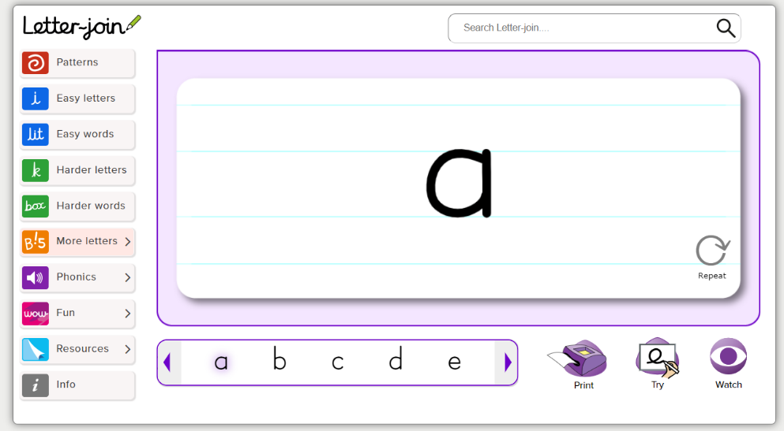

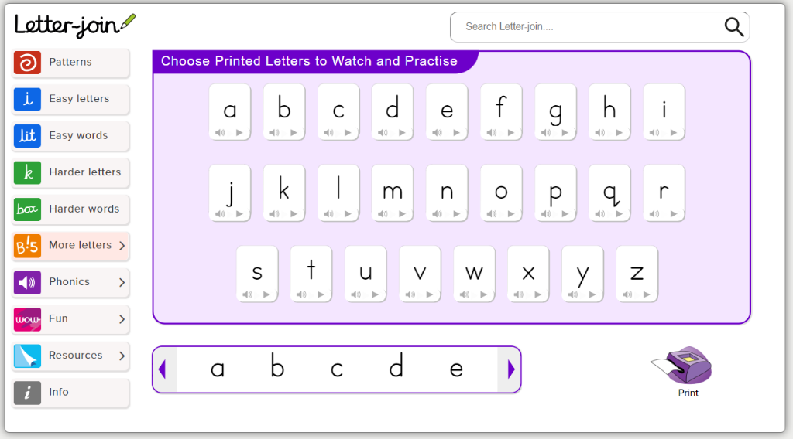

Handwriting is a basic skill that influences the quality of work throughout the curriculum.

Our Aims:
- At the end of key stage 1, we intend pupils should have the ability to produce clear, legible writing printing their letters carefully and correctly.
- We aim to make handwriting an automatic process that does not disrupt the creative and mental thinking of the children.
- To establish and maintain high expectations for the presentation of written work.

Expectations:
All teaching staff are encouraged to model the printed style of handwriting, whether on whiteboards, displays or in pupils’ books. Throughout the school Pupils should experience coherence and continuity in the learning and teaching of handwriting across all school years and be encouraged to take pride in the presentation of their work. Our objective is to help pupils enjoy learning and developing their handwriting with a sense of achievement and pride. Children will use a sharp pencil to establish consistency with their handwriting.

Handwriting Frequency:
Handwriting is a cross-curricular task and will be taken into consideration during all lessons. Formal teaching of handwriting will be carried out regularly and systematically to ensure Key Stage targets are met.

Inclusion:
For children who experience handwriting difficulties due to fine motor development, including those who are left-handed and those with special educational needs, the appropriate additional support will be put into place. Letter-join’s Lesson Planners all include differentiation activities for extra practice/challenge.
Early Years
In the Early Years there is a big emphasis upon gross motor skills and fine motor skills. We use a range of resources to practice these basic skills. This moves into correct letter and number formation with a focus on both upper-case and lower-case letters. This will be used alongside our systematic synthetic phonics programme Little Wandle. Within Little Wandle there are rhymes which also help the children with the formation of letters. As a result, the children will develop a print style of writing.

Key Stage One:
Handwriting will be taught regularly across the week following the letter join planning and teaching resources. This will increase as the children enter into year 2.

Year One | Opportunities for writing linked to their interests and text led approach in school:  - Continue fine motor activities as above as and when appropriate for individual/ groups of children.  - Encourage correct sitting when doing best handwriting (as appropriate).  - Teach letter formation as they are taught in phonics and linked to letter-join scheme.  - Practice printing in handwriting books during taught sessions.  - Provide challenges in outside and inside area as appropriate for individuals  - Provide opportunities during continuous provision for children to practice handwriting skills.
Year Two | Opportunities for writing linked to their interests and text led approach in school:  - Explicit teaching of handwriting joins – systematic approach to ensure all joins are taught correctly using Letter-join  - Consistent printed handwriting.  - Practice printing in handwriting books during taught sessions.  - To print letters consistently and accurately across all subjects.  - Interventions for those not forming letters correctly or not consistent with size of letters.

Pupils should be taught to sit correctly at a table, holding a pencil comfortably and correctly.

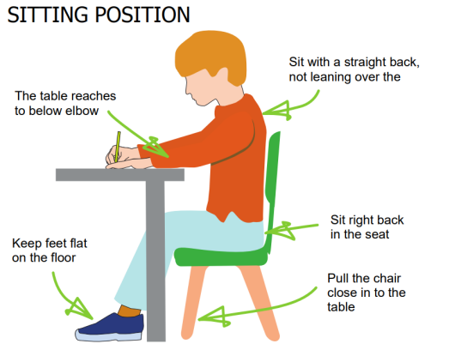

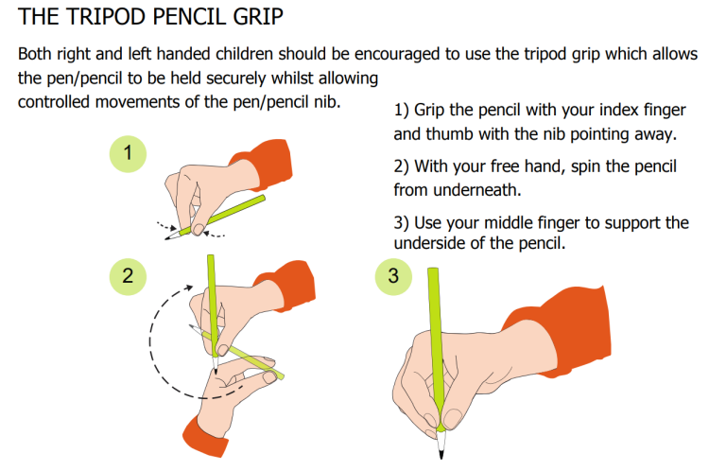

Impact:
Our policy enables pupils to develop a neat, legible handwriting style using printed letters by the end of Year 2 that leads to producing letters and words automatically in independent writing.

EYFS
By the end of the EYFS, children will be able to:
✓ Begin to sit in the correct position and hold a pencil correctly to allow fluid movement of the tip.
✓ Improve fine and gross motor skills by enjoying drawing print patterns in a variety of writing materials such as: modelling clay, air writing, sand trays, felt pens, crayons, pencils, IWB, tablets. ✓ Understand the language needed to describe pencil movements in preparation of letter formation.
✓ Hold a pencil in an effective manner for writing and be encouraged to correct any errors in grip or stature
✓ Understand that letters are written on a base line and that all letters start from the same place.

KS1
By the end of KS1, children will be able to:
✓ Write legibly using upper and lower case letters.
✓ Ensure that letters sit on the base line and are consistent in size with ascenders and descenders that are the correct length and formation.
✓ Leave the correct space between words.
✓ Form capital letters and use where appropriate.
✓ Form numerals that are consistent in size and sit on the base line.
✓ Begin to form printed letters and understand when they are to be used.
✓ Improve the speed of writing and begin to write automatically so promoting creativity in independent writing

