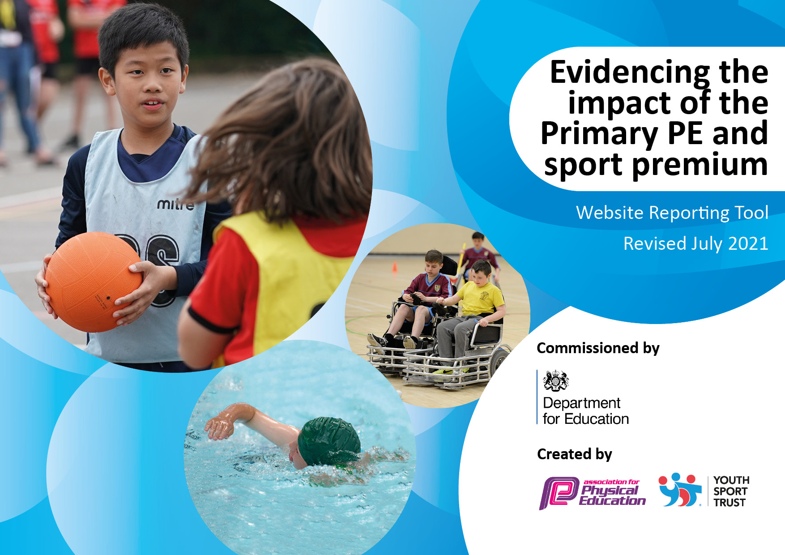

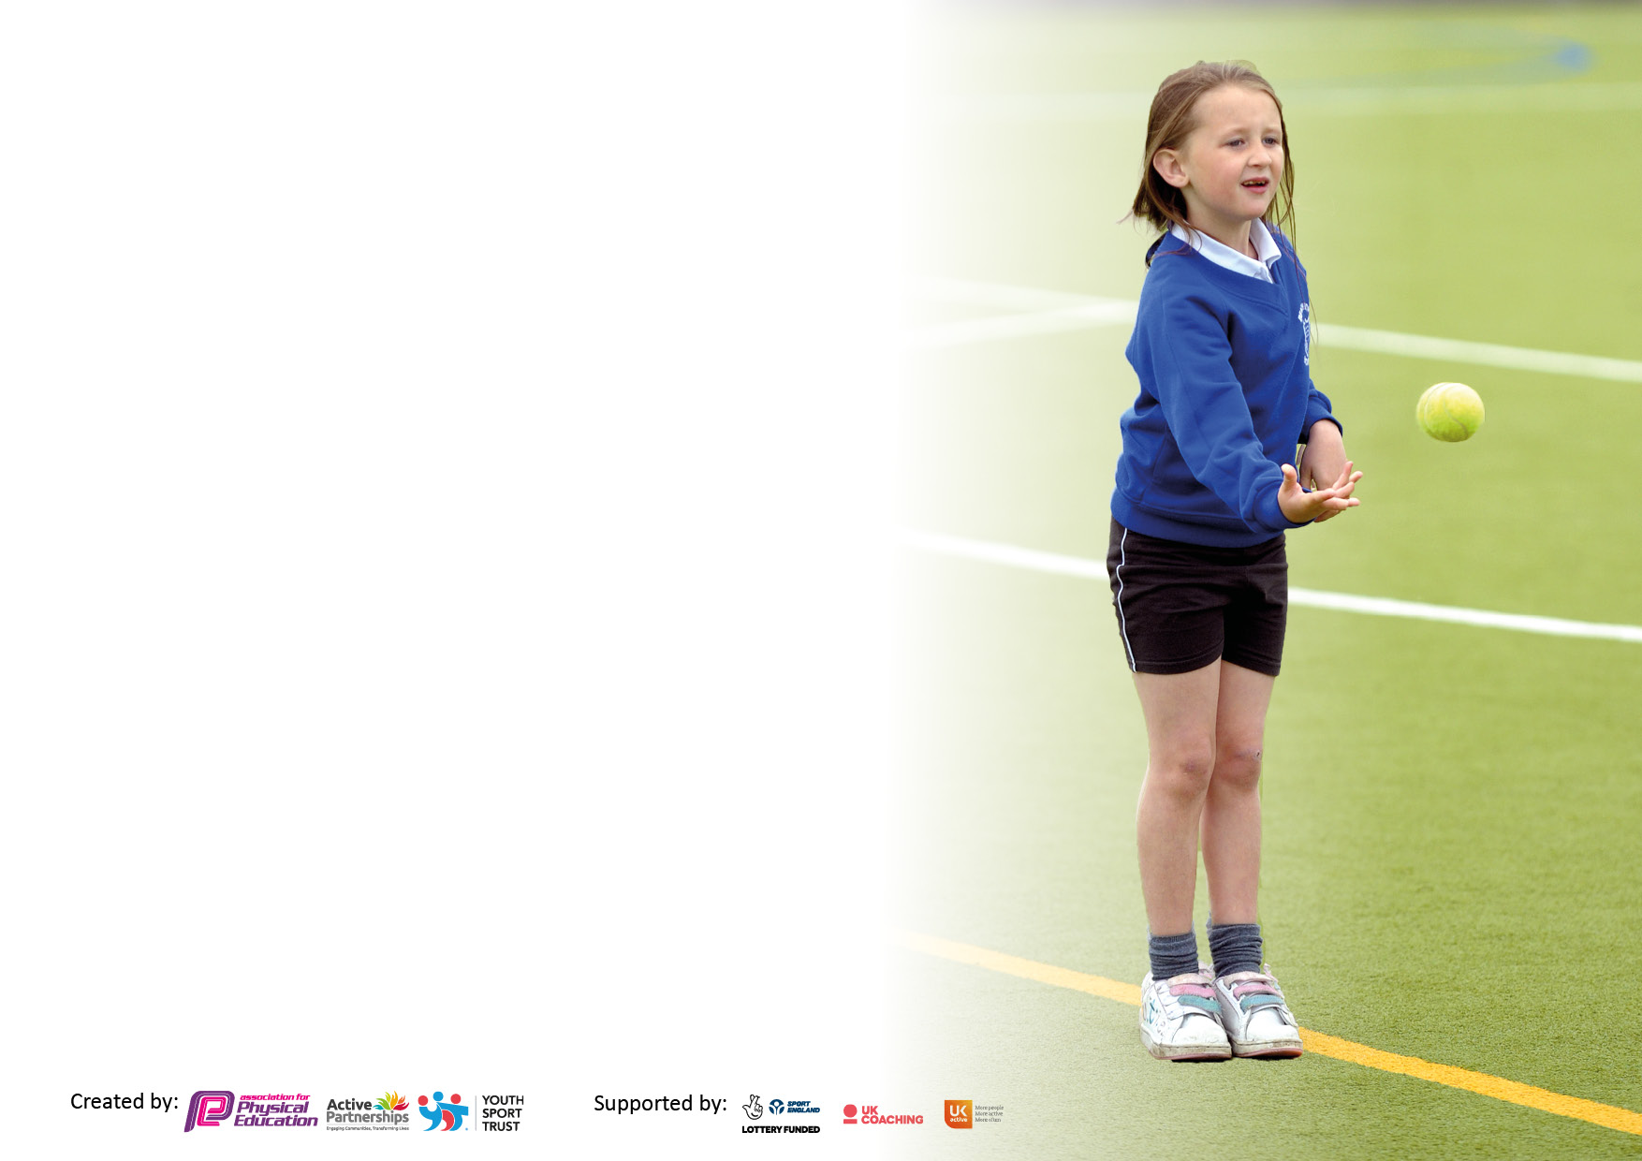

It is important that your grant is used effectively and based on school need. The Education Inspection Framework makes clear there will be a focus on **‘whether leaders and those responsible for governors all understand their respective roles and perform these in a way that enhances the effectiveness of the school’**.

Under the Quality of Education Ofsted inspectors consider:

**Intent** - Curriculum design, coverage and appropriateness

**Implementation** - Curriculum delivery, Teaching (pedagogy) and Assessment

**Impact** - Attainment and progress

To assist schools with common transferable language this template has been developed to utilise the same three headings which should make your plans easily transferable between working documents.

Schools must use the funding to make **additional and sustainable** improvements to the quality of Physical Education, School Sport and Physical Activity (PESSPA) they offer. This means that you should use the Primary PE and sport premium to:

* Develop or add to the PESSPA activities that your school already offer
* Build capacity and capability within the school to ensure that improvements made now will benefit pupils joining the school in future years
* The Primary PE and sport premium should not be used to fund capital spend projects; the school’s budget should fund these.

Pleasevisitgov.ukfortherevisedDfEguidanceincludingthe5keyindicatorsacrosswhichschoolsshoulddemonstrate animprovement.Thisdocumentwillhelpyoutoreviewyourprovisionandtoreportyourspend.DfEencouragesschools to use this template as an effective way of meeting the reporting requirements of the Primary PE and sport premium.

We recommend you start by reflecting on the impact of current provision and reviewing the previous spend.

Schools are required to publish details of how they spend this funding, including any under-spend from 2019/2020, as well as on the impact it has on pupils’ PE and sport participation and attainment. **All funding must be spent by 31st July 2022.**

We recommend regularly updating the table and publishing it on your website throughout the year. This evidences your ongoing self-evaluation of how you are using the funding to secure maximum, sustainable impact. Final copy must be posted on your website by the end of the academic year and no later than the 31st July 2021. To see an example of how to complete the table please click HERE.

Created by: Supported by:

**Details with regard to funding**

Please complete the table below.

|  |  |
| --- | --- |
| Total amount allocated for 2024/25 | £16,490 |
| Total amount of funding for 2024/25 To be spent and reported on by 31st July 2025. | £16,490 |

**Swimming Data**

Please report on your Swimming Data below.

|  |  |
| --- | --- |
| Meeting national curriculum requirements for swimming and water safety.  N.B. Complete this section to your best ability. For example you might have practised safe self-rescue techniques on dry land which you can then transfer to the pool when school swimming restarts.  **Due to exceptional circumstances priority should be given to ensuring that pupils can perform safe self rescue even if they do not fully meet the first two requirements of the NC programme of study** | N/A – Infant School |
| What percentage of your current Year 6 cohort swim competently, confidently and proficiently over a distance of at least 25 metres?  **N.B.** Even though your pupils may swim in another year please report on their attainment on leaving primary school at the end of the summer term 2021.  Please see note above | %  N/A – Infant School |
| What percentage of your current Year 6 cohort use a range of strokes effectively [for example, front crawl, backstroke and breaststroke]?  Please see note above | %  N/A – Infant School |
| **What percentage of your current Year 6 cohort perform safe self-rescue in different water-based situations?** | %  N/A – Infant School |
| Schools can choose to use the Primary PE and sport premium to provide additional provision for swimming but this must be for activity **over and above** the national curriculum requirements. Have you used it in this way? | Yes/No  As a school, we provide 1 term of targeted swimming lessons taught by trained coaches for our year 2 pupils to ensure that all children are confident in water and being to develop the basic skills needed for swimming |

**Action Plan and Budget Tracking**

Capture your intended annual spend against the 5 key indicators. Clarify the success criteria and evidence of impact that you intend to measure to evaluate for pupils today and for the future.

|  |  |  |  |  |
| --- | --- | --- | --- | --- |
| **Academic Year:** 2024/25 | **Total fund allocated: £16,490** | **Date Updated:** July 2024 | |  |
| **Key indicator 1:** The engagement of all pupils in regular physical activity – Chief Medical Officers guidelines recommend that primary school pupils undertake at least 30 minutes of physical activity a day in school | | | | Percentage of total allocation: |
| % |
| **Intent** | **Implementation** | | **Impact** |  |
| Your school focus should be clear what you want the pupils to know and be able to do and about  what they need to learn and to  consolidate through practice: | Make sure your actions to achieve are linked to your intentions: | Funding allocated: | Evidence of impact: what do pupils now know and what can they now do? What has changed?: | Sustainability and suggested next steps: |
| Improve the physical health and mental wellbeing of all pupils. | Children to participate in the ‘Daily mile’ for up to four sessions a week. Allow teachers to complete session within timetable when they see fit. | £0 | Children are more active and levels of fitness raised. Impact  Employing specialist teachers of Physical Education to ensure children get quality of education. Staff CPD to ensure high quality of education. They are able to observe the lessons of specialist staff and re-create activities and skills in additional lessons and break times.  Children are more active and levels of fitness raised. Children more enthusiastic/ confident and willing to try in PE lessons.  Take into account what clubs/sessions/ activities pupils want to engage in to improve uptake  Pupils will be encouraged to move and feel confident within themselves. All pupils to be encouraged to try new games when out on the playground. Children to enjoy a range of equipment to increase their love of sport and fitness. Aim to improve behaviour during break times. | Monitor impact via pupil voice.  Monitor the impact of specialist trainers on staff CPD and quality of provision for children. Monitor the impact on children during lessons – have their learning behaviours improved?  Pupil voice to be collected on breaktimes and lunchtime provision – what do they want to see on the playground? Is it safe? School council to lead and feedback to PE Lead.  Monitor club registers for uptake and sustainability. |
| Introduce the role of ‘Sports Leaders’ to develop leadership skills in key stage 1 pupils. | Children to take part in ‘Sports Leaders’ training  Purchase of Sports Leaders tabards | £1000 |
| Offer a range of variety of sports/activity to all pupils. | Children to participate in a range of different sports to ensure a broad range of sports are being experienced by children. | £1250 |
| Children to participate in ‘Fit for life Active ’lunchtime sessions | Stay active session run by PH sports to increase activity at lunchtimes for children as well as offer CPD to MDSA’s in order for them to continue sessions throughout the week. Targeted children are able to work on the Fit for Life program with the aim of building healthy choices into their daily routine for life | £480 |
| Offer after school clubs with PH sports | Children able to access a variety of different sports outside of school hours and promote healthy living and develop enthusiasm for sports. | £1980 |
| Children able to access a variety of different sports outside of school hours and promote healthy living and develop enthusiasm for sports. | Children can participate in sports during lunch time and after school, promoting physical activity throughout the day. | £3824 |
| **Key indicator 2:** The profile of PESSPA being raised across the school as a tool for whole school improvement | | | | Percentage of total allocation: |
|  |
| **Intent** | **Implementation** | | **Impact** |  |
| Your school focus should be clear what you want the pupils to know and be able to do and about  what they need to learn and to  consolidate through practice: | Make sure your actions to achieve are linked to your intentions: | Funding allocated: | Evidence of impact: what do pupils now know and what can they now do? What has changed?: | Sustainability and suggested next steps: |
| Healthy lifestyles and sports displays around the school  PE and Healthy eating to become more visible and have a higher profile within the school.  Promote good sportsmanship and appropriate behaviours within sport and play.  To ensure children hear and use language related to the different areas within PE. | Healthy lifestyles and ports displays introduced around the school.  PE and Healthy Eating to become more visible and have a higher profile within school.  Ensure children understand expectations, they are modelled at all times and good practice is regularly shared. Weekly class good sportsman award.  To enable their understanding and transfer of skills across the different areas | £0  £0  £0 | To encourage pupils to lead a Healthy Lifestyle by learning to eat healthily.  Improved understanding sportsmanship within sports and link to everyday life. Improved behaviour across the school.  Children will recognise skills and be able to transfer them to different sports. I.e. passing in netball and basketball. | Monitor impact of Sportsmanship/behaviour within all sports and play across the school.  Monitor via pupil voice/staff feedback. |

|  |  |  |  |  |
| --- | --- | --- | --- | --- |
| **Key indicator 3:** Increased confidence, knowledge and skills of all staff in teaching PE and sport | | | | Percentage of total allocation: |
| % |
| **Intent** | **Implementation** | | **Impact** |  |
| Your school focus should be clear | Make sure your actions to | Funding | Evidence of impact: what do | Sustainability and suggested |
| what you want the pupils to know | achieve are linked to your | allocated: | pupils now know and what | next steps: |
| and be able to do and about | intentions: |  | can they now do? What has |  |
| what they need to learn and to |  |  | changed?: |  |
| consolidate through practice: |  |  |  |  |
| • Improved quality of teaching and learning – staff are more confident and competent at teaching PE lessons against national curriculum standards  1. Staff skills, knowledge and confidence to deliver PE is developed through targeted CPD.  2. Improved delivery of PE sessions through progression documents produced by PH sports  4. Lesson drop-ins to monitor effectiveness of teaching and curriculum | PE coordinators to audit where staff feel their weaknesses are and target CPD towards where teachers need it. PE lead to drop in to lessons and gather pupil voice. Give support and feedback, if needed. | £10,344.70 | All staff to feel confident in delivering a range of sports and activities. To fill gaps in teacher’s knowledge. To build up their enthusiasm for teaching Pe and Sports. |  |
| **Key indicator 4:** Broader experience of a range of sports and activities offered to all pupils | | | | Percentage of total allocation: |
|  |
| **Intent** | **Implementation** | | **Impact** |  |
| Your school focus should be clear | Make sure your actions to | Funding | Evidence of impact: what do | Sustainability and suggested |
| what you want the pupils to know | achieve are linked to your | allocated: | pupils now know and what | next steps: |
| and be able to do and about | intentions: | £1,592.50 | can they now do? What has |  |
| what they need to learn and to |  |  | changed?: |  |
| consolidate through practice: |  |  |  |  |
| To buy new, challenging bikes/scooters for reception to meet their fundamental needs | To ensure that EYFS have scooters, bikes and balance bikes that challenge them | £500 | EYFS children will have the opportunity to improve on their gross motor and balance/coordination skills |  |
| Review sports resources and equipment for PE lessons and playtimes | Sports equipment that needs purchasing throughout the year to maintain high levels of teaching PE sessions. | £470 | Resources are available for all planned sports activities. Improved range of equipment for teachers to use to inspire children |  |
| For all children to leave year 2 being confident in water and having developed the basic swimming skills which can then be built upon in the future. | Weekly swimming lessons throughout the Summer Term. | £900 | All children to leave year 2 being confident in water and having developed the basic swimming skills which can then be built upon in the future. |  |

|  |  |  |  |  |
| --- | --- | --- | --- | --- |
| **Key indicator 5:** Increased participation in competitive sport | | | | Percentage of total allocation: |
| % |
| **Intent** | **Implementation** | | **Impact** |  |
| Your school focus should be clear | Make sure your actions to | Funding | Evidence of impact: what do | Sustainability and suggested |
| what you want the pupils to know | achieve are linked to your | allocated: | pupils now know and what | next steps: |
| and be able to do and about | intentions: |  | can they now do? What has |  |
| what they need to learn and to |  |  | changed?: |  |
| consolidate through practice: |  |  |  |  |
| Liaise with Southbroom St James and Devizes Secondary Sports Leaders to organise and set up intra sports tournaments within school  Opportunities for celebrating and sharing sports achievements. i.e. dance festivals. Raise profile of sport in school | Improve links with schools in the local area/federation.  Set up and update sports notice board celebrating the sports each year groups are partaking in including competitions. Share and celebrate the class success on the website, in the newsletter and via seesaw. | £0 | Improved confidence and pride for individuals and the whole school.  Increased uptake in the number of children partaking in the after school Multi-skills club.  Children keen to join and engaged in sports outside of school. |  |