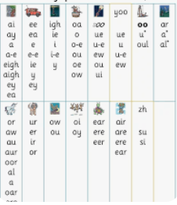

**Phonics and Early Reading**

This term, we will continue to progress

with our phase five phonics journey

and learn new GPCs and tricky words.

We will apply this newly taught

learning to reading books.

**Physical Education (PE)**

This term we will be learning about dance and movement. We will be performing dances using simple movement patterns.

**Personal, Social and Emotional Development**

This term, we will be

learning about our

personal dreams

and goals.

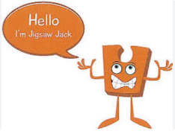

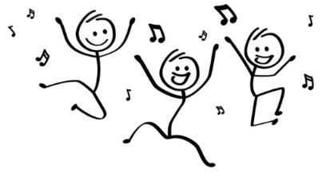

**English**

Our core texts this term will be:

Poles Apart and Dear Greenpeace.

We will be continuing to learn about sentence structure (capital letters, full stops, and finger spaces), as well as adjectives and using the connectives “and” and “because” in our writing.

Our end units will be to write a part of a well-known story and to write a non-chronological report.

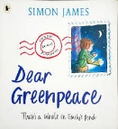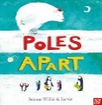

**Maths**

This term we will be continuing to learn

about the place value of numbers,

all the way up to 100.

In addition, and subtraction, we will be focusing on the numbers: 11, 12, 13, 14,15, and 16. We will be partitioning these numbers and writing both addition and subtraction number sentences using them.

**Year One Overview**

**Term 3**

**2024/2025**

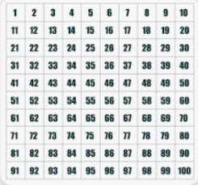



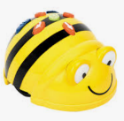

**Computing**

This term we will be learning

about programming and using bee-bots.



**Science**

This term we will continue to learn about materials and be using vocabulary to describe their properties. We will be performing simple tests so we can group materials and answer posed scientific questions.

**Art**

This term we will be painting

and experimenting using the water colours.

**History**

This term we will look at toys and how they have changed over time. We will discuss similarities and differences, and create a toy timeline.

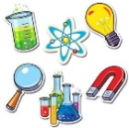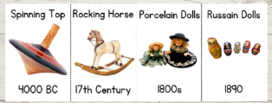

**Religious Education**

This term we will be focusing

on Judaism.

