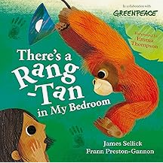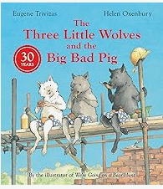Caring

**English**- Our texts for the term will be The Three Little Wolves and the Big Bad Pig and There’s a Rang-Tan in my Bedroom.

* Daily phonics/spelling sessions
* Reading skills taught daily
* Active learning
* Grammar rules taught explicitly
* Character description
* Retelling of a story
* Diary entry
* Non-chronological report
* Fact file

**Value of the term:**

* Caring

**Geography:**

We will learn about different places around the World with a focus on homes and weather.

**PSHE**: Dreams and goals

* Working in a group and evaluating
* Discussing our skills and how these complement each other
* Analysing the different roles people play in a group and the feelings related to this

**Year Two Curriculum Overview**

**Term 3 2024/2025**



**Maths**:

* Recalling and using multiplication facts for the 2, 5- and 10-times table.
* Recalling and using division facts for the 2, 5- and 10-times table.
* Measure the mass of objects (kg, g)
* Compare the mass of objects using >, < and =.
* Measure lengths (m, cm)
* Estimate heights (cm)

**DT: Sewing**

This term we will be making and decorating money pouches using a running stitch.

**Science**: Living things and their habitats

* Understand what is living and non-living.
* Exploring micro and world habitats.
* Ordering food chains.
* Finding out how and why animals adapt.

**Hook for Learning:**

* Wanted poster for the Big Bad Pig

**Fabulous finish to the theme**:

Parent workshop - Habitat making

**Music**:

Musical me

**RE**:

We’re going to be learning about a new religion - Sikhism. We’ll be answering the question: Who is God to Sikhs?

**PE**:

Dance and team games.

**ICT skills in Computing**:

* E-safety
* Programming