**Personal, Social and Emotional** **Development Jigsaw: Dreams and Goals Children will be learning:** To understand if they persevere, they can tackle challenges. To talk about a time, they didn’t give up until they achieved a goal. To set a goal and work towards it. To use kind words to encourage people. To understand the link between what they learn now and the job they might do when they are older. To say how they feel when they achieve a goal and know what it means to feel proud.

**Physical Development:**  *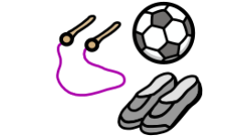***Children will continue:** To develop their small motor skills so that they can use a range of tools competently, safely, and confidently. Suggested tools: pencils for drawing and writing, paintbrushes, scissors, knives, forks, and spoon. To develop the overall body strength, co-ordination, balance, and agility needed to engage successfully with future physical education sessions and other physical disciplines including dance, gymnastics, sport, and swimming. To continue to develop core muscle strength to achieve a good posture when sitting at a table or sitting on the floor. **PE Focus** Gymnastics ..

**Communication and Language 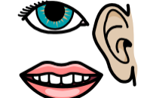 Children will be learning:** To use recently introduced vocabulary in different contexts. To articulate their ideas and thoughts in well‑formed

sentences. To connect one idea or action to another using

a range of connectives.

**Literacy Children will be learning**: **Phase 3 graphemes**:ai ee igh oa oo oo ar or ur ow oi ear air er To read words with double letters. To read longer words. To read the tricky words: was you they my by all are sure pure To orally retell the story (simpler version and using actions.) To story map the story. To orally retell a story using a story map. **This Term’s Texts** 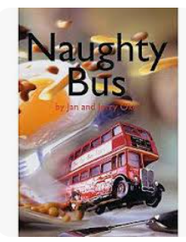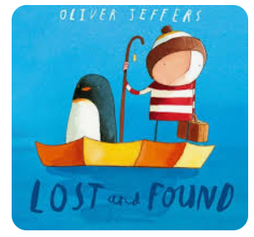

**Expressive Arts and Design:**  **Children will be learning:** **Music** To explore musical stories. **Art and Design** To create a drip style painting piece in the style of Jackson Pollock. To recognise and name the primary colours being used, in addition children will begin to know secondary colours.

**Reception Curriculum Overview**

**Term 3**

****r

**Literacy Children will be learning**: **Phase 3 graphemes**:ai ee igh oa oo oo ar or ur ow oi ear air er To read words with double letters. To read longer words. To read the tricky words: was you they my by all are sure pure To orally retell the story (simpler version and using actions.) To story map the story. To orally retell a story using a story map. To write a sentence.

**This Term’s Value**

**Caring**



**Maths:**  **Children will be learning:** To instantly recognise (without counting) how many dots there are on each card in the Set 1 Ten frame flashcards (5-wise arrangements). To represent a number from 1 – 5 in different ways on their fingers, using one or two hands. To make Numicon shapes 1– 5 from other objects without the Numicon shapes to refer to. To orally count in 1s from 1 to 20, saying each number clearly. To Identify 1 more and 1 fewer than numbers to 5 using equipment such as Numicon and 10 frames, independently using the sentence stem “1 more than … is …”/ “1 fewer than … is …”. To add two single digit numbers.

**Understanding the World:**   **Children will be learning: People, culture and communities:** To talk about features of places. To use maps and follow directions. To talk about celebrations that happen in the winter.

**The Natural World:** To talk about seasonal changes- winter.