Physical Development: 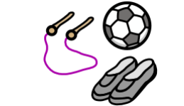Children will be learning: To develop their small motor skills so that they can use a range of tools competently, safely, and confidently. Suggested tools: pencils for drawing and writing, paintbrushes, scissors, knives, forks, and spoon. To develop the overall body strength, co-ordination, balance, and agility needed to engage successfully with future physical education sessions and other physical disciplines including dance, gymnastics, sport, and swimming. To continue to develop core muscle strength to achieve a good posture when sitting at a table or sitting on the floor

. .

Communication and Language 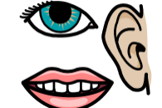 Children will be learning:
To Listen to others 1:1, in small groups and whole class.
To Enjoy listening to stories and remember what happens. To maintain attention in whole class and small group contexts for a short time. To use sentences of 4-6 words. To Join in with repeated refrains and anticipate key events and phases in stories or rhymes.
To learn and use new vocabulary.

Personal, Social and Emotional 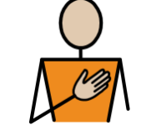Development Jigsaw: Being Me in My World Children will be learning: To understand how it feels to belong and that we are similar and different. To start to recognise and manage their feelings. To work together and consider other people’s feelings. To understand why it is good to be kind and use gentle hands. To start to understand children’s rights and this means we should all be allowed to learn and play. To learn what being responsible means.

Reception Curriculum Overview
Term 1
Expressive Arts and Design:  Children will be learning: To explore making marks and patterns. To create simple observational drawings. To use a variety of colours and materials to create a self-portrait. To explore using voices to make a variety of sounds. To explore how to use their bodies to make sounds. To explore the sounds of different instruments.


Value of the term:
Respect
Understanding the World:  Children will be learning: To talk about members of their immediate family and the relationship to them. To name and describe people who are familiar to them. To talk about and describe features of their own family, talk about families in other countries across the world.

Literacy Children will be learning: Phase 2 graphemes: s a t p i n m d g o c k ck e u r h b f l To blend with known letters for reading VC and CVC words. To orally segment VC and CVC words for spelling To read and write the tricky words is I the. To write the initial sounds in words. To Listen and enjoy sharing a range of books. To hold a book correctly, handle with care and turn pages from front to back and recognise front and back cover. To know that print carries meaning and in English, is read from left to right and top to bottom. To orally retell the story using story maps

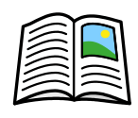

Maths: 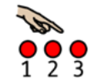 Children will be learning: To subitise standard dice pattens. To develop number sense of numbers 1-5. To understand the concept of “lots”, “few” and “more”. To Identify one more and one fewer. To name and use 2d shapes to make pictures. To use mathematical language to describe position and direction. To use mathematical language to describe size. To explore repeating patterns.

