**Personal, Social and Emotional 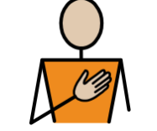Development Jigsaw: Healthy Me Children will be learning:**  To understand that they need to exercise to keep their bodies healthy. To understand how moving and resting are good for their bodies. To know which foods are healthy and not so healthy and can make healthy eating choices. To know how to help themselves go to sleep and understand why sleep is good for them. To know what a stranger is and how to stay safe if a stranger approaches them.

**Physical Development:**  *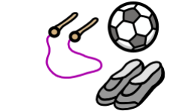***Children will continue:** To develop their small motor skills so that they can use a range of tools competently, safely, and confidently. Suggested tools: pencils for drawing and writing, paintbrushes, scissors, knives, forks, and spoon. To develop the overall body strength, co-ordination, balance, and agility needed to engage successfully with future physical education sessions and other physical disciplines including dance, gymnastics, sport, and swimming. To continue to develop core muscle strength to achieve a good posture when sitting at a table or sitting on the floor. **PE Focus** Dance ..

**Communication and Language 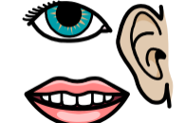 Children will continue to:** To use recently introduced vocabulary in different contexts. To articulate their ideas and thoughts in well‑formed

sentences. To connect one idea or action to another using

a range of connectives.

**Expressive Arts and Design:**  **Children will be learning:** **Music** To explore music and movement **Art and Design** To create art work inspired by Frida Kahlo and Paul CézanneTo use a variety of malleable media such as clay, plasticine, salt dough through exploration and also to create 3D form art.

**Literacy Children will be learning**: Review Phase 3: Read longer words, including those with double letters. Read words with –s /z/ in the middle. Read words with –es /z/ at the end. Read words with –s /s/ and /z/ at the end. To review all tricky words taught so far. To orally retell a story (simpler version and using actions.) To innovate a story. To write a three-part story. **This Term’s Texts**

**Reception Curriculum Overview**

**Term 4**

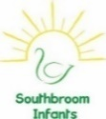r

**Understanding the World:**    **Children will be learning: People, culture and communities:**  To talk about celebrations that happen in Spring

**The Natural World:** To talk about seasonal changes. To make close observations of animals in the natural world. I make comparisons and identify similarities and differences.

To understand through books and observations that animals change and explain a range of lifecycles.

**Maths:**  **Children will be learning:** To orally count in 1s from a specified number to and beyond 20 · To orally count in 1s from 10 to 0.To add two single digit numbers (where the total is 5 or less), using equipment such as 10 frames or Numicon and use the language of addition, for example; “… add … equals …” · To partition a number to 5 using equipment such as double-sided counters, cubes, Numicon shapes/ pegs, etc. and use the language of addition such as “… is equal to … add …” · To represent patterns within numbers such as odd and even, doubles and halves.

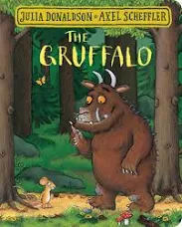 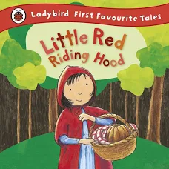

**Literacy Children will be learning**: **Phase 3 graphemes**:ai ee igh oa oo oo ar or ur ow oi ear air er To read words with double letters. To read longer words. To read the tricky words: was you they my by all are sure pure To orally retell the story (simpler version and using actions.) To story map the story. To orally retell a story using a story map. To write a sentence.

**This Term’s Value**

**Understanding**

