**Personal, Social and Emotional 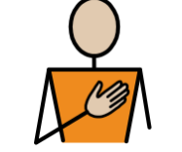Development Jigsaw: Healthy Me Children will be learning:**  To identify some of the jobs they do with their family and how they feel like they belong. To know how to make friends to stop themselves from feeling lonely. To think of ways to solve problems and stay friends. To start to understand the impact of unkind words. To know how to be a good friend.

**Physical Development:**  *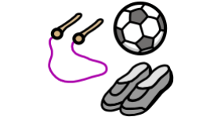***Children will continue:** To develop their small motor skills so that they can use a range of tools competently, safely, and confidently. Suggested tools: pencils for drawing and writing, paintbrushes, scissors, knives, forks, and spoon. To develop the overall body strength, co-ordination, balance, and agility needed to engage successfully with future physical education sessions and other physical disciplines including dance, gymnastics, sport, and swimming. To continue to develop core muscle strength to achieve a good posture when sitting at a table or sitting on the floor. **PE Focus** Athletics  ..

**Communication and Language 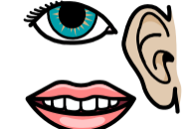 Children will continue to:** To use recently introduced vocabulary in different contexts. To articulate their ideas and thoughts in well‑formed

sentences. To connect one idea or action to another using

a range of connectives.

**Literacy Children will be learning**: Phase 4 Phonics: Short vowels with adjacent consonants longer words and compound words words ending in suffixes: –ing, –ed /t/, –ed /id/ /ed/, –est **Tricky words**:said so have like some come love do were here little says there when what one out today To orally retell a story (simpler version and using actions.) To innovate a story. To write a three-part story. **This Term’s Texts** 

**Expressive Arts and Design:**  **Children will be learning:** **Music** To explore music and movement. To explore making music with instruments. **Art and Design** To explore painting in the style of Claude Monet.

**Reception Curriculum Overview**

**Term 5**

****r

**Understanding the World:**    **Children will be learning:**

**The Natural World:** To make close observations of plants in the natural world. To talk about what plants need to grow and survive.



**Maths: Children will be learning:** To orally count in 1s from 1 to 20and from 10 to 0. To add and subtract from numbers to 10. To understand the concepts of doubling and halving. To compare numbers to 10. To order numbers according to height. To instantly recall number facts to 5.

**Literacy Children will be learning**: **Phase 3 graphemes**:ai ee igh oa oo oo ar or ur ow oi ear air er To read words with double letters. To read longer words. To read the tricky words: was you they my by all are sure pure To orally retell the story (simpler version and using actions.) To story map the story. To orally retell a story using a story map. To write a sentence.

**This Term’s Value**

Thoughtfulness 