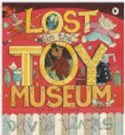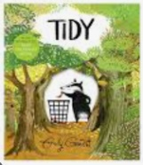

**PSHE: Healthy Me**

In our six puzzle pieces this term, we will focus on ‘Relationships’, and looking at how to be a good, helpful, respectful friend to everyone and how to include all.

**Maths**

We will be focusing on adding and subtracting, thinking about noticing patterns when adding or subtracting the numbers 10 and 9 in particular. We will revisit how to double and halving numbers. We will learn how to count in multiples of 2s, 5s and 10s, before beginning a new unit around multiplication and division. We will learn about groups, arrays and sharing.

**English**

We will be using the texts ‘Lost in the Toy Museum’ and ‘Tidy’ as our focus books. We will be writing in full sentences, using the suffix “est” and the past tense. Our end unit pieces will be: Retelling a part of the Lost in the Toy Museum story, and Writing Instructions.

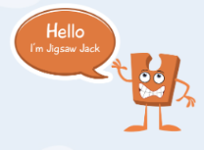

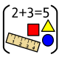

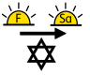 

**Art: Sculpture**

We will be making observational drawings based upon an artist’s sculpture, before we explore materials to be able to design and make a castle sculpture.

**Year One Curriculum Overview**

**Term 5**

**2024/2025**

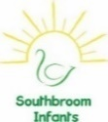

**PE**

In PE the children will be learning how to throw and catch with our PE coach.

**RE**

Our BIG question this term is: ‘Is Shabbat important to Jewish children?’

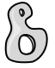

**Science: Animals including pets**

We will be learning about different animals, how they can be grouped, their different features and characteristics as well as their diets.

**History**

We will be learning about castles and why they were built. We will focus on the different people and jobs that they had inside a castle, and focus on a knight. We will also learn about the Norman Invasions.

**Computing**

We will be focusing on the strand digital literacy and learning how to create a typed piece of writing using the app 2Write on Purple Mash.

**Value of the term:**

Thoughtfulness

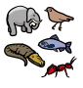

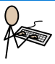



**Music**

We will be learning about … using ‘Under the Sea’ themed musical tunes.

