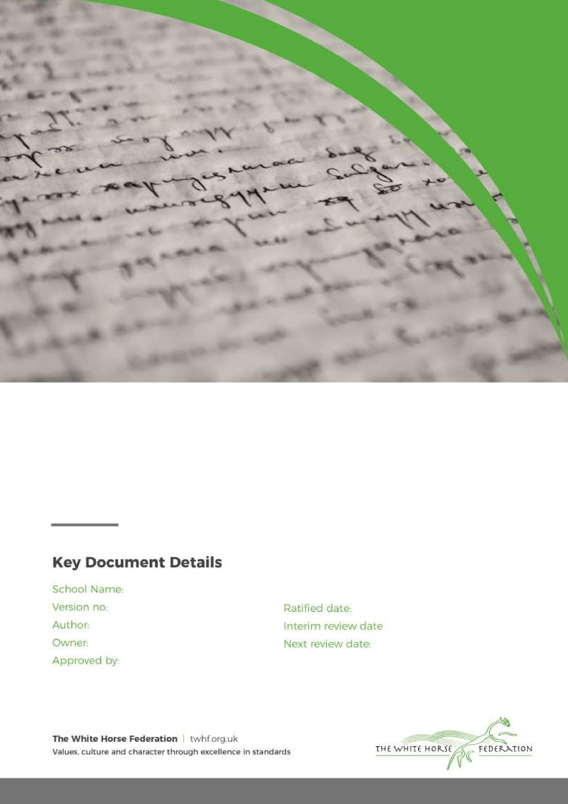
The Southbroom Infant School uniform is very important to us. It is one way in which we identify ourselves as a school family, and it promotes a strong, cohesive school identity that supports high standards and expectations in all areas of school life. All children are expected to wear our uniform, and we encourage them to maintain an acceptable standard of clean and tidy dress in school. The commitment to wear our agreed school uniform is a key feature of our home/school agreement.

Uniform Policy

1

A.Edwards

A.Edwards

A.Edwards

September 2023

n/a

September 2024

Southbroom Infant School
Our uniform policy is based on the notion of:
‘Look Smart, Act Smart’
At Southbroom Infant School, we believe that a school uniform is important, because it:
- Reminds us that we are at school for a serious purpose – to work and to learn.
- Identifies our children with our school, that as pupils of Southbroom Infant School we belong to a special group, and we should be proud of it.
- Promotes a sense of pride in the school and fosters a feeling of community identity and belonging.
- Is practical and smart.
- Ensures our pupils’ wellbeing — We want to ensure that all our pupils are appropriately dressed at school and protect children from social pressures to dress in a particular way.
- Nurtures cohesion and promotes good relations between different groups of pupils.
- Supports positive behaviour and discipline.
- Enables us to easily identify our pupils when on visits or accessing out-of-school learning activities.
- Above all, school uniform supports effective teaching and learning.
Uniform Expectations

Uniform (Nursery)

Although uniform within nursery is optional, to encourage a positive sense of community, it is encouraged.

Bottle-green school sweatshirt

Bottle-green polo-shirt

Sensible footwear e.g. school shoes or trainers

Uniform (Reception to Year 2)
- Grey school trousers, shorts, skirt or pinafore
- Green and white gingham dress during summer months
- White polo shirt
- Plain grey, black, or white socks
- Black shoes (not trainers)
- Bottle-green school sweatshirt

PE Kit (Reception – Year 2)

Pupils must come to school in full PE kit on their allocated PE day
- Bottle-green school jumper
- Coloured house team round-neck T-shirt
- Navy or black PE shorts or tracksuit bottoms
- Plimsolls, or trainers

Equipment and Bags
All pupils are expected to bring their book bag to school daily.
All pupils need to bring a named water bottle to school each day (water only)

Other Uniform Expectations and Clarification

Jewellery
We only allow our children to wear stud earrings and inexpensive watches. We would prefer an analogue rather than a digital watch in order to reinforce teaching of time. If a watch is designed for games or making disruptive noises, it should not be worn for school. Other accessories, loom bands and necklaces for example, are not permitted.
Hair and Makeup
We want our children to look smart, and as a result we don’t expect or allow makeup or our children to have extreme haircuts or colouring that could distract other children or impact on our uniform statement - ‘Act Smart, Look Smart’. Hair bands and clips should be discreet designs in keeping with our school colours. No nail varnish may be worn during the school day.

Seasonal Safety
All children require a coat in school when weather is changeable, cold, or wet. On hot, sunny days, children should be protected from the sun when outdoors by:
- Wearing a cap or a hat
- Wearing appropriate SPF sunscreen that has been applied from home or brought into school for them to apply.

Roles and Responsibilities

The Role of Parents
Acceptance of the uniform policy is a key element of our home/school agreement, and we ask all parents who have children at Southbroom Infant School to support our uniform policy and send their children to school correctly dressed, clean, and ready for their daily school work. Please ensure that all school uniform items are marked with your child’s name.
If any parents would like the school to modify the uniform, they should discuss the request with the principal in the first instance. We welcome children from all backgrounds and faith communities and would not wish to discriminate. If there are religious reasons why a parent might request a modification to our uniform, these requests will be responded to. Similarly, should an item of school uniform be problematic for a pupil with disabilities, parents are invited to discuss this with the principal. We will not treat pupils with disabilities unfavourably.

The Role of the School
Items bearing the school’s logo are available to purchase from our providers, Scholars or OHM in Devizes.
The school cannot accept any liability for loss or damage to uniform or personal items brought into the school.
Acceptance of the uniform policy is a key element of our home/school agreement and staff will raise issues relating to uniform by sending home a ‘school uniform reminder slip’ to parents if the uniform policy isn’t followed.

The Role of Governors
The governing body supports the principal in the implementation of the school uniform policy. It considers all representations from parents considering this policy and will liaise with the principal to ensure that this policy is consistent with our equalities policy and is implemented fairly and consistently

